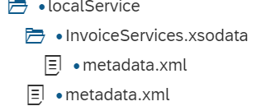

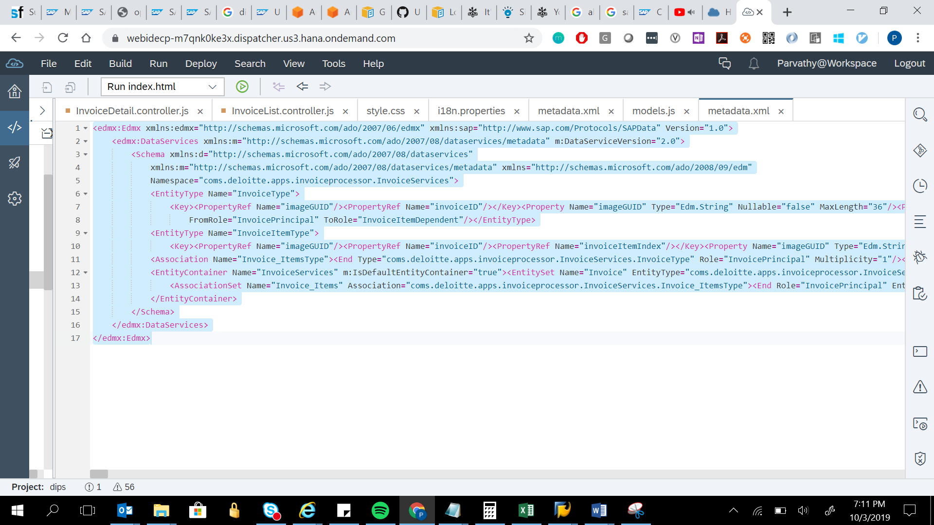

<edmx:Edmx xmlns:edmx="http://schemas.microsoft.com/ado/2007/06/edmx" xmlns:sap="http://www.sap.com/Protocols/SAPData" Version="1.0">

<edmx:DataServices xmlns:m="http://schemas.microsoft.com/ado/2007/08/dataservices/metadata" m:DataServiceVersion="2.0">

<Schema xmlns:d="http://schemas.microsoft.com/ado/2007/08/dataservices"

xmlns:m="http://schemas.microsoft.com/ado/2007/08/dataservices/metadata" xmlns="http://schemas.microsoft.com/ado/2008/09/edm"

Namespace="coms.deloitte.apps.invoiceprocessor.InvoiceServices">

<EntityType Name="InvoiceType">

<Key><PropertyRef Name="imageGUID"/><PropertyRef Name="invoiceID"/></Key><Property Name="imageGUID" Type="Edm.String" Nullable="false" MaxLength="36"/><Property Name="invoiceID" Type="Edm.String" Nullable="false" MaxLength="10"/><Property Name="invoiceStatus" Type="Edm.String" MaxLength="20"/><Property Name="documentType" Type="Edm.String" MaxLength="10"/><Property Name="documentDate" Type="Edm.DateTime" sap:display-format="Date"/><Property Name="invoiceDate" Type="Edm.DateTime" sap:display-format="Date"/><Property Name="postingDate" Type="Edm.DateTime" sap:display-format="Date"/><Property Name="invoicingParty" Type="Edm.String" MaxLength="20"/><Property Name="companyCode" Type="Edm.String" MaxLength="20"/><Property Name="paymentCurrency" Type="Edm.String" MaxLength="5"/><Property Name="invoiceType" Type="Edm.String" MaxLength="10"/><Property Name="headerText" Type="Edm.String" MaxLength="100"/><Property Name="supplierNumber" Type="Edm.String" MaxLength="10"/><Property Name="paymentMethod" Type="Edm.String" MaxLength="10"/><Property Name="paymentBlock" Type="Edm.String" MaxLength="10"/><Property Name="partnerBank" Type="Edm.String" MaxLength="20"/><Property Name="houseBank" Type="Edm.String" MaxLength="20"/><Property Name="houseBankAccountID" Type="Edm.String" MaxLength="10"/><Property Name="paymentMethodSupp" Type="Edm.String" MaxLength="20"/><Property Name="autoCalculateTaxIndicator" Type="Edm.String" MaxLength="1"/><Property Name="totalTaxAmount" Type="Edm.Decimal" Precision="34"/><Property Name="taxJurisdiction" Type="Edm.String" MaxLength="10"/><Property Name="baselineDate" Type="Edm.DateTime" sap:display-format="Date"/><Property Name="dueDate" Type="Edm.DateTime" sap:display-format="Date"/><Property Name="vatAmount" Type="Edm.Decimal" Precision="34"/><Property Name="vatAmount1" Type="Edm.Decimal" Precision="34"/><Property Name="vatAmount2" Type="Edm.Decimal" Precision="34"/><Property Name="vatAmount3" Type="Edm.Decimal" Precision="34"/><Property Name="vatAmount4" Type="Edm.Decimal" Precision="34"/><Property Name="vatRate" Type="Edm.Decimal" Precision="34"/><Property Name="vatRate1" Type="Edm.Decimal" Precision="34"/><Property Name="vatRate2" Type="Edm.Decimal" Precision="34"/><Property Name="vatRate3" Type="Edm.Decimal" Precision="34"/><Property Name="vatRate4" Type="Edm.Decimal" Precision="34"/><Property Name="paymentTerms" Type="Edm.String" MaxLength="100"/><Property Name="day1" Type="Edm.String" MaxLength="20"/><Property Name="day2" Type="Edm.String" MaxLength="20"/><Property Name="day3" Type="Edm.String" MaxLength="20"/><Property Name="discount1" Type="Edm.String" MaxLength="20"/><Property Name="discount2" Type="Edm.String" MaxLength="20"/><Property Name="exchangeRate" Type="Edm.Decimal" Precision="34"/><Property Name="withholdingTax" Type="Edm.Decimal" Precision="34"/><Property Name="unplannedDeliveryCost" Type="Edm.Decimal" Precision="34"/><Property Name="instanceKey" Type="Edm.String" MaxLength="20"/><Property Name="bankAccount" Type="Edm.String" MaxLength="20"/><Property Name="bankName" Type="Edm.String" MaxLength="20"/><Property Name="bankNumber" Type="Edm.String" MaxLength="20"/><Property Name="bankPartnerType" Type="Edm.String" MaxLength="20"/><Property Name="vatID" Type="Edm.String" MaxLength="20"/><Property Name="vatID1" Type="Edm.String" MaxLength="20"/><Property Name="vatID2" Type="Edm.String" MaxLength="20"/><Property Name="vatID3" Type="Edm.String" MaxLength="20"/><Property Name="vatID4" Type="Edm.String" MaxLength="20"/><Property Name="requestorEmail" Type="Edm.String" MaxLength="20"/><Property Name="invoiceFreightAmount" Type="Edm.Decimal" Precision="34"/><Property Name="invoiceHandlingCharges" Type="Edm.Decimal" Precision="34"/><Property Name="alternatePayee" Type="Edm.String" MaxLength="20"/><Property Name="documentItemInInvoice" Type="Edm.String" MaxLength="20"/><Property Name="purchaseOrder" Type="Edm.Int32"/><Property Name="itemPurchaseOrder" Type="Edm.String" MaxLength="10"/><Property Name="uomPurchaseOrder" Type="Edm.String" MaxLength="10"/><Property Name="amountDocumentCurrency" Type="Edm.String" MaxLength="10"/><Property Name="deliveryNoteNumber" Type="Edm.String" MaxLength="20"/><Property Name="materialNumber" Type="Edm.String" MaxLength="10"/><Property Name="taxCode" Type="Edm.String" MaxLength="10"/><Property Name="accountAssigned" Type="Edm.String" MaxLength="10"/><Property Name="directPostingGL" Type="Edm.String" MaxLength="10"/><Property Name="directPostingMaterial" Type="Edm.String" MaxLength="10"/><Property Name="lastUser" Type="Edm.String" MaxLength="20"/><Property Name="currentUser" Type="Edm.String" MaxLength="20"/><Property Name="lastUpdatedTS" Type="Edm.DateTime"/><Property Name="lastRole" Type="Edm.String" MaxLength="10"/><Property Name="invoiceCategory" Type="Edm.String" MaxLength="10"/><Property Name="shipToAddress1" Type="Edm.String" MaxLength="100"/><Property Name="shipToAddress2" Type="Edm.String" MaxLength="100"/><Property Name="billToCompany" Type="Edm.String" MaxLength="100"/><Property Name="billToName" Type="Edm.String" MaxLength="100"/><Property Name="billToPhone" Type="Edm.String" MaxLength="10"/><Property Name="billToAddress1" Type="Edm.String" MaxLength="100"/><Property Name="billToAddress2" Type="Edm.String" MaxLength="100"/><Property Name="billToCountry" Type="Edm.String" MaxLength="20"/><Property Name="billToVAT" Type="Edm.String" MaxLength="6"/><Property Name="billToEmail" Type="Edm.String" MaxLength="20"/><Property Name="remitName" Type="Edm.String" MaxLength="20"/><Property Name="remitToAddress1" Type="Edm.String" MaxLength="100"/><Property Name="remitToAddress2" Type="Edm.String" MaxLength="100"/><Property Name="remitToPin" Type="Edm.String" MaxLength="7"/><Property Name="remitToStreet" Type="Edm.String" MaxLength="10"/><Property Name="remitToVAT" Type="Edm.String" MaxLength="10"/><Property Name="remitToEmail" Type="Edm.String" MaxLength="20"/><Property Name="remitToPhone" Type="Edm.String" MaxLength="10"/><Property Name="supplierName" Type="Edm.String" MaxLength="100"/><Property Name="supplierName2" Type="Edm.String" MaxLength="100"/><Property Name="supplierPOBox" Type="Edm.String" MaxLength="20"/><Property Name="supplierPOBoxZip" Type="Edm.String" MaxLength="20"/><Property Name="supplierStreet" Type="Edm.String" MaxLength="20"/><Property Name="supplierState" Type="Edm.String" MaxLength="20"/><Property Name="supplierZip" Type="Edm.String" MaxLength="20"/><Property Name="netAmount" Type="Edm.Decimal" Precision="34"/><Property Name="ibanNumber" Type="Edm.String" MaxLength="20"/><Property Name="swiftCode" Type="Edm.String" MaxLength="20"/><Property Name="grossAmount" Type="Edm.Decimal" Precision="34"/><Property Name="glAccount" Type="Edm.String" MaxLength="10"/><Property Name="glDescription" Type="Edm.String" MaxLength="30"/><Property Name="costCenter" Type="Edm.String" MaxLength="10"/><Property Name="costCenterDescription" Type="Edm.String" MaxLength="30"/><Property Name="wbsElement" Type="Edm.String" MaxLength="10"/><Property Name="wbsElementDescription" Type="Edm.String" MaxLength="30"/><Property Name="internalOrder" Type="Edm.String" MaxLength="10"/><Property Name="internalOrderDescription" Type="Edm.String" MaxLength="30"/><Property Name="assetID" Type="Edm.String" MaxLength="10"/><Property Name="assetDescription" Type="Edm.String" MaxLength="30"/><Property Name="invoiceFileName" Type="Edm.String" MaxLength="128"/><Property Name="postedInvoice" Type="Edm.String" MaxLength="10"/><NavigationProperty Name="items" Relationship="com.deloitte.apps.invoiceprocessor.InvoiceServices.Invoice_ItemsType"

FromRole="InvoicePrincipal" ToRole="InvoiceItemDependent"/></EntityType>

<EntityType Name="InvoiceItemType">

<Key><PropertyRef Name="imageGUID"/><PropertyRef Name="invoiceID"/><PropertyRef Name="invoiceItemIndex"/></Key><Property Name="imageGUID" Type="Edm.String" Nullable="false" MaxLength="36"/><Property Name="invoiceID" Type="Edm.String" Nullable="false" MaxLength="10"/><Property Name="invoiceItemIndex" Type="Edm.String" Nullable="false" MaxLength="5"/><Property Name="itemNumber" Type="Edm.String" MaxLength="20"/><Property Name="itemCode" Type="Edm.String" MaxLength="10"/><Property Name="itemCompanyCode" Type="Edm.String" MaxLength="10"/><Property Name="itemDescription" Type="Edm.String" MaxLength="40"/><Property Name="itemQuantity" Type="Edm.Int32"/><Property Name="itemUnit" Type="Edm.Int32"/><Property Name="unitPrice" Type="Edm.Decimal" Precision="34"/><Property Name="itemQuantityShipped" Type="Edm.Decimal" Precision="34"/><Property Name="itemTax" Type="Edm.Decimal" Precision="34"/><Property Name="itemTaxRate" Type="Edm.Decimal" Precision="34"/><Property Name="totalAmount" Type="Edm.Decimal" Precision="34"/><Property Name="pgiDate" Type="Edm.DateTime" sap:display-format="Date"/></EntityType>

<Association Name="Invoice_ItemsType"><End Type="coms.deloitte.apps.invoiceprocessor.InvoiceServices.InvoiceType" Role="InvoicePrincipal" Multiplicity="1"/><End Type="coms.deloitte.apps.invoiceprocessor.InvoiceServices.InvoiceItemType" Role="InvoiceItemDependent" Multiplicity="*"/></Association>

<EntityContainer Name="InvoiceServices" m:IsDefaultEntityContainer="true"><EntitySet Name="Invoice" EntityType="coms.deloitte.apps.invoiceprocessor.InvoiceServices.InvoiceType"/><EntitySet Name="InvoiceItem" EntityType="com.deloitte.apps.invoiceprocessor.InvoiceServices.InvoiceItemType"/>

<AssociationSet Name="Invoice_Items" Association="coms.deloitte.apps.invoiceprocessor.InvoiceServices.Invoice_ItemsType"><End Role="InvoicePrincipal" EntitySet="Invoice"/><End Role="InvoiceItemDependent" EntitySet="InvoiceItem"/></AssociationSet>

</EntityContainer>

</Schema>

</edmx:DataServices>

</edmx:Edmx>