

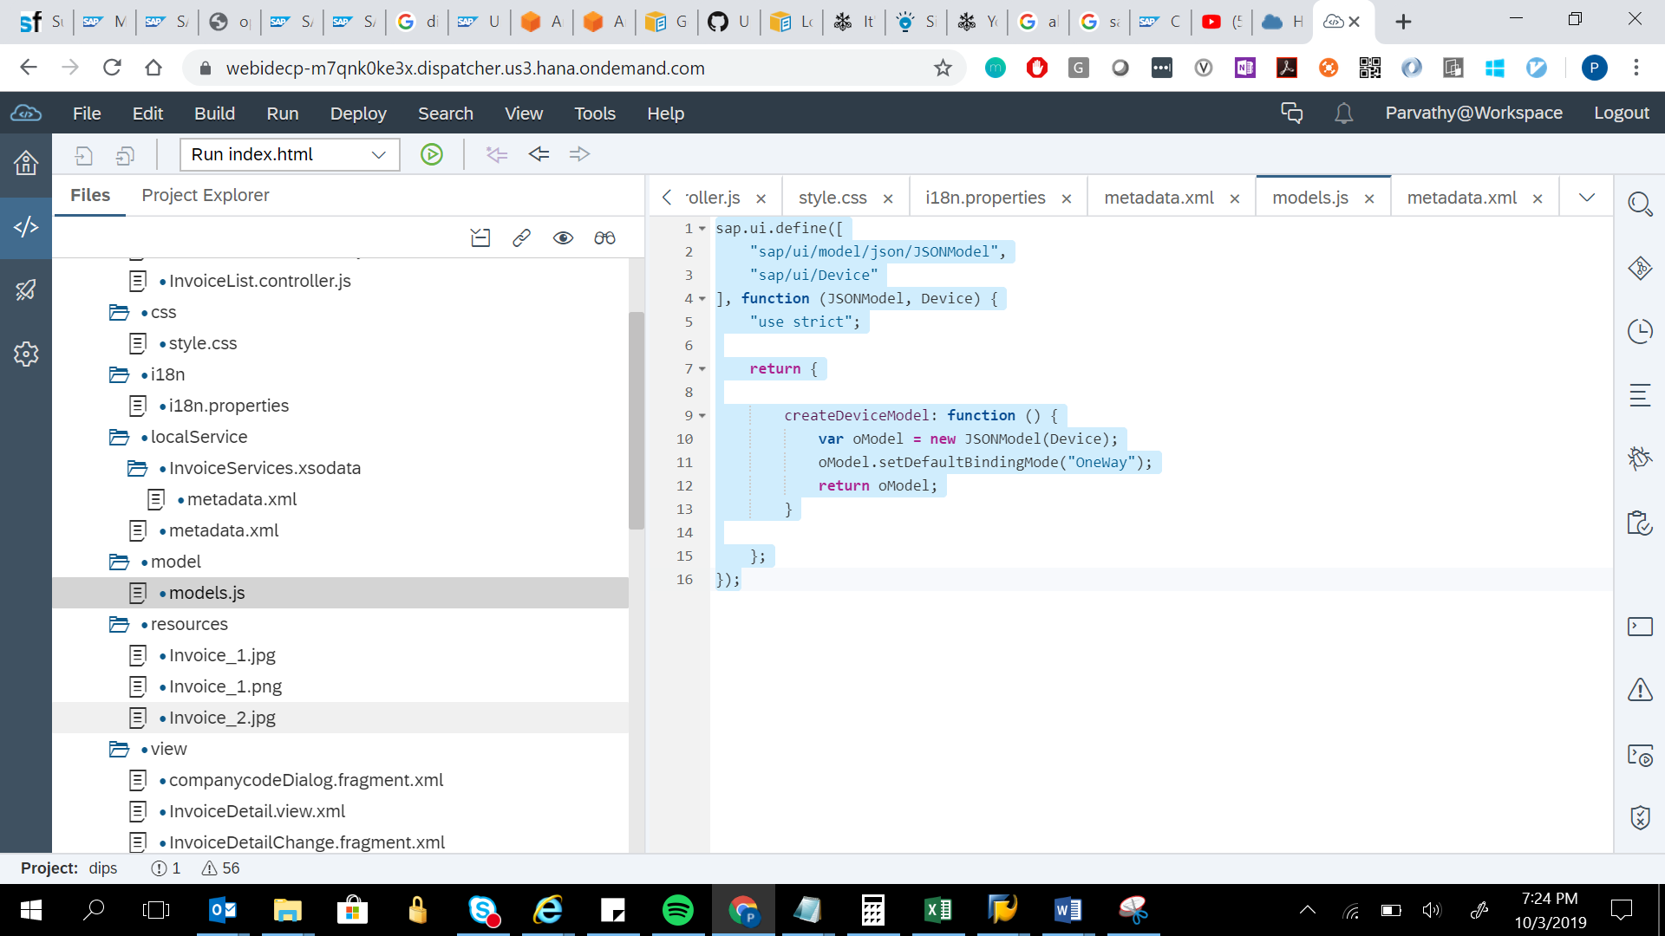

sap.ui.define([

"sap/ui/model/json/JSONModel",

"sap/ui/Device"

], function (JSONModel, Device) {

"use strict";

return {

createDeviceModel: function () {

var oModel = new JSONModel(Device);

oModel.setDefaultBindingMode("OneWay");

return oModel;

}

};

});