

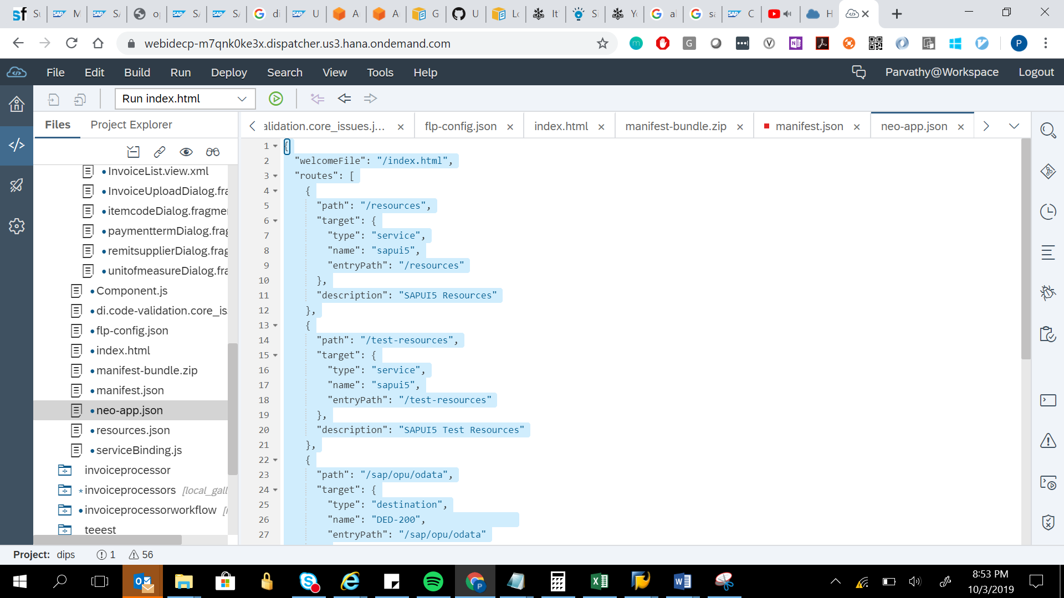

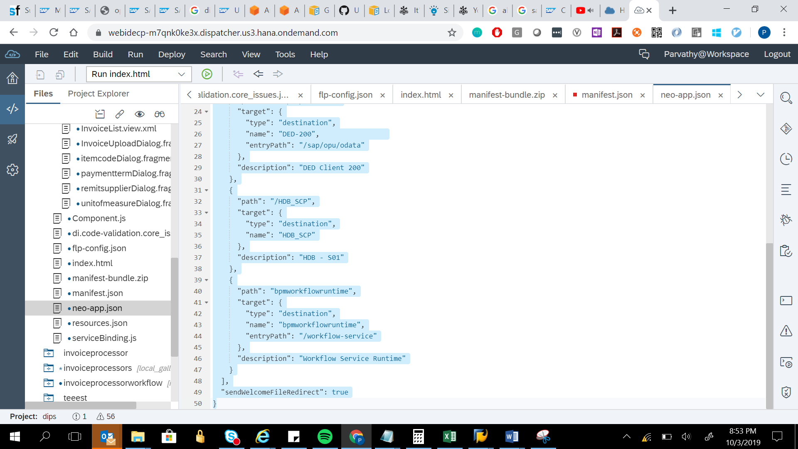

{

"welcomeFile": "/index.html",

"routes": [

{

"path": "/resources",

"target": {

"type": "service",

"name": "sapui5",

"entryPath": "/resources"

},

"description": "SAPUI5 Resources"

},

{

"path": "/test-resources",

"target": {

"type": "service",

"name": "sapui5",

"entryPath": "/test-resources"

},

"description": "SAPUI5 Test Resources"

},

{

"path": "/sap/opu/odata",

"target": {

"type": "destination",

"name": "DED-200",

"entryPath": "/sap/opu/odata"

},

"description": "DED Client 200"

},

{

"path": "/HDB_SCP",

"target": {

"type": "destination",

"name": "HDB_SCP"

},

"description": "HDB - S01"

},

{

"path": "bpmworkflowruntime",

"target": {

"type": "destination",

"name": "bpmworkflowruntime",

"entryPath": "/workflow-service"

},

"description": "Workflow Service Runtime"

}

],

"sendWelcomeFileRedirect": true

}