

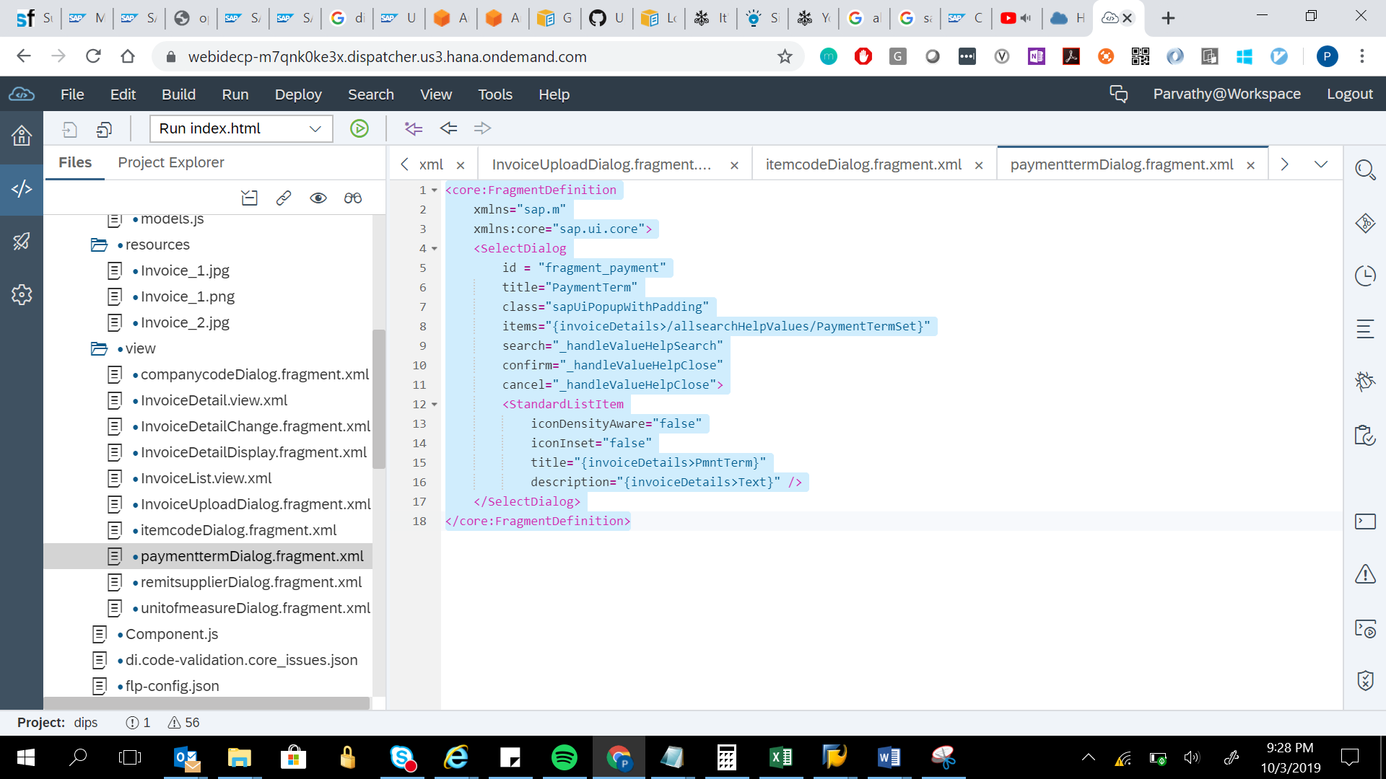

<core:FragmentDefinition

xmlns="sap.m"

xmlns:core="sap.ui.core">

<SelectDialog

id = "fragment_payment"

title="PaymentTerm"

class="sapUiPopupWithPadding"

items="{invoiceDetails>/allsearchHelpValues/PaymentTermSet}"

search="_handleValueHelpSearch"

confirm="_handleValueHelpClose"

cancel="_handleValueHelpClose">

<StandardListItem

iconDensityAware="false"

iconInset="false"

title="{invoiceDetails>PmntTerm}"

description="{invoiceDetails>Text}" />

</SelectDialog>

</core:FragmentDefinition>