

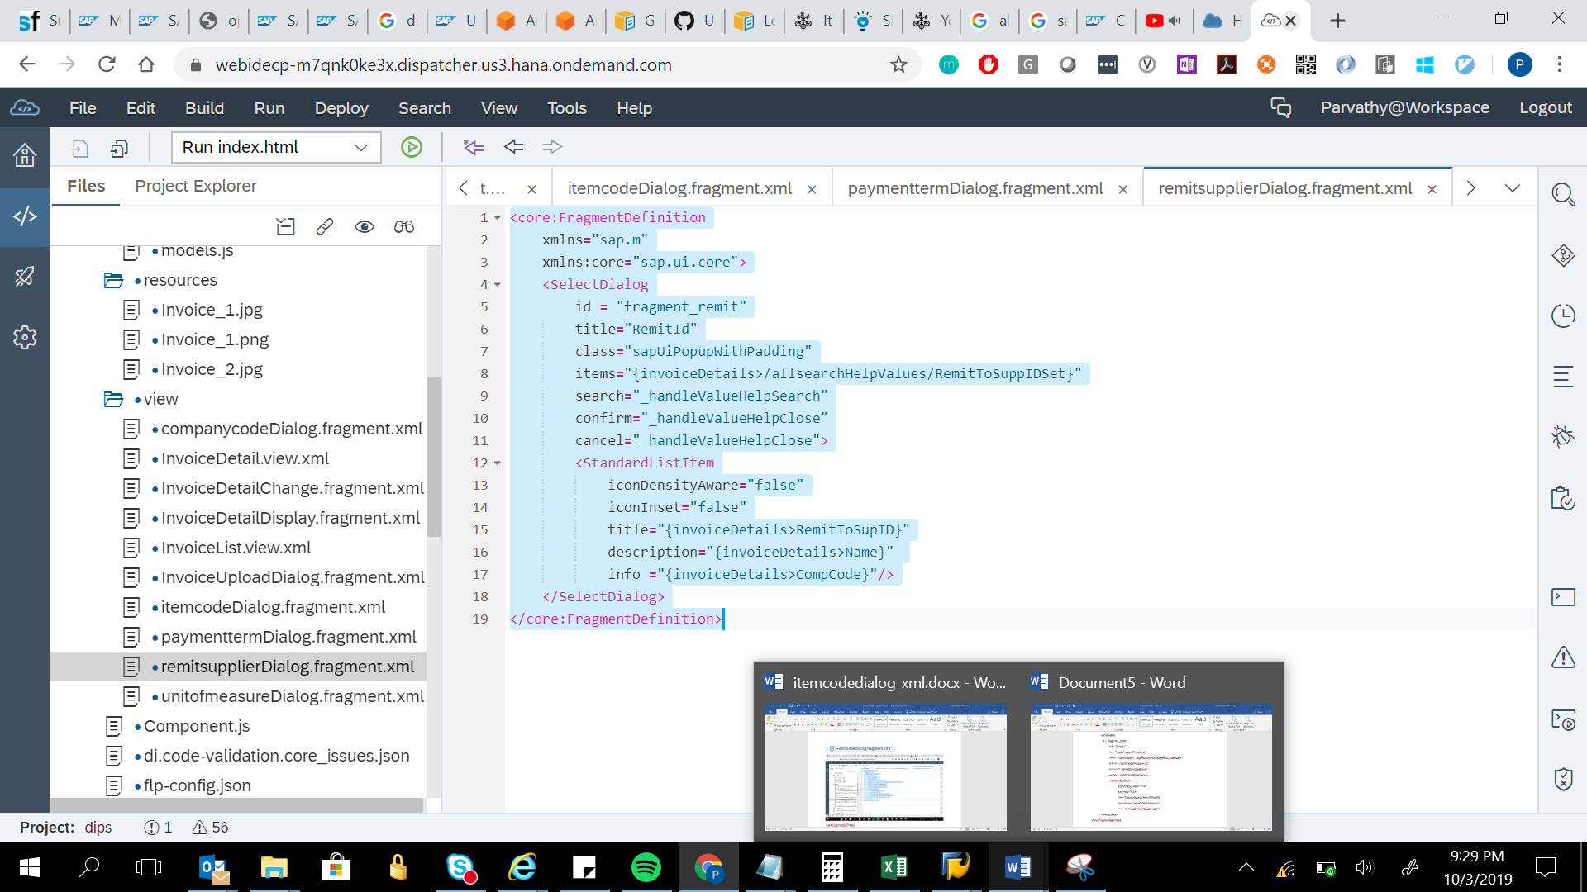

<core:FragmentDefinition

xmlns="sap.m"

xmlns:core="sap.ui.core">

<SelectDialog

id = "fragment_remit"

title="RemitId"

class="sapUiPopupWithPadding"

items="{invoiceDetails>/allsearchHelpValues/RemitToSuppIDSet}"

search="_handleValueHelpSearch"

confirm="_handleValueHelpClose"

cancel="_handleValueHelpClose">

<StandardListItem

iconDensityAware="false"

iconInset="false"

title="{invoiceDetails>RemitToSupID}"

description="{invoiceDetails>Name}"

info ="{invoiceDetails>CompCode}"/>

</SelectDialog>

</core:FragmentDefinition>