

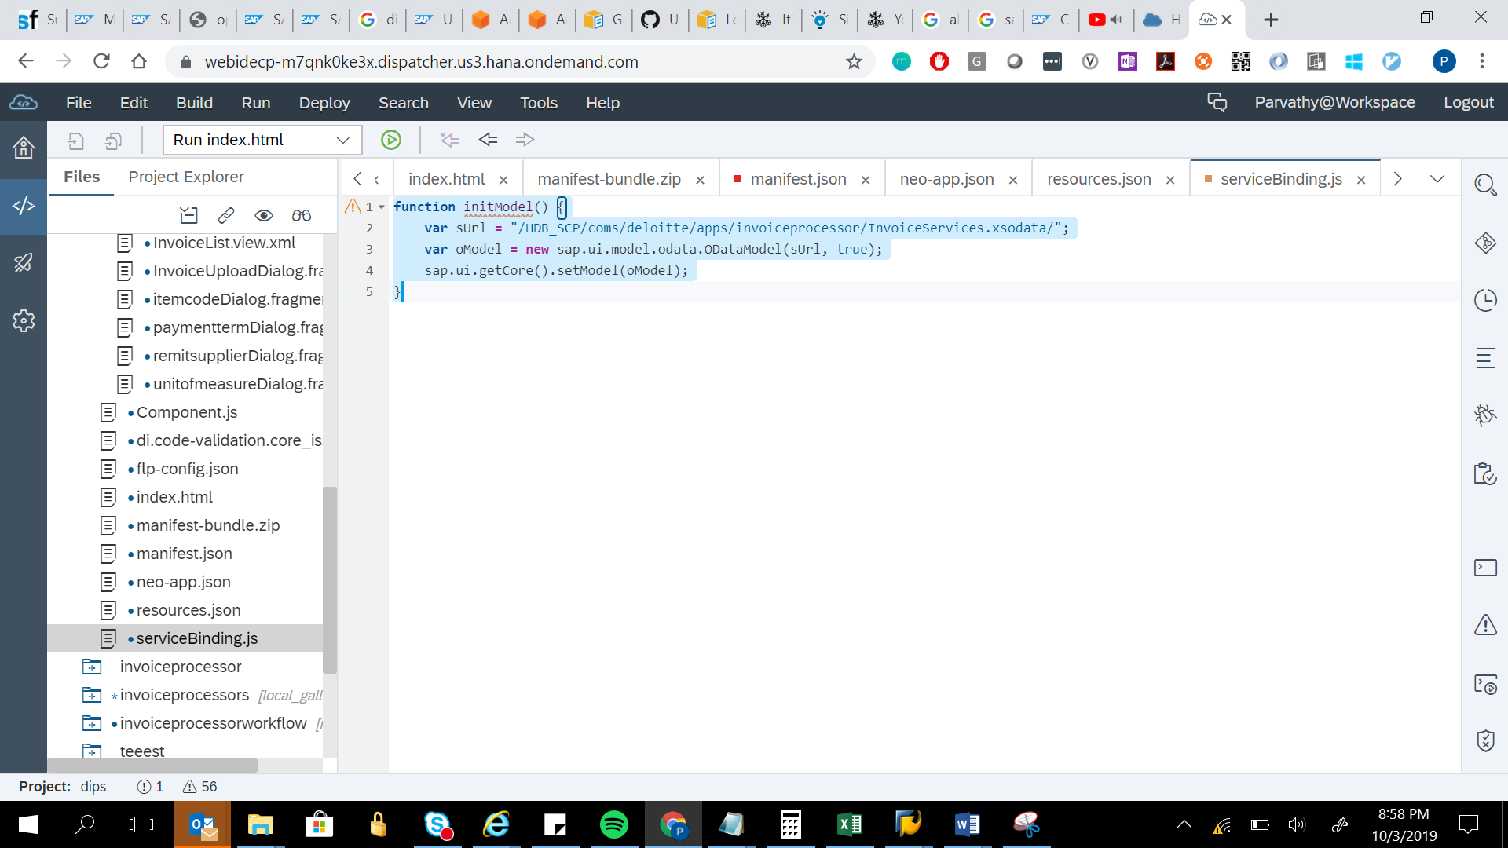

function initModel() {

var sUrl = "/HDB_SCP/coms/deloitte/apps/invoiceprocessor/InvoiceServices.xsodata/";

var oModel = new sap.ui.model.odata.ODataModel(sUrl, true);

sap.ui.getCore().setModel(oModel);

}