

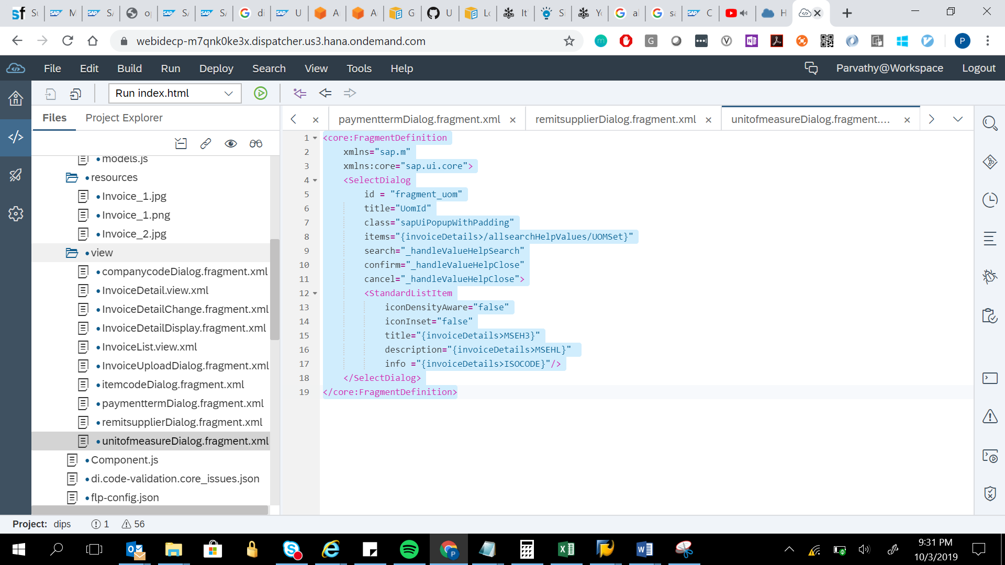

<core:FragmentDefinition

xmlns="sap.m"

xmlns:core="sap.ui.core">

<SelectDialog

id = "fragment_uom"

title="UomId"

class="sapUiPopupWithPadding"

items="{invoiceDetails>/allsearchHelpValues/UOMSet}"

search="_handleValueHelpSearch"

confirm="_handleValueHelpClose"

cancel="_handleValueHelpClose">

<StandardListItem

iconDensityAware="false"

iconInset="false"

title="{invoiceDetails>MSEH3}"

description="{invoiceDetails>MSEHL}"

info ="{invoiceDetails>ISOCODE}"/>

</SelectDialog>

</core:FragmentDefinition>