EXPERIMENT-5

CREATE TABLE Items_63(itemid int primary key, Itemname varchar(50), category varchar(50), Price int, Instock int check (Instock >=0));
CREATE TABLE Customer_63(C_ID int primary key,C_name varchar(50),c_address varchar(50),c_state varchar(50));
CREATE TABLE Order_63(Order_id int primary key,itemid int,C_ID int,Quantity int,order_date date,
FOREIGN KEY(itemid) references Items_63(itemid),
FOREIGN KEY (C_ID) references Customer_63(C_ID),
CHECK(Quantity>0));
CREATE TABLE Delivery_63(D_ID int primary key,C_ID int,Order_id int,
FOREIGN KEY (C_ID) references Customer_63(C_ID),
FOREIGN KEY (Order_id) references Order_63(Order_id));

INSERT INTO Items_63 VALUES (01, 'Samsung Galaxy S24', 'Electronics', 79999, 50);
INSERT INTO Items_63 VALUES (02, 'Apple iPhone 15', 'Electronics', 89999, 30);
INSERT INTO Items_63 VALUES (03, 'Dell ', 'Computers', 65000, 20);
INSERT INTO Items_63 VALUES (04, ' Headphones', 'Accessories', 29999, 40);
INSERT INTO Items_63 VALUES (05, ' Refrigerator', 'Home Appliances', 32000, 15);
INSERT INTO Items_63 VALUES (06, 'Nike Shoes', 'Fashion', 12000, 60);
select * From Items_63;
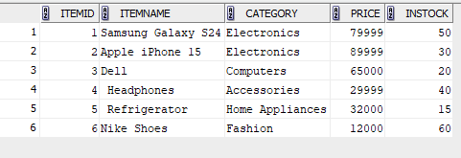

INSERT INTO Customer_63 values(101,'Parvathy','Muvattupuzha','Kerala');
INSERT INTO Customer_63 values(102,'Amala','Pala','Kerala');
INSERT INTO Customer_63 values(103,'Sreehari','Thrikkalathoor','Kerala');
INSERT INTO Customer_63 values(104,'Ambady','Thodupuzha','Kerala');
INSERT INTO Customer_63 values(105,'Jyothi','Kothamangalam','Kerala');
INSERT INTO Customer_63 values(106,'Mickey','Trivandrum','Kerala');
select * From Customer_63;
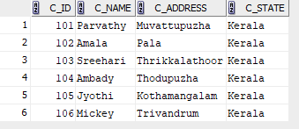

INSERT INTO Order_63 VALUES (1001, 01, 101, 1, TO_DATE ('2026-01-10','YYYY-MM-DD'));
INSERT INTO Order_63 VALUES (1002, 03, 102, 1, TO_DATE ('2026-01-10','YYYY-MM-DD'));
INSERT INTO Order_63 VALUES (1003, 04, 103, 2, TO_DATE ('2026-01-10','YYYY-MM-DD'));
INSERT INTO Order_63 VALUES (1004, 06, 105, 1, TO_DATE ('2026-01-10','YYYY-MM-DD'));
INSERT INTO Order_63 VALUES (1005, 02, 104, 1,TO_DATE ('2026-01-10','YYYY-MM-DD'));
INSERT INTO Order_63 VALUES (1006, 05, 105, 1, TO_DATE ('2026-01-10','YYYY-MM-DD'));
INSERT INTO Order_63 VALUES (1007, 06, 106, 1, TO_DATE ('2026-01-10','YYYY-MM-DD'));

select * From Order_63;
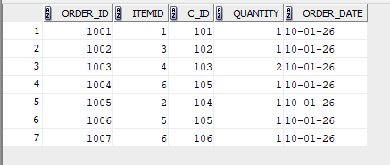

INSERT INTO Delivery_63 VALUES (5001, 105, 1006);
INSERT INTO Delivery_63 VALUES (5002, 102, 1002);
INSERT INTO Delivery_63 VALUES (5003, 103, 1003);
INSERT INTO Delivery_63 VALUES (5004, 104, 1005);
select * From Delivery_63;

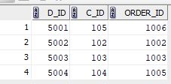

1) SELECT DISTINCT c.* FROM Customer_63 c JOIN Order_63 o ON c.C_ID = o.C_ID;

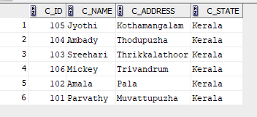

2) SELECT DISTINCT c.* FROM Customer_63 c JOIN Delivery_63 d ON c.C_ID = d.C_ID;

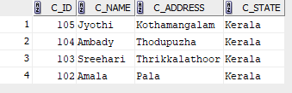

3) SELECT o.order_date FROM Order_63 o JOIN Customer_63 c ON o.C_ID = c.C_ID WHERE c.C_name LIKE 'J%';

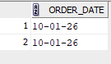
4) SELECT i.Itemname, Price FROM Items_63 i JOIN Order_63 o ON i.itemid = o.itemid JOIN Customer_63 c ON o.C_ID = c.C_ID WHERE c.C_name = 'Mickey';

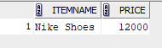

5) SELECT DISTINCT c.*FROM Customer_63 c JOIN Order_63 o ON c.C_ID = o.C_ID LEFT JOIN Delivery_63 d ON o.Order_id = d.Order_id WHERE o.order_date > '31-01-2013' AND d.D_id IS NULL;
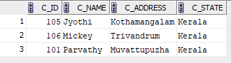

6) SELECT itemid FROM Order_63 UNION SELECT o.itemid FROM Order_63 o LEFT JOIN Delivery_63 d ON o.Order_id = d.Order_id WHERE d.D_id IS NULL;

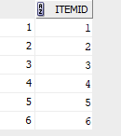

7) SELECT C_name FROM Customer_63 WHERE C_ID IN (SELECT C_ID FROM Order_63) INTERSECT SELECT C_name FROM Customer_63 WHERE C_ID IN (SELECT o.C_ID FROM Order_63 o JOIN Delivery_63 d ON o.Order_id = d.Order_id );

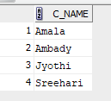

8) SELECT C_name FROM Customer_63 WHERE C_ID IN (SELECT C_ID FROM Order_63) MINUS SELECT C_name FROM Customer_63 WHERE C_ID IN (SELECT o.C_ID FROM Order_63 o JOIN Delivery_63 d ON o.Order_id = d.Order_id);

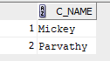

9) SELECT C_name FROM Customer_63 WHERE C_ID = (SELECT C_ID FROM Order_63 GROUP BY C_ID ORDER BY COUNT(Order_id) DESC FETCH FIRST 1 ROW ONLY);

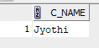

10) SELECT DISTINCT c.* FROM Customer_63 c JOIN Order_63 o ON c.C_ID = o.C_ID JOIN Items_63 i ON o.itemid = i.itemid WHERE i.Price > 5000

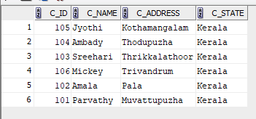

11) SELECT C_name, c_address FROM Customer_63 WHERE C_ID NOT IN (SELECT o.C_ID FROM Order_63 o JOIN Items_63 i ON o.itemid = i.itemid WHERE i.Itemname = 'Samsung Galaxy S24');

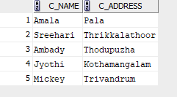

12) Left Outer Join:
SELECT c.*, o.* FROM Customer_63 c LEFT OUTER JOIN Order_63 o ON c.C_ID = o.C_ID;
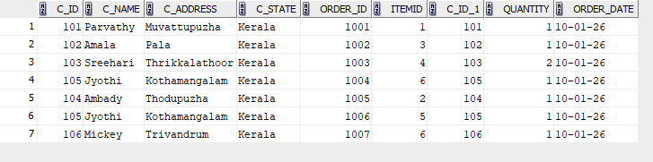
Right Outer Join:
SELECT c.*, o.* FROM Customer_63 c RIGHT OUTER JOIN Order_63 o ON c.C_ID = o.C_ID;
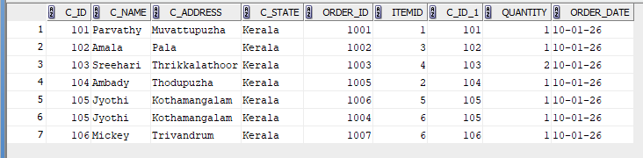

13) SELECT c_state, COUNT(*) AS total_customers FROM Customer_63 GROUP BY c_state;
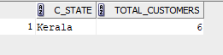

14) SELECT * FROM Items_63 WHERE Price > (SELECT AVG(Price) FROM Items_63) ORDER BY category;
