CollateralLoans- Risk Assessment

|  |  |
| --- | --- |
|  |  |

## Purpose of this document

The purpose of the software requirement document is to systematically capture requirements for the project and the system “Collateral Loans – Risk Assessment System” that has to be developed. Both functional and non-functional requirements are captured in this document. It also serves as the input for the project scoping.

The scope of this document is limited to addressing the requirements from a user, quality, and non-functional perspective.

High Level Design considerations are also specificed wherever applicable, however the detailed design considerations have to be strictly adhered to during implementation.

## Project Overview

The term "collateral" refers to any asset or property that a consumer promises to a Bank as backup in exchange for a loan. Typically, collateral loan agreements let the Bank to take over the asset if the borrowers fail to repay the debt according to the loan contract.

This Collateral can be any item of value that is accepted as an alternate form of repayment in case of default. If loan payments are not made, assets can be seized and sold by banks. This ensures that a lender receives full or partial compensation for any outstanding balance on a defaulted debt.

The Bank wants to develop a Microservies based middleware layer, for the core components like:

1. Loan Management
2. Collateral Management
3. Risk Assessment

There will be an based back office portal called “Collateral Loans” portal, that will allow the back office staff to continuously monitor the risks (for both consumer and as well as bank) for every loan issued by the bank.

As part of enhancement to the application, the bank wants to enable its customers with the following options

* + 1. Apply for loan
    2. Check loan status

It should also enable the bank to approve/reject loan application.

## Scope

Below are the modules that needs to be developed part of the Project:

|  |  |  |
| --- | --- | --- |
| **Req. No.** | **Req. Name** | **Req. Description** |
| REQ_01 | Loan Management | Loan Management Module is a Middleware Microservice that performs following operations:   * Get the Loan Details * Save Collaterals for Sanctioned Loan * Apply Loan * View Loan application status * Approve/Reject Loan application |
| REQ_02 | Collateral Management | Collateral Management Module is a Middleware Microservice that performs the following operations:   * Verify and Save the Collaterals * Get Collaterals |
| REQ_03 | Risk Assessment | Risk Assessment Module is a Middleware Microservice that performs the following operations:   * Raise Risk based the Collaterals Value based on Market |
| REQ_04 | Collaterals Loan Portal | A Web Portal that allows a Back Office Staff to Login and allows to do following operations:   * Login * Get Loan Details based on customer / loan ID * Save Collaterals for a sanctioned Loan * View Risk Assessment for every Collateral Loans (for Bank) |

## System Architecture Diagram

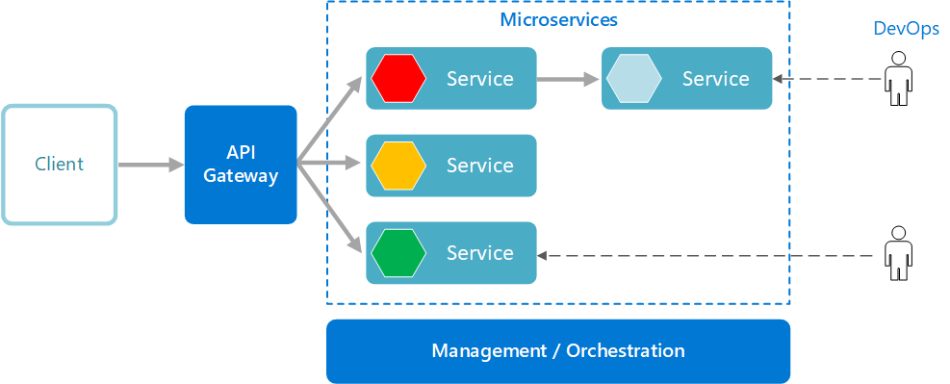

## 

## Use Case Diagram

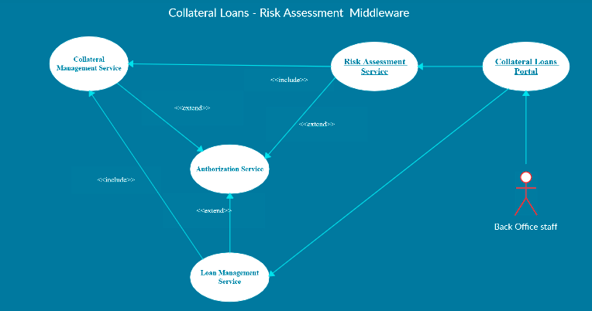

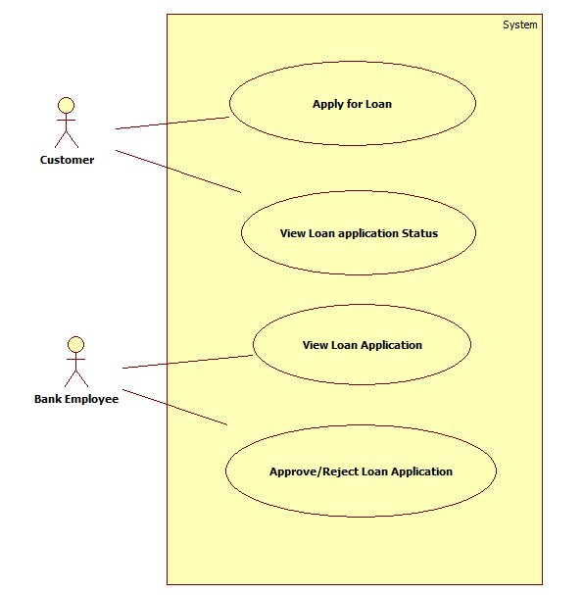

## Individual Components of the System

### **Collaterals Management Microservice**

|  |  |
| --- | --- |
| Collateral Loans – Risk Assessment | Collaterals Management Microservice |
| **Functional Requirements**  This Microservice will be invoked by Loan Management Service and Risk Assessment Service.  When invoked by Loan Management Microservice,   * Authorization will be performed * For a sanctioned loan, save the collateral details for the loan ID.   When invoked by Risk Assessment Microservice,   * Authorization will be performed * While assessing a risk, the Risk Assssment Microservice wil invoke the Collateral Management Microservice to retrieve the latest collateral details | |
| **Entities**   1. **Collateral_Loan**   <Details of Collateral like Loan ID, Collateral ID, Collateral Value, Pledged Date etc.>  Few Entities based on type of collaterals can be created, given below are examples.   1. **Collateral_RealEstate**   <Loan ID and Details of Collateral like Collateral Type, Owner Details, Address, Current Value, Rate Per Sq.Ft., Depreciation Rate etc.>   1. **Collateral_CashDeposits**   < Loan ID and Details of Collateral like Collateral Type, Owner Details, Bank Name, Current Value, Interest Rate, Deposit Amount, Lock Period etc.>  **REST End Points**  **Collaterals Management Microservice**   * + GET: /getCollaterals (Input: Loan_ID, Customer_ID | Output: Collateral ID, Type, Collateral Details based on each Type)   + POST: /saveCollaterals (Input: Loan_ID, Collateral_ID, Collateral Type, Details of the Collateral based on Type) | Output: Status)   **Note:** can also have different POST calls for different type of collaterals, or can be in single POST call. | |
| **Trigger** – Can be invoked from Loan Management Service or from Risk Assessment Service | |
| **Steps and Actions**   1. Once a request is received to Collaterals Service, Authorization will be performed 2. If /getCollaterals end point is invoked the corresponding collateral details of the loan, has to be returned. 3. If /saveCollateral end point is invoked, then the Microservice will save the collateral based on appropriate type. | |
| **Non-Functional Requirement:**   * Only Authorized Back Office Staff can access these REST End Points | |

### **Loan Management Microservice**

|  |  |
| --- | --- |
| Collateral Loans Risk Assessment | Loan Management Microservice |
| **Functional Requirements**  Loan Management Microservice will be invoked from Collateral Loans Portal. This Microservice will be invoke Collateral Management Service for saving the Collaterals related to the loan.  To view the loan details:   * Retrieve the Loan Details based on Loan ID   To save the collaterals for the sanctioned loan:   * This will in turn reach the Collateral Management Microservice and saves the collateral details   To Apply for Loan.   * This will enable the customer to apply for loan   To View the loan application status   * This will enable the customer to view the loan application status   To Approve/Reject loan application   * This will enable the authorized bank employee to approve/reject the loan application by evaluating the merit of loan application like collateral details etc. * If the application is approved, the status of the loan application to be updated with “approved” status, else the loan status to be updated with “Rejected” status. * Once the loan is approved, the loan details to be updated in the database. Also, the microservice needs to communicate with the Collateral Management Microservice to update the collateral details in the database. * Verifying the loan application is a manual process. Based on the verification, loan application can be approved or rejected. | |
| **Entities**   1. **Loan**   <Loan Products, Maximum Loan eligible, Interest, Tenure, Type of Collateral Accepted etc.>   1. **Customer_Loan**   <Loan Product ID, Loan_ID, Customer_ID, Loan_Principal, Tenure, Interest, EMI, Collateral ID etc.>   1. **Customer**   <Details of the Customer>  **4. Loan_Application**  <application_id, customer _id, loan amount, tenure, collateral Details, status>  **REST End Points**  **Loan Management Microservice**   * + GET: /getLoanDetails (Input: Loan_ID, Customer_ID | Output: Loan ID, Sanctioned Loan Amount, Tenure, Interest, Collateral ID pledged etc.)   + POST: /saveCollaterals (Input: Loan_ID, Collateral_ID, Collateral Type, Details of the Collateral based on Type) | Output: Status)   + POST: /applyLoan(Input: Loan_Application) | Output : Status   + GET:/ getLoanApplicationStatus (Input: application_id | Output: Loan_Application)   + PUT: /approveLoanApplication (Input: application_id | Output: Status)   + PUT: /rejectLoanApplication (Input :application_id | Output: Status) | |
| **Trigger** – Can be invoked from Collaterals Loan Portal, however for saving collaterals, this will in turn invoke the Collateral management microservice. | |
| **Steps and Actions**   1. Loans Management Microservice will have 2 End Points exposed to Collaterals Loan Portal used by Back Office. 2. If /getLoanDetails end point is invoked, the Microservice will return the appropriate loan details 3. If / saveCollaterals end point is invoked, then the Microservice will invoke the Collaterals Management Microservice for saving the collateral details of the sanctioned loan. | |
|  | |

### **Risk Assessment Microservice**

|  |  |
| --- | --- |
| Collateral Loans Risk Assessment | Risk Assessment Microservice |
| **Functional Requirements**  Risk Assessment Microservice interacts with Collaterals Management Microservice. Collaterals Loan Portal will invoke the services of Risk Assessment Microservice to portray the risks of the collaterls held by the bank   * View Risks of Collaterals held by the bank | |
| **Entities**   1. **Collateral_Risk**   <Risk Details of each Collateral pledged, % Risk, Date Assessed, Market Value, Sanctioned Loan etc..>   1. **Collateral_Market_Value**   <market Value of each collateral ex: Rate / Square feet of land in dfferent areas, Intereset rate of a Fixed Deposit in a Bank.> - Assume that this will be refreshed in the system using a flat file, whenever there is a change. However there must ben an option to refresh the values using a file.  **REST End Points**  **Risk Assessment Microservice**   * + GET: /getCollateralRisk (Input: Loan_ID | Output (Risk Percent, Date of Risk Assessed) | |
| **Trigger** – Can be invoked from Collaterals Loan Application. Howeve this Microservice need to access Collaterals Management Microservice for getting the details of collaterals pledged for a given Loan ID. | |
| **Steps and Actions**   1. Risk Assessment Microservice will have only one end point exposed to Collateral Loans Portal    * Based on Collateral Market Value for the pledged collateral, whenever the market value goes down beyond the loan sanctioned, then a risk alert must be raised. | |

### **Authorization Microservice**

|  |  |
| --- | --- |
| Collateral Loans Risk Assessment | Authorization Microservice |
| **Security Requirements**   * Service to Service communication has to happen using JWT * Pass End User Context across Microservices * Have the token expired after specific amount of time say 15 minutes. | |

### **Collateral Loans Portal**

|  |  |
| --- | --- |
| Collateral Loans Risk Assessment | Collateral Loans Portal |
| **Client Portal Requirements**  There are 2 kinds of users for the portal,   1. Bank Back-office staff login 2. Customer login  * Collateral Loans Portal must allow a Back Office Staff to Login. Once successfully logged in, the staff should be redirected to the staff home page where he/she can do the following operations:   + View Loan Details   + Save Collaterals of a Sanctioned Loan   + View Risks associated with the collateral   + View Loan application   + Approve/Reject Loan application * Collateral Loan portal should also enable is customers login. Once successfully logged in, he/she should be redirected to the home page of the customer where he/she can do the following operations.   + Apply for loan   + View loan application status * Each of the above operations will reach out to the middleware Microservices. | |