1)Download apache-tomcat 9.0

2)maven

3)jdk

4)git

5) set JAVA\_HOME ,MAVEN\_HOME as environment variables

6) From jenkins.io - download jenkins.war

7) Paste the jenkins.war file - tomcat->webapps folder

8) Open cmd prompt where jenkins.war file is downloaded and execute the command ,java -jar jenkins.war

9) Run startup.bat file in tomcat bin folder to start the tomcat server

10) After jenkins and tomcat is started, access <http://localhost:8080> , will display the below page

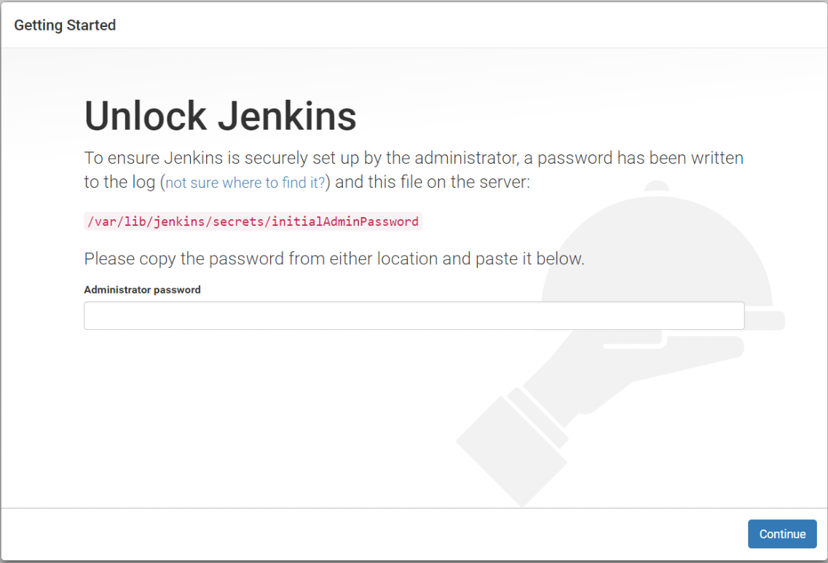

11) Copy the password from the terminal and paste it into the "Administrator password" field and then click continue.

12) Select suggested plugins to install.

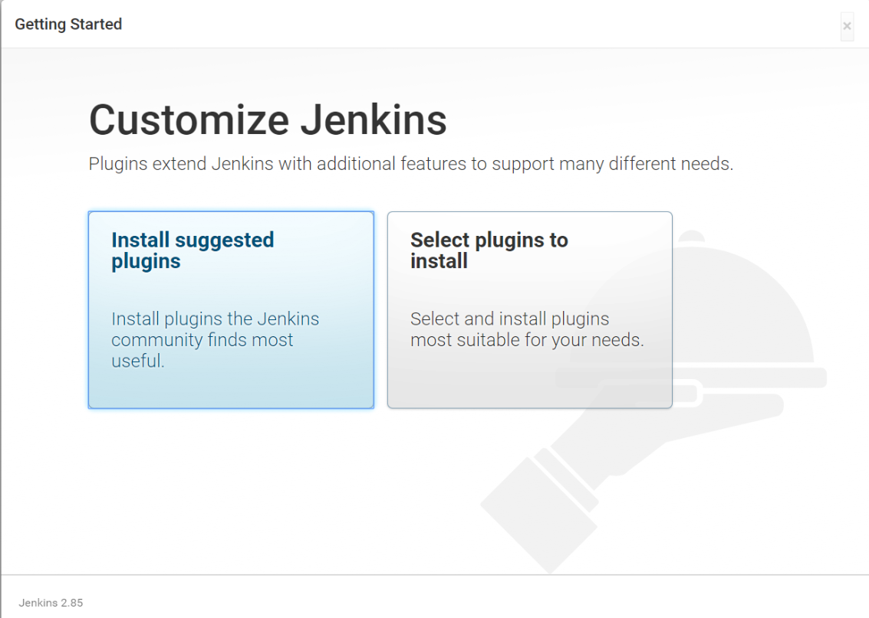

13) After installation, create admin user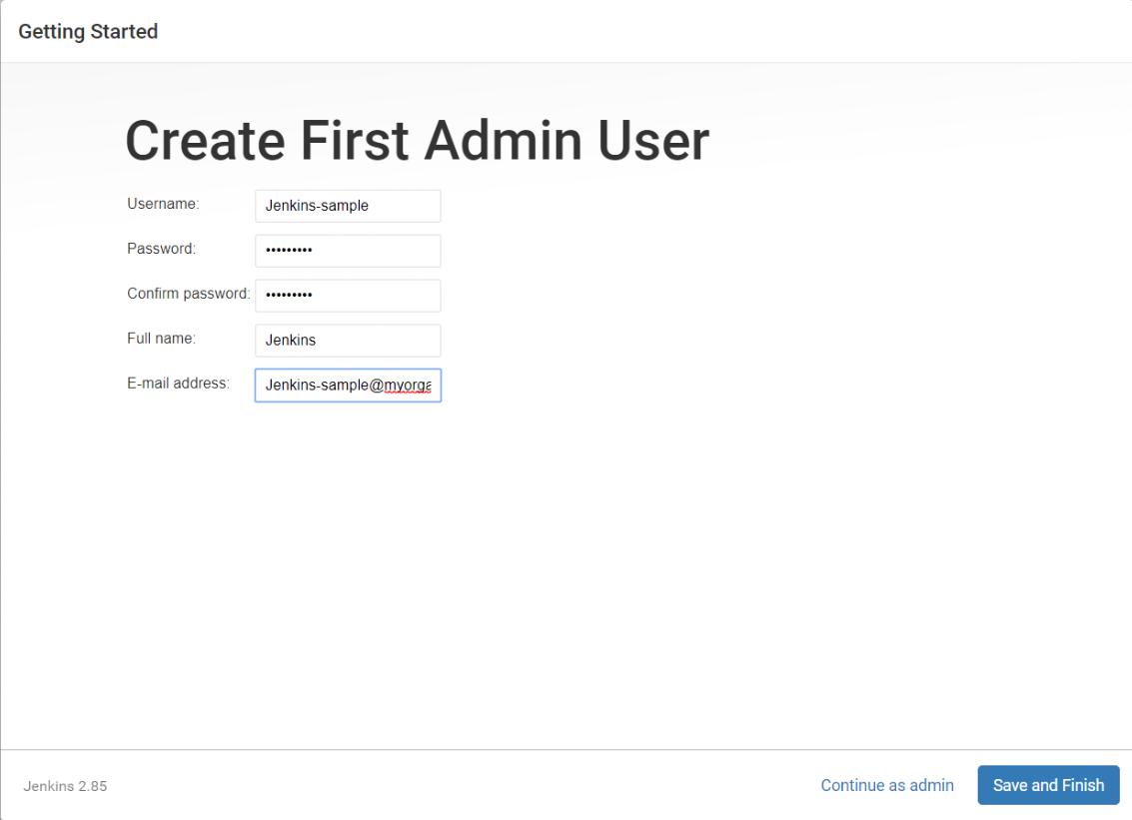

GitHub Setup for Jenkins

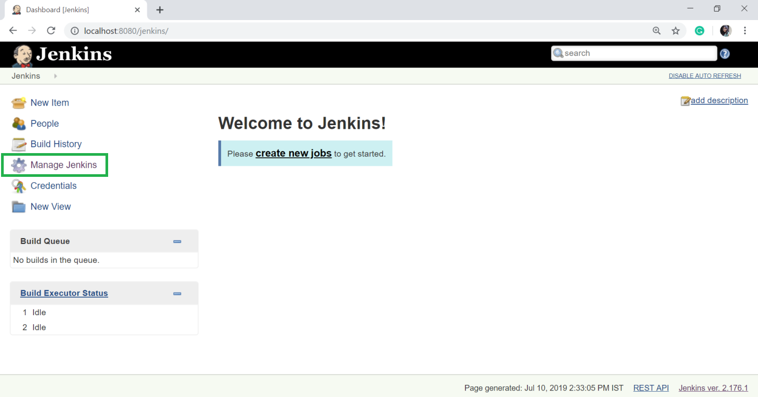

14) click the ‘Manage Plugins’ option.

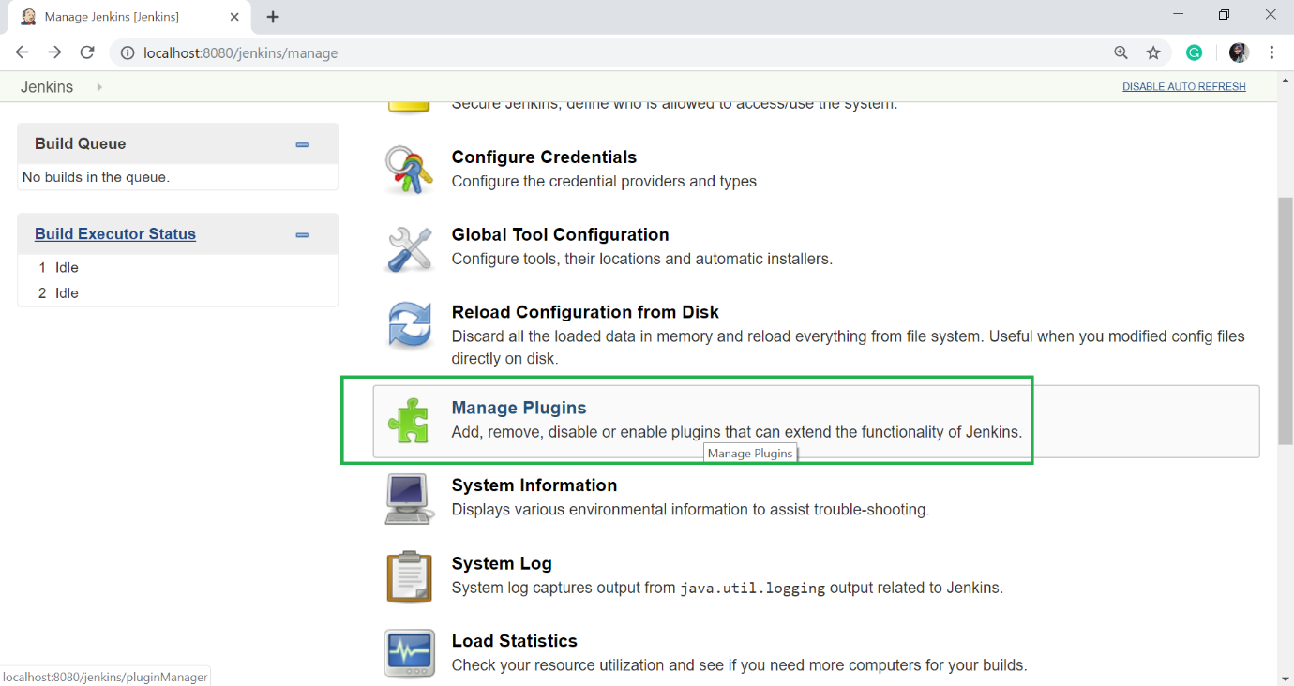

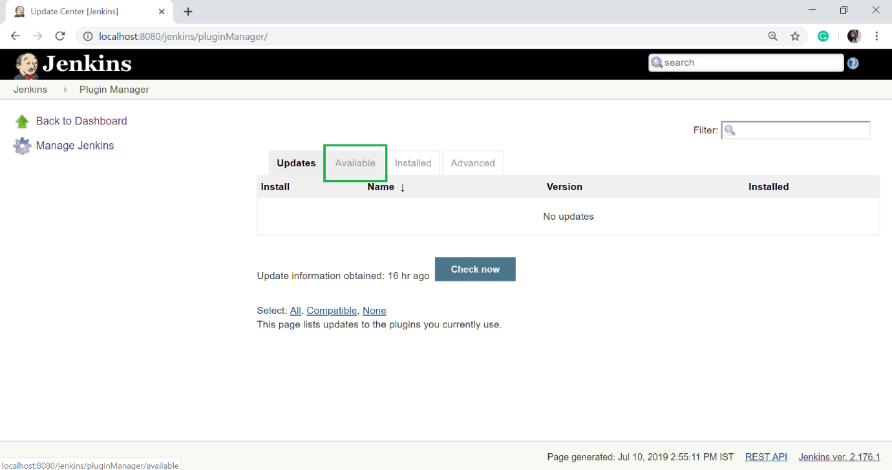

* The "Available" tab gives a list of plugins which are available for downloading. In the Filter tab type, type the "Git Plugin".
* Select the Git Plugin.
* Click on the "**install without restart**". The plugin will take some time to finish downloading depending on your internet connection, and will be installed automatically.
* You can also click on "**Download now and install after restart**" button in which the git plugin is installed after restart.
* If you already have the Git plugin installed then go to "Installed" tab and in filter option type Git plugin.
* 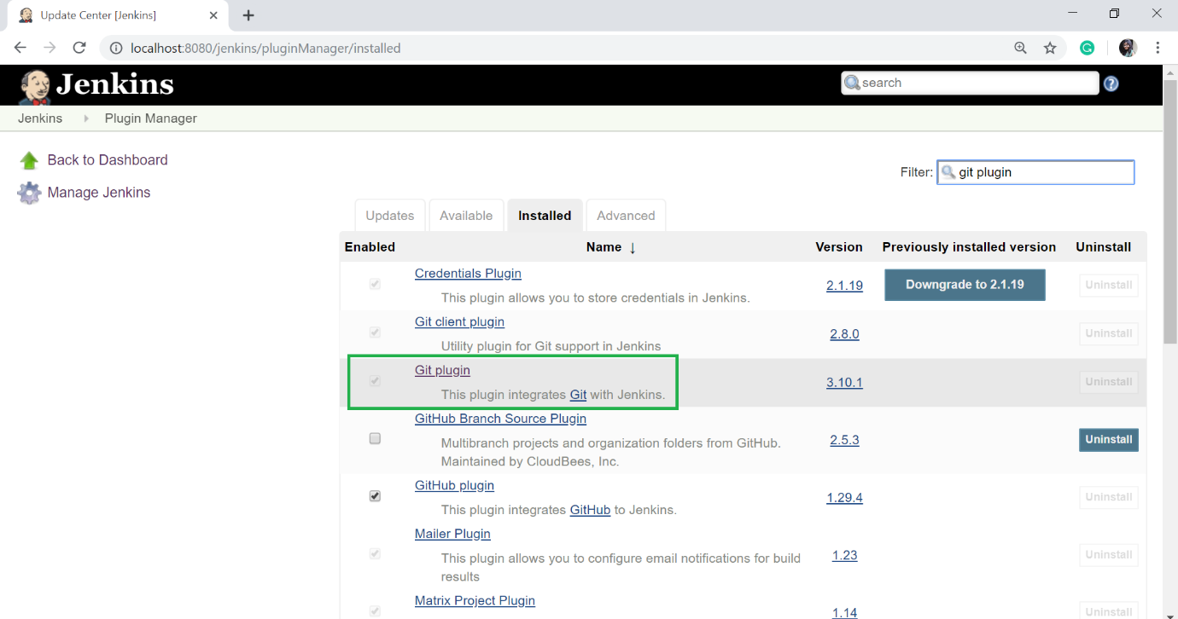
* Once all the installations are completed, restart Jenkins by giving the following command in the browser. [http://localhost:8080/jenkins/restart](http://localhost:8080/jenkins/restart" \t "_blank)

After Jenkins is restarted, Git will available as an option while configuring jobs.

## Jenkins and Maven

## Maven Setup

## Maven Setup

To Give a **Name** and **JAVA\_HOME** path, or check on **install automatically** checkbox to 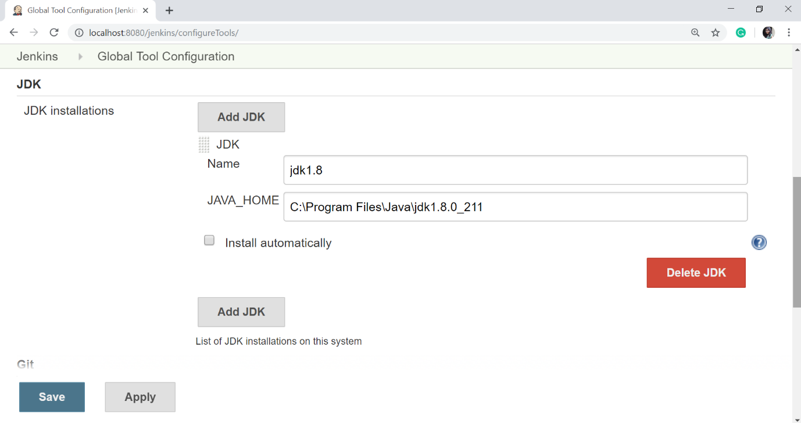 configure Java, click on "**Add JDK**" button in the JDK section.

And now, to configure Maven, click on "Add Maven" button in the Maven section, give any **Name** and **MAVEN\_HOME** path or check to install automatically checkbox.

## Maven Setup

Then, click on the "**Save**" button at the end of the screen.

Build Project

Now, you can create a job with the Maven project. To do that, click on the **New Item** option or **create a new job** option.

Enter item name ,select Maven Project and click ok

Under the newly created item, click source code management and configure Git remote repository url.

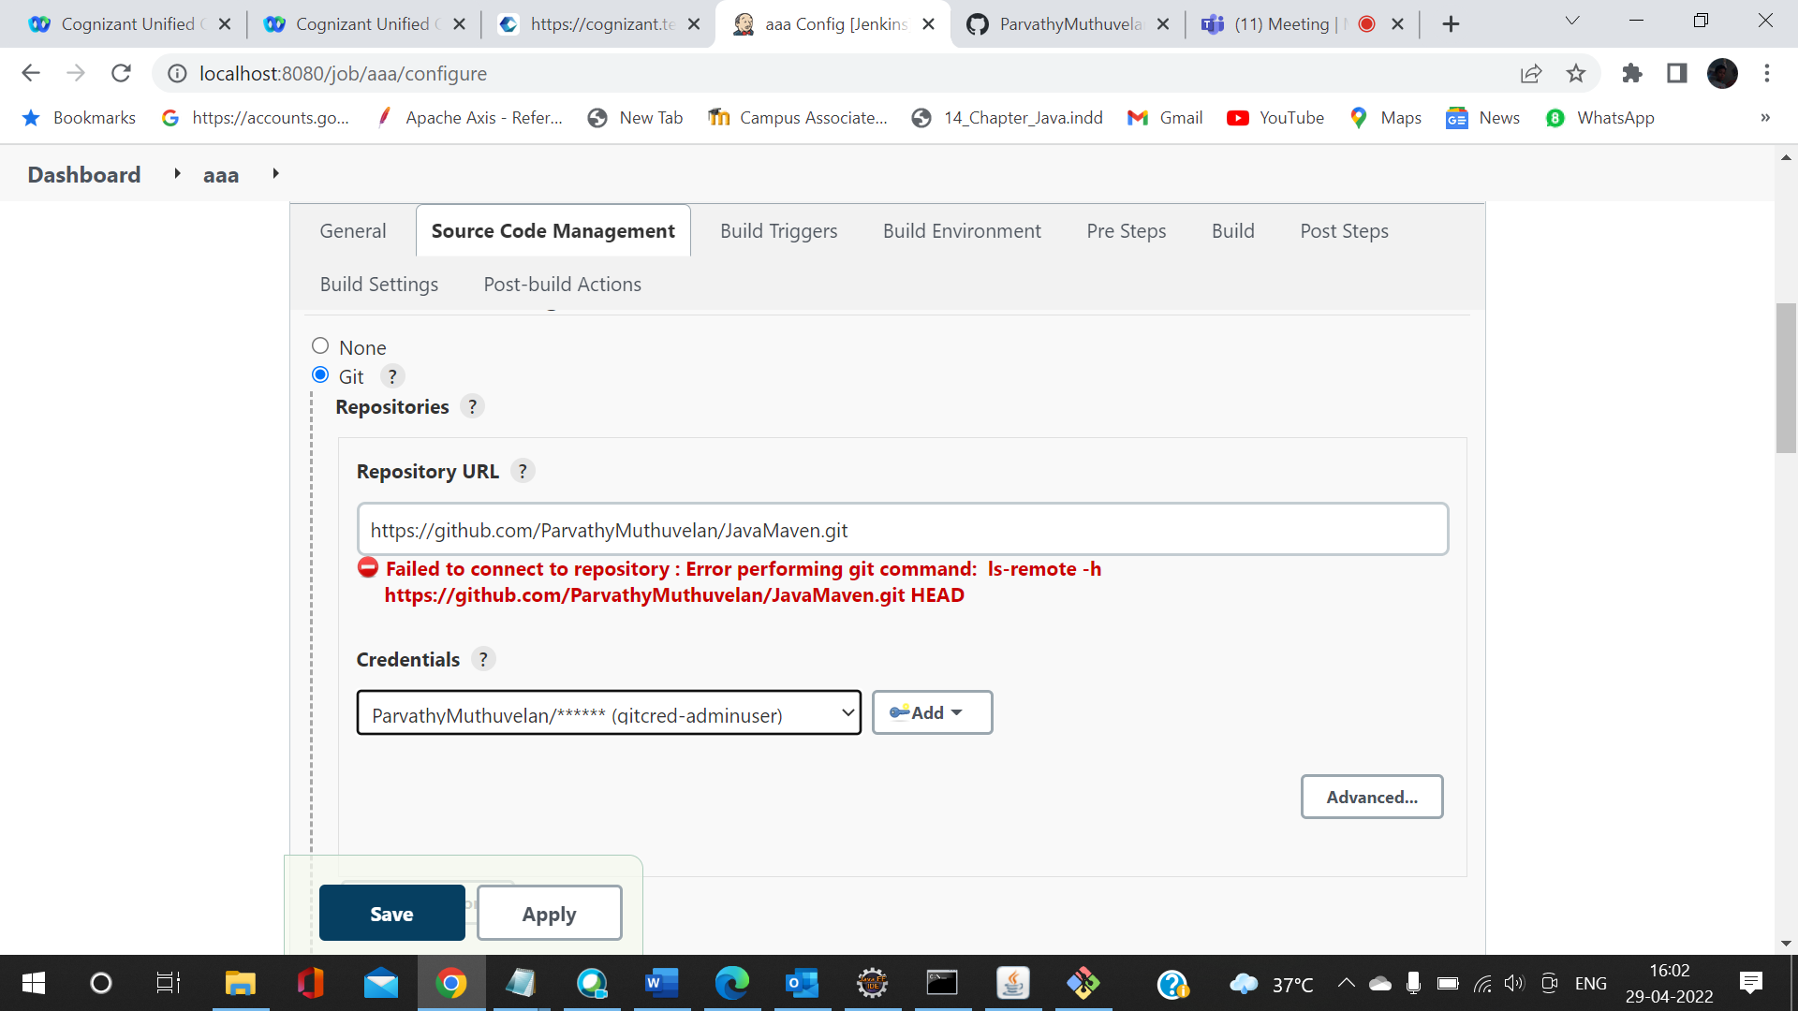

For authentication with git, use git username as username and PAT as password.

PAT is personal access token- generate in github.

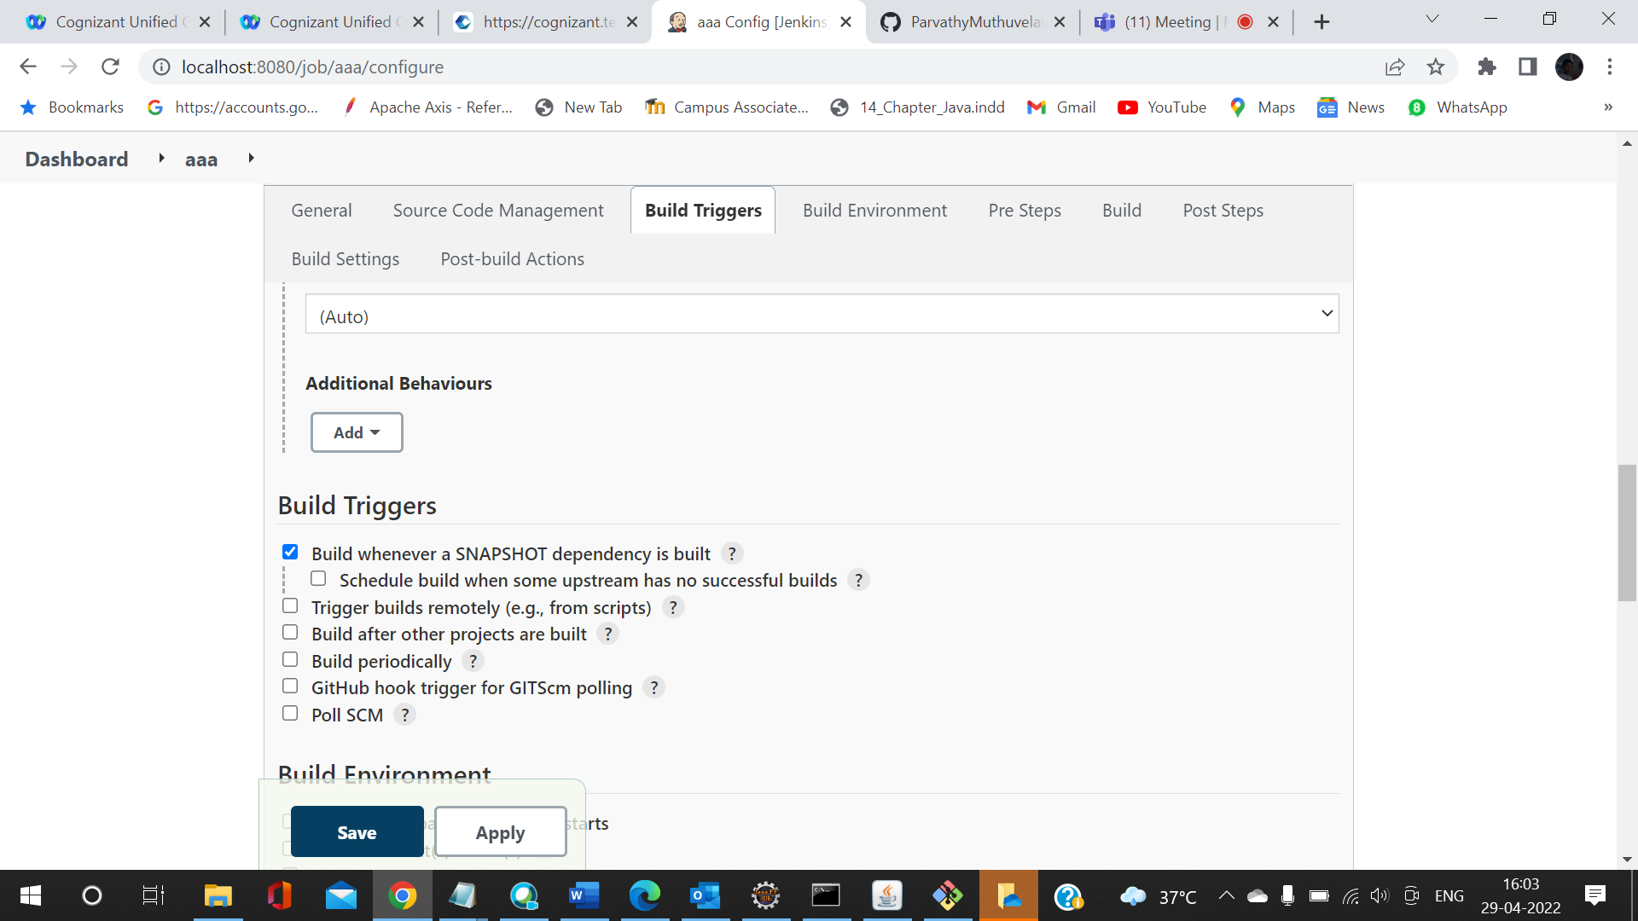

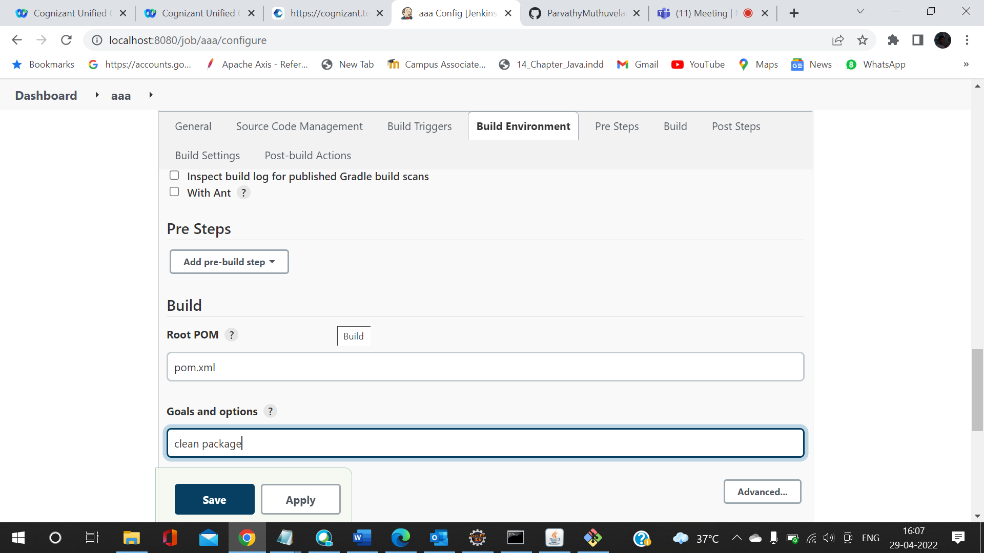

Click apply and save.

In the dashboard, click Build now. The project will be build and the result will be shown,