Assignment-6

1.How do you evaluate the performance of a project in agile?

In agile project development the preference is given more to :-

- individuals and interactions
- functional software
- cutomer collaboration
- responding to change

The perfomance of an agile project can be evaluated by:-

1) Velocity – Is the average amount of work a team does during a sprint.Measured in story points or actual hours.
* The velocity for the first release plan is predicted from the previous data or historical data.

velocity=units of effort completed/sprint.

2) Hit Rate- The Hit Rate is the percentage of work allocated to a Timebox that was actually completed.
* Ideally 100%.
* Low hit rate means the team not completed its aim.It doesn’t complete the aimed story points.

3) Work Remaining on Tasks- The team estimates the work remaining after each active Task.
* The value may rise if the Task is more complicated than
anticipated.

4) Project Cost- Its the actual cost estimated gor a project.
* The cost of a project must be tracked to ensure it does not go over budget.

Three management measures are :-

- – Cost Performance Index (CPI) -

- it is the measure of efficiency of expenses used on a project
- where CPI is the Baseline Cost per Story Point/Actual Cost per Story Point

- *CPI=(BC/SP)/(AC/SP)
- * ideal is 1.
- *If CPI>1 means less than what is expectes per story point

- – Schedule Performance Index (SPI)-
- It describes how much of the work is being done compared to the scheduled plan of work.
- The work completed is compared with the plan to make sure it is on schedule.

- * SPI=AV/BV
- * ideal is 1.
- *If SPI>1 means finishing earlier than expected.

- – Earned Business Value (EBV)- Business value means it is trying to
determine how valuable something will be once it is released.EBV means The value earned by the feature upto a particular sprint.Based on the customer satisfaction.

2.Compare traditional monitoring & control with agile monitoring & control
with respect to metrics generation.

Metrics | Traditional | Agile
Frequent Delivery | * No frequent delivery.  * Only after the final product is reached contacted with the customer. | *The working software is continously delivered after each sprint to the customer so that he can give feedbacks.
Colocation | * Different teams are assigned different tasks and at different locations.  * Issue resolving is difficult and it takes time. | *Members work together at same locations  * so that issues can be discussed and corrected at any time.  * Accelerates communication and reliability  *Reduces cost  *team management is easier.
Daily team meeting | *There are no daily meetings during project development. | *An everyday short time meeting is conducted to discuss problems usually for 15 mins or less.  *discusses on:-  - what was done  - what is to be done.  - What are the impediments
Timebox review meeting | *No such reviewing process is done inbetween the development of a project | *After delivering of working product at each stage,  *a reviewing process is done based on customer feedbacks
Project performance measurement | *project success is calulated based on CPI and SPI .  *no business value.  *Progress is compared with the plan schedule. | *CPI,SPI, and EBV are calculated to determine progress.  *business value is based on the outcome not based on output.

3.With a total project budget of $ 175,000, and having
completed one out of
four Iterations, we have this product backlog and these actuals:

In our example, after Iteration 1 we should be at 25% complete)
Calculate Planned Value
Actual % Complete
Earned Value

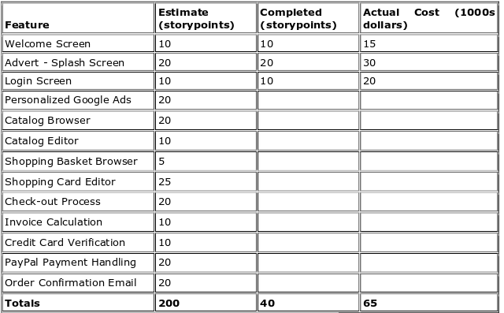

- Acutal % complete= (TAC/TPC)*100 =(40/200)*100=20%
- Planned value=cost of work expected to be completed
ie,= (expected cost for 1 sprint*total cost)
=(25/100)*175000=43750
- Earned value=cost of work completed
ie = (cost of completed work*total cost)
=(20/100)*175000=35000

