Assignment-7

1) When to use (Rapid Application Development) RAD model.When not to use (Rapid Application Development) RAD model ?

* Rapid Application Development is a software development model that concentrates on input output source and destination of information.

* Incremental model and skeleton type thing of a project.

We can use RAD model when :-

- Time is critical.Wanted to deliver within 2-3 months
- functionality delivered to the customer as increments.
- Budget is high enough
- When customer not looking for Quality software
- Project has changing requirements
- When stakeholders are not sure about the requirements
- need to reuse the components
- development time is less
- domain experts,high-level artifacts are available
- User will be involved whole through the lifecycle

We cannot use RAD model when:-

- quality software is needed
- Budget is not high
- skilled developers/designers are not available
- system developed cannot be modularised
- dealing with complex projects

Describe the Entity Relationships for the following diagram

c_id
c_name
Requirement
analysis

Client

pr_id
pr_name

Releases
product
Business Analyst
Project manager
controls

controls

Gives
documents

manages
Development team

product
releases
Review and
testing
do
p_id
p_name
budget
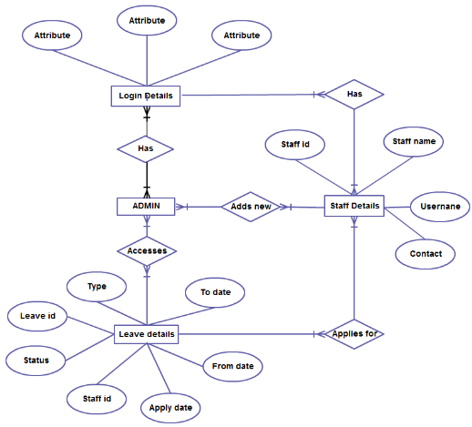

In the above ER diagram , The entities are :-

- Admin
- Login details
- Staff details
- Leave details

And these entities has got various attributes.

- Both Admin and staffs can login
- There may be more than one admin who has the login details of all the staffs so that he can manage every staffs login.
- Admins can add new staffs details when new staffs join.
- Admin accesses leave details so that he can sanction leaves applied by the staffs.
- Staffs can apply for leave and has the attributes :-
*staff_id,staff name,contacts,username

All relationship have many to many cardinalities.

