DRAG AND DROP

USER GUIDE

Created By: Parvathy Ravikumar

Date: 13th October 2016

Mailto: <parvathyravikumar26@gmail.com>

1. Scope and Purpose

Drag and Drop is a simple and user friendly single page tool for answering the question using drag and drop method or by clicking the answer.

This guide tell users how to use the tool and well understand the requirement. Also the various test cases to follow while testing

1. Quick Start
2. Open the DragNDrop folder
3. There is an html page called dragndrop
4. Open the html page with chrome
5. Requirement
6. Computer
7. Internet Connection(to get Google JQuery files)
8. Technologies Used
9. Html5
10. CSS3
11. JavaScript
12. JQuery
13. Bootstrap
14. Dreamweaver (IDE)
15. Description

It is a tool for answering the question using drag and drop method or either by clicking the answer.

* Landing page look like this

=> There are 5 statements and 5 options. Only one statement is displayed on screen.

=> After answering the first statement second one appears.

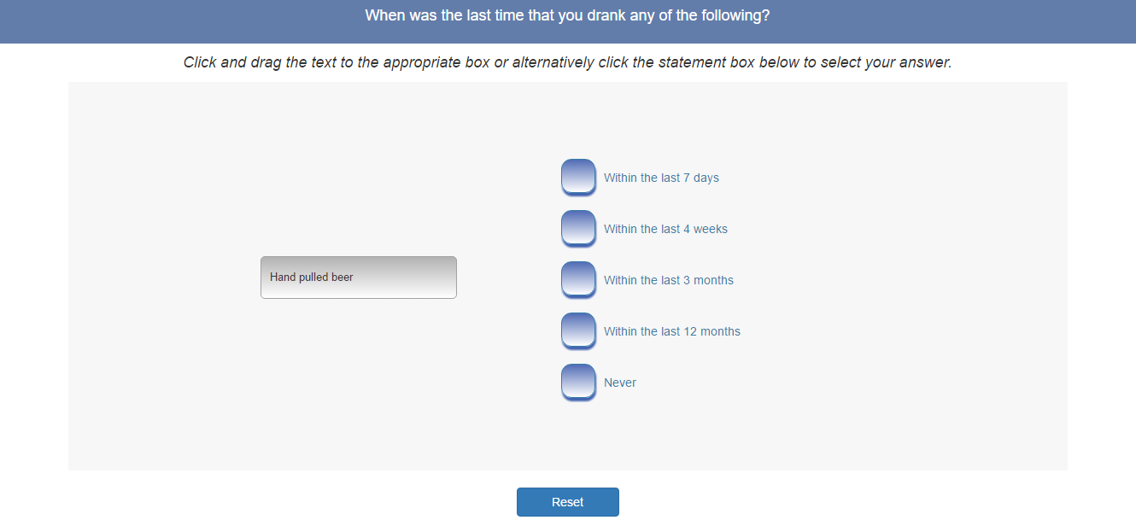

=> Select answer either by dragging the statement on to the option or by clicking the option.

=> At any point you can reload the page by clicking the reset button

=> The options get highlighted on hover. As shown below

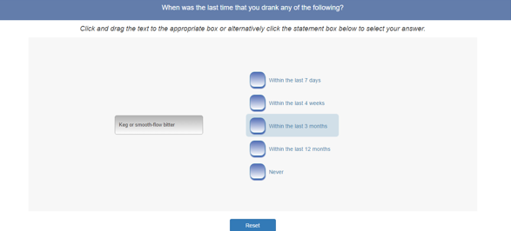

=> If you drag the statement somewhere else other than on the options, the statement will return to its initial position.

=> While dragging the statements, it becomes transparent as shown below

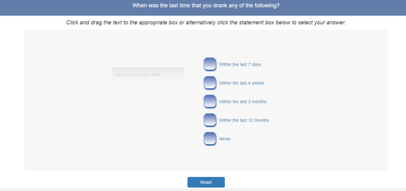

Test Cases

1. Test all elements are aligned as shown in the main screenshot.
2. Check whether the statements can be dragged properly and options are droppable.
3. Check whether options get highlighted on select.
4. Check whether each statement appears on the screen with animation. (enter from left hand side)
5. Check whether statement’s background gets lighter on hover.
6. Check whether the statements become transparent while dragging.
7. Check whether a black tick mark appears on the corresponding option while clicking the option.
8. Check whether the page get refreshed on reset button click.