RANKING TOOL

USER GUIDE

Created By: Parvathy Ravikumar

Date: 13th October 2016

Mailto: <parvathyravikumar26@gmail.com>

1. Scope and Purpose

Ranking tool is a simple and user friendly single page tool for selecting the items according to you preference

This guide tell users how to use the tool and well understand the requirement. Also the various test cases to follow while testing

1. Quick Start
2. Open the RankingTool folder
3. There is an html page called rankingTool
4. Open the html page with chrome
5. Requirement
6. Computer
7. Internet Connection (to get Google JQuery files.
8. Technologies Used
9. Html5
10. CSS3
11. JavaScript
12. JQuery
13. Bootstrap
14. Dreamweaver (IDE)
15. Description

It is a tool for selecting the items according your preference by clicking on the image

* Landing page look like this

=> There are 10 images in which you can select top three.

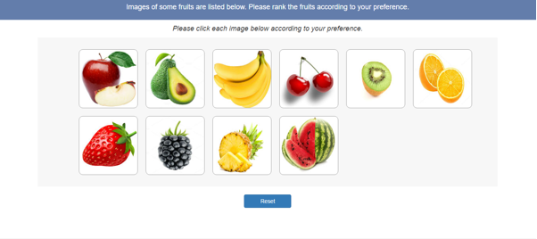

=> When you click on an image, it is considered as your first preference.

=> To indicate that a number is shown on the top of the image when you click it as shown below

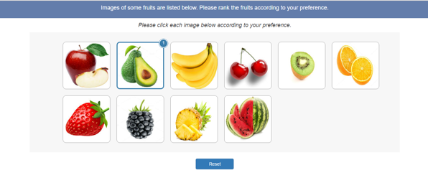

=> Top 3 preferences can be given. The images get numbered according to that as shown below

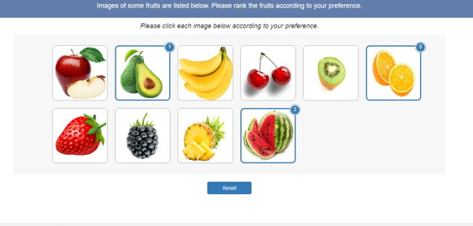

=> You can refresh the screen by clicking the reset button

=> When you place mouse over any image it will get zoomed as shown below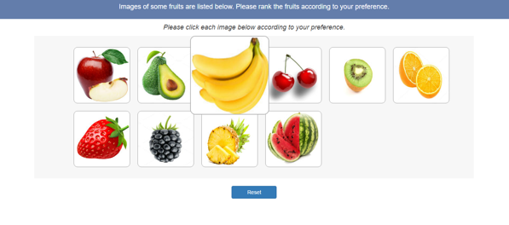

=> Images can be zoomed even after ranking as shown below

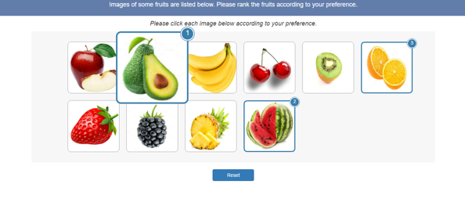

Test Cases

1. Test all elements are aligned as shown in the main screenshot.
2. Check whether the images get zoomed when mouse pointer brings over the image.
3. Check whether a number with a highlighting border is appearing on the image while clicking on the image.
4. Make sure that not more than one ranking possible on the same image.
5. Check whether the number gets incremented on every click.
6. Make sure only three ranking possible.
7. Check whether images get zoomed when hovered, even after ranking.
8. Check whether no number is coming on the image while clicking it after three ranking.
9. Check whether the page get refreshed on reset button click.