DIT project
2025-11-08
#STATISTICAL VALUES(MEAN, MEDIAN, STANDARD DEVIATION, VARIANCE)
# Load data
library(readxl)
df <- read_excel("/Users/asmitabaul/Desktop/files/DIT Project (Responses)_cleaned sample.xlsx")
# Select only relevant columns (categorical questions)
cols <- c("Which airline do you travel with most often?",
"Which airline is most affordable according to you?",
"Which airline is most punctual(less delays) according to you?",
"Which airline has most comfortable seatings according to you?",
"Which airline has best customer service according to you?")
# Loop through each column and compute statistics based on frequency counts
for (col in cols) {
cat("\n\nColumn:", col, "\n")
freq <- table(df[[col]])
freq_values <- as.numeric(freq)
mean_val <- mean(freq_values)
median_val <- median(freq_values)
var_val <- var(freq_values)
sd_val <- sd(freq_values)
print(freq)
cat("Mean:", mean_val, "\n")
cat("Median:", median_val, "\n")
cat("Variance:", var_val, "\n")
cat("Standard Deviation:", sd_val, "\n")
}
##
##
## Column: Which airline do you travel with most often?
##
## Air India Akasa Indigo
## 12 5 34
## Mean: 17
## Median: 12
## Variance: 229
## Standard Deviation: 15.13275
##
##
## Column: Which airline is most affordable according to you?
##
## Air India Akasa Indigo Spice jet
## 11 14 25 1
## Mean: 12.75
## Median: 12.5
## Variance: 97.58333
## Standard Deviation: 9.878428
##
##
## Column: Which airline is most punctual(less delays) according to you?
##
## Air India Akasa Indigo Not sure Vistara
## 9 7 32 2 1
## Mean: 10.2
## Median: 7
## Variance: 159.7
## Standard Deviation: 12.63725
##
##
## Column: Which airline has most comfortable seatings according to you?
##
## Air India Akasa Indigo Not sure Vistara
## 10 9 29 1 2
## Mean: 10.2
## Median: 9
## Variance: 126.7
## Standard Deviation: 11.25611
##
##
## Column: Which airline has best customer service according to you?
##
## Air India Akasa Indigo Not Sure SpiceJet Vistara
## 9 12 26 1 2 1
## Mean: 8.5
## Median: 5.5
## Variance: 94.7
## Standard Deviation: 9.731393
#Z-TEST
# Count total and IndiGo responses
n <- nrow(df)
x <- sum(df$`Which airline do you travel with most often?` == "Indigo")
# Number of airlines (categories)
k <- length(unique(df$`Which airline do you travel with most often?`))
p0 <- 1 / k
# One-sample right-tailed proportion test
prop.test(x, n, p = p0, alternative = "greater", correct = FALSE)
##
## 1-sample proportions test without continuity correction
##
## data: x out of n, null probability p0
## X-squared = 25.5, df = 1, p-value = 2.212e-07
## alternative hypothesis: true p is greater than 0.3333333
## 95 percent confidence interval:
## 0.5521315 1.0000000
## sample estimates:
## p
## 0.6666667
#VISUALISATIONS
# Load required libraries
library(ggplot2)
library(dplyr)
##
## Attaching package: 'dplyr'
## The following objects are masked from 'package:stats':
##
## filter, lag
## The following objects are masked from 'package:base':
##
## intersect, setdiff, setequal, union
library(reshape2)
library(ggcorrplot)
ggplot(df, aes(x = `Which airline do you travel with most often?`)) +
geom_bar(fill = "skyblue", color = "black") +
labs(title = "Most Preferred Airline", x = "Airline", y = "Count") +
theme_minimal()
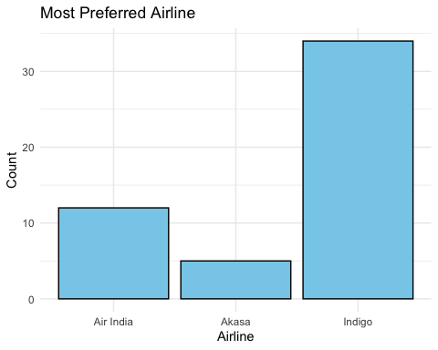
# Prepare data for pie chart
affordable_data <- df %>%
count(`Which airline is most affordable according to you?`)
ggplot(affordable_data, aes(x = "", y = n, fill = `Which airline is most affordable according to you?`)) +
geom_bar(stat = "identity", width = 1) +
coord_polar("y", start = 0) +
labs(title = "Most Affordable Airline", x = NULL, y = NULL, fill = "Airline") +
theme_void()
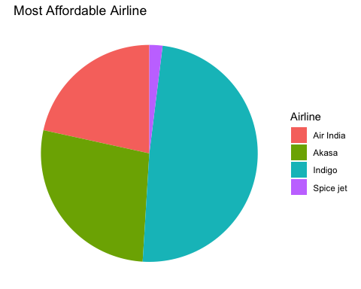
# Encode categorical data as numeric
df$punctual_num <- as.numeric(factor(df$`Which airline is most punctual(less delays) according to you?`))
ggplot(df, aes(y = punctual_num)) +
geom_boxplot(fill = "lightgreen") +
labs(title = "Boxplot of Airline Punctuality Preferences", y = "Encoded Airline Value") +
theme_minimal()
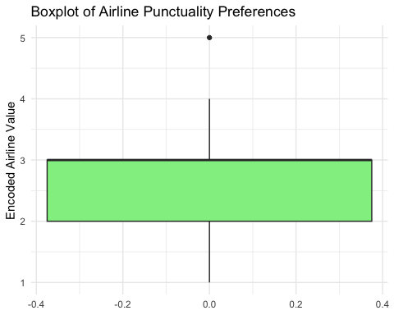
ggplot(df, aes(x = `Which airline has best customer service according to you?`)) +
geom_bar(fill = "orchid", color = "black") +
labs(title = "Best Customer Service (as per Respondents)", x = "Airline", y = "Count") +
theme_minimal()
