**Database file link:**https://drive.google.com/file/d/15ehp3FtyuYqExne3FaFcWHB4TFI_vtSR/view?usp=sharing

**Table structure**

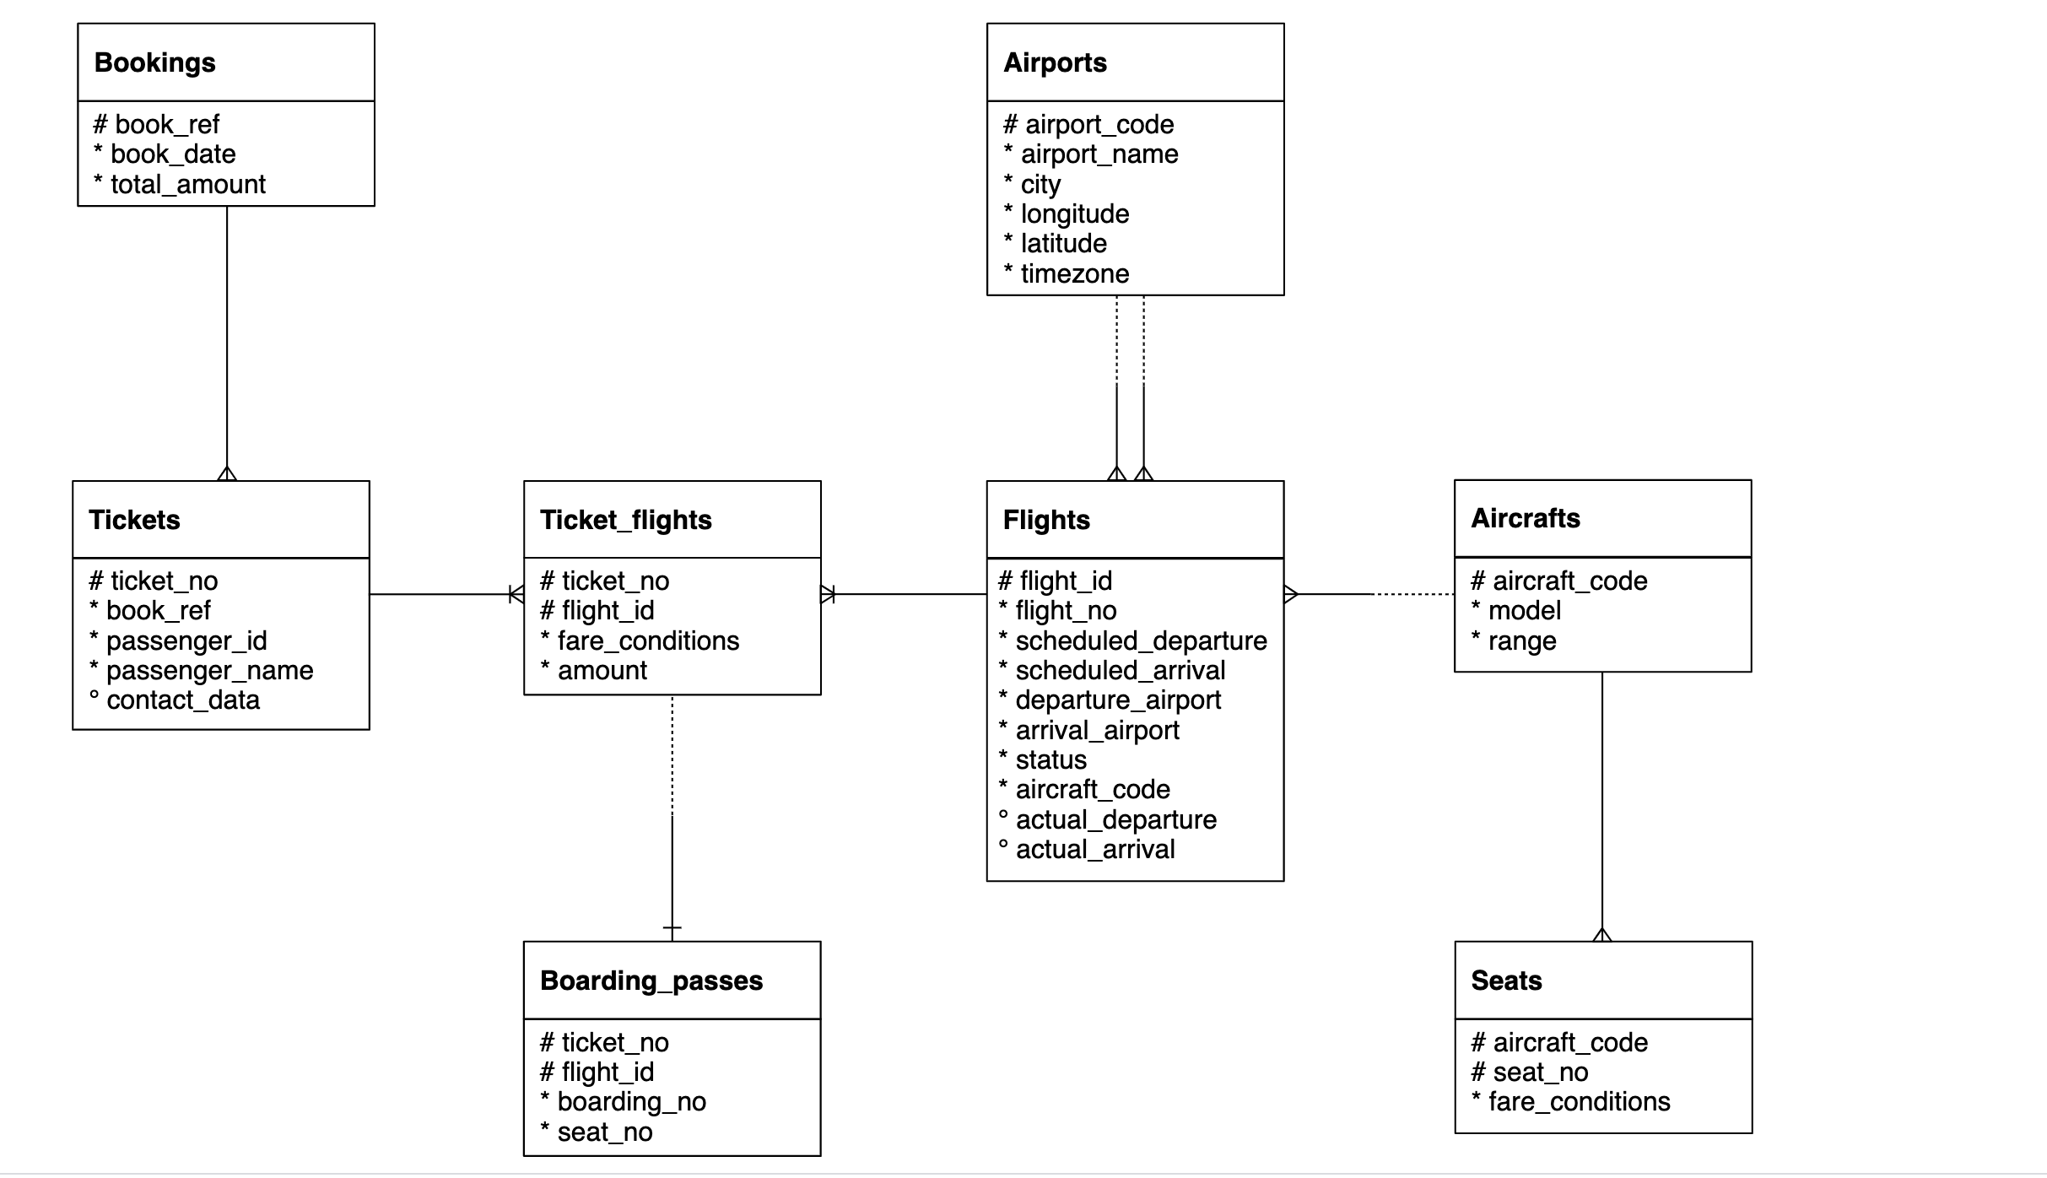

Table names has “**booking.”** as prefix. For example, bookings.tickets, bookings.boarding_passes

1. Represent the “book_date” column in “yyyy-mmm-dd”. User Bookings table

*Expected output*

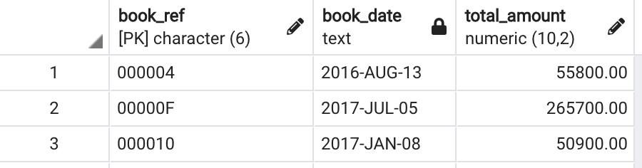

ANSWER 1

select

book_ref,

to_char(book_date,'YYYY-Mon-DD') as book_date,

total_amount

from bookings.bookings

1. Create a table having ticket_no, boarding_no, seat_number, passenger_id, passenger_name.

*Expected output*

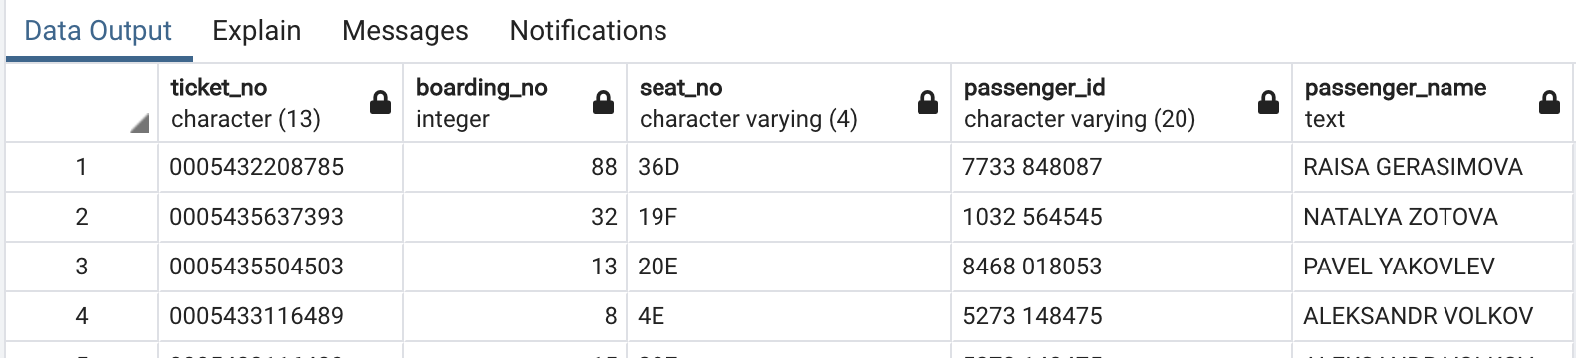

ANSWER

CREATE TABLE passenger__detail(

ticket_no char(13) not null,

boarding_no integer,

seat_no varchar (4),

passenger_id varchar(20),

passenger_name text

)

insert into passenger__detail(ticket_no ,boarding_no,seat_no,passenger_id,passenger_name)

values('0005432208785',88,'36D','7733848087','RAISA GRASIMOVA')

select * from passenger__detail

1. Which seat number is least allocated among all the seats?

ANSWER

SELECT

aircraft_code,

count(seat_no)

from bookings.seats

group by aircraft_code

order by count(seat_no) asc

limit 1

OUTPUT: CN1 = 12

1. In the database, identify the month wise highest paying passenger name and passenger id

*Expected output*

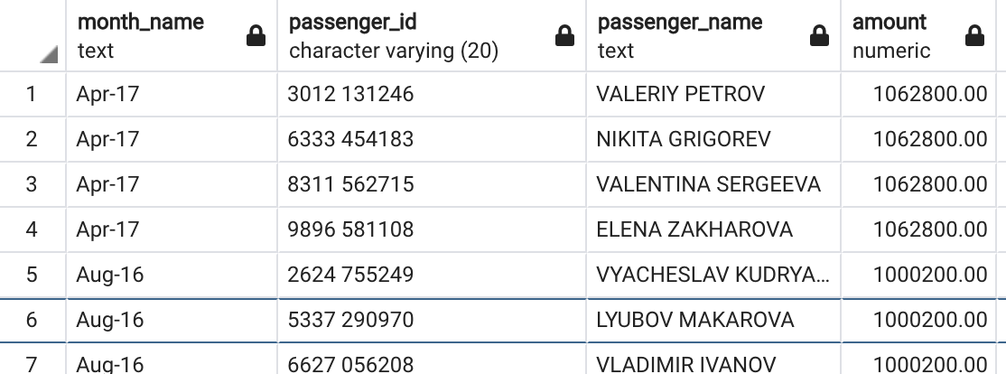

ANSWER

with table1 as(

select

to_char(b.book_date,'Mon-YY') month_name,

t.passenger_id,

t.passenger_name,

sum(b.total_amount) as total_amount

from bookings.tickets t

left join bookings.bookings b

on t.book_ref = b.book_ref

group by 1,2,3

order by 4 desc),

table2 as (

select *,

rank() over ( partition by month_name order by total_amount desc) as ran_amount

from table1)

select * from table2

where ran_amount = 1

1. In the database, identify the month wise least paying passenger name and passenger id?

*Expected output*

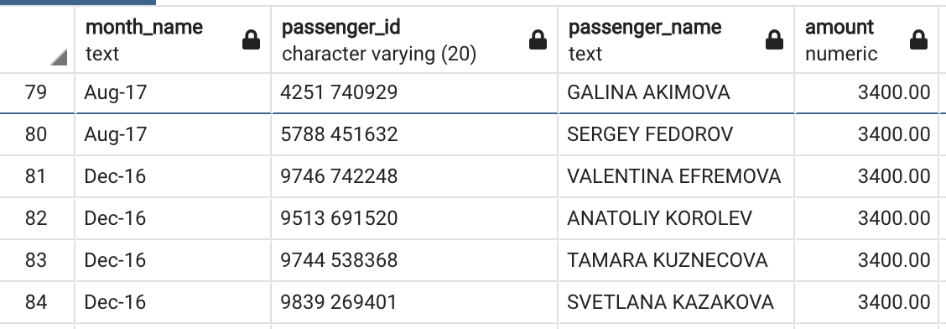

ANSWER

with table1 as(

select

to_char(b.book_date,'Mon-YY') month_name,

t.passenger_id,

t.passenger_name,

sum(b.total_amount) as total_amount

from bookings.tickets t

left join bookings.bookings b

on t.book_ref = b.book_ref

group by 1,2,3

order by 4 asc),

table2 as (

select *,

rank() over ( partition by month_name order by total_amount asc) as ran_amount

from table1)

select * from table2

where ran_amount = 1

1. Identify the travel details of non no stop journeys or return journeys (having more than 1 flight).

*Expected output*

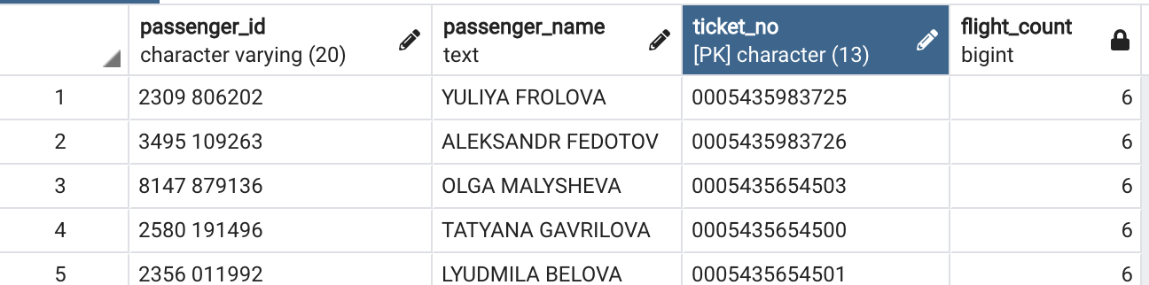

ANSWER

select t.ticket_no,t.passenger_id,t.passenger_name,

count(tf.flight_id) flight_count

from bookings.tickets t

left join bookings.ticket_flights tf

on tf.ticket_no = t.ticket_no

group by t.ticket_no,t.passenger_id,t.passenger_name

having count(tf.flight_id) > 1

order by flight_count desc

1. How many tickets are there without boarding passes?

ANSWER

with table1 as(

select *

from bookings.tickets t

full outer join bookings.boarding_passes bp

on t.ticket_no = bp.ticket_no)

select * from table1

where table1.boarding_no = null

1. Identify details of the longest flight (using flights table) ?

ANSWER

select *,

(scheduled_ARRIVAL - scheduled_DEPARTURE) as long

FROM BOOKINGS.FLIGHTS f

order by long desc

limit 1

1. Categorize flights using following logic (using flights table) :
   1. Early morning flights: 2 AM to 6AM
   2. Morning flights: 6 AM to 11 AM
   3. Noon flights: 11 AM to 4 PM
   4. Evening flights: 4 PM to 7 PM
   5. Night flights: 7 PM to 11 PM
   6. Late Night flights: 11 PM to 2 AM

*Expected output*

A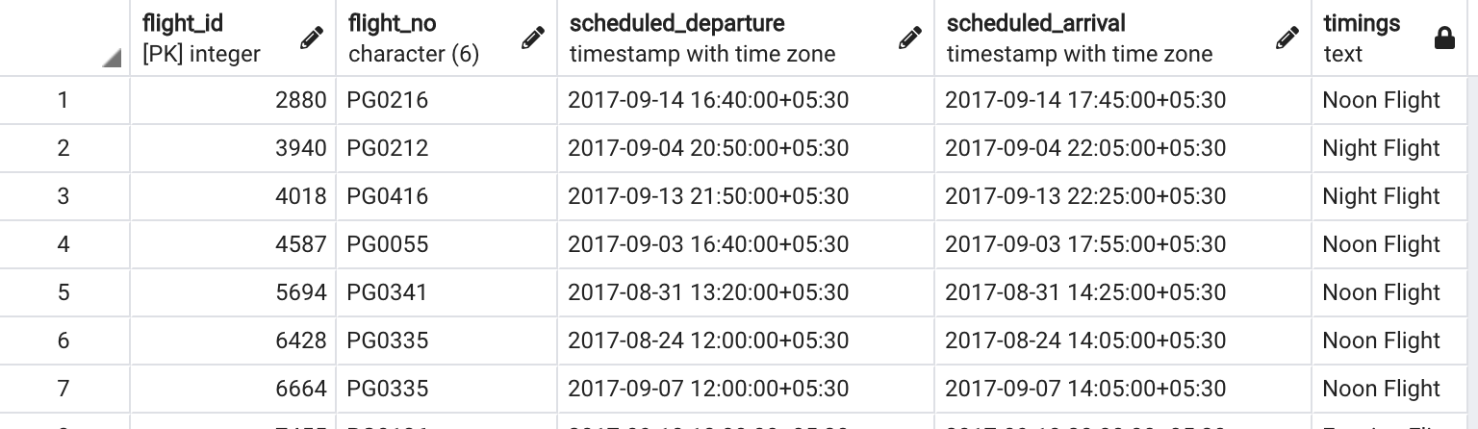ANSWER

SELECT

FLIGHT_ID,

FLIGHT_NO,

SCHEDULED_DEPARTURE,

SCHEDULED_ARRIVAL,

CASE WHEN EXTRACT(HOUR FROM SCHEDULED_DEPARTURE) BETWEEN 2 AND 5 THEN 'Early morning flights'

WHEN EXTRACT(HOUR FROM SCHEDULED_DEPARTURE) BETWEEN 6 AND 10 THEN 'Morning flights'

WHEN EXTRACT(HOUR FROM SCHEDULED_DEPARTURE) BETWEEN 11 AND 15 THEN 'Noon flights'

WHEN EXTRACT(HOUR FROM SCHEDULED_DEPARTURE) BETWEEN 16 AND 20 THEN 'Evening flights'

WHEN EXTRACT(HOUR FROM SCHEDULED_DEPARTURE) BETWEEN 21 AND 22 THEN 'Night flights'

ELSE 'Late Night flights'

END AS TIMINGS

FROM BOOKINGS.FLIGHTS

1. Identify details of all the morning flights (morning means between 6AM to 11 AM, using flights table) ?

ANSWER

with table1 as (

SELECT *,

CASE WHEN EXTRACT(HOUR FROM SCHEDULED_DEPARTURE) BETWEEN 6 AND 11 THEN 'Morning flights'

END AS TIMINGS

FROM BOOKINGS.FLIGHTS)

select * from table1

WHERE TIMINGS = 'Morning flights'

1. Identify the earliest morning flight available from every airport.

*Expected output*

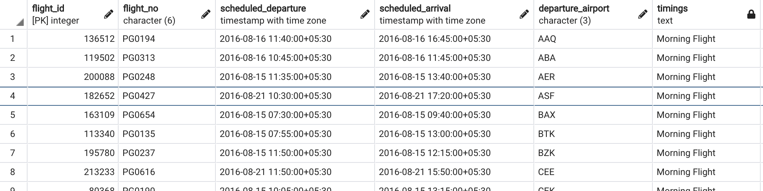

ANSWER

WITH TABLE_1 AS (SELECT

FLIGHT_ID,

FLIGHT_NO,

SCHEDULED_DEPARTURE,

SCHEDULED_ARRIVAL,

DEPARTURE_AIRPORT,

RANK()OVER(PARTITION BY DEPARTURE_AIRPORT ORDER BY SCHEDULED_DEPARTURE) AS ORDER_OF_DEPARTURE,

CASE WHEN EXTRACT(HOUR FROM SCHEDULED_DEPARTURE) BETWEEN 2 AND 5 THEN 'Early morning flights'

    WHEN EXTRACT(HOUR FROM SCHEDULED_DEPARTURE) BETWEEN 6 AND 10 THEN 'Morning flights'

    WHEN EXTRACT(HOUR FROM SCHEDULED_DEPARTURE) BETWEEN 11 AND 15 THEN 'Noon flights'

    WHEN EXTRACT(HOUR FROM SCHEDULED_DEPARTURE) BETWEEN 16 AND 20 THEN 'Evening flights'

    WHEN EXTRACT(HOUR FROM SCHEDULED_DEPARTURE) BETWEEN 21 AND 22 THEN 'Night flights'

    ELSE 'Late Night flights'

    END AS TIMINGS

FROM BOOKINGS.FLIGHTS)

SELECT

FLIGHT_ID,

FLIGHT_NO,

SCHEDULED_DEPARTURE,

SCHEDULED_ARRIVAL,

DEPARTURE_AIRPORT,

TIMINGS

FROM TABLE_1

WHERE ORDER_OF_DEPARTURE = 1 AND TIMINGS = 'Morning flights'