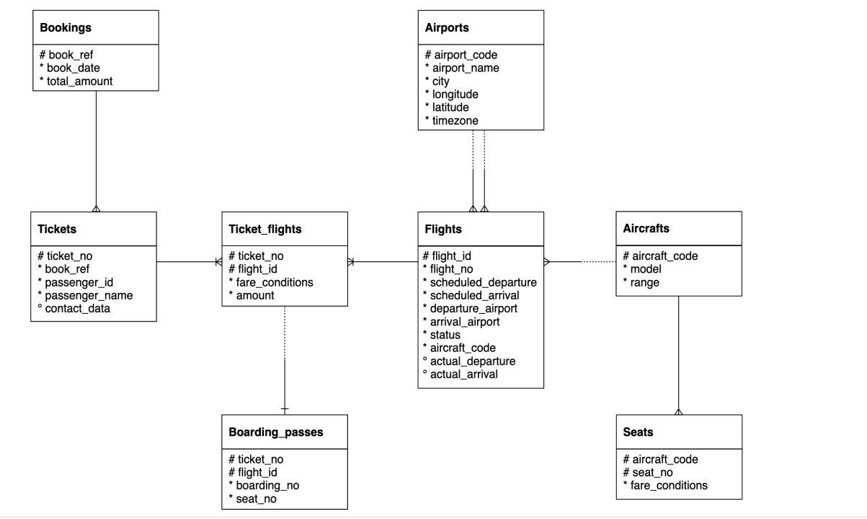

Submit query after every question

1. Find list of airport codes in Europe/Moscow timezone

ANSWER

select * from bookings.Airports

Where timezone in ('Europe/Moscow')

1. Write a query to get the count of seats in various fare condition for every aircraft code?

ANSWER

select s.aircraft_code,s.fare_conditions,

count(seat_no) total_seat

from bookings.Seats s

group by s.aircraft_code,s.fare_conditions

1. How many aircrafts codes have at least one Business class seats?

ANSWER

select s.fare_conditions,

count(distinct aircraft_code) total_code

from bookings.Seats s

WHERE s.fare_conditions in ('Business')

group by s.fare_conditions

OUTPUT - 7

1. Find out the name of the airport having maximum number of departure flight

ANSWER

select departure_airport,

count(flight_id) cnt

from bookings.flights

group by departure_airport

order by cnt desc

OUTPUT – DME (20875)

1. Find out the name of the airport having least number of scheduled departure flights

ANSWER

select departure_airport,

count(flight_id) cnt

from bookings.flights

group by departure_airport

order by cnt ASC

OUTPUT – KXK (113)

1. How many flights from ‘DME’ airport don’t have actual departure?

ANSWER

select departure_airport,

count(flight_id) cnt

from bookings.flights

where actual_departure is null

group by departure_airport

order by cnt desc

OUTPUT : 1591

1. Identify flight ids having range between 3000 to 6000

ANSWER

select * from bookings.flights

WHERE flight_id between 3000 and 6000

1. Write a query to get the count of flights flying between URS and KUF?

ANSWER

select

count(flight_id)

from bookings.flights

where departure_airport in('URS','KUF') and arrival_airport in ('KUF','URS')

ANSWER - 792

1. Write a query to get the count of flights flying from either from NOZ or KRR?

ANSWER

select count(flight_id)

from bookings.flights

where departure_airport in ('NOZ','KRR')

ANSWER - 3903

1. Write a query to get the count of flights flying from KZN, DME,

NBC,NJC,GDX,SGC,VKO,ROV

ANSWER

select departure_airport,

COUNT(flight_id)

from bookings.flights

where departure_airport in ( 'KZN', 'DME',

'NBC','NJC','GDX','SGC','VKO','ROV' )

group by departure_airport

1. Write a query to extract flight details having range between 3000 and 6000 and flying from DME

ANSWER

select * from bookings.flights

where departure_airport in ('DME') and flight_id between 3000 and 6000

1. Find the list of flight ids which are using aircrafts from “Airbus” company and got cancelled or delayed

ANSWER

WITH TABLE_1 AS

(SELECT

*,

SUBSTRING(CAST(MODEL AS TEXT),9,POSITION(' ' IN CAST(MODEL AS TEXT) )-1) AS AIRCRAFT_MODEL FROM BOOKINGS.AIRCRAFTS_DATA)

SELECT

B.FLIGHT_ID,

A.AIRCRAFT_CODE,

B.STATUS,

A.AIRCRAFT_MODEL

FROM BOOKINGS.FLIGHTS B

JOIN  TABLE_1 A

ON A.AIRCRAFT_CODE = B.AIRCRAFT_CODE

WHERE A.AIRCRAFT_MODEL = 'Airbus' AND B.STATUS IN ('Cancelled',’Delayed’)

OR

with table1 as(

select *,

cast (model as text) as model_text from bookings.aircrafts_data

)

select f.flight_id,f.status,f.aircraft_code,t.model_text

from bookings.flights f

inner join table1 t

on f.aircraft_code = t.aircraft_code

where model_text ilike '%Airbus%' And status in('Cancelled','Delayed')

1. Find the list of flight ids which are using aircrafts from “Boeing” company and got cancelled or delayed

ANSWER

with table1 as(

select *,

cast (model as text) as model_text from bookings.aircrafts_data

)

select f.flight_id,f.status,f.aircraft_code,t.model_text

from bookings.flights f

inner join table1 t

on f.aircraft_code = t.aircraft_code

where model_text ilike '%Boeing%' And status in('Cancelled','Delayed')

1. Which airport(name) has most cancelled flights (arriving)?

ANSWER

select arrival_airport,

count(status) status_cnt

from bookings.flights

where status in ('Cancelled')

group by arrival_airport

order by status_cnt desc

OUTPUT - DME

1. Identify flight ids which are using “Airbus aircrafts”

ANSWER

with table1 as(

select *,

cast (model as text) as model_text from bookings.aircrafts_data

)

select f.flight_id,t.model_text

from bookings.flights f

inner join table1 t

on f.aircraft_code = t.aircraft_code

where model_text ilike '%Airbus%'

1. Identify date-wise last flight id flying from every airport?

ANSWER

WITH TABLE_1 AS (

SELECT

*,

RANK()OVER(PARTITION BY DEPARTURE_AIRPORT ,DATE(ACTUAL_DEPARTURE) ORDER BY ACTUAL_DEPARTURE DESC) ORDER_OF_DEPT

FROM BOOKINGS.FLIGHTS)

      SELECT

*

FROM TABLE_1

WHERE ORDER_OF_DEPT = 1

1. Identify list of customers who will get the refund due to cancellation of the flights?

And how much amount they will get?

ANSWER

select * from bookings.flights f

left join bookings.ticket_flights tf

on f.flight_id = tf.flight_id

where status = 'Cancelled'

PROBLEM -> REFUND AMOUNT TABLE IS NOT GIVEN

1. Identify date wise first cancelled flight id flying for every airport?

ANSWER

with table1 as (

select *,

rank() over ( partition by departure_airport, DATE(scheduled_departure) order by

scheduled_departure asc) as dept_rank

from bookings.flights)

select * from table1

where dept_rank = 1 and status = ‘Cancelled’

1. Identify list of Airbus flight ids which got cancelled.

ANSWER

with table1 as(

select *,

cast (model as text) as model_text from bookings.aircrafts_data

)

select f.flight_id,t.model_text

from bookings.flights f

inner join table1 t

on f.aircraft_code = t.aircraft_code

where model_text ilike '%Airbus%' and status = ‘Cancelled’

1. Identify list of flight ids having highest range

ANSWER

select f.flight_id,ad.range

from bookings.flights f

inner join bookings.aircrafts_data ad

on f.aircraft_code = ad.aircraft_code

where ad.range = (select max(range) from bookings.aircrafts_data)