FreshMart Retail Chain
Forecasting Monthly Sales
Step-by-Step Explanation of the Python Notebook
Time Series Forecasting Case Study | Business Analytics
Dataset: Monthly sales in INR lakhs, January 2020 to December 2024 (60 months)
Methods covered: Moving Average, Exponential Smoothing, AR, ARIMA, SARIMA, Holt-Winters

Contents
1. Introduction
2. Getting Ready: Libraries, Loading and Checking the Data
3. Task 1: Moving Average (MA)
4. Preparing for Forecasting: Train-Test Split and Error Measures
5. Task 2: Exponential Smoothing
6. Task 3: Autoregressive (AR) Models
7. Task 4: ARIMA Models
8. Task 5: Seasonal ARIMA (SARIMA)
9. Task 6: Holt-Winters Seasonal Method
10. Comparing All the Models
11. Forecasting the Next 12 Months (2025)
12. Insights and Recommendations
13. Overall Summary

1. Introduction

1.1 What is the problem?
FreshMart is a big retail chain that sells groceries and household items across the country. The management wants to know how much it will sell in each coming month. If they know this in advance, they can order the right amount of stock, avoid running out of items (called a stockout), and avoid keeping too much unsold stock.
Our job, as the Business Analytics team, is to look at the past 5 years of monthly sales and build a time series forecasting model that predicts the future.

1.2 What is a time series?
A time series is simply a list of numbers recorded one after another over time, for example sales for January, February, March and so on. In a time series, the order matters, because today's value is usually related to yesterday's value. Time series usually contains three things:
- Trend: the long-term direction (going up, going down or staying flat).
- Seasonality: a pattern that repeats every year, such as higher sales in December because of festivals.
- Noise (random ups and downs): small unpredictable changes that we cannot explain.

1.3 What is in this report?
The professor's case study has 6 tasks. The Python notebook solves all of them one by one. This report walks through the notebook in the same order and explains, in simple words, what each step does, why it is done and what the result means. All the pictures (graphs) from the notebook are included.
Task | Method | What it does in one line
Task 1 | Moving Average | Smooths the ups and downs to show the trend
Task 2 | Exponential Smoothing (SES, Double, Triple) | Forecasts by giving more weight to recent months
Task 3 | Autoregressive (AR) | Predicts using the previous months' values
Task 4 | ARIMA | AR + differencing + moving average errors
Task 5 | SARIMA | ARIMA with a yearly seasonal pattern
Task 6 | Holt-Winters | Exponential smoothing with trend and season

2. Getting Ready: Libraries, Loading and Checking the Data

Step 1: Import the libraries (Cell 1)
Before doing any analysis, Python needs its tools. A library is a ready-made toolbox that saves us from writing everything from scratch. The notebook loads the following:
Library | What we use it for
pandas | Holding the data in a table and working with dates
numpy | Mathematical calculations
matplotlib and seaborn | Drawing graphs and charts
scikit-learn (sklearn) | Calculating error measures such as MAE and RMSE
statsmodels | All the forecasting models (SES, Holt, AR, ARIMA, SARIMA, Holt-Winters) and tests
warnings | Hiding unnecessary warning messages so the notebook looks clean

Step 2: Load the dataset (Cell 2)
The notebook reads the file FreshMart_Monthly_Sales.csv. It then does four small but important things:
- Converts the Month column (text such as "Jan-20") into a real date, so Python understands it as time.
- Sorts the rows from oldest to newest month.
- Makes Month the index (the row label) of the table, which is the standard way to store a time series.
- Prints the first 10 rows and the shape of the data.
Result: The data has 60 rows and 1 column (Sales). That means 60 months, from January 2020 to December 2024. The first values are: Jan-2020 = 54.99, Feb-2020 = 52.98, Mar-2020 = 54.14 and so on (in INR lakhs).

Step 3: Check the quality of the data (Cell 3)
Before building a model, we always make sure the data is clean. The notebook checks for missing values, data types and basic statistics.
Check | Result | Meaning
Missing values | 0 | No blanks, so no cleaning is needed
Data type of Sales | float64 | Sales are decimal numbers, which is correct
Number of months | 60 | 5 full years
Average sales | 62.19 | A typical month is about 62 lakhs
Minimum / Maximum | 44.45 / 79.95 | Lowest and highest month
Standard deviation | 8.19 | Sales move about 8 lakhs around the average

Step 4: Plot the sales (Cell 4)
The first graph is always the simple line chart of the raw data. It lets us see the story with our own eyes before using any formula.
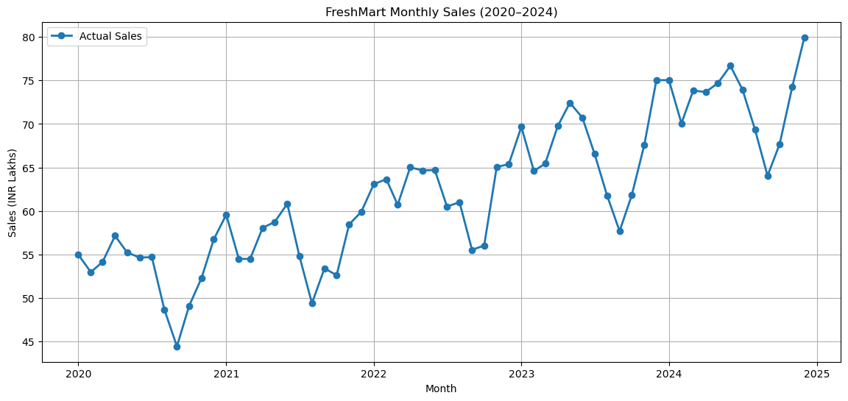
Figure 1: FreshMart monthly sales, 2020 to 2024
What we learn from Figure 1
1. Upward trend: Sales grow over the 5 years, from about 55 lakhs in early 2020 to about 80 lakhs at the end of 2024.
2. Repeating pattern: Each year the line goes up and down in a similar shape, which suggests seasonality.
3. Random noise: The line is not smooth; small jumps happen every month.

3. Task 1: Moving Average (MA)

The idea in simple words
A moving average takes the average of the last few months and slides forward one month at a time. Imagine you look at your marks for the last 3 exams and take their average. Next time you drop the oldest exam and add the newest. This smooths out sudden jumps, so you can see the real direction.

Step 5: Calculate 3, 6 and 12-month moving averages (Cell 5)
The notebook makes a copy of the data and adds three new columns: MA_3, MA_6 and MA_12. For example, the MA_3 of March 2020 is the average of Jan, Feb and Mar 2020 = (54.99 + 52.98 + 54.14) / 3 = 54.04.
The first few rows show NaN (empty) because there are not enough earlier months. MA_3 starts from the 3rd month, MA_6 from the 6th month and MA_12 from the 12th month.

Step 6: Plot the moving averages against actual sales (Cell 6)
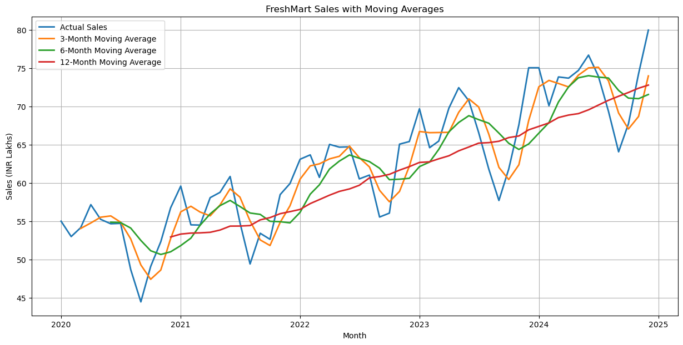
Figure 2: Actual sales with 3, 6 and 12-month moving averages
How to read Figure 2:
- Blue line (actual sales): very jumpy, it follows every small change.
- Orange line (3-month MA): a bit smoother, but still moves a lot with the actual data.
- Green line (6-month MA): smoother and still shows the seasonal ups and downs.
- Red line (12-month MA): almost a straight, gently rising line. It completely removes the yearly seasonality and shows only the trend.

Step 7: Measure how smooth each average is (Cell 7)
To back up what we saw in the graph with numbers, the notebook calculates the standard deviation (how much the line moves) of each moving average. A smaller value means a smoother line.
Moving Average | Standard Deviation | Smoothness
3-Month MA | 7.51 | Least smooth
6-Month MA | 6.99 | Medium
12-Month MA | 6.12 | Smoothest

Step 8: Save the results to Excel (Cells 8 and 9)
The notebook saves the actual sales and the three moving averages into a separate Excel file called FreshMart_Task1_Moving_Averages.xlsx, so it can be submitted or opened in Excel. It also prints the current working folder (os.getcwd) so we know where the file was saved.
Answer to the Task 1 question: Which moving average is best?
The 6-month moving average is the best balance. It removes most of the noise but still keeps the seasonal shape.
The 3-month MA is too close to the noisy actual data. The 12-month MA gives the clearest trend, but it over-smooths: it hides the seasonal changes and reacts late to changes (it lags behind).
If we only want to see the long-term growth, the 12-month MA is the clearest choice. If we want a trend that is still useful for planning, the 6-month MA is better.

4. Preparing for Forecasting: Train-Test Split and Error Measures

Step 9: Split the data into training and testing (Cell 10)
To check whether a model is good, we cannot test it on the same data it learned from. It is like a student who sees the exam paper before the exam: a high score would mean nothing. So the data is split in two parts:
Part | Months | Period | Purpose
Training set | 48 | Jan 2020 to Dec 2023 | The model learns from this
Testing set | 12 | Jan 2024 to Dec 2024 | We hide it, ask the model to forecast it and compare with the real values

Step 10: Define the error measures (Cell 11)
To decide which model is the best we need a score. The notebook defines two functions, MAPE and RMSE, and later also uses MAE. For all three, a lower value is better.
Measure | Full name | Simple meaning
MAE | Mean Absolute Error | On average, how many lakhs is the forecast wrong by?
RMSE | Root Mean Squared Error | Like MAE, but big mistakes are punished more heavily
MAPE | Mean Absolute Percentage Error | On average, by what percent is the forecast wrong? Easy to explain to management

5. Task 2: Exponential Smoothing
Exponential smoothing is a family of methods which forecast the future by taking a weighted average of the past, where recent months get more weight and old months get less. There are three versions, each adding one more feature.

5.1 Simple Exponential Smoothing (SES)

Step 11: Try many alpha values (Cell 12)
SES has one setting called alpha (α), the smoothing factor, which lies between 0 and 1.
- Small alpha (e.g. 0.1): the model changes slowly and trusts the long past more.
- Large alpha (e.g. 0.9): the model reacts quickly and trusts the latest month more.
The task asks us to experiment with different alphas. The notebook uses a loop to try every alpha from 0.01 to 0.99 (99 values). For each one it fits the model on the training data, forecasts 12 months, and records RMSE and MAPE. For example, alpha = 0.01 gave RMSE 16.29, while alpha = 0.05 gave 11.35, which shows that the choice of alpha matters a lot.

Step 12: Pick the best alpha and forecast (Cells 13 and 14)
The notebook selects the alpha with the lowest RMSE, and re-fits the model with it.
Best alpha | RMSE | MAPE
0.75 | 4.101 | 4.65%

SES gives a flat line as its forecast (you can see this in Figure 3), because it has no idea about trend or seasonality. It is good only for data with no clear pattern.

5.2 Double Exponential Smoothing (Holt's method)

Step 13: Tune alpha and beta (Cells 15, 16, 17)
Double exponential smoothing adds a second setting, beta (β), which lets the model learn the trend (whether sales are rising or falling). Now there are two settings to tune, so the notebook uses a loop inside a loop, testing every combination of alpha (0.1 to 0.9) and beta (0.1 to 0.9), which is 81 combinations.
Best alpha | Best beta | RMSE | MAPE
0.4 | 0.1 | 4.605 | 5.57%

The forecast is now a sloped line (going upward) because the model has learnt the growth trend. But the accuracy did not improve; it is actually a little worse than SES, because the real data goes up and down in a yearly pattern and a straight sloping line cannot copy that.

5.3 Triple Exponential Smoothing (Holt-Winters)

Step 14: Add seasonality (Cell 18)
Triple exponential smoothing adds a third component, seasonality. The notebook uses trend = additive, seasonal = additive and seasonal_periods = 12 (the pattern repeats every 12 months). Python finds the best alpha, beta and gamma settings on its own.
RMSE | MAPE
1.968 | 2.22%

Step 15: Compare the three methods (Cells 19 and 20)
Model | RMSE | MAPE (%)
Simple Exponential Smoothing | 4.101 | 4.651
Double Exponential Smoothing | 4.605 | 5.572
Triple Exponential Smoothing | 1.968 | 2.224

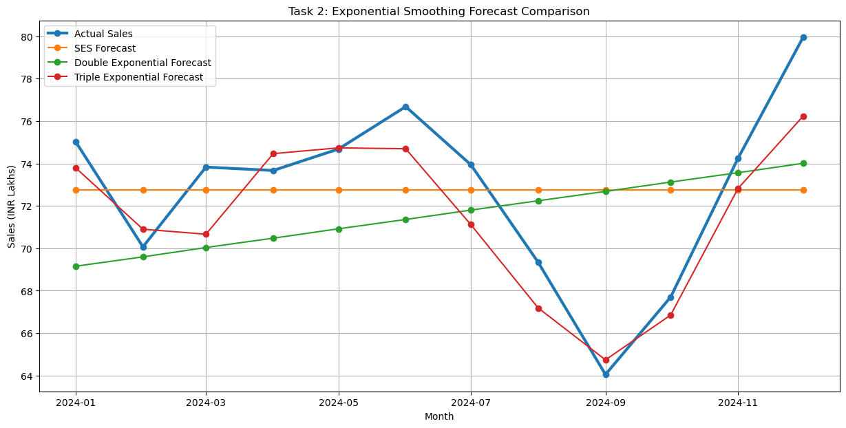
Figure 3: Actual 2024 sales vs SES, Double and Triple exponential forecasts
How to read Figure 3: the thick blue line is the real sales in 2024. The orange line (SES) is flat, and the green line (Double) is a slow upward slope, and both miss the real ups and downs. The red line (Triple) follows the blue line closely, including the big fall in September and the big rise in November and December.
Answer to the Task 2 question: How does triple smoothing improve accuracy over double smoothing?
Double smoothing knows only about trend, so it draws a straight sloping line. Triple smoothing knows about trend and seasonality, so it can copy the yearly up-and-down pattern.
The error fell from RMSE 4.605 to 1.968 and from MAPE 5.57% to 2.22%, which is an improvement of more than half. FreshMart's sales are clearly seasonal, so a method that understands seasonality wins.

6. Task 3: Autoregressive (AR) Models

The idea in simple words
"Auto" means self and "regression" means predicting from something. An AR model predicts this month's sales using the sales of previous months. AR(1) uses only last month. AR(2) uses the last two months, and AR(3) uses the last three months. The number in brackets is called the order or the lag.

Step 16: Plot ACF and PACF (Cell 21)
To decide how many past months are useful, we draw two special graphs:
- ACF (Autocorrelation Function): shows how strongly today's value is related to the value 1, 2, 3... months ago.
- PACF (Partial Autocorrelation Function): the same idea, but it removes the effect of the in-between months. It shows the direct link only. The PACF is the main graph used for choosing the AR order.
The blue shaded area is the "not significant" zone. A bar that goes outside the blue area is significant (a real relationship). A bar inside the blue area could just be random luck.
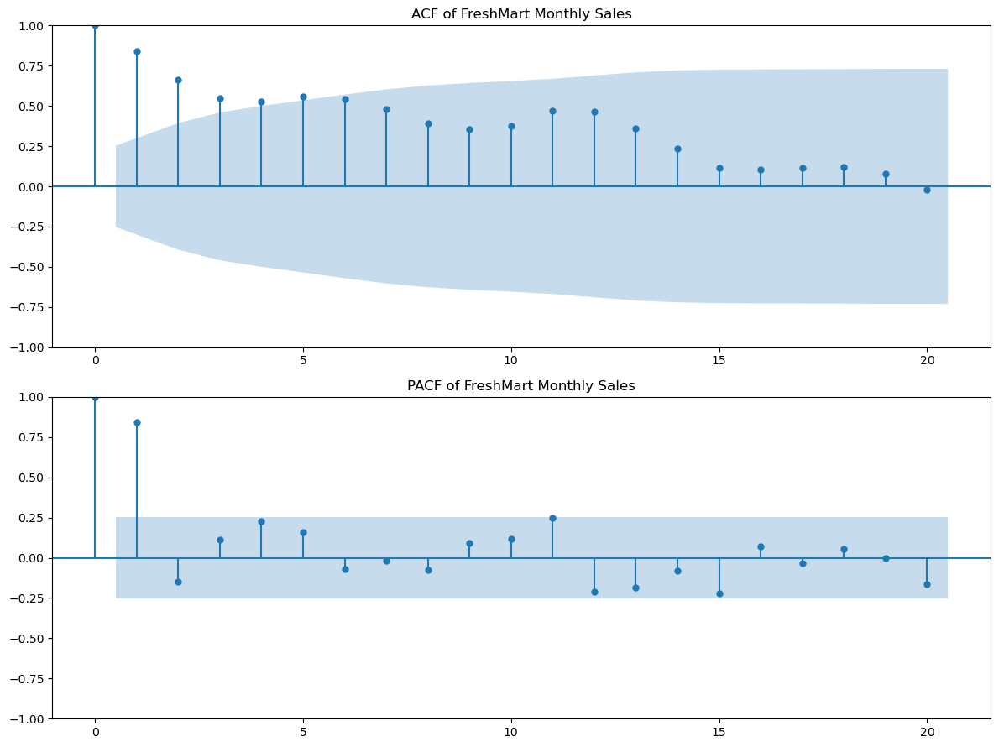
Figure 4: ACF and PACF of the FreshMart sales series
What we see in Figure 4:
- The ACF starts high (about 0.84 at lag 1) and falls slowly. A slow fall like this is a sign of a trend in the data.
- The PACF has one very tall bar at lag 1 (about 0.84), and after that the bars are mostly inside the blue zone. This tells us that lag 1 is the most important, so an AR(1) model should be enough.

Step 17: Build AR(1), AR(2), AR(3) (Cells 22 and 23)
A loop builds the three AR models on the training data, forecasts 12 months and calculates the errors.
Model | RMSE | MAPE (%)
AR(1) | 6.417 | 6.862
AR(2) | 8.787 | 9.738
AR(3) | 8.587 | 9.453

Answer to the Task 3 question: Which lag order fits best?
AR(1) is the best, with the lowest errors (RMSE 6.417, MAPE 6.86%). This matches the PACF graph, where only lag 1 was clearly significant.
Adding more lags (AR(2) and AR(3)) made the forecast worse, since the extra lags only add noise. Even the best AR model is weaker than Holt-Winters, because AR alone cannot handle trend and seasonality.

7. Task 4: ARIMA Models

The idea in simple words
ARIMA stands for AutoRegressive Integrated Moving Average. It has three settings, written as ARIMA(p, d, q):
Letter | Name | Meaning
p | AR order | How many past values are used
d | Differencing | How many times we subtract the previous value to remove the trend
q | MA order | How many past forecast errors are used

ARIMA works only on stationary data. A stationary series is one whose average and spread stay steady over time, without a trend. Our sales keep growing, so they are probably not stationary. To follow the Box-Jenkins method, we do the following steps in order: check stationarity, identify p, d, q, estimate (fit) the model, and check the residuals (diagnostics).

Step 18: Check stationarity with the ADF test (Cell 24)
The ADF (Augmented Dickey-Fuller) test gives a p-value. The rule is simple: if p-value is 0.05 or below, the series is stationary. If it is above 0.05, it is not stationary.
Series | ADF Statistic | p-value | Conclusion
Original training data | 0.470 | 0.984 | Not stationary
After first differencing | -7.216 | 0.0000000002 | Stationary

The original data has a p-value of 0.98, which is far above 0.05, so it is not stationary.

Step 19: Differencing (Cells 25, 26, 27)
Differencing means replacing each value by "this month minus last month". This removes the upward trend. The notebook plots the differenced series and repeats the ADF test.
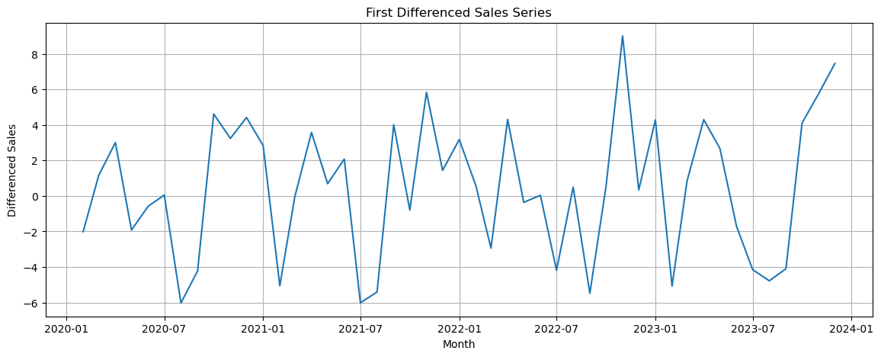
Figure 5: First differenced sales series
After one differencing the graph moves around a steady middle value (zero) without any upward drift, and the p-value becomes almost zero, so the series is now stationary. The notebook then automatically picks d = 1 because one round of differencing was enough.

Step 20: Identification, choosing p and q from ACF/PACF (Cell 28)
Now the ACF and PACF graphs are drawn again, but on the differenced data, to guess suitable p and q values.
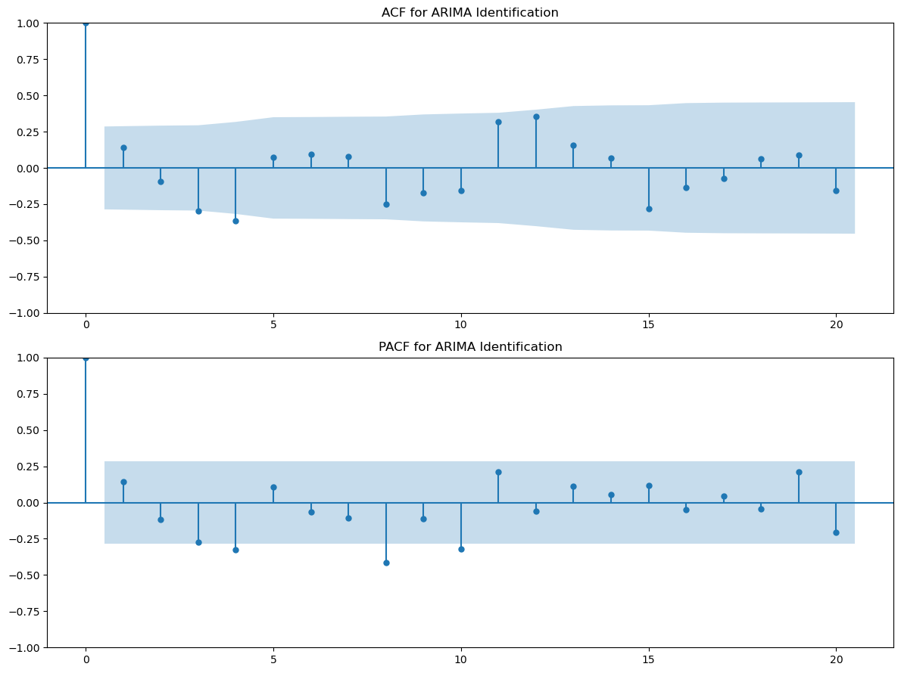
Figure 6: ACF and PACF of the differenced series (for ARIMA identification)
Several bars around lags 3, 4 and 8 cross the blue zone, which suggests that a fairly big model with lags up to 3 or 4 might be needed. Because reading p and q by eye is difficult, the notebook does not rely on the graphs alone, and tests many combinations in the next step.

Step 21: Estimation, fit many ARIMA models (Cells 29, 30, 31)
The notebook fits ARIMA models for every combination of p from 0 to 3 and q from 0 to 3, with d = 1, which is 16 models. It records AIC (a score where lower is better and which penalises complicated models), RMSE and MAPE. The top results are:
ARIMA(p,d,q) | AIC | RMSE | MAPE (%)
(3,1,3) | 255.82 | 2.928 | 3.374
(2,1,2) | 255.06 | 3.100 | 3.628
(3,1,2) | 256.43 | 3.449 | 3.825
(3,1,0) | 262.37 | 4.541 | 5.397
(2,1,0) | 264.40 | 4.591 | 4.718

The model with the lowest RMSE is ARIMA(3,1,3), with RMSE 2.928 and MAPE 3.37%. (Note: ARIMA(2,1,2) has a slightly lower AIC, so it is a simpler model that is almost as good. The notebook chose the model by RMSE on the test data.)

Step 22: Diagnostic check, residual analysis (Cells 32 and 33)
Residuals are the leftover errors, the difference between the real value and what the model fitted. If the model has captured all the useful patterns, the residuals should look like pure random noise: no pattern, centred around zero, and with no relationship between one residual and the next.
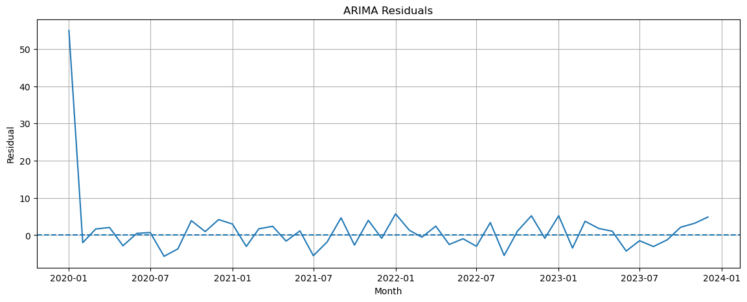
Figure 7: ARIMA residuals over time
In Figure 7 the residuals move randomly around zero for almost the whole period. The one tall spike at the very start (January 2020) is not a real error. It happens because the model has no earlier month to compare with at the beginning, so it can be ignored.
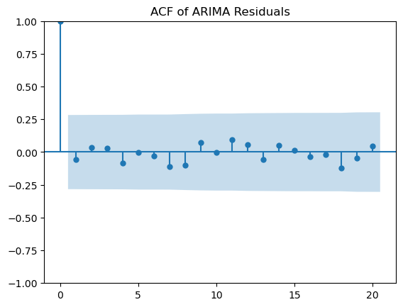
Figure 8: ACF of the ARIMA residuals
In Figure 8, apart from the first bar (which is always 1), all the bars are inside the blue zone. This means the residuals are not related to each other, so the model has picked up the patterns it could, and the diagnostic check is passed.
Answer to the Task 4 question: How does ARIMA compare with exponential smoothing?
ARIMA(3,1,3) (RMSE 2.93, MAPE 3.37%) is better than SES and Double smoothing (RMSE about 4.1 and 4.6), because it handles the trend through differencing and learns from past errors.
But it is not better than Triple smoothing / Holt-Winters (RMSE 1.97, MAPE 2.22%). A plain ARIMA has no seasonal part, so it cannot copy the yearly pattern. That is why we move on to SARIMA.

8. Task 5: Seasonal ARIMA (SARIMA)

Step 23: Look for seasonal patterns (Cell 34)
Before adding seasonality to the model, we first check that seasonality really exists. The notebook draws a box plot for each month (1 = January and 12 = December). Each box shows the range of sales for that month across the 5 years, and the line in the middle of the box is the median.
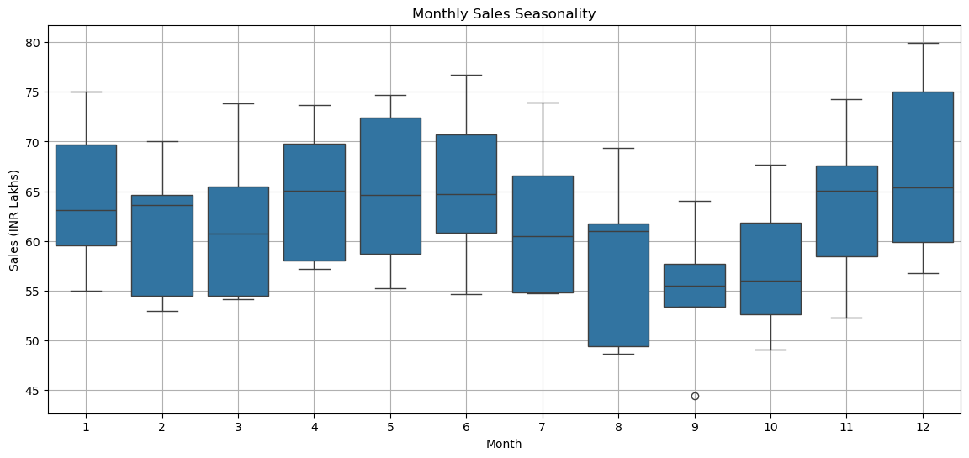
Figure 9: Box plot of sales by calendar month
In Figure 9 we can see that:
- December (12) has the highest sales, and November, and also April to June, are also high.
- August, September and October (8, 9, 10) have the lowest sales. September is the weakest month, and it even has one very low point (a dot below the box) which is an outlier from 2020.
So sales do follow a yearly pattern, which is what the case study expected (higher sales in November-December).

Step 24: Decompose the series (Cell 35)
Decomposition splits the series into its building blocks. The notebook uses the additive model with period = 12, which means: Sales = Trend + Seasonal + Residual.
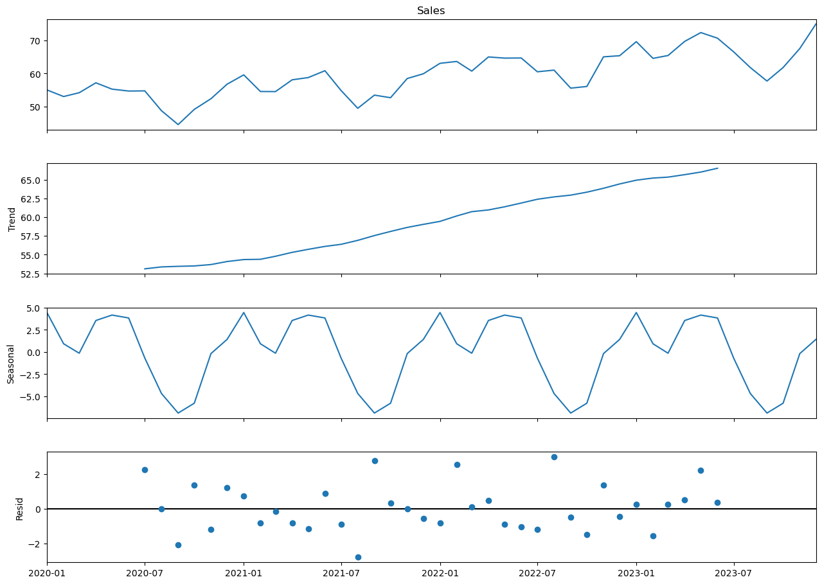
Figure 10: Time series decomposition (trend, seasonal and residual)
The four panels in Figure 10 from top to bottom:
- Sales: the original data.
- Trend: a smooth line that rises steadily from about 53 to about 66 lakhs, showing steady growth.
- Seasonal: a wave that repeats exactly every 12 months. It goes up to about +4.5 (peak months) and down to about -7 (weakest months, around August-September).
- Residual: small leftover dots scattered randomly around zero, which is the noise. There is no clear pattern left, so trend plus seasonality explains most of the data.

Step 25: Understand and tune SARIMA (Cell 36)
SARIMA = ARIMA + a seasonal part. It is written as SARIMA(p,d,q)(P,D,Q)[s]. The first bracket is the normal ARIMA part. The second bracket (capital letters) is the same idea applied to the seasonal cycle, and s = 12 tells the model that the pattern repeats every 12 months.
The notebook tunes the model with a grid search, which means trying all the combinations of the settings and keeping the best:
Setting | Values tried
p | 0, 1, 2
d | 0, 1
q | 0, 1, 2
P | 0, 1
D | 0, 1
Q | 0, 1

This gives 3 x 2 x 3 x 2 x 2 x 2 = 144 models. Each is fitted on the training data, then used to forecast 12 months and scored. The top 5 are:
p | d | q | P | D | Q | AIC | RMSE | MAPE (%)
2 | 1 | 0 | 1 | 0 | 0 | 178.67 | 1.338 | 1.394
2 | 0 | 1 | 1 | 0 | 0 | 178.82 | 1.378 | 1.523
2 | 0 | 2 | 0 | 1 | 1 | 103.33 | 1.425 | 1.770
1 | 0 | 2 | 0 | 1 | 1 | 101.57 | 1.438 | 1.805
2 | 0 | 1 | 1 | 1 | 1 | 107.80 | 1.452 | 1.750

Step 26: Validate the best SARIMA model (Cell 37 and 38)
The best model is SARIMA(2,1,0)(1,0,0)[12]. Its errors on the unseen 2024 data are RMSE 1.338, MAPE 1.39%. This is the lowest error so far, which means on average its forecast is wrong by only about 1.4%.
Why SARIMA works better
ARIMA(3,1,3) had an RMSE of 2.93. SARIMA cut this to 1.34, a more than 50% reduction in error, because SARIMA adds the seasonal pattern that ARIMA was missing.

9. Task 6: Holt-Winters Seasonal Method

Step 27: Additive and multiplicative versions (Cells 39 and 40)
Holt-Winters is the same triple exponential smoothing from Task 2. There are two ways to add seasonality:
Version | How the season works | Best when
Additive | The seasonal effect is a fixed amount added (e.g. +5 lakhs in December) | The size of the seasonal swings stays the same as sales grow
Multiplicative | The seasonal effect is a percentage (e.g. +8% in December) | The seasonal swings get bigger as sales grow

Both are fitted on the training data with a trend and a 12-month season, and forecast the 12 test months.
Method | MAE | RMSE | MAPE (%)
Holt-Winters Additive | 1.644 | 1.968 | 2.224
Holt-Winters Multiplicative | 1.738 | 1.970 | 2.383

The two are almost the same, and the additive one is slightly better. This tells us the seasonal swings in FreshMart's data are roughly a fixed size, and do not grow much with sales. (The additive Holt-Winters is the same model as the triple exponential smoothing in Task 2, which is why the numbers are the same.)

10. Comparing All the Models

Step 28: Final comparison table (Cell 41)
The notebook collects the MAE, RMSE and MAPE of every model into one table and sorts it from best to worst by RMSE. This is the main deliverable asked by the professor.
Rank | Model | MAE | RMSE | MAPE (%)
1 | SARIMA(2,1,0)(1,0,0)[12] | 1.012 | 1.338 | 1.394
2 | Triple Exp. / Holt-Winters | 1.644 | 1.968 | 2.224
3 | Holt-Winters Additive | 1.644 | 1.968 | 2.224
4 | Holt-Winters Multiplicative | 1.738 | 1.970 | 2.383
5 | ARIMA(3,1,3) | 2.434 | 2.928 | 3.374
6 | SES | 3.318 | 4.101 | 4.651
7 | Double Exponential | 4.011 | 4.605 | 5.572
8 | AR(1) | 5.134 | 6.417 | 6.862
9 | AR(3) | 7.053 | 8.587 | 9.453
10 | AR(2) | 7.257 | 8.787 | 9.738

Reading the table: the seasonal models (SARIMA and Holt-Winters) take the top spots, the models without seasonality (ARIMA, SES, Double) are in the middle, and the plain AR models are at the bottom. The lesson is that for data with a strong yearly pattern, the model must understand seasonality.

Step 29: Plot actual vs forecast (Cell 42)
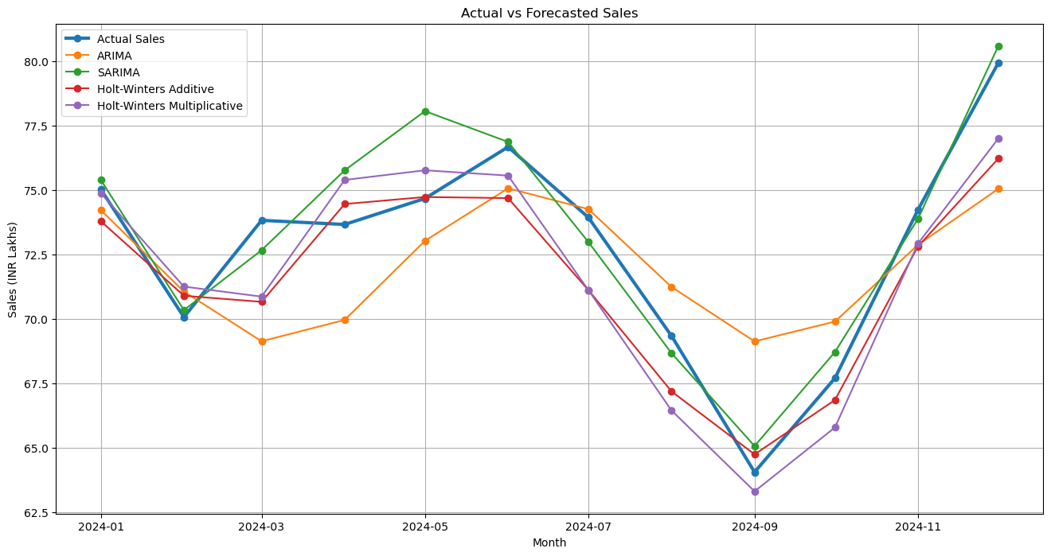
Figure 11: Actual 2024 sales vs ARIMA, SARIMA and Holt-Winters forecasts
In Figure 11 the thick blue line is the actual sales. The SARIMA (green) line sits very close to it for most months, and especially in the big rise at the end of the year. The Holt-Winters lines are also close. The ARIMA (orange) line is the furthest away in several months, for example it misses the low point in September, because it has no seasonal knowledge.

11. Forecasting the Next 12 Months (2025)

Step 30: Create future dates (Cell 43)
Now that we know which models work, we forecast the real future. The notebook first makes a list of the next 12 month dates, from January 2025 to December 2025.

Step 31: Refit on the full data and forecast (Cells 44 to 47)
This time the models are re-trained on all 60 months (not just 48), since for the real forecast we want the model to learn from every bit of available history. ARIMA, SARIMA, Holt-Winters Additive and Holt-Winters Multiplicative are each used to forecast 2025 with the settings found earlier.

Step 32: The forecast table (Cell 48)
The results are collected in one table (values in INR lakhs):
Month | ARIMA | SARIMA | HW Additive | HW Multiplicative
Jan 2025 | 79.48 | 79.79 | 80.30 | 81.79
Feb 2025 | 76.21 | 75.87 | 77.08 | 77.48
Mar 2025 | 73.28 | 78.97 | 77.72 | 78.35
Apr 2025 | 73.68 | 78.78 | 80.81 | 82.02
May 2025 | 76.93 | 79.74 | 81.30 | 82.69
Jun 2025 | 79.86 | 81.44 | 81.74 | 83.15
Jul 2025 | 79.53 | 79.05 | 78.40 | 78.80
Aug 2025 | 76.31 | 75.10 | 74.40 | 73.71
Sep 2025 | 73.37 | 70.52 | 71.45 | 69.58
Oct 2025 | 73.64 | 73.67 | 73.93 | 72.70
Nov 2025 | 76.83 | 79.33 | 80.07 | 80.44
Dec 2025 | 79.78 | 84.26 | 84.00 | 85.46

Step 33: Plot the future forecast (Cell 49)
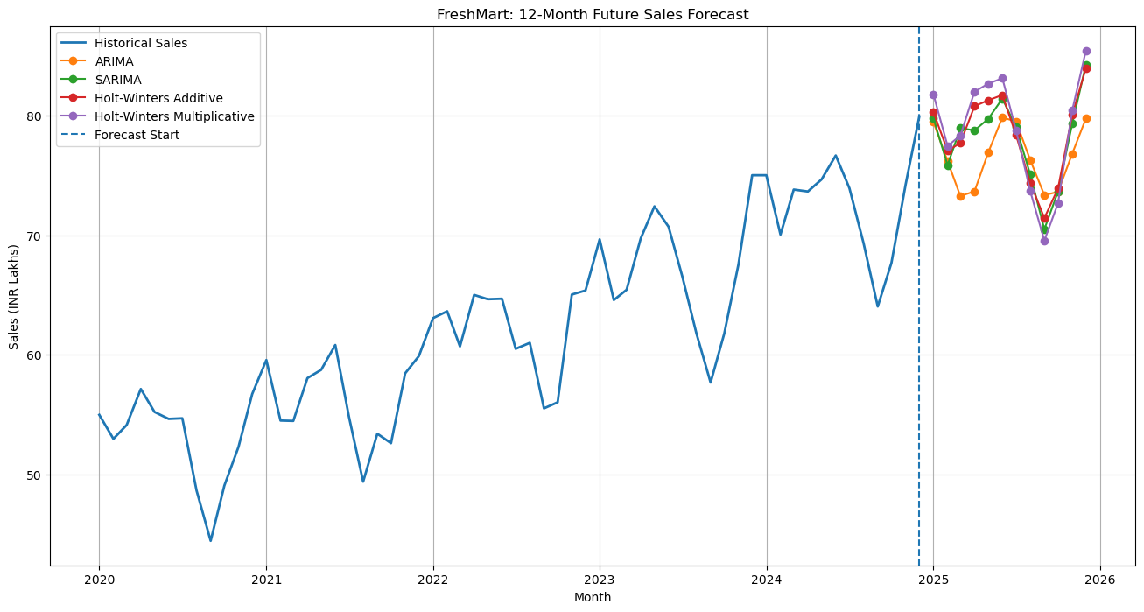
Figure 12: Historical sales and the 12-month forecast for 2025
In Figure 12 the dashed vertical line marks where the real data ends and the forecast begins. All models predict that sales will keep growing into 2025, and that the yearly pattern will continue: a dip around September and a peak in December.

Step 34: Save to Excel (Cells 50, 51)
Finally, the notebook saves the forecast table into FreshMart_12_Month_Forecast.xlsx and the model comparison into FreshMart_Model_Comparison.xlsx. These are the tabulated deliverables asked by the professor.

Step 35: Pick the winner (Cell 52)
The last code cell finds the model with the lowest RMSE and the lowest MAPE automatically. Both point to the same model: SARIMA(2,1,0)(1,0,0)[12].

12. Insights and Recommendations

12.1 Which model is most suitable for FreshMart?
Recommended model: SARIMA(2,1,0)(1,0,0)[12]
It has the lowest error on every measure (MAE 1.01, RMSE 1.34, MAPE 1.39%), which means it is typically within about 1.4% of the real sales.
It captures trend and yearly seasonality, which are the two most important features of FreshMart's data.
Holt-Winters Additive is a strong and simpler second choice (MAPE 2.22%), and it is a good backup for checking the SARIMA forecast.

12.2 How can the forecast help inventory planning?
- Stock up before the peaks: the forecast shows a peak in May-June and the highest sales in November-December (about 84 to 85 lakhs in December 2025). Order extra stock and arrange extra staff and transport in advance, to avoid stockouts.
- Reduce stock in the slow months: August to October are the weakest months (September 2025 is forecast at about 70 lakhs). Ordering less in these months reduces unsold stock, storage cost and wastage, which is especially important for groceries that expire.
- Plan orders with suppliers: a 12-month forecast lets the supply chain team agree quantities and prices with suppliers in advance.
- Plan the budget and cash flow: knowing the expected sales helps the company plan how much money it needs for purchasing each month.

12.3 How can the forecast help promotions?
- Run promotions in the slow months: offers and discounts in August to October can lift sales when demand is naturally low.
- Do not give big discounts in peak months: customers already buy a lot in November and December, so heavy discounts may reduce profit without adding much sales.
- Measure the effect of promotions: if actual sales are higher than the forecast in a promotion month, the difference shows how much the promotion helped.

12.4 Points to keep in mind
- Forecasts are estimates, not guarantees. Events such as festivals, price changes, a new competitor or economic shocks can change sales.
- The best model was chosen using the 2024 test data, so the true accuracy for 2025 may be a little worse than 1.4%.
- Only 5 years of data is a small sample for seasonal models. The model should be updated every few months as new sales data comes in, and its error should be tracked.
- The four models give slightly different values (for example, March 2025 is 73 by ARIMA but about 78 to 79 by the others). It is sensible to use SARIMA as the main forecast and to treat the other seasonal models as a range to compare against.

13. Overall Summary
Task | Method | Key finding
1 | Moving Average | 6-month MA gives the best balance; 12-month MA shows the clearest trend but over-smooths
2 | Exponential Smoothing | Triple smoothing (RMSE 1.97) is far better than SES (4.10) and Double (4.61) because it handles seasonality
3 | AR models | AR(1) is best (RMSE 6.42), which matches the PACF graph; more lags do not help
4 | ARIMA | Data needed d = 1; ARIMA(3,1,3) gives RMSE 2.93 and passes the residual check, but has no seasonality
5 | SARIMA | SARIMA(2,1,0)(1,0,0)[12] is the best model of all (RMSE 1.34, MAPE 1.39%)
6 | Holt-Winters | Additive (MAPE 2.22%) slightly beats multiplicative (2.38%); both are second to SARIMA

In one sentence: FreshMart's sales have a steady upward trend and a clear yearly pattern, so models that understand both trend and seasonality (especially SARIMA) forecast best, and their forecast can be used to plan stock and promotions through 2025.

