**Q1. Top 3 tools for coding**

Here are the top 3 AI tools for coding that developers frequently use:

1. GitHub Copilot

* Description: An AI-powered code completion tool that helps generate code, suggest improvements, and even write whole functions based on comments or partial code.
* Features:
  + Autocompletes code snippets.
  + Suggests functions and algorithms.
  + Supports multiple languages like Python, Java, JavaScript, and more.
* Best For: Speeding up development and generating boilerplate code.

2. ChatGPT (Code Interpreter and Developer Modes)

* Description: An AI chatbot that can generate, debug, and optimize code while providing in-depth explanations for programming concepts.
* Features:
  + Debugging assistance.
  + Code generation in various languages.
  + Explaining algorithms and complex concepts.
* Best For: Learning, debugging, and problem-solving across a range of programming languages.

3. Replit Ghostwriter

* Description: A code assistant integrated into the Replit IDE that helps with writing and understanding code.
* Features:
  + Provides intelligent code completion.
  + Can explain code snippets.
  + Suggests fixes and optimizations.
* Best For: Collaborative and cloud-based coding environments.

Here are the official websites for the mentioned AI coding tools:

1. **GitHub Copilot**  
   Website: <https://github.com/features/copilot>
2. **ChatGPT (OpenAI)**  
   Website: <https://openai.com/chatgpt>
3. **Replit Ghostwriter**  
   Website: <https://replit.com/site/ghostwriter>

**Q2. Create simple website using google and explore 5 features**

<https://sites.google.com/d/1nTAb08v_szzqJIfiPHNDYafgV09ijgXv/p/1G3V8fibO__gWe82awGGPmRNhhQAxxsUC/edit>



**Q3 Mobile app using 3 AI tools**

* + 1. https://www.appypie.com/ai-app-generator

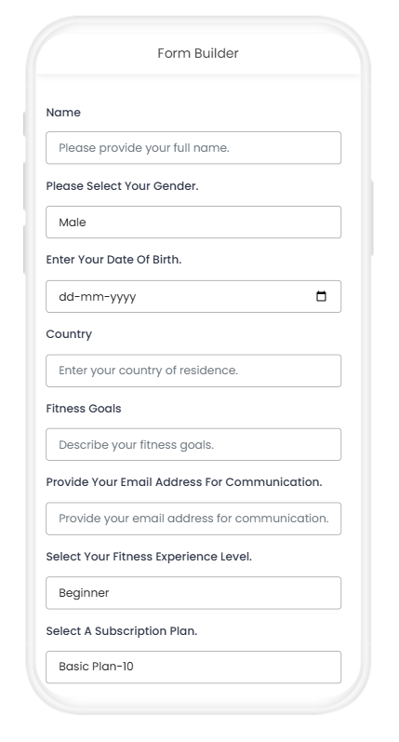

* + 1. <https://go.glideapps.com/?signIn>
  + I made restaurant app named eatease
  + 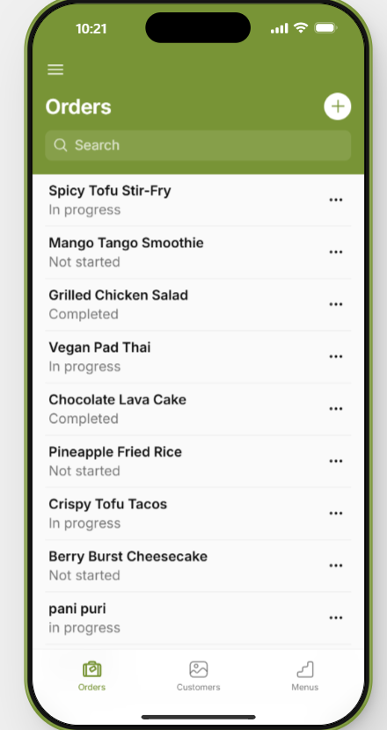

3) <https://previewer.adalo.com/5c8dc8e3-4957-4aa9-9fe1-9e7e7d8604de?target=atztd3wh9q45fswq5dlhxlutp&params=%7B%7D>

I made ecommerce app

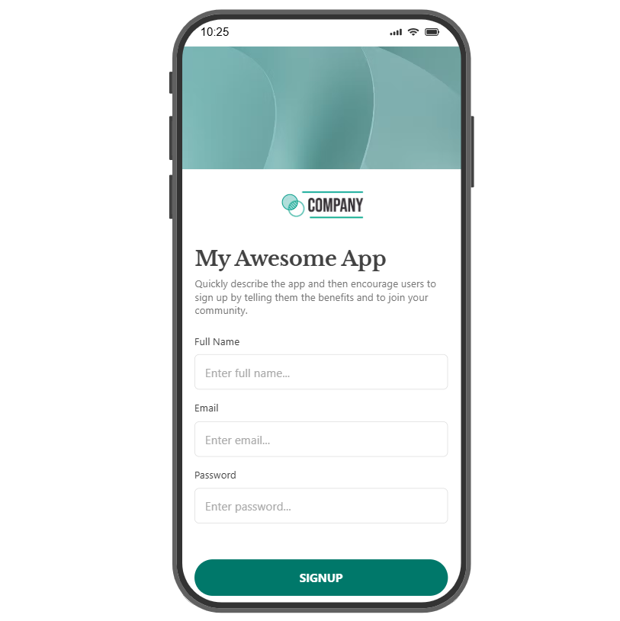s