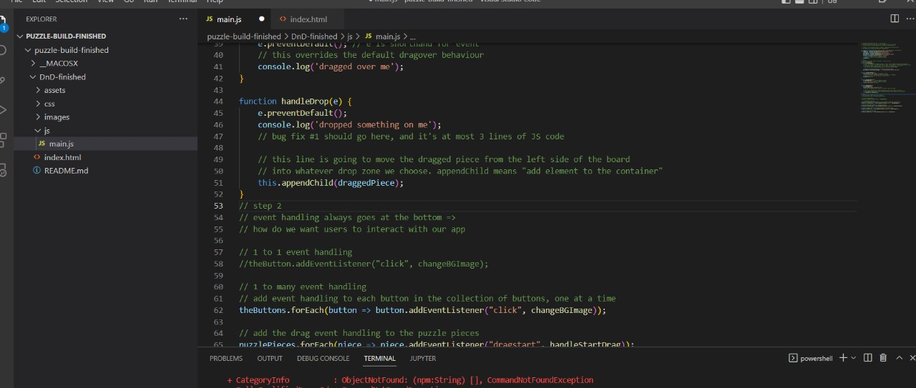
Bugs and their fix updated code.

Previous Code

Updated code after bug fix.

function handleDrop(e) {
e.preventDefault();
console.log('dropped something on me');

// Check if the drop zone already has a child (puzzle piece)
if (this.children.length === 0) {
// It's empty, so append the dragged piece
this.appendChild(draggedPiece);
} else {
// It's not empty, so you can choose to not append or swap the piece
// For example, to replace the piece, you would do:
// this.replaceChild(draggedPiece, this.children[0]);
}
}

Error
Drop issue error:Puzzle picture was overlapping the other picture,Now its fixed with the updated code.

Bug 2:

Previous Code

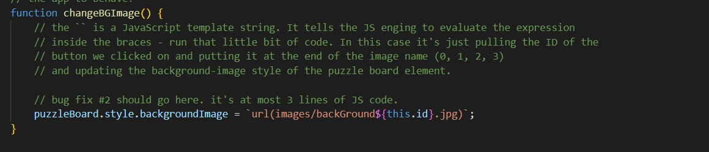

Code after bug fixing:

function changeBGImage() {
// Bug fix #2: Ensure puzzle pieces reset properly when changing the background image.
puzzleBoard.style.backgroundImage = url(images/backGround${this.id}.jpg);
// Clear out the drop zones when changing puzzles
dropZones.forEach(zone => { while (zone.firstChild) { zone.removeChild(zone.firstChild); } });
// Reset puzzle pieces to their original position by appending them back to the .puzzle-pieces container
puzzlePieces.forEach(piece => { puzzlePiecesContainer.appendChild(piece); });
}

Error

Drop back issue with image.

Images were not getting back to its original place when we were changing the background wallpapers.

Bug 3

Code after bug fixing

function handleDrop(e) {
e.preventDefault();
console.log('dropped something on me');
// Bug Fix #1: Prevent dragging puzzle pieces over each other
// Bug Fix #3: Swapping puzzle pieces if drop zone already contains a piece
// Check if the drop zone already contains a puzzle piece
if (this.children.length !== 0 && this.children[0] !== draggedPiece) {
// Store the piece currently in the drop zone
let pieceInDropZone = this.children[0];

// Get the parent of the dragged piece
let draggedPieceParent = draggedPiece.parentNode;

// Move the piece in the drop zone to the original parent of the dragged piece
draggedPieceParent.appendChild(pieceInDropZone); // Move the piece in the drop zone back to its original parent

// Move the dragged piece to the drop zone
this.appendChild(draggedPiece); // Move the dragged piece to the drop zone
} else if (this.children.length === 0) {
// If the drop zone is empty, just append the dragged piece
this.appendChild(draggedPiece);
}
}

Error
Swapping was not possible in the board.
Swapping was not available in the puzzle board,So we added code for swapping and now we can swap the picture in the board.

Bug 4

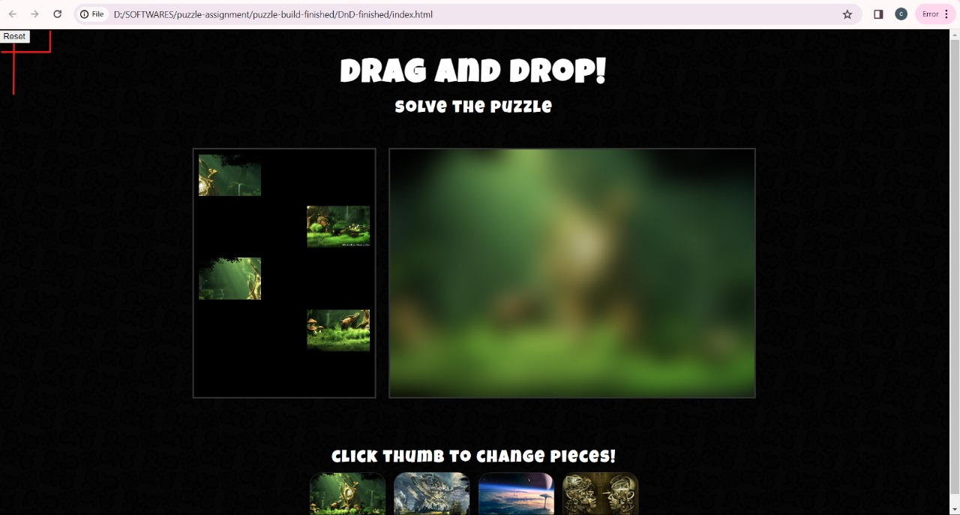

Code for the reset button

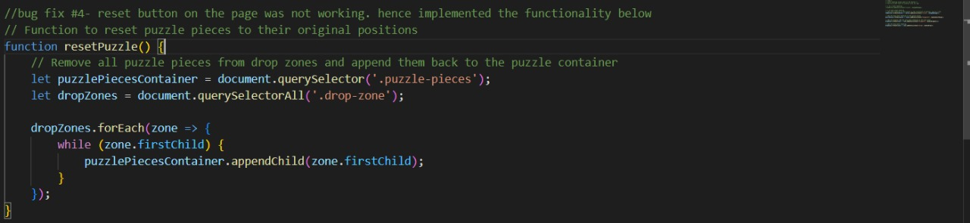

Reset button
Reset button was already present but it was non functional,So we added this code or its functionality now the reset button is working.
After pressing the reset button all the pieces will move to board to its original position.

