**Deen Dayal Upadhyaya College**

**University of Delhi**



**COMPUTER GRAPHICS PRACTICALS**

Index

1. DDA and Bresenham’s Line Drawing Algorithm Page 3-5

2. Mid-Point Circle Drawing Algorithm Page 6-7

3. Cohen and Sutherland Line Clipping Algorithm Page 8-10

4. Sutherland Hodgeman Polygon Clipping Algorithm Page 11-12

5. Scan Line Fill Algorithm for Polygon Filling Page 13-14

6. 2D Object Transformations using Homogeneous Coordinates Page 15-17

7. 3D Object Transformations with Parallel and Perspective Projection Page 18-21

8. Hermite / Bezier Curve Drawing Page 22-24Q1. Write a program to implement DDA and Bresenham’s line drawing algorithm.

**Code:**

**import matplotlib.pyplot as plt**

**def draw_line_DDA(x1, y1, x2, y2):**

**dx = x2 - x1**

**dy = y2 - y1**

**steps = max(abs(dx), abs(dy))**

**x_increment = dx / steps**

**y_increment = dy / steps**

**x = x1**

**y = y1**

**plt.plot(x, y, 'ro')**

**print("Intermediate points using DDA:")**

**for _ in range(steps):**

**x += x_increment**

**y += y_increment**

**plt.plot(round(x), round(y), 'ro')**

**print(f"({round(x)}, {round(y)})")**

**plt.plot([x1, x2], [y1, y2], 'b')**

**def draw_line_Bresenham(x1, y1, x2, y2):**

**dx = abs(x2 - x1)**

**dy = abs(y2 - y1)**

**p = 2 * dy - dx**

**x = x1**

**y = y1**

**plt.plot(x, y, 'ro')**

**print("Intermediate points using Bresenham:")**

**if x1 < x2:**

**x_increment = 1**

**else:**

**x_increment = -1**

**if y1 < y2:**

**y_increment = 1**

**else:**

**y_increment = -1**

**while x != x2:**

**x += x_increment**

**if p < 0:**

**p += 2 * dy**

**else:**

**y += y_increment**

**p += 2 * (dy - dx)**

**plt.plot(x, y, 'ro')**

**print(f"({x}, {y})")**

**plt.plot([x1, x2], [y1, y2], 'g')**

**# Test the functions**

**x1, y1 = 9, 18**

**x2, y2 = 14, 22**

**plt.figure(figsize=(8, 6))**

**# Plotting using DDA**

**plt.subplot(1, 2, 1)**

**plt.title('DDA Algorithm')**

**draw_line_DDA(x1, y1, x2, y2)**

**plt.grid(True)**

**plt.axis('equal')**

**# Plotting using Bresenham's**

**plt.subplot(1, 2, 2)**

**plt.title('Bresenham Algorithm')**

**draw_line_Bresenham(x1, y1, x2, y2)**

**plt.grid(True)**

**plt.axis('equal')**

**plt.show()**

**Output:**

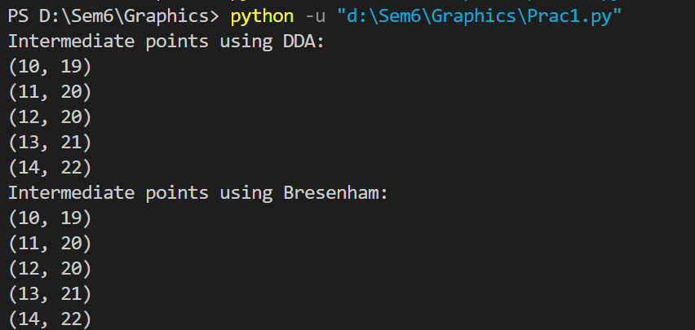

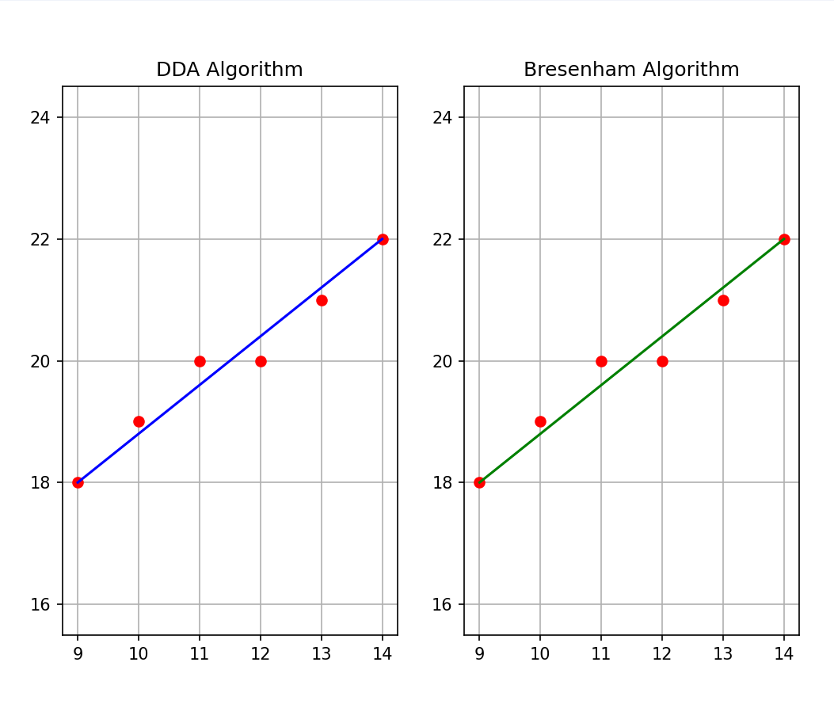

Q2. Write a program to implement mid-point circle drawing algorithm.

**Code:**

**import matplotlib.pyplot as plt**

**def draw_circle_midpoint(radius):**

**x = 0**

**y = radius**

**p = 1 - radius # Initial decision parameter**

**points = set()**

**draw_circle_points(x, y, points)**

**print("Intermediate points:")**

**while x < y:**

**x += 1**

**if p < 0:**

**p += 2 * x + 1**

**else:**

**y -= 1**

**p += 2 * (x - y) + 1**

**draw_circle_points(x, y, points)**

**print(f"({x}, {y}), ({-x}, {y}), ({x}, {-y}), ({-x}, {-y}), ({y}, {x}), ({-y}, {x}), ({y}, {-x}), ({-y}, {-x})")**

**plot_points(points)**

**def draw_circle_points(x, y, points):**

**points.add((x, y))**

**points.add((-x, y))**

**points.add((x, -y))**

**points.add((-x, -y))**

**points.add((y, x))**

**points.add((-y, x))**

**points.add((y, -x))**

**points.add((-y, -x))**

**def plot_points(points):**

**x_values = [point[0] for point in points]**

**y_values = [point[1] for point in points]**

**plt.plot(x_values, y_values, 'ro')**

**plt.grid(True)**

**plt.axis('equal')**

**plt.title('Mid-Point Circle Drawing Algorithm')**

**plt.show()**

**# function**

**radius = 10**

**draw_circle_midpoint(radius)**

**Output:**

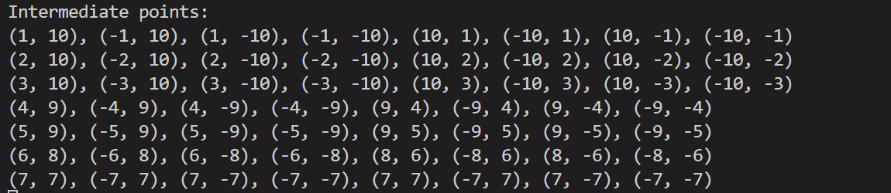

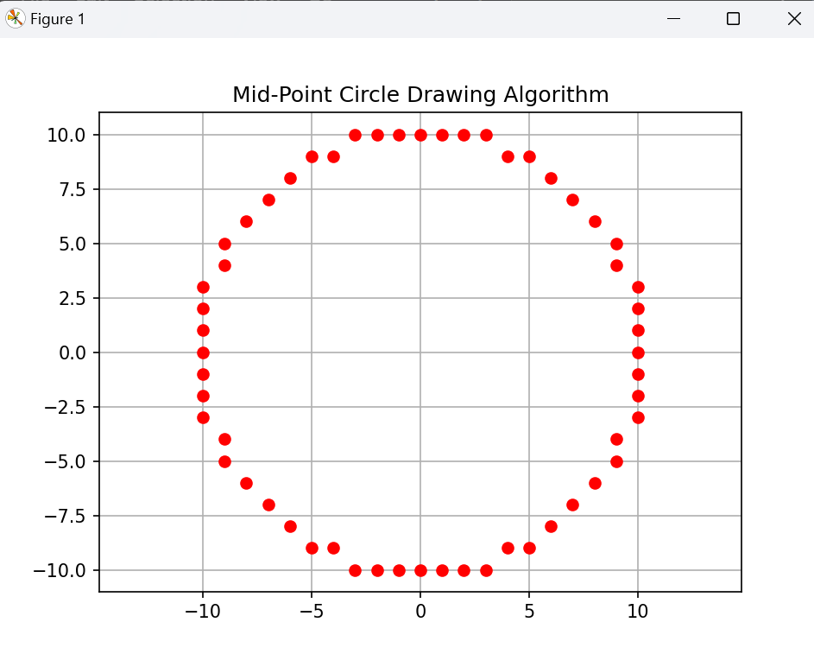

Q3) Write a program to clip a line using Cohen and Sutherland line clipping algorithm.

**Code:**

**import matplotlib.pyplot as plt**

**INSIDE = 0 # 0000**

**LEFT = 1 # 0001**

**RIGHT = 2 # 0010**

**BOTTOM = 4 # 0100**

**TOP = 8 # 1000**

**def computeCode(x, y):**

**code = INSIDE**

**if x < x_min: # left of rectangle**

**code |= LEFT**

**elif x > x_max: # right of rectangle**

**code |= RIGHT**

**if y < y_min: # below**

**code |= BOTTOM**

**elif y > y_max: # above**

**code |= TOP**

**return code**

**def cohenSutherlandClip(x1, y1, x2, y2):**

**code1 = computeCode(x1, y1)**

**code2 = computeCode(x2, y2)**

**accept = False**

**while True:**

**if code1 == 0 and code2 == 0:**

**accept = True**

**break**

**elif (code1 & code2) != 0:**

**break**

**else:**

**x = 1.0**

**y = 1.0**

**if code1 != 0:**

**code_out = code1**

**else:**

**code_out = code2**

**if code_out & TOP:**

**x = x1 + (x2 - x1) * (y_max - y1) / (y2 - y1)**

**y = y_max**

**elif code_out & BOTTOM:**

**x = x1 + (x2 - x1) * (y_min - y1) / (y2 - y1)**

**y = y_min**

**elif code_out & RIGHT:**

**y = y1 + (y2 - y1) * (x_max - x1) / (x2 - x1)**

**x = x_max**

**elif code_out & LEFT:**

**y = y1 + (y2 - y1) * (x_min - x1) / (x2 - x1)**

**x = x_min**

**if code_out == code1:**

**x1 = x**

**y1 = y**

**code1 = computeCode(x1, y1)**

**else:**

**x2 = x**

**y2 = y**

**code2 = computeCode(x2, y2)**

**if accept:**

**print(f"Line accepted from {x1:.2f}, {y1:.2f} to {x2:.2f}, {y2:.2f}")**

**plt.plot([x1, x2], [y1, y2], color='black', linewidth=2) # Plot the accepted line**

**else:**

**print("Line rejected")**

**x_max = 10.0**

**y_max = 8.0**

**x_min = 4.0**

**y_min = 4.0**

**# Plot the clipping window**

**plt.plot([x_min, x_max, x_max, x_min, x_min], [y_min, y_min, y_max, y_max, y_min], color='blue', linewidth=2)**

**# Test lines**

**cohenSutherlandClip(3, 5, 5, 7)**

**plt.plot([3, 5], [5, 7], color='green', linewidth=1)**

**cohenSutherlandClip(8, 2, 8, 6)**

**plt.plot([8, 8], [2, 6], color='green', linewidth=1)**

**cohenSutherlandClip(1, 5, 4, 1)**

**plt.plot([1, 5], [4, 1], color='green', linewidth=1)**

**# Set plot limits and aspect ratio**

**plt.xlim(0, 12)**

**plt.ylim(0, 10)**

**plt.gca().set_aspect('equal', adjustable='box')**

**plt.show()**

**Output:**

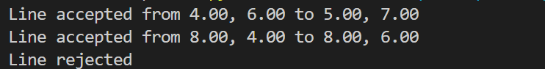

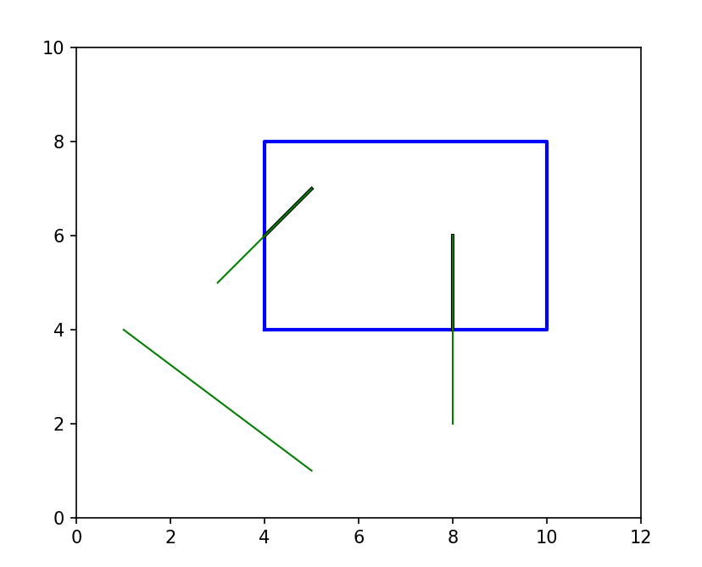

Q4. Write a program to clip a polygon using Sutherland Hodgeman algorithm.

**Code:**

**def clip(subjectPolygon, clipPolygon):**

**def inside(p):**

**return(cp2[0]-cp1[0])* (p[1]-cp1[1]) > (cp2[1]-cp1[1]) * (p[0]-cp1[0])**

**def computeIntersection():**

**dc = [ cp1[0] - cp2[0], cp1[1] - cp2[1] ]**

**dp = [ s[0] - e[0], s[1] - e[1] ]**

**n1 = cp1[0] * cp2[1] - cp1[1] * cp2[0]**

**n2 = s[0] * e[1] - s[1] * e[0]**

**n3 = 1.0 / (dc[0] * dp[1] - dc[1] * dp[0])**

**return [(n1*dp[0] - n2*dc[0]) * n3, (n1*dp[1] - n2*dc[1]) * n3]**

**outputList = subjectPolygon**

**cp1 = clipPolygon[-1]**

**for clipVertex in clipPolygon:**

**cp2 = clipVertex**

**inputList = outputList**

**outputList = []**

**s = inputList[-1]**

**for subjectVertex in inputList:**

**e = subjectVertex**

**if inside(e):**

**if not inside(s):**

**outputList.append(computeIntersection())**

**outputList.append(e)**

**elif inside(s):**

**outputList.append(computeIntersection())**

**s = e**

**cp1 = cp2**

**return(outputList)**

**# Example usage:**

**subjectPolygon = [(50, 50), (200, 50), (200, 150), (50, 150)]**

**clipPolygon = [(100, 100), (300, 100), (300, 250), (100, 250)]**

**clippedPolygon = clip(subjectPolygon, clipPolygon)**

**# Plotting**

**import matplotlib.pyplot as plt**

**subject_x = [point[0] for point in subjectPolygon]**

**subject_y = [point[1] for point in subjectPolygon]**

**clip_x = [point[0] for point in clipPolygon]**

**clip_y = [point[1] for point in clipPolygon]**

**clipped_x = [point[0] for point in clippedPolygon]**

**clipped_y = [point[1] for point in clippedPolygon]**

**plt.plot(subject_x + [subject_x[0]], subject_y + [subject_y[0]], 'r-', label='Subject Polygon')**

**plt.plot(clip_x + [clip_x[0]], clip_y + [clip_y[0]], 'b-', label='Clip Polygon')**

**plt.plot(clipped_x + [clipped_x[0]], clipped_y + [clipped_y[0]], 'g-', label='Clipped Polygon')**

**plt.fill(clipped_x, clipped_y, color='green', alpha=0.5) # Fill the clipped polygon**

**plt.legend()**

**plt.xlabel('X')**

**plt.ylabel('Y')**

**plt.title('Sutherland-Hodgman Polygon Clipping')**

**plt.axis('equal')**

**plt.grid(True)**

**plt.show()**

**Output:**

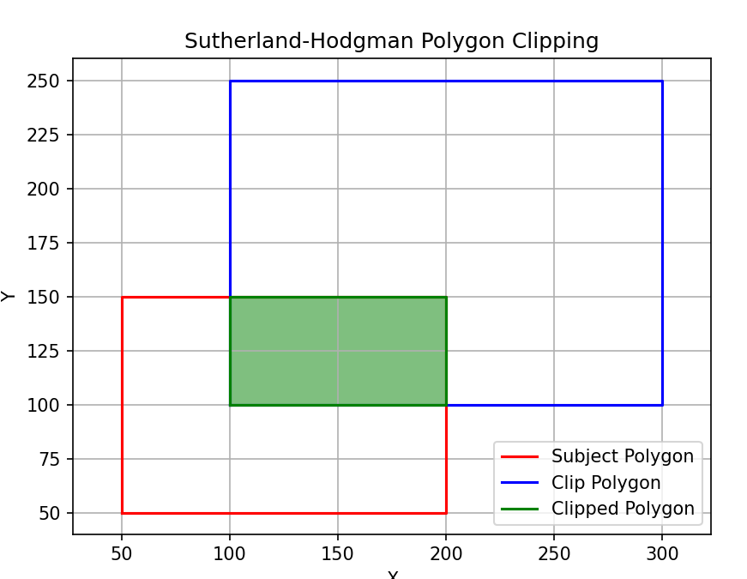

Q5. Write a program to fill a polygon using Scan line fill algorithm.

**Code:**

**import matplotlib.pyplot as plt**

**import numpy as np**

**def edge_table(vertices):**

**edges = []**

**ymin = min(vertices, key=lambda x: x[1])[1]**

**ymax = max(vertices, key=lambda x: x[1])[1]**

**for i in range(len(vertices)):**

**x1, y1 = vertices[i]**

**x2, y2 = vertices[(i + 1) % len(vertices)]**

**if y1 != y2:**

**if y1 < y2:**

**edges.append((x1, y1, x2, y2))**

**else:**

**edges.append((x2, y2, x1, y1))**

**return edges, ymin, ymax**

**def intersect_x(edge, y):**

**x1, y1, x2, y2 = edge**

**if y1 == y2:**

**return x1**

**return x1 + (y - y1) * (x2 - x1) / (y2 - y1)**

**def fill_polygon(vertices):**

**edges, ymin, ymax = edge_table(vertices)**

**active_edges = []**

**scanline_points = {}**

**for y in range(ymin, ymax + 1):**

**for edge in edges:**

**x1, y1, x2, y2 = edge**

**if y1 <= y < y2 or y2 <= y < y1:**

**x_int = intersect_x(edge, y)**

**if y not in scanline_points:**

**scanline_points[y] = []**

**scanline_points[y].append(x_int)**

**if y in scanline_points:**

**active_edges.extend(scanline_points[y])**

**active_edges.sort()**

**for i in range(0, len(active_edges), 2):**

**x1 = int(active_edges[i])**

**x2 = int(active_edges[i + 1])**

**plt.plot(range(x1, x2+1), [y] * (x2 - x1 + 1), color='r')**

**active_edges = [x for x in active_edges if x not in scanline_points[y]]**

**# Example**

**vertices = [(50, 50), (100, 100), (150, 50), (100, 25),(50,50)]**

**plt.figure()**

**plt.gca().set_aspect('equal', adjustable='box')**

**plt.plot(*zip(*vertices), marker='o', color='b')**

**fill_polygon(vertices)**

**plt.show()**

**Output:**

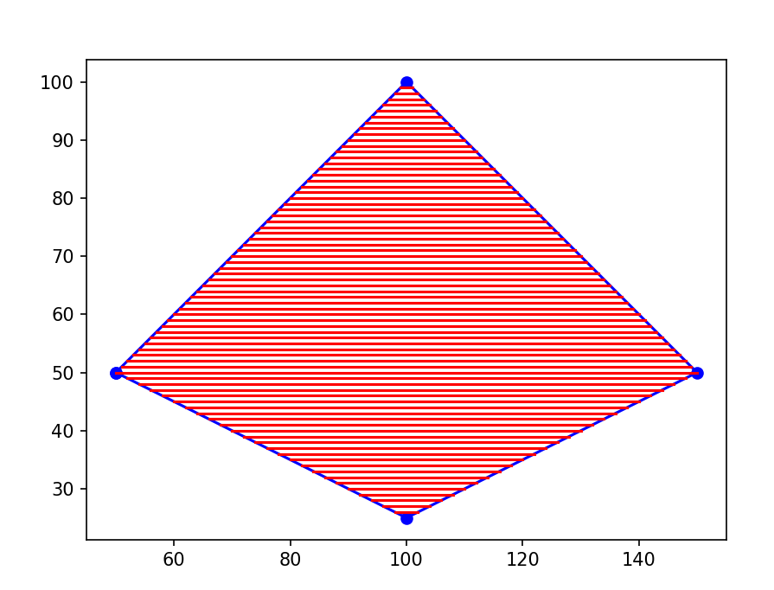

Q6. Write a program to apply various 2D transformations on a 2D object (use homogenous Coordinates).

**Code:**

**import numpy as np**

**import matplotlib.pyplot as plt**

**def translate(tx, ty):**

**return np.array([**

**[1, 0, tx],**

**[0, 1, ty],**

**[0, 0, 1]**

**])**

**def rotate(theta):**

**cos_theta = np.cos(theta)**

**sin_theta = np.sin(theta)**

**return np.array([**

**[cos_theta, -sin_theta, 0],**

**[sin_theta, cos_theta, 0],**

**[0, 0, 1]**

**])**

**def scale(sx, sy):**

**return np.array([**

**[sx, 0, 0],**

**[0, sy, 0],**

**[0, 0, 1]**

**])**

**def shear(kx, ky):**

**return np.array([**

**[1, kx, 0],**

**[ky, 1, 0],**

**[0, 0, 1]**

**])**

**# Define a square**

**square = np.array([**

**[0, 0, 1],**

**[1, 0, 1],**

**[1, 1, 1],**

**[0, 1, 1],**

**[0, 0, 1]**

**])**

**# Apply transformations**

**translation_matrix = translate(2, 2)**

**rotation_matrix = rotate(np.pi/4) # 45 degrees**

**scaling_matrix = scale(1.5, 1)**

**shearing_matrix = shear(0.5, 0)**

**translated_square = np.dot(square, translation_matrix.T)**

**rotated_square = np.dot(square, rotation_matrix.T)**

**scaled_square = np.dot(square, scaling_matrix.T)**

**sheared_square = np.dot(square, shearing_matrix.T)**

**# Get the maximum and minimum values of x and y coordinates**

**x_min = min(np.min(square[:, 0]), np.min(translated_square[:, 0]), np.min(rotated_square[:, 0]), np.min(scaled_square[:, 0]), np.min(sheared_square[:, 0]))**

**x_max = max(np.max(square[:, 0]), np.max(translated_square[:, 0]), np.max(rotated_square[:, 0]), np.max(scaled_square[:, 0]), np.max(sheared_square[:, 0]))**

**y_min = min(np.min(square[:, 1]), np.min(translated_square[:, 1]), np.min(rotated_square[:, 1]), np.min(scaled_square[:, 1]), np.min(sheared_square[:, 1]))**

**y_max = max(np.max(square[:, 1]), np.max(translated_square[:, 1]), np.max(rotated_square[:, 1]), np.max(scaled_square[:, 1]), np.max(sheared_square[:, 1]))**

**# Plot original and transformed squares**

**plt.figure(figsize=(12, 6))**

**plt.subplot(1, 5, 1)**

**plt.plot(square[:, 0], square[:, 1], '-o')**

**plt.xlim(x_min, x_max)**

**plt.ylim(y_min, y_max)**

**plt.title('Original Square')**

**plt.subplot(1, 5, 2)**

**plt.plot(translated_square[:, 0], translated_square[:, 1], '-o')**

**plt.xlim(x_min, x_max)**

**plt.ylim(y_min, y_max)**

**plt.title('Translated Square')**

**plt.subplot(1, 5, 3)**

**plt.plot(rotated_square[:, 0], rotated_square[:, 1], '-o')**

**plt.xlim(x_min, x_max)**

**plt.ylim(y_min, y_max)**

**plt.title('Rotated Square')**

**plt.subplot(1, 5, 4)**

**plt.plot(scaled_square[:, 0], scaled_square[:, 1], '-o')**

**plt.xlim(x_min, x_max)**

**plt.ylim(y_min, y_max)**

**plt.title('Scaled Square')**

**plt.subplot(1, 5, 5)**

**plt.plot(sheared_square[:, 0], sheared_square[:, 1], '-o')**

**plt.xlim(x_min, x_max)**

**plt.ylim(y_min, y_max)**

**plt.title('Sheared Square')**

**plt.tight_layout()**

**plt.show()**

**Ouput:**

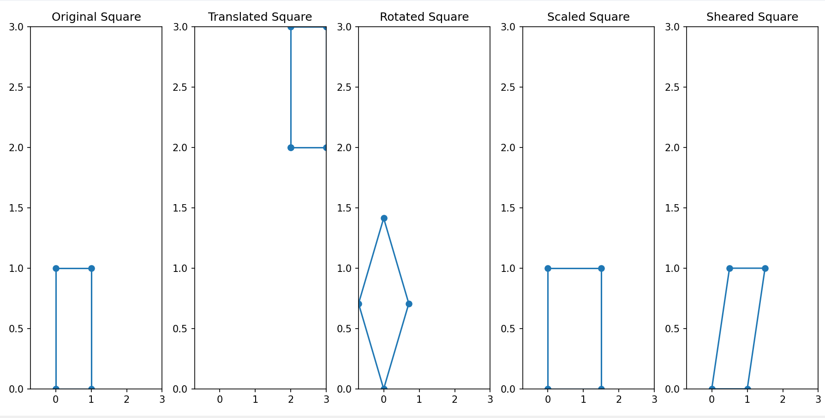

Q7. Write a program to apply various 3D transformations on a 3D object and then apply parallel and perspective projection on it.

**Code:**

**import numpy as np**

**import matplotlib.pyplot as plt**

**from mpl_toolkits.mplot3d import Axes3D**

**# Define a cube**

**cube_vertices = np.array([**

**[0, 0, 0, 1],**

**[1, 0, 0, 1],**

**[1, 1, 0, 1],**

**[0, 1, 0, 1],**

**[0, 0, 1, 1],**

**[1, 0, 1, 1],**

**[1, 1, 1, 1],**

**[0, 1, 1, 1]**

**])**

**# Define edges to connect vertices of the cube**

**cube_edges = [**

**(0, 1), (1, 2), (2, 3), (3, 0), # Bottom face**

**(4, 5), (5, 6), (6, 7), (7, 4), # Top face**

**(0, 4), (1, 5), (2, 6), (3, 7) # Connecting edges**

**]**

**# Function to plot the cube**

**def plot_cube(vertices, edges, ax):**

**for edge in edges:**

**start = vertices[edge[0]]**

**end = vertices[edge[1]]**

**ax.plot3D([start[0], end[0]], [start[1], end[1]], [start[2], end[2]], color='blue')**

**# Function to apply transformations (translation, rotation, scaling)**

**def transform(vertices, transformation_matrix):**

**transformed_vertices = np.dot(vertices, transformation_matrix.T)**

**return transformed_vertices**

**# Apply transformations**

**translation_matrix = np.array([[1, 0, 0, 1],**

**[0, 1, 0, 1],**

**[0, 0, 1, 1],**

**[0, 0, 0, 1]])**

**rotation_matrix_x = np.array([[1, 0, 0, 0],**

**[0, np.cos(np.pi/4), -np.sin(np.pi/4), 0],**

**[0, np.sin(np.pi/4), np.cos(np.pi/4), 0],**

**[0, 0, 0, 1]])**

**rotation_matrix_y = np.array([[np.cos(np.pi/4), 0, np.sin(np.pi/4), 0],**

**[0, 1, 0, 0],**

**[-np.sin(np.pi/4), 0, np.cos(np.pi/4), 0],**

**[0, 0, 0, 1]])**

**rotation_matrix_z = np.array([[np.cos(np.pi/4), -np.sin(np.pi/4), 0, 0],**

**[np.sin(np.pi/4), np.cos(np.pi/4), 0, 0],**

**[0, 0, 1, 0],**

**[0, 0, 0, 1]])**

**scaling_matrix = np.array([[2, 0, 0, 0],**

**[0, 1.5, 0, 0],**

**[0, 0, 0.5, 0],**

**[0, 0, 0, 1]])**

**parallel_projection_matrix = np.array([**

**[1, 0, 0, 0],**

**[0, 1, 0, 0],**

**[0, 0, 0, 0],**

**[0, 0, 0, 1]**

**])**

**perspective_projection_matrix = np.array([**

**[1, 0, 0, 0],**

**[0, 1, 0, 0],**

**[0, 0, 0, -0.001],**

**[0, 0, 0, 1]**

**])**

**translated_cube = transform(cube_vertices, translation_matrix)**

**rotated_x_cube = transform(cube_vertices, rotation_matrix_x)**

**rotated_y_cube = transform(cube_vertices, rotation_matrix_y)**

**rotated_z_cube = transform(cube_vertices, rotation_matrix_z)**

**scaled_cube = transform(cube_vertices, scaling_matrix)**

**parallel_cube = transform(cube_vertices, parallel_projection_matrix)**

**perspective_cube = transform(cube_vertices, perspective_projection_matrix)**

**# Visualize the cube after transformations**

**fig = plt.figure(figsize=(10, 8))**

**ax1 = fig.add_subplot(231, projection='3d')**

**plot_cube(cube_vertices, cube_edges, ax1)**

**ax1.set_title('original cube')**

**ax2 = fig.add_subplot(232, projection='3d')**

**plot_cube(translated_cube, cube_edges, ax2)**

**ax2.set_title('Translated Cube')**

**ax3 = fig.add_subplot(233, projection='3d')**

**plot_cube(rotated_x_cube, cube_edges, ax3)**

**ax3.set_title('Rotated 45° around X-axis')**

**ax4 = fig.add_subplot(234, projection='3d')**

**plot_cube(rotated_y_cube, cube_edges, ax4)**

**ax4.set_title('Rotated 45° around Y-axis')**

**ax5 = fig.add_subplot(235, projection='3d')**

**plot_cube(rotated_z_cube, cube_edges, ax5)**

**ax5.set_title('Rotated 45° around Z-axis')**

**ax6 = fig.add_subplot(236, projection='3d')**

**plot_cube(scaled_cube, cube_edges, ax6)**

**ax6.set_title('Scaled Cube')**

**plt.show()**

**fig = plt.figure(figsize=(10, 8))**

**ax1 = fig.add_subplot(131, projection='3d')**

**plot_cube(cube_vertices, cube_edges, ax1)**

**ax1.set_title('original cube')**

**ax2 = fig.add_subplot(132, projection='3d')**

**plot_cube(parallel_cube, cube_edges, ax2)**

**ax2.set_title('parallel projection')**

**ax3 = fig.add_subplot(133, projection='3d')**

**plot_cube(perspective_cube, cube_edges, ax3)**

**ax3.set_title('perspective projection')**

**plt.tight_layout()**

**plt.show()**

**Output:**

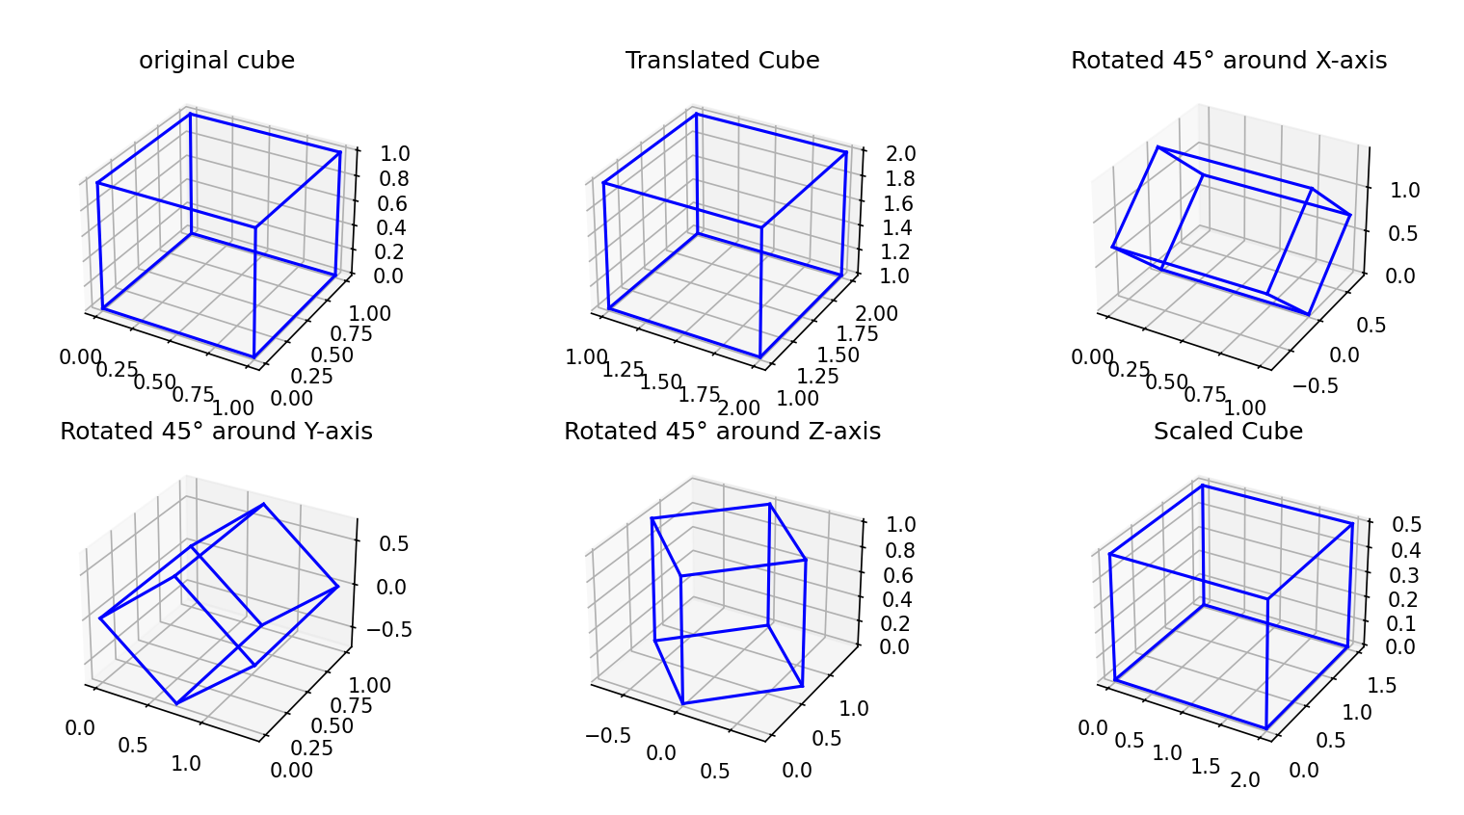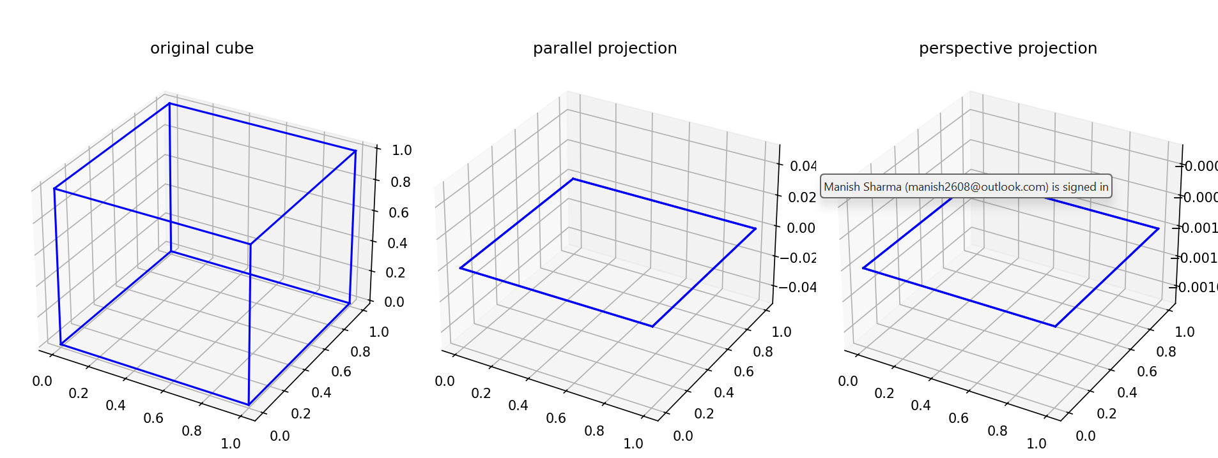

Q8.Write a program to draw Hermite /Bezier curve.

**Code:**

**import numpy as np**

**import matplotlib.pyplot as plt**

**# Hermite curve function**

**def hermite_curve(P0, P1, T0, T1, num_points=100):**

**t = np.linspace(0, 1, num_points)**

**H = np.zeros((num_points, 2))**

**for i in range(num_points):**

**H[i] = (2*t[i]**3 - 3*t[i]**2 + 1) * P0 + \**

**(-2*t[i]**3 + 3*t[i]**2) * P1 + \**

**(t[i]**3 - 2*t[i]**2 + t[i]) * T0 + \**

**(t[i]**3 - t[i]**2) * T1**

**return H**

**# Bezier curve function**

**def bezier_curve(P0, P1, P2, P3, num_points=100):**

**t = np.linspace(0, 1, num_points)**

**B = np.zeros((num_points, 2))**

**for i in range(num_points):**

**B[i] = (1-t[i])**3 * P0 + \**

**3*t[i]*(1-t[i])**2 * P1 + \**

**3*t[i]**2*(1-t[i]) * P2 + \**

**t[i]**3 * P3**

**return B**

**# Control points for Hermite curve**

**P0_hermite = np.array([1, 1])**

**P1_hermite = np.array([3, 3])**

**T0_hermite = np.array([2, 0])**

**T1_hermite = np.array([0, 2])**

**# Control points for Bezier curve**

**P0_bezier = np.array([1, 1])**

**P1_bezier = np.array([2, 3])**

**P2_bezier = np.array([4, 2])**

**P3_bezier = np.array([5, 5])**

**# Calculate Hermite curve points**

**H = hermite_curve(P0_hermite, P1_hermite, T0_hermite, T1_hermite)**

**# Calculate Bezier curve points**

**B = bezier_curve(P0_bezier, P1_bezier, P2_bezier, P3_bezier)**

**# Plot Hermite curve**

**plt.plot(H[:,0], H[:,1], label='Hermite Curve', color='blue')**

**# Plot Bezier curve**

**plt.plot(B[:,0], B[:,1], label='Bezier Curve', color='red')**

**# Plot control points**

**plt.scatter([P0_hermite[0], P1_hermite[0], T0_hermite[0], T1_hermite[0]],**

**[P0_hermite[1], P1_hermite[1], T0_hermite[1], T1_hermite[1]],**

**color='blue')**

**plt.scatter([P0_bezier[0], P1_bezier[0], P2_bezier[0], P3_bezier[0]],**

**[P0_bezier[1], P1_bezier[1], P2_bezier[1], P3_bezier[1]],**

**color='red')**

**# Plot lines connecting control points for Hermite curve**

**plt.plot([P0_hermite[0], T0_hermite[0]], [P0_hermite[1], T0_hermite[1]], 'b--')**

**plt.plot([P1_hermite[0], T1_hermite[0]], [P1_hermite[1], T1_hermite[1]], 'b--')**

**# Plot lines connecting control points for Bezier curve**

**plt.plot([P0_bezier[0], P1_bezier[0], P2_bezier[0], P3_bezier[0]],**

**[P0_bezier[1], P1_bezier[1], P2_bezier[1], P3_bezier[1]], 'r--')**

**plt.xlabel('X')**

**plt.ylabel('Y')**

**plt.title('Hermite and Bezier Curves')**

**plt.legend()**

**plt.grid(True)**

**plt.gca().set_aspect('equal', adjustable='box')**

**plt.show()**

**Output:**

