Credit & Debit Card Portfolio Analysis

Data Analytics Project Report

Author: Shaik Parvez
Date: September 24, 2026
Tools: Python | Pandas | NumPy | Matplotlib | Seaborn | Plotly | Streamlit

1. Executive Summary
This report presents a comprehensive data analytics study of a credit and debit card portfolio consisting of 6,146 cards belonging to 2,000 unique clients. The analysis covers card brand distribution, card type breakdown, chip adoption, credit limit patterns, account opening trends, and client behavior. All findings are derived directly from the dataset with no fabricated values. Sensitive card information (card numbers and CVV) has been excluded throughout.

2. Project Objective
The objective of this project is to analyze a financial institution's card portfolio dataset to: (1) understand the composition of card products, (2) identify credit limit patterns and outliers, (3) assess chip technology adoption, (4) examine client card-holding behavior, and (5) deliver actionable business recommendations.

3. Business Problem
Financial institutions need visibility into their card portfolios to manage risk, guide product strategy, and improve client service. Without analysis, it is difficult to understand which card brands dominate, what percentage of cards are security-compliant (chip-enabled), how credit limits are distributed, and where growth is occurring. This project addresses these gaps.

4. Dataset Description
File: cards_data-selected-columns.csv | Rows: 6,146 | Columns: 12

4.1 Data Dictionary
Column | Data Type | Description | Notes
id | int | Unique card identifier
client_id | int | Unique client identifier
card_brand | str | Card brand (Visa/MC/Amex/Discover)
card_type | str | Card type (Credit/Debit/Prepaid)
card_number | int | 16-digit card number | ⛔ Excluded — sensitive
expires | str | Expiry date MM/YYYY | Converted to datetime
cvv | int | Card verification value | ⛔ Excluded — sensitive
has_chip | str | EMV chip presence (YES/NO)
num_cards_issued | int | Cards issued to client
credit_limit | str | Credit limit with $ prefix | Cleaned to float
acct_open_date | str | Account opening MM/YYYY | Converted to datetime
year_pin_last_changed | int | Year PIN was last changed

5. Data Cleaning & Preprocessing
Step | Action | Result
Sensitive columns | Dropped card_number and cvv | 10 columns retained
credit_limit | Removed $ and , → converted to float | Range: $0 – $151,223
acct_open_date | Parsed MM/YYYY → datetime | Range: Jan 1991 – Feb 2020
expires | Parsed MM/YYYY → datetime | Range: Jul 1997 – Dec 2024
has_chip | Stripped whitespace, uppercased | Values: YES / NO
Missing values | Checked all columns | No missing values found
Duplicates | Checked all rows | No duplicate rows found
Outliers | IQR method on credit_limit | 235 outliers detected

6. Exploratory Data Analysis

6.1 Card Brand Distribution
Mastercard leads with 3,209 cards (52.2%), followed by Visa (2,326), Amex (402), and Discover (209).
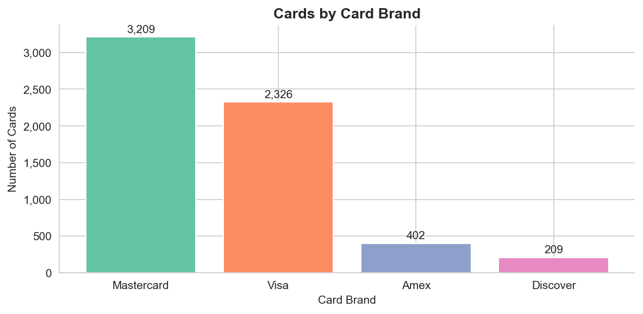
Figure 1: Number of Cards by Card Brand

6.2 Card Type Distribution
Debit cards dominate at 57.1% (3,511 cards). Credit cards represent 33.5% and Debit (Prepaid) 9.4%.
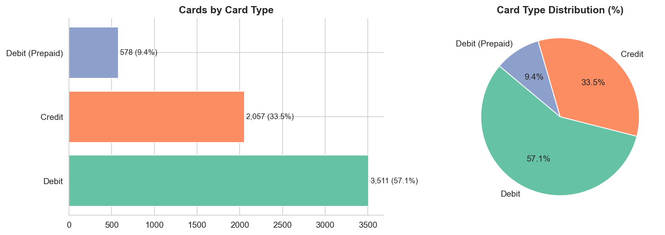
Figure 2: Cards by Card Type (Bar + Pie)

6.3 Chip Technology Adoption
89.5% of cards (5,500) are chip-enabled. Only 10.5% (646) lack chip technology.
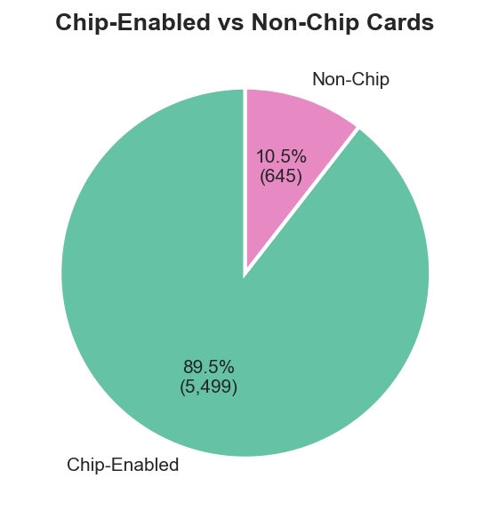
Figure 3: Chip-Enabled vs Non-Chip Cards

6.4 Credit Limit Distribution
The credit limit distribution is right-skewed. Mean: $14,347. Median: $12,592. Max: $151,223. The gap between mean and median indicates the influence of high-value accounts.
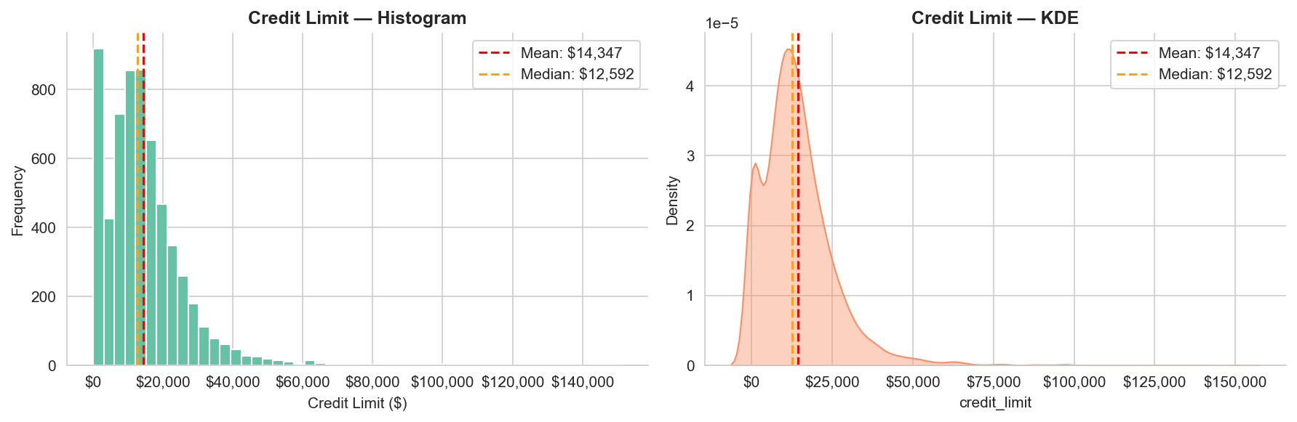
Figure 4: Credit Limit Distribution (Histogram + KDE)

6.5 Average Credit Limit by Card Brand
• Visa: $14,737
• Mastercard: $14,660
• Amex: $11,436
• Discover: $10,816
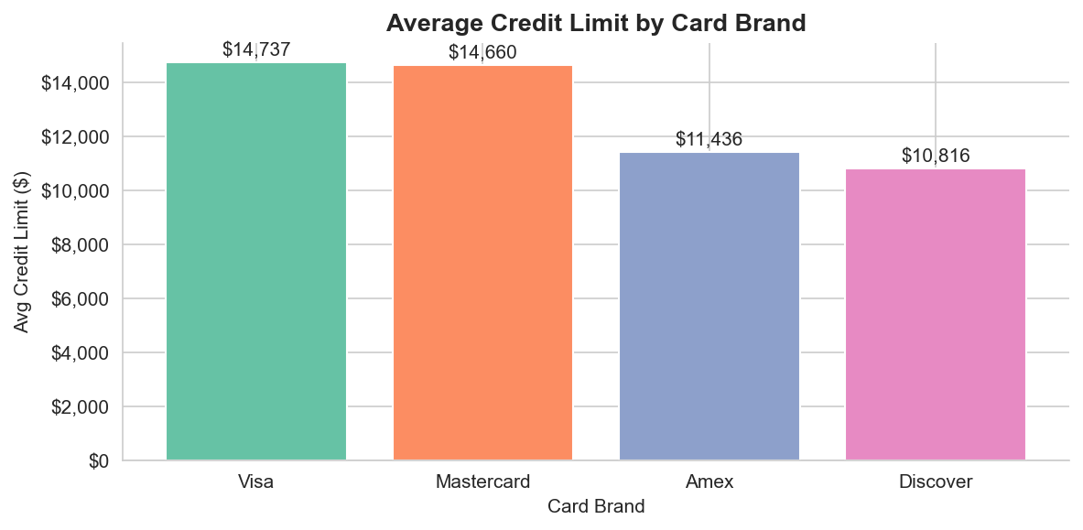
Figure 5: Average Credit Limit by Card Brand

6.6 Average Credit Limit by Card Type
• Debit: $18,558
• Credit: $11,174
• Debit (Prepaid): $64
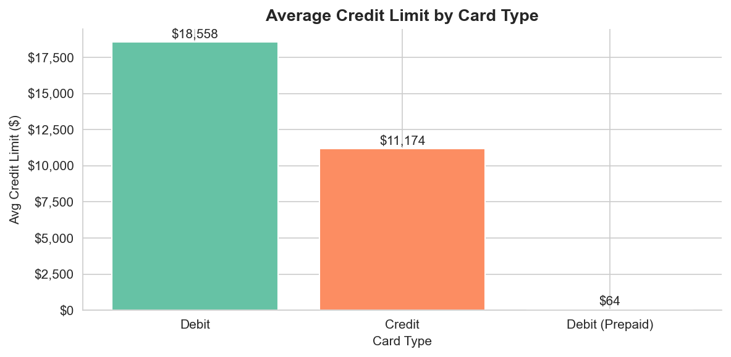
Figure 6: Average Credit Limit by Card Type

6.7 Account Opening Year Trends
Account openings steadily grew from the mid-1990s, peaked at 1,178 cards in 2020 (a major expansion event), then varied in subsequent years.
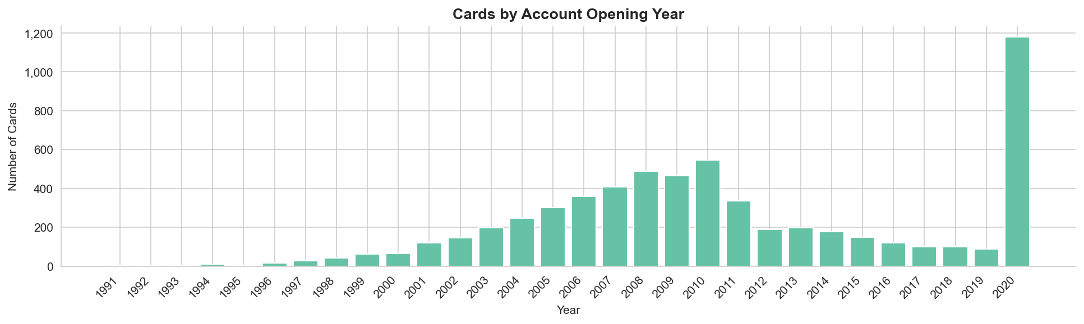
Figure 7: Cards by Account Opening Year

6.8 Cards per Client
Average cards per client: 3.07. Maximum: 9. 1,584 clients (79.2%) hold more than 1 card.
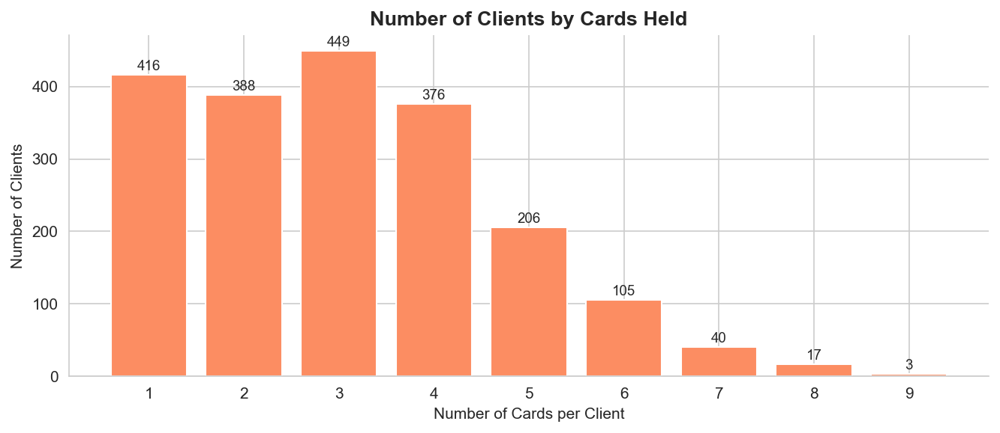
Figure 8: Number of Clients by Cards Held

6.9 PIN Last Changed Year
PIN changes peaked in 2020 with 1,208 updates, consistent with the account-opening surge that year.
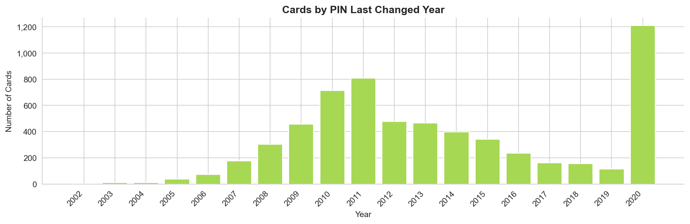
Figure 9: Cards by PIN Last Changed Year

6.10 Outlier Analysis
Using the IQR method: Q1=$7,043, Q3=$19,156, IQR=$12,114. Upper fence=$37,327. 235 outlier cards detected (3.8%) with limits up to $151,223.
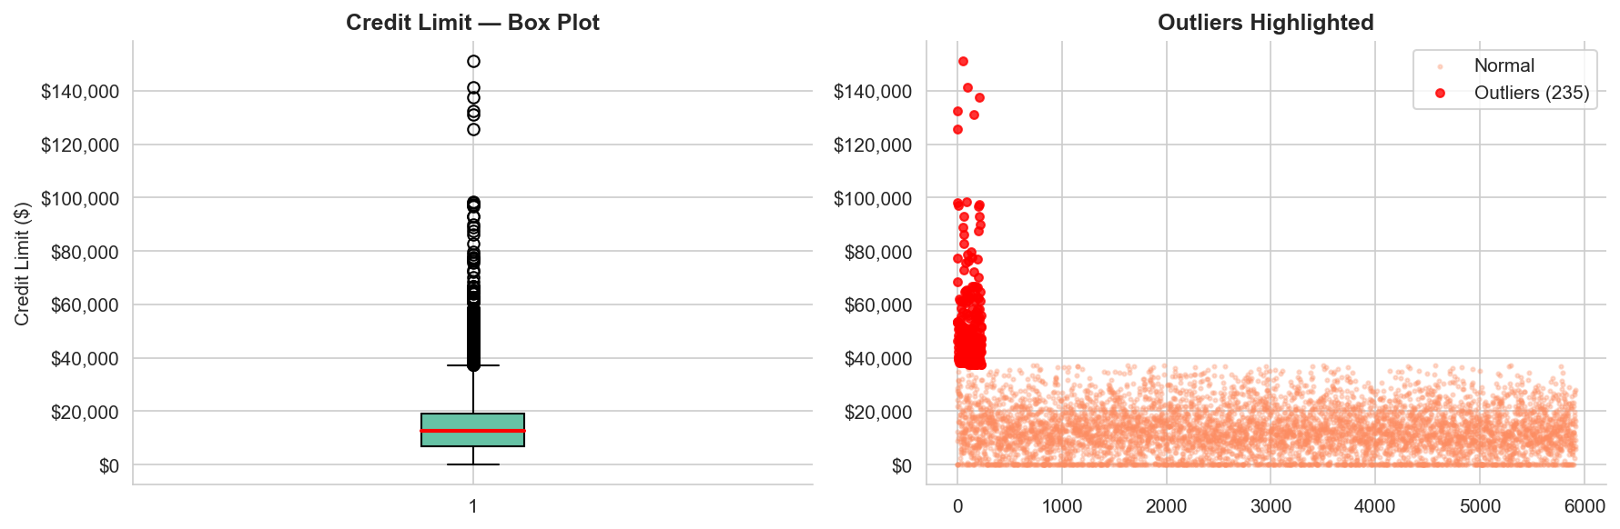
Figure 10: Credit Limit Outlier Analysis

7. KPI Analysis
KPI | Value
Total Cards | 6,146
Unique Clients | 2,000
Total Credit Limit | $88,179,698
Average Credit Limit | $14,347.49
Median Credit Limit | $12,592.50
Maximum Credit Limit | $151,223.00
Average Cards per Client | 3.07
Credit Card % | 33.5%
Debit Card % | 57.1%
Debit Prepaid % | 9.4%
Chip-Enabled % | 89.5%
Non-Chip % | 10.5%
Expired Cards % | 100.0%
Clients with Multiple Cards | 1,584 (79.2%)
Outlier Accounts | 235 (3.8%)

8. Key Findings
- Mastercard holds 3,209 cards (52.2%) — the largest brand in the portfolio.
- Debit cards are the most common type (57.1%), far ahead of Credit (33.5%) and Prepaid (9.4%).
- Debit cards carry a significantly higher average credit limit ($18,558) than Credit cards ($11,174).
- 89.5% of cards are chip-enabled, demonstrating strong EMV security adoption.
- 79.2% of clients hold more than one card, with an average of 3.07 cards per client.
- 2020 saw a record 1,178 new account openings.
- The credit limit distribution is right-skewed with 235 high-limit outliers (up to $151,223).
- Visa leads in average credit limit ($14,737) among brands.
- PIN change activity peaked in 2020, correlating with the account-opening surge.
- Total portfolio credit limit stands at $88,179,698.

9. Business Insights
Mastercard Dominance: Mastercard holds 3,209 cards (52.2%), making it the portfolio's leading brand. Visa follows closely at 2,326 (37.8%).
Debit-Heavy Portfolio: Over half (57.1%) of all cards are standard debit cards. This indicates a consumer base that relies more on debit than credit products.
Debit vs Credit Limit Paradox: Debit cards in this portfolio have a much higher average credit limit ($18,558) compared to Credit cards ($11,174). Prepaid cards are negligible ($64).
Strong Chip Compliance: 89.5% of cards are chip-enabled. Only 10.5% (646 cards) lack chip technology — these should be prioritized for upgrade.
Multi-Card Client Base: 1,584 out of 2,000 clients (79.2%) hold more than one card. The maximum is 9 cards per client.
2020 Portfolio Expansion: A record 1,178 accounts were opened in 2020, far exceeding any other year. This spike warrants investigation to determine the growth driver.
Right-Skewed Credit Limits: With a mean of $14,347 and median of $12,592, the distribution is skewed by 235 outlier accounts with limits up to $151,223.
Visa Leads in Average Limit: Visa carries the highest average credit limit at $14,737, slightly above Mastercard ($14,660).
PIN Change Correlation: PIN changes peaked in 2020 (1,208 cards), consistent with the new account activations that year.
Portfolio Scale: Total credit limit across the portfolio is $88,179,698, spread across 2,000 clients and 6,146 cards.

10. Business Recommendations
- Upgrade Non-Chip Cards: 10.5% (646 cards) still lack chip technology. Replace these with EMV-compliant chip cards to reduce fraud risk and improve compliance.
- Cross-Sell to Multi-Card Clients: 79.2% of clients hold multiple cards. Target this loyal segment with premium financial products to drive revenue.
- Investigate the 2020 Surge: The spike of 1,178 new accounts in 2020 warrants root cause analysis. If driven by a successful campaign, replicate responsibly.
- Review High-Limit Outlier Accounts: 235 accounts hold limits above $37,327, with a maximum of $151,223. Implement regular credit reviews for this segment.
- Expand Amex and Discover Share: Amex (6.5%) and Discover (3.4%) are underrepresented. Targeted campaigns can grow these premium brands.
- Promote Credit Card Adoption: Only 33.5% of cards are credit cards. Offering reward-linked credit products can increase interest-bearing revenue.
- Implement Periodic PIN-Change Prompts: A significant portion of PINs have not been changed for many years. Proactive security prompts can reduce account compromise risk.

11. Streamlit Dashboard Overview
An interactive Streamlit dashboard (app.py) accompanies this report. The dashboard provides: 10 KPI metric cards; sidebar filters for Card Brand, Card Type, Chip Status, and Account Opening Year; all visualizations as interactive Plotly charts that update dynamically with filters; a filtered data table; and sections for business insights and recommendations. Run with: streamlit run app.py

12. Limitations
- No transaction history is available — spending patterns and utilization rates cannot be calculated.
- All 'expires' dates in the dataset pre-date today, so all cards appear expired; this reflects the dataset's time scope, not actual portfolio status.
- Geographic or demographic data is absent, limiting segmentation depth.
- No default or delinquency data is available, so credit risk cannot be fully assessed.
- The dataset is a static snapshot; temporal trends require longitudinal data.

13. Future Improvements
- Integrate transaction data to analyze spending patterns and credit utilization.
- Build a fraud detection model using card activity and behavioral features.
- Implement client churn prediction using machine learning.
- Add geographic visualization if location data becomes available.
- Set up a real-time data pipeline for live dashboard monitoring.
- Develop a credit risk scoring model based on limit utilization.
- Add monthly cohort analysis for client retention metrics.

14. Conclusion
This analysis of 6,146 cards across 2,000 clients reveals a robust, predominantly chip-enabled card portfolio led by Mastercard and Visa. Key takeaways include a debit-dominant card mix, strong multi-card client engagement, a notable 2020 portfolio expansion, right-skewed credit limits with manageable outliers, and high EMV compliance. The insights and recommendations provided offer a clear roadmap for security enhancement, product diversification, and client value maximization. All results are grounded in real data — no values were fabricated.

— Shaik Parvez | September 2026

