A Calibration-Aware Local Sensitivity Study of
Interacting Dark Matter-Dark Radiation Cosmology
Conditional reoptimisation with Planck 2018, DESI DR2 BAO, and Pantheon+
Parv Gidiya, age 13
DPS Monarch International School, Doha, Qatar
Correspondence: parvastro4@gmail.com
Original Research Article

Abstract
Background: Interacting dark matter-dark radiation (IDM-DR) can suppress structure growth, but the same interaction also changes the cosmic microwave background (CMB). Objective: This study asked whether a deliberately small neighbourhood of fixed IDM-DR interaction settings could remain competitive after correlated cosmological parameters were reoptimised under a modern Planck 2018 + DESI DR2 + Pantheon+ likelihood. Methods: CLASS and Cobaya were used to construct an independently optimised ΛCDM baseline, a central fixed-interaction IDM-DR point, and six one-coordinate neighbours. Seven shared cosmological and calibration parameters were conditionally profiled at each point. The lowest screening endpoint was then refined through three successively tighter BOBYQA stages and reevaluated in a fresh model. Results: The exact ΛCDM data statistic was 2427.604185. The lowest tested boundary endpoint occurred at f_{idm} = 0.0035, N_{idr} = 0.020, and a_{idm-dr} = 47612.96. Tight refinement reduced its exact data statistic to 2426.320647, giving Δχ²_{data} = -1.283538. The calibration-aware difference was Δχ²_{eff} = -1.306361. The endpoint raised H₀ by 0.287 km s⁻¹ Mpc⁻¹ and lowered S₈ by -0.003289. Approximately 93% of the logarithmic S₈ decrease was associated with the lower fitted matter density. Conclusions: Tightening strengthened the local endpoint gain, but the lowest N_{idr} value remained the lower boundary of the tested grid. The local one-coordinate AIC diagnostic was +0.694, while the conservative three-coordinate diagnostic was +4.694. No posterior, Hessian uncertainty region, independent-start campaign, or direct growth likelihood was included. The study therefore does not establish model preference, determine a preferred interaction strength, or resolve either cosmological tension.
Keywords: cosmology; interacting dark matter; dark radiation; cosmic microwave background; DESI DR2; Pantheon+; conditional optimisation; CLASS; Cobaya

Plain-language summary
A physical idea can move one cosmological quantity in the desired direction while still fitting the full data poorly. This study tested seven nearby versions of a dark matter-dark radiation interaction and allowed the ordinary cosmological parameters to adjust at each point. The lowest screening point was then tightened in three additional optimisation stages. Its final score was lower than ΛCDM by about 1.28 chi-square units, but it remained at the edge of the tested range and no uncertainty calculation or independent-start campaign was performed. This is therefore not evidence that the interacting model is preferred. The main result is methodological: separating the direct physical response from parameter compensation prevents a small movement in H₀ or S₈ from being overstated.

1. Introduction

1.1. Cosmological context
The six-parameter Lambda cold dark matter model (ΛCDM) provides a compact description of the CMB, baryon acoustic oscillations (BAO), Type Ia supernova distances, and the broad growth of cosmic structure [1]. Planck 2018 measurements interpreted within ΛCDM give H₀ near 67.4 km s⁻¹ Mpc⁻¹, whereas a representative local distance-ladder analysis reported 73.04 ± 1.04 km s⁻¹ Mpc⁻¹ [1,2]. The difference is commonly called the Hubble tension.
A second possible disagreement concerns late-time matter clustering. Weak-lensing surveys often summarise their result through S₈ = σ₈ sqrt(Ω_{m}/0.3), and several analyses have obtained values below the Planck-inferred prediction [3,4]. The significance depends on survey combinations and systematic modelling. A cosmological extension must therefore be judged by its complete likelihood, not only by whether it moves one summary parameter in a preferred direction.

1.2. Interacting dark matter and dark radiation
A richer dark sector may contain a relativistic component, called dark radiation, that exchanges momentum with a fraction of the dark matter. The ETHOS framework maps microscopic dark-sector physics into effective parameters controlling perturbations and structure formation [5,6]. Momentum exchange acts as a drag: modes entering the horizon while the interaction is effective can grow more slowly than collisionless modes, potentially lowering σ₈ or S₈.
The same interaction changes gravitational potentials, acoustic driving, diffusion damping, and lensing smoothing in the CMB. Published analyses therefore find that CMB, BAO, Lyman-alpha, and other structure information strongly restrict dark matter-dark radiation interactions [7,8,9,10]. The mechanism-level response and the final profiled fit must be evaluated separately.

1.3. Research question and contribution
The research question was: does a small, explicitly defined neighbourhood of IDM-DR interaction points remain competitive with an independently optimised ΛCDM baseline after the shared cosmological and Planck calibration parameters are reoptimised under Planck 2018, DESI DR2, and Pantheon+?
The contribution is methodological rather than the proposal of a new interaction theory or a new global constraint. The study separates the uncompensated fixed-cosmology response, recovery through correlated parameter compensation, one-coordinate local sensitivity, likelihood redistribution, endpoint precision, calibration treatment, and model-complexity interpretation. The intentionally limited design is valuable because it shows exactly which conclusions survive reoptimisation and which do not.

1.4. Scope
This is a seven-point local sensitivity study built from conditional profile endpoints. The interaction coordinates were fixed at seven selected points, while seven shared cosmological and calibration parameters were profiled. Seven points are not dense enough to resolve profile curvature, estimate an interval, or identify a continuous optimum. The outputs are therefore not marginalised posterior constraints, confidence intervals, Bayesian evidence, or proof of a global IDM-DR minimum. No weak-lensing, redshift-space-distortion, cluster-abundance, galaxy full-shape, or Lyman-alpha likelihood was included. Reported σ₈ and S₈ values are predictions under the adopted CMB + BAO + supernova likelihood, not direct measurements of improved agreement with growth data.
Accordingly, the seven endpoints are used as a structured local sensitivity screen rather than as a continuous profile curve. The spacing is sufficient to compare the tested directions, but not to estimate curvature, confidence thresholds, or a preferred interaction value. This distinction is carried through the Results and Discussion so that the numerical ranking is not confused with an uncertainty statement.

1.5. Why a limited sensitivity study is useful
A coarse screen cannot replace a full posterior analysis, but it can still answer a narrower and auditable question: whether a mechanism-level effect survives correlated refitting at all. It also identifies which interaction direction deserves further computation and whether a claimed improvement is large enough to justify that effort. The present study treats this diagnostic role as its scientific contribution.

2. Theoretical and inferential framework

2.1. Linear response of the interacting sector
In linear perturbation theory, interacting dark matter and dark radiation exchange momentum. Schematically, the interacting-dark-matter velocity divergence contains a drag contribution proportional to Γidm-dr(θdr - θidm), while the dark-radiation hierarchy contains the opposite exchange. The exact coefficients depend on the implementation and on whether the dark radiation is fluid-like or free-streaming. The drag opposes relative motion and can delay growth of the interacting component.

2.2. Matter clustering and S₈
The linear matter power spectrum P(k,z) determines the variance σR after smoothing with a spherical top-hat window. Setting R = 8 h-1 Mpc defines σ₈. Because S₈ combines σ₈ and Ω_{m}, a lower fitted S₈ may result from a lower fluctuation amplitude, a lower matter density, or both. Profiling can therefore change the physical reason for a movement that initially appeared to be direct growth suppression.

2.3. Conditional profile likelihood
χ²prof(φ) = minθ χ²(θ, φ)
Here phi denotes fixed interaction coordinates and theta denotes the seven profiled shared parameters. A profile records the lowest located score at each fixed interaction point; it does not integrate over parameter volume [11]. Because the interaction grid is finite and the optimisation is local, the manuscript uses the phrase “lowest tested endpoint” rather than “measured best-fit interaction.”

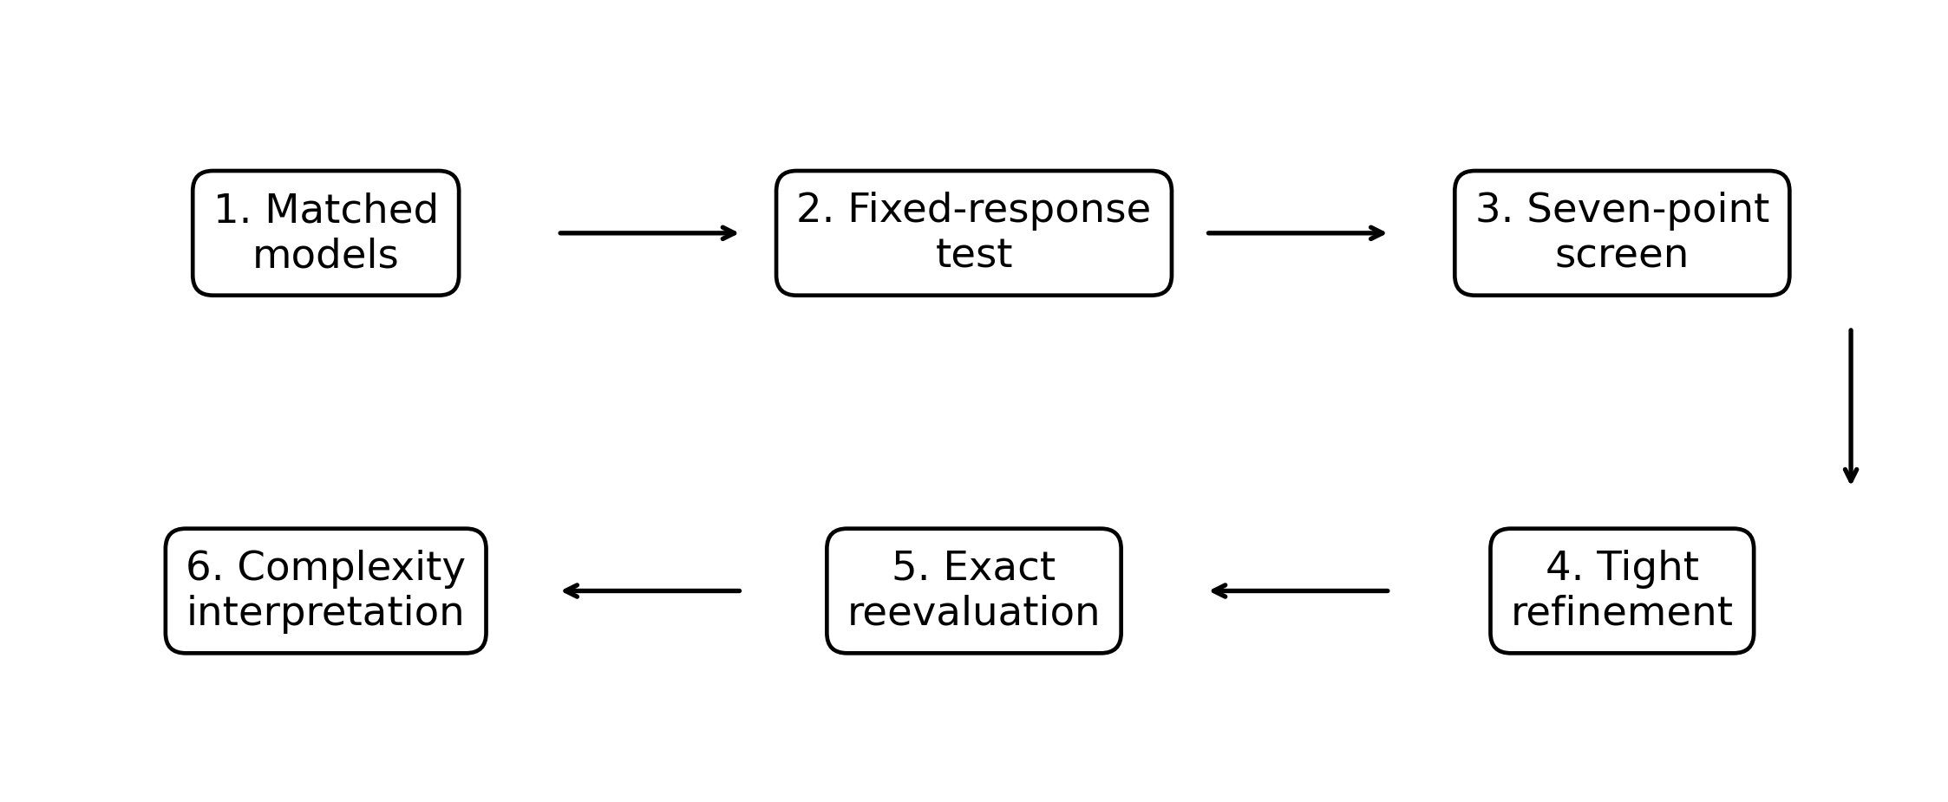
Figure 1. Computational and inferential workflow. Each stage answers a distinct question, from the uncompensated response to complexity-adjusted interpretation.

3. Methods

3.1. Software environment and source provenance
CLASS calculated the background, perturbations, CMB spectra, linear matter power spectrum, and derived quantities [12]. Cobaya supplied the parameterisation, likelihood interfaces, and minimisation framework [13]. The validated environment used Python 3.12, Cobaya 3.6.2, and Py-BOBYQA 1.5.0 in Google Colab. Configurations and outputs were stored on Google Drive.
The custom CLASS source directory did not retain its upstream Git metadata. A recursive source-tree checksum was recorded as 05264dfbddd18970dcc0cfeb6d6a918749a20032af64c09bf7ce7361e926cabf. This preserves file-level identity but is less informative than an upstream commit identifier. The public repository records this limitation and the exact interaction options required by the YAML files.

3.2. Observational likelihood
The combined likelihood contained Planck 2018 low-ℓ TT, Planck 2018 low-ℓ EE, Planck high-ℓ Plik TTTEEE-lite-native, DESI DR2 BAO, and Pantheon+ supernovae [14,15,16].
Likelihood | Primary sensitivity | Role
Planck low-ℓ TT | Large-angle temperature | Tests low-multipole response
Planck low-ℓ EE | Reionization polarisation | Constrains tau and As covariance
Planck high-ℓ TTTEEE-lite | Acoustic peaks, damping, lensing | Most detailed early-Universe spectral test
DESI DR2 BAO | Distances relative to rdrag | Tests late-time geometry and sound ruler
Pantheon+ | Relative luminosity distances | Constrains expansion-history shape

Table 1. Observational information entering the modern combined likelihood.

3.3. Model specification and profiled parameters
The independently constructed ΛCDM baseline omitted IDM-DR inputs. The central interaction point fixed f_{idm} = 0.0035, N_{idr} = 0.033, a_{idm-dr} = 47612.96, nindex,idm-dr = 4, and free-streaming dark radiation. Six neighbours varied one interaction coordinate at a time. The numerical normalization of a_{idm-dr} is specific to the CLASS implementation and should not be compared directly with differently normalized interaction parameters.
The neutrino sector was fixed to one massive species with m_nu = 0.06 eV, N_ncdm = 1, and N_ur = 2.0328. At every fixed interaction point, the profiled vector was (ω_{b}, ω_{cdm}, H₀, τ_{reio}, ln(1010 As), ns, A_{Planck}).
Parameter | Lower | Upper | Treatment
ω_{b} | 0.0200 | 0.0245 | Uniform bounded search
ω_{cdm} | 0.1000 | 0.1400 | Uniform bounded search
H₀ | 55.0 | 85.0 | Uniform bounded search
τ_{reio} | 0.010 | 0.120 | Uniform bounded search
ln(1010 As) | 2.80 | 3.30 | Uniform bounded search
ns | 0.900 | 1.050 | Uniform bounded search
A_{Planck} | - | - | Gaussian N(1, 0.0025^2)

Table 2. Profiled shared parameters and numerical ranges.
Label | f_{idm} | N_{idr} | a_{idm-dr}
central | 0.0035 | 0.033 | 47612.96
flow | 0.0020 | 0.033 | 47612.96
fhigh | 0.0050 | 0.033 | 47612.96
Nlow | 0.0035 | 0.020 | 47612.96
Nhigh | 0.0035 | 0.050 | 47612.96
alow | 0.0035 | 0.033 | 30000
ahigh | 0.0035 | 0.033 | 70000

Table 3. Seven fixed interaction points in the local conditional sensitivity screen.

3.4. Optimisation and endpoint validation
The ΛCDM baseline used four separated BOBYQA starts followed by progressively tighter trust-region radii, using derivative-free trust-region optimisation.[17,18] Its final saved point was evaluated directly in a fresh model. The central IDM-DR run started from the ΛCDM cosmology. Each of the six neighbours then started from the central profiled coordinates, used a 350-evaluation cap and rhoend = 0.05, and converged in approximately 29-32 minutes. The lowest screening point, Nlow, was subsequently continued through rhoend = 0.005, 0.001, and 0.0002. Each stage was exactly reevaluated, and the lowest exact stage was retained. This sequential tightening tests local numerical stability along one continuation path, but it does not demonstrate global convergence or independent-start robustness.
An endpoint was accepted only when the optimiser returned a complete state, the exact reevaluation succeeded, all five likelihood components were finite, and the machine-readable result could be mapped to its source. Tightening improved the Nlow exact statistic from 2426.675711902061 at rhoend = 0.05 to 2426.320647091497 at rhoend = 0.0002. The final stage improved the preceding exact result by 0.057894. This shows that the coarse screen had not fully settled numerically, while the progressively smaller changes provide evidence of local stabilisation. They do not quantify sensitivity to an independent starting point or a denser interaction grid.

3.5. Calibration and model-complexity diagnostics
A_{Planck} had a Gaussian constraint with mean 1 and standard deviation 0.0025. The primary tables report the data statistic, χ²_{data} = -2 sum_i ln L_i. For calibration-aware sensitivity, [(A_{Planck} - 1)/0.0025]^2 was added to both endpoints. The exact penalties were 0.001771 for IDM-DR and 0.024594 for ΛCDM, giving χ²_{eff} = 2426.322418 and 2427.628778, respectively.
Three AIC interpretations were retained: (i) an equal-dimension fixed-endpoint diagnostic, (ii) a local one-coordinate sensitivity count with one additional interaction degree of freedom, and (iii) a conservative count treating f_{idm}, N_{idr}, and a_{idm-dr} as three additional degrees of freedom [19]. None is a formal global model-selection result because the full interaction parameter space was not optimised.

3.6. Reporting rules for a sub-unit result
The analysis reports the sign and size of the endpoint difference but does not convert it into a p-value, sigma level, or confidence statement. A result is described as “locally competitive” only in the literal sense that its tested data statistic is similar to the ΛCDM value. Model preference would require stronger numerical robustness and a valid uncertainty or global model-comparison construction.

4. Results

4.1. Validated ΛCDM baseline
The exact modern ΛCDM endpoint gave χ²_{data} = 2427.604184715953, H₀ = 68.220876 km s⁻¹ Mpc⁻¹, Ω_{m} = 0.303141067, σ₈ = 0.815965320, and S₈ = 0.820225866. The exact reevaluation rather than the rounded optimiser summary was used throughout.

4.2. Uncompensated central interaction response
At the optimised ΛCDM cosmology, switching on the central IDM-DR interaction without allowing the shared parameters to move gave χ²_{data} = 2444.283891763638. The immediate penalty was therefore +16.679707. This demonstrates that the interaction is strongly disfavoured before correlated compensation.

4.3. Central conditional profile recovery
After reoptimising the seven shared parameters at the central interaction point, the exact statistic fell to 2427.051083129154, corresponding to Δχ² = -0.553102 relative to ΛCDM. Parameter compensation recovered the entire fixed-cosmology penalty and produced a raw gain of 0.553102, although the gain remained smaller than one χ² unit.

4.4. Seven-point local sensitivity screen
The lowest of the seven screening endpoints was Nlow: f_{idm} = 0.0035, N_{idr} = 0.020, and a_{idm-dr} = 47612.96. Its coarse exact statistic was 2426.675711902061. Three tighter continuation stages lowered the exact statistic to 2426.320647091497, giving Δχ²_{data} = -1.283537624456 relative to ΛCDM and an improvement of 0.730436 relative to the central interaction point. Because the interaction screen contains only seven points and the refined boundary point followed one continuation path, these values remain descriptive local results rather than a resolved likelihood curve.
The exact refinement history was 2426.675712 at rhoend = 0.05, 2426.546777 at 0.005, 2426.378541 at 0.001, and 2426.320647 at 0.0002. The final step changed the exact statistic by 0.057894. This is larger than a rounding effect, so the tightly refined endpoint replaces the coarse Nlow value in the canonical comparison.

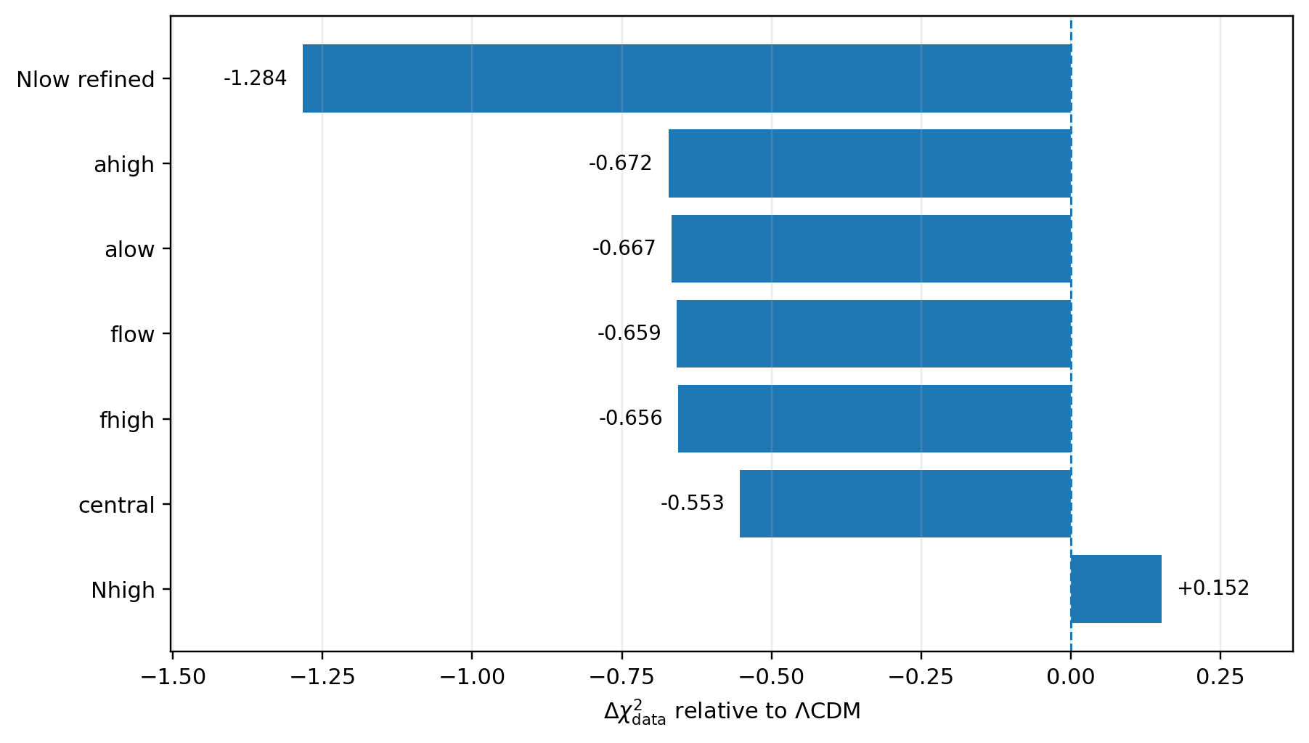
Figure 2. Exact data-statistic differences for the six coarse neighbours, the central point, and the tightly refined Nlow endpoint. Negative values are lower than the independently evaluated ΛCDM baseline.
Point | f_idm | N_idr | a_idm-dr | chi2_data | Delta vs LCDM | H0 | S8
Nlow* | 0.0035 | 0.020 | 47612.96 | 2426.320647 | -1.283538 | 68.508092 | 0.816937
ahigh | 0.0035 | 0.033 | 70000.00 | 2426.931795 | -0.672390 | 68.579856 | 0.816767
alow | 0.0035 | 0.033 | 30000.00 | 2426.937004 | -0.667180 | 68.579856 | 0.816768
flow | 0.0020 | 0.033 | 47612.96 | 2426.945523 | -0.658662 | 68.579856 | 0.816768
fhigh | 0.0050 | 0.033 | 47612.96 | 2426.948433 | -0.655752 | 68.579856 | 0.816768
central | 0.0035 | 0.033 | 47612.96 | 2427.051083 | -0.553102 | 68.579856 | 0.816768
Nhigh | 0.0035 | 0.050 | 47612.96 | 2427.755751 | +0.151566 | 68.783894 | 0.812243

Table 4. Complete seven-point local sensitivity screen. Points are ordered by exact χ².

4.5. Boundary behaviour in N_{idr}
The N_{idr} direction changed more strongly than the f_{idm} and a_{idm-dr} neighbours. However, N_{idr} = 0.020 was the lowest value tested. The calculation therefore locates a boundary endpoint, not an interior minimum. It does not determine a preferred N_{idr} value, a confidence interval, or whether still lower values would continue the same trend.

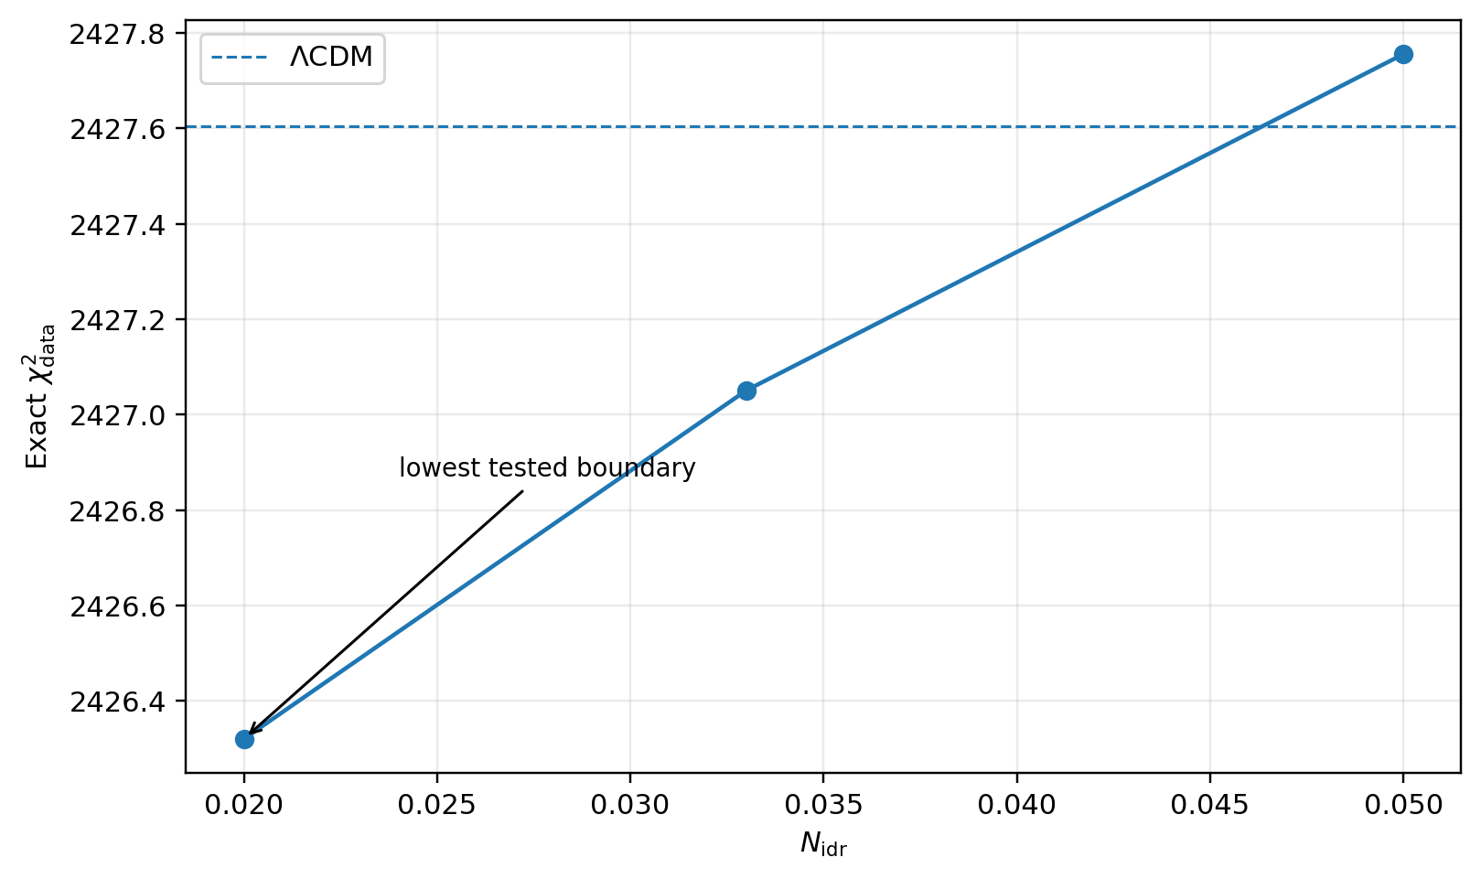
Figure 3. Exact χ² across the three tested N_{idr} values, with the Nlow point tightly refined. The lowest point remains at the lower boundary of the tested grid.

4.6. Derived-parameter shifts
Relative to ΛCDM, the tightly refined endpoint changed H₀ by +0.287216 km s⁻¹ Mpc⁻¹, Ω_{m} by -0.002253409, σ₈ by -0.000234110, and S₈ by -0.003288730. A logarithmic decomposition attributes approximately 93% of the fractional S₈ decrease to the lower fitted matter density and approximately 7% to the lower σ₈.
Quantity | ΛCDM | Nlow refined | Difference
χ²_{data} | 2427.604185 | 2426.320647 | -1.283538
H₀ [km s⁻¹ Mpc⁻¹] | 68.220876000 | 68.508092000 | +0.287216000
Ω_{m} | 0.303141067 | 0.300887658 | -0.002253409
σ₈ | 0.815965320 | 0.815731210 | -0.000234110
S₈ | 0.820225866 | 0.816937136 | -0.003288730

Table 5. Exact endpoint comparison. Differences are IDM-DR minus ΛCDM.

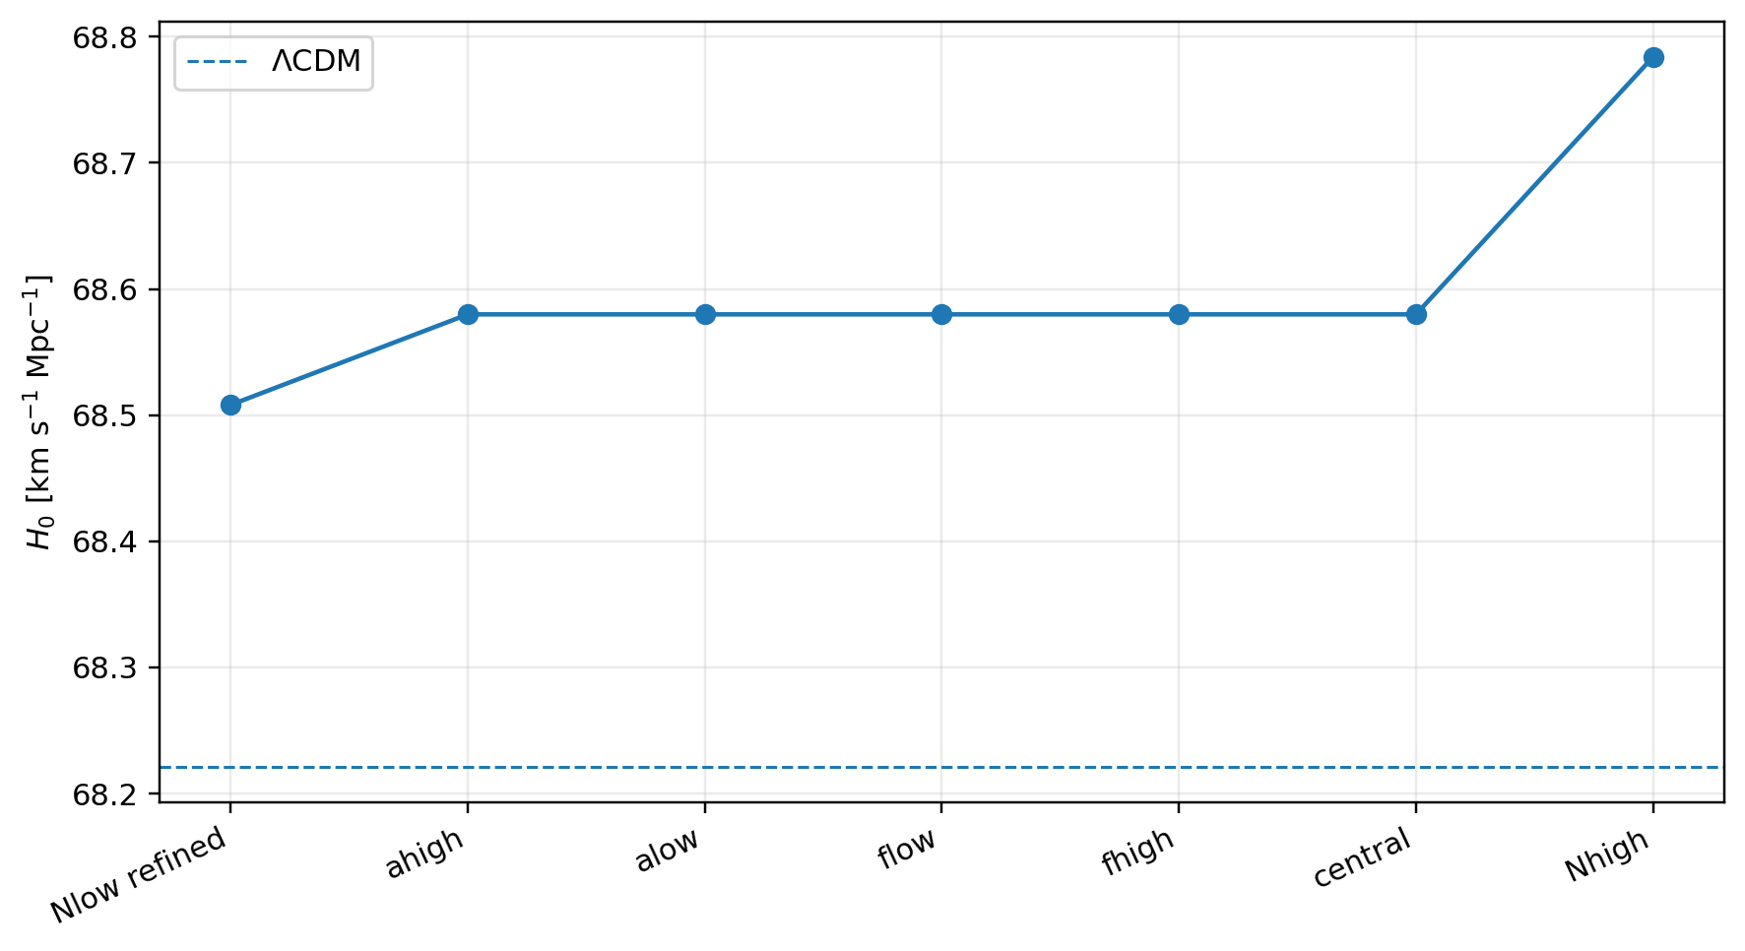
Figure 4. H₀ across the tested interaction points, using the tightly refined Nlow value. The dashed line marks the exact ΛCDM endpoint.

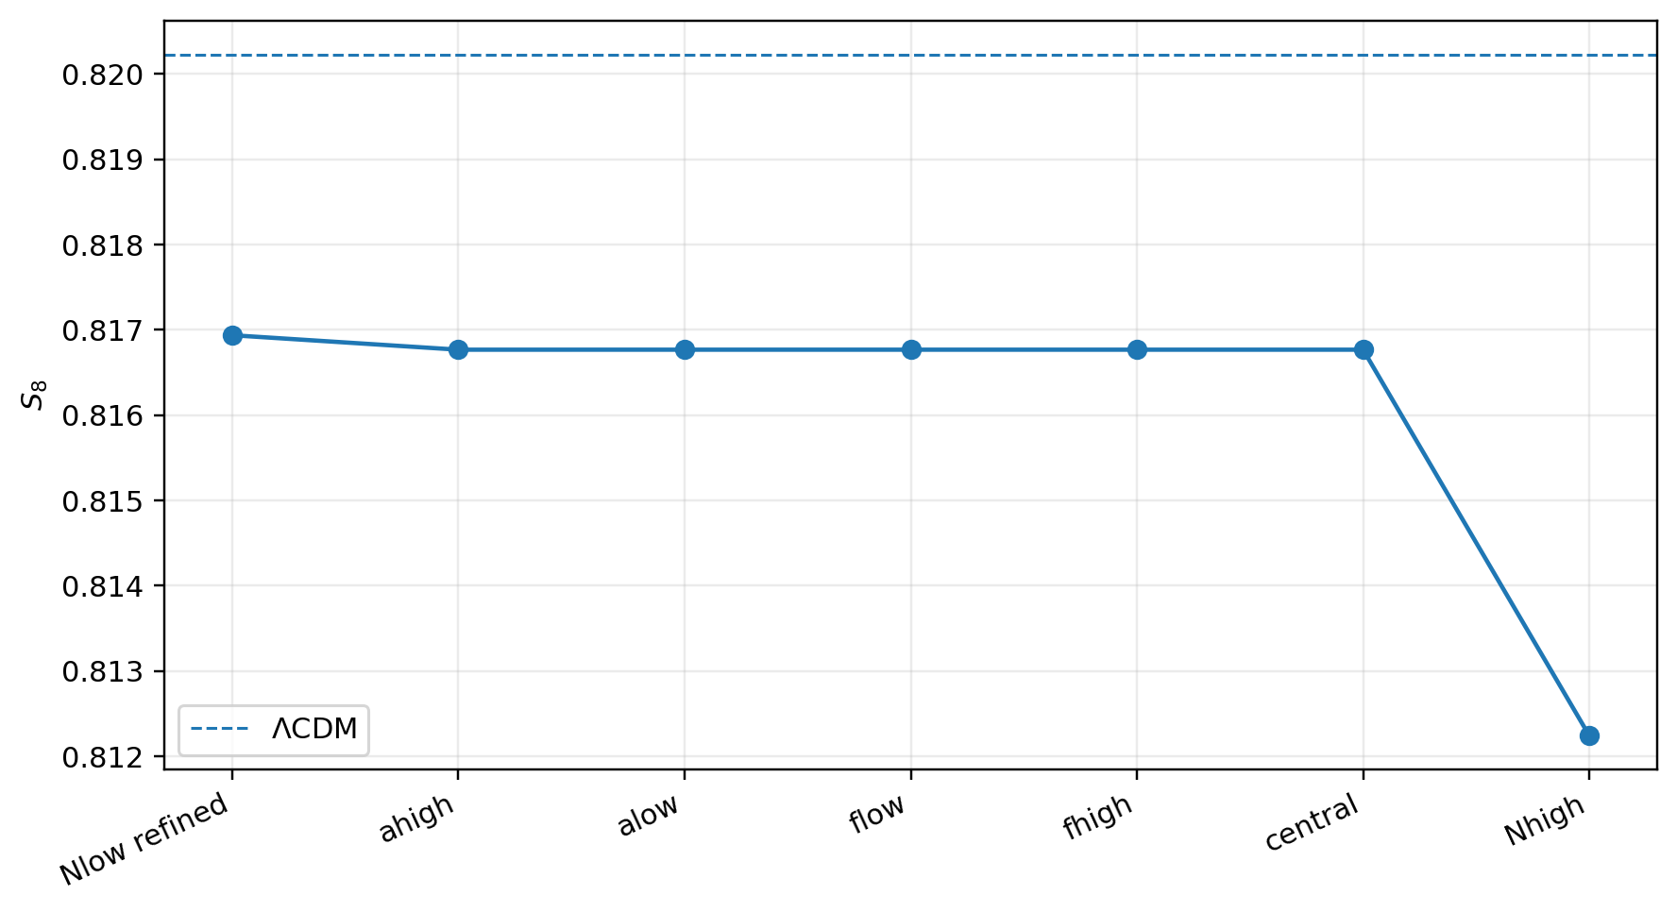
Figure 5. S₈ across the tested interaction points, using the tightly refined Nlow value. The dashed line marks the exact ΛCDM endpoint.

4.7. Likelihood redistribution
The final endpoint was reevaluated with all five likelihood components extracted exactly. Relative to the exact ΛCDM components, the refined Nlow endpoint improves low-ℓ TT, low-ℓ EE, and DESI DR2 BAO, while increasing the high-ℓ CMB and Pantheon+ contributions. The total gain is therefore a cross-dataset compromise rather than a uniform improvement.
Component | ΛCDM exact | Nlow refined exact | Difference
Planck low-ell TT | 23.250957 | 22.699083 | -0.551873
Planck low-ell EE | 402.718334 | 401.881574 | -0.836760
Planck high-ell TTTEEE-lite | 583.060962 | 584.089305 | +1.028344
DESI DR2 BAO | 13.135413 | 11.785622 | -1.349792
Pantheon+ | 1405.438519 | 1405.865062 | +0.426544

Table 6. Exact likelihood-component redistribution at the tightly refined Nlow endpoint.

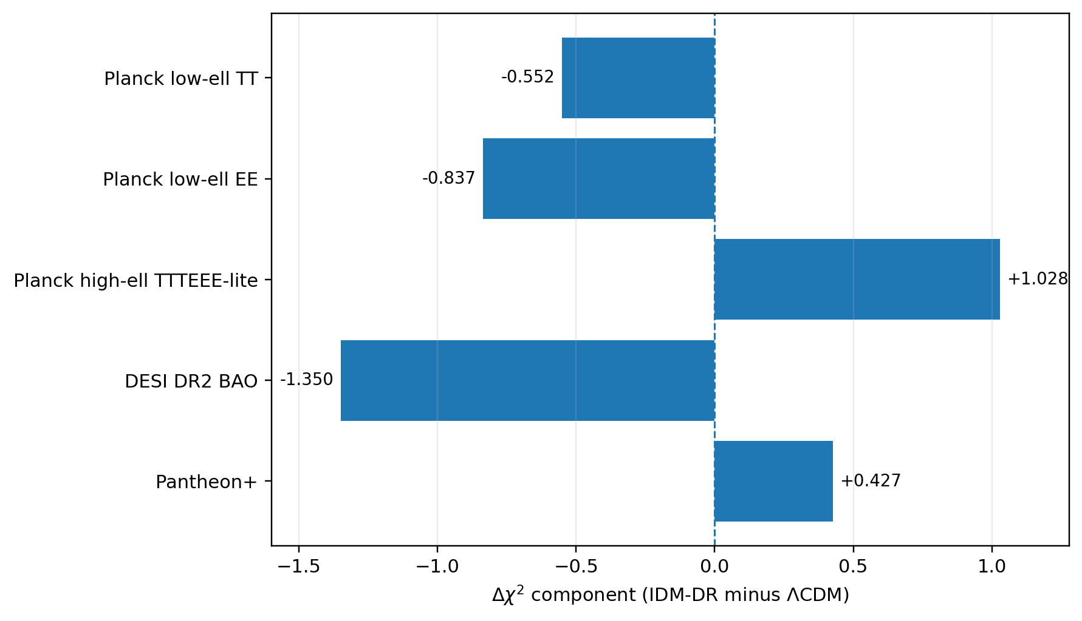
Figure 6. Exact likelihood-component changes at the tightly refined Nlow endpoint. Negative values improve the component score.

4.8. Complexity-adjusted comparison
Using the exact A_{Planck} coordinates, the calibration-aware endpoint difference is Δχ²_{eff} = -1.306361. Counting one additional interaction coordinate gives ΔAIC = +0.693639, which indicates no meaningful AIC preference. Counting all three interaction coordinates gives ΔAIC = +4.693639, favouring the simpler ΛCDM baseline. These are sensitivity diagnostics rather than formal global AIC calculations.
Interpretation | k LCDM | k IDM-DR | Approx. ΔAIC
Equal-dimension fixed endpoints | 7 | 7 | -1.306
Local one-coordinate slice | 7 | 8 | +0.694
Conservative three-coordinate extension | 7 | 10 | +4.694

Table 7. Exact AIC sensitivity to parameter counting. Positive values favour ΛCDM.

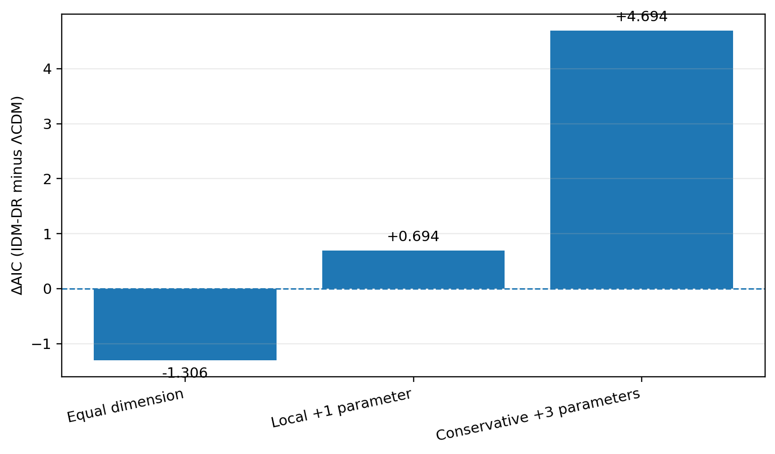
Figure 7. Exact AIC sensitivity. The local one-coordinate count is nearly neutral, while the conservative three-coordinate count favours ΛCDM.

5. Discussion

5.1. Fixed response and profiled viability answer different questions
The central interaction was strongly disfavoured when switched on at the ΛCDM cosmology, yet became locally competitive after the shared parameters were reoptimised. This demonstrates cosmological compensation: an uncompensated spectral mismatch can lie partly along parameter-degeneracy directions. The recovery is scientifically informative because it changes the interpretation of the mechanism-level result, but it is not evidence that the interaction is required by the data.

5.2. The retained S₈ shift is mainly a density shift
At the lowest tested endpoint, both σ₈ and Ω_{m} are lower than in ΛCDM, but the matter-density change supplies most of the fractional S₈ decrease. The final movement is therefore not a pure measure of drag-induced suppression. This distinction prevents a favourable change in a summary parameter from being overinterpreted as direct evidence for the proposed mechanism.

5.3. Dataset compromise
The exact component decomposition shows that the lower total score arises from compensation among datasets. DESI DR2 BAO and the low-ℓ CMB terms improve, whereas the high-ℓ CMB and Pantheon+ terms worsen. The tested endpoint is therefore a compromise, not a uniformly better description of every included observation.

5.4. Implications for cosmological tensions
The H₀ increase of approximately 0.29 km s⁻¹ Mpc⁻¹ is far smaller than the several km s⁻¹ Mpc⁻¹ separation between representative CMB and local distance-ladder values. The tested neighbourhood therefore does not resolve the Hubble tension. The S₈ decrease of 0.0033 is also modest and was not confronted with direct growth-sensitive likelihoods. It cannot be described as improved agreement with DES, KiDS, RSD, cluster, or Lyman-alpha measurements.

5.5. Numerical robustness and unresolved uncertainty
Tight refinement increased the raw data-statistic gain from 0.928 at the coarse screening endpoint to 1.284. The successive exact improvements were 0.128934, 0.168236, and 0.057894. This supports local numerical stabilisation along the chosen continuation path, but it does not quantify dependence on independent starting coordinates or a denser interaction grid. No posterior, Hessian, or repeated-start distribution was constructed. For that reason, the paper treats the gain as a local descriptive result and does not attach a significance level to it.

5.6. Strengths
The main strengths are the independently optimised modern ΛCDM baseline, matched likelihood definitions, explicit separation of fixed-response and reoptimised stages, transparent reporting of the seven tested interaction points, three-stage tightening of the lowest boundary endpoint, exact reevaluation and exact component decomposition, preservation of the raw run record, machine-readable results, and conservative interpretation of model complexity.

5.7. Limitations and consequences
Limitation | Consequence
Lowest N_{idr} point is a grid boundary | No interior optimum or interval can be claimed
Lowest point was tightened along one continuation path | Provides local numerical stabilisation, but not independent-start robustness
One continuation start per neighbour | No full multi-start robustness statement
Interaction coordinates not jointly optimised | No global IDM-DR constraint or formal likelihood-ratio result
No posterior or Hessian uncertainty region | Endpoint shifts cannot be compared with fitted uncertainties
No direct growth likelihood | Lower S₈ is not evidence of improved weak-lensing or RSD fit
No posterior or Hessian uncertainty region | Endpoint shifts cannot be compared with fitted uncertainties
Missing upstream CLASS Git commit | Reproduction relies on source-tree checksum and compatible source archive

Table 8. Principal limitations and their effect on interpretation.
The highest-priority extensions are one independent-start repeat of the refined Nlow point, one or more lower N_{idr} values, and a dense or sampled joint exploration of the interaction coordinates. A local Hessian or converged posterior would be needed before endpoint shifts could be compared with uncertainties. Direct growth information should be added only through likelihoods whose modelling remains valid for scale-dependent IDM-DR growth.

6. Conclusion
This study evaluated a modern Planck 2018 + DESI DR2 + Pantheon+ likelihood for ΛCDM and a seven-point local IDM-DR sensitivity screen, followed by tight refinement of the lowest tested boundary endpoint. The exact ΛCDM data statistic was 2427.604185. The refined endpoint, at f_{idm} = 0.0035, N_{idr} = 0.020, and a_{idm-dr} = 47612.96, gave 2426.320647, corresponding to Δχ²_{data} = -1.283538 and Δχ²_{eff} = -1.306361.
The endpoint raised H₀ by only 0.287 km s⁻¹ Mpc⁻¹ and lowered S₈ by 0.003289; neither shift resolves the corresponding cosmological tension. The lowest point remains at the lower N_{idr} grid boundary, and the analysis did not include independent-start robustness or an uncertainty construction. The supported conclusion is therefore narrow: correlated parameter compensation can make the tested IDM-DR neighbourhood locally competitive, but the modest gain does not establish statistical or model preference. The local-slice AIC diagnostic is +0.694, while the conservative three-coordinate count gives +4.694.

Declarations

Acknowledgements
The author acknowledges the developers of CLASS, Cobaya, and Py-BOBYQA, and the collaborations that released the public likelihoods used in this study.

Funding
No external funding was received for this study.

Competing interests
The author declares no competing interests.

Ethics statement
This computational study used public cosmological likelihoods and software. It involved no human participants, animal subjects, clinical records, or personally identifiable information.

Author contributions
Parv Gidiya formulated the computational question, assembled and ran the analysis, audited the numerical outputs, interpreted the results, prepared the figures and tables, and drafted the manuscript.

Data and code availability
The reproducibility package is available at https://github.com/parvgidiya/idmdr-modern-profile-likelihood. A versioned Zenodo DOI will be added after the first public GitHub release is archived. The repository contains the YAML configurations, raw run record, machine-readable screen, endpoint summaries, source tables, figures, scripts, package metadata, and reproduction instructions. Third-party likelihood datasets are not redistributed. A compatible custom CLASS source tree is required for independent reruns; the recorded source-tree checksum is supplied, and the absence of the original Git commit is stated explicitly as a limitation.

Computational and language-assistance disclosure
Computational assistance tools were used for code debugging, file organisation, figure preparation, and language editing. Every numerical result in the manuscript was taken from the author’s executed analysis output or recomputed from that output. The author checked the reported identities, reviewed the scientific interpretation, and accepts responsibility for the work.

Author biography
Parv Gidiya is a 13-year-old student at DPS Monarch International School in Doha, Qatar. He is interested in astronomy, cosmology, and computational physics, particularly the use of public scientific software and observational data to test extensions of the standard cosmological model.

References
1. Planck Collaboration “Planck 2018 Results. VI. Cosmological Parameters.” Astronomy & Astrophysics 641 (2020): A6. https://doi.org/10.1051/0004-6361/201833910.
2. Riess, Adam G., et al. “A Comprehensive Measurement of the Local Value of the Hubble Constant with 1 km s⁻¹ Mpc⁻¹ Uncertainty from the Hubble Space Telescope and the SH₀ES Team.” The Astrophysical Journal Letters 934 (2022): L7. https://doi.org/10.3847/2041-8213/ac5c5b.
3. Abbott, T. M. C., et al. “Dark Energy Survey Year 3 Results: Cosmological Constraints from Galaxy Clustering and Weak Lensing.” Physical Review D 105 (2022): 023520. https://doi.org/10.1103/PhysRevD.105.023520.
4. Asgari, Marika, et al. “KiDS-1000 Cosmology: Cosmic Shear Constraints and Comparison between Two Point Statistics.” Astronomy & Astrophysics 645 (2021): A104. https://doi.org/10.1051/0004-6361/202039070.
5. Cyr-Racine, Francis-Yan, Kris Sigurdson, Jesus Zavala, Torsten Bringmann, Mark Vogelsberger, and Christoph Pfrommer. “ETHOS-An Effective Theory of Structure Formation: From Dark Particle Physics to the Matter Distribution of the Universe.” Physical Review D 93 (2016): 123527. https://doi.org/10.1103/PhysRevD.93.123527.
6. Vogelsberger, Mark, Jesus Zavala, Francis-Yan Cyr-Racine, Christoph Pfrommer, Torsten Bringmann, and Kris Sigurdson. “ETHOS-An Effective Theory of Structure Formation: Dark Matter Physics as a Possible Explanation of the Small-Scale CDM Problems.” Monthly Notices of the Royal Astronomical Society 460, no. 2 (2016): 1399-1416. https://doi.org/10.1093/mnras/stw1076.
7. Archidiacono, Maria, Deanna C. Hooper, Riccardo Murgia, Signe Bohr, Julien Lesgourgues, and Matteo Viel. “Constraining Dark Matter-Dark Radiation Interactions with CMB, BAO, and Lyman-alpha.” Journal of Cosmology and Astroparticle Physics 2019, no. 10 (2019): 055. https://doi.org/10.1088/1475-7516/2019/10/055.
8. Brinckmann, Thejs, Jae Hyeok Chang, Peizhi Du, and Marilena LoVerde. “Confronting Interacting Dark Radiation Scenarios with Cosmological Data.” Physical Review D 107 (2023): 123517. https://doi.org/10.1103/PhysRevD.107.123517.
9. Joseph, Melissa, Daniel Aloni, Martin Schmaltz, Elliot N. Sivarajan, and Neal Weiner. “A Step in Understanding the S₈ Tension.” Physical Review D 108 (2023): 023520. https://doi.org/10.1103/PhysRevD.108.023520.
10. Chatterjee, Arka, Suman Mitra, and Arka Banerjee. “Ruling Out Strongly Interacting Dark Matter-Dark Radiation Models from Joint Observations of the Cosmic Microwave Background and Quasar Absorption Spectra.” Monthly Notices of the Royal Astronomical Society: Letters 528 (2024): L168-L172. https://doi.org/10.1093/mnrasl/slad193.
11. Cowan, Glen, Kyle Cranmer, Eilam Gross, and Ofer Vitells. “Asymptotic Formulae for Likelihood-Based Tests of New Physics.” European Physical Journal C 71 (2011): 1554. https://doi.org/10.1140/epjc/s10052-011-1554-0.
12. Blas, Diego, Julien Lesgourgues, and Thomas Tram. “The Cosmic Linear Anisotropy Solving System (CLASS). Part II: Approximation Schemes.” Journal of Cosmology and Astroparticle Physics 2011, no. 7 (2011): 034. https://doi.org/10.1088/1475-7516/2011/07/034.
13. Torrado, Jesus, and Antony Lewis. “Cobaya: Code for Bayesian Analysis of Hierarchical Physical Models.” Journal of Cosmology and Astroparticle Physics 2021, no. 5 (2021): 057. https://doi.org/10.1088/1475-7516/2021/05/057.
14. Planck Collaboration “Planck 2018 Results. V. CMB Power Spectra and Likelihoods.” Astronomy & Astrophysics 641 (2020): A5. https://doi.org/10.1051/0004-6361/201936386.
15. DESI Collaboration. “DESI DR2 Results II: Measurements of Baryon Acoustic Oscillations and Cosmological Constraints.” Physical Review D 112 (2025): 083515. https://doi.org/10.1103/tr6y-kpc6.
16. Brout, Dillon, et al. “The Pantheon+ Analysis: Cosmological Constraints.” The Astrophysical Journal 938 (2022): 110. https://doi.org/10.3847/1538-4357/ac8e04.
17. Powell, Michael J. D. “The BOBYQA Algorithm for Bound Constrained Optimization without Derivatives.” Department of Applied Mathematics and Theoretical Physics, University of Cambridge, Report DAMTP 2009/NA06
18. Cartis, Coralia, Jan Fiala, Benjamin Marteau, and Lindon Roberts. “Improving the Flexibility and Robustness of Model-Based Derivative-Free Optimization Solvers.” ACM Transactions on Mathematical Software 45, no. 3 (2019): 32. https://doi.org/10.1145/3338517.
19. Akaike, Hirotugu. “A New Look at the Statistical Model Identification.” IEEE Transactions on Automatic Control 19, no. 6 (1974): 716-723. https://doi.org/10.1109/TAC.1974.1100705.

Appendix A. Reported endpoint coordinates
The exact χ² values were obtained from fresh-model reevaluations. The refined Nlow coordinates below are the final rhoend = 0.0002 values used for the canonical comparison.
Parameter | ΛCDM exact record | Nlow refined coordinate
ω_{b} | 0.022456882 | 0.022536034
ω_{cdm} | 0.117983500 | 0.118037200
H₀ | 68.220876 | 68.508092000
τ_{reio} | 0.071294617 | 0.070244317
logA | 3.071522200 | 3.070654500
ns | 0.968697530 | 0.971546570
A_{Planck} | 0.99960794 | 1.000105200

Table A1. Sampled endpoint coordinates available in the packaged records.

Appendix B. Reproducibility contents
- Exact ΛCDM and seven IDM-DR YAML configurations
- Raw completed continuation-profile stdout
- Machine-readable seven-point profile in CSV and JSON
- Endpoint and AIC summaries
- Figure source tables and rendered figures
- Scripts for minimisation, parsing, exact reevaluation, validation, and optional boundary extension
- Pinned package versions and environment metadata
- CLASS source-tree checksum and provenance note
- README, reproduction guide, citation metadata, and results map

Appendix C. Claim-evidence map
Manuscript claim | Machine-readable source
Exact ΛCDM endpoint | results/lcdm/lcdm_exact_summary.json
Complete seven-point ordering | results/derived/modern_idmdr_seven_point_profile.csv
Lowest tested Nlow endpoint | results/idmdr/final/modern_idmdr_final_best_endpoint.json
AIC sensitivity | results/idmdr/final/modern_idmdr_final_best_endpoint.json
Likelihood redistribution | results/idmdr/final/modern_idmdr_final_best_chi2_components.csv
Original completed run record | results/raw/neighbour_profile_stdout.txt

Table C1. Direct mapping from central claims to repository evidence.

