1. Using 127.0.0.1 $FLASK_PORT
   1. What is the return code for GET /home HTTP/1.1?

HTTP/1.0 200 OK

* 1. What is the return code for GET /wiki HTTP/1.1?

HTTP/1.0 302 FOUND

* + 1. What is the next HTTP statement a browser would send after this return code?

It would be a GET request to the new URI it has to be redirected to.

* 1. What is the return code for PUT /wiki HTTP/1.1?

HTTP/1.0 405 METHOD NOT ALLOWED

1. Explain what happens when your browser loads <http://people.ischool.berkeley.edu/>~<USER>/server/wiki from sending the request to loading HTML

The browser gets redirected to the Wikipedia homepage by the proxy server. After getting the HTTP return code 302 from the proxy, stating that the resource is at another server and receiving the 301 code (stating that the request has a new URI) then the browser sends a GET request for the new URI. If the body of the page has not changed since the last time the browser opened (saved in the cache) then it gets a 304, if it has changed then it would not get a 304 and just continue to get the resources needed with code 200 for each (saving the body to the cache for the first time).

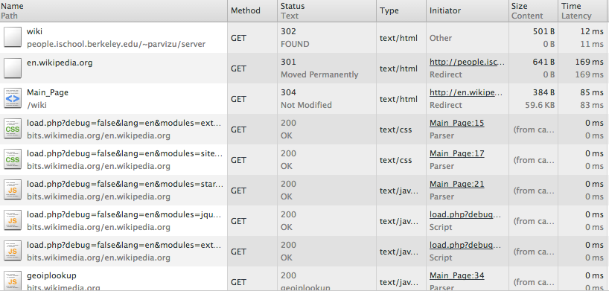

1. What is the return code for <http://people.ischool.berkeley.edu/>~<USER>/server/ ?

127.0.0.1 - - [26/Sep/2013 18:39:15] "GET /wiki HTTP/1.1" 302 -

1. What is the return code for <http://people.ischool.berkeley.edu/>~<USER>/server/ ?

127.0.0.1 - - [26/Sep/2013 18:42:54] "GET / HTTP/1.1" 404 -