OS LAB 5
- RMS
- #include <stdio.h>
- #include <math.h>

- int gcd(int a, int b) {
- if (b == 0)
- return a;
- return gcd(b, a % b);
- }

- int lcm(int a, int b) {
- return (a * b) / gcd(a, b);
- }

- int main() {
- int n;

- printf("Enter number of processes: ");
- scanf("%d", &n);

- int Ci[n], Ti[n], remaining[n], original_id[n];

- for (int i = 0; i < n; i++) {
- printf("Enter execution time (C%d): ", i + 1);
- scanf("%d", &Ci[i]);

- printf("Enter period (T%d): ", i + 1);
- scanf("%d", &Ti[i]);

- remaining[i] = 0;
- original_id[i] = i + 1;
- }

- double U = 0;
- for (int i = 0; i < n; i++) {
- U += (double)Ci[i] / Ti[i];
- }

- double U_bound = n * (pow(2, (double)1/n) - 1);

- printf("\nCPU Utilization (U) = %.4f\n", U);
- printf("Utilization Bound (U_bound) = %.4f\n", U_bound);

- if (U > U_bound) {
- printf("Not Schedulable under RMS\n");
- return 0;
- }

- printf("Schedulable under RMS\n");

- int hyperperiod = Ti[0];
- for (int i = 1; i < n; i++) {
- hyperperiod = lcm(hyperperiod, Ti[i]);
- }

- printf("\nLCM (Hyperperiod) = %d\n", hyperperiod);

- for (int i = 0; i < n - 1; i++) {
- for (int j = i + 1; j < n; j++) {
- if (Ti[i] > Ti[j]) {
- int temp;

- temp = Ti[i]; Ti[i] = Ti[j]; Ti[j] = temp;
- temp = Ci[i]; Ci[i] = Ci[j]; Ci[j] = temp;
- temp = original_id[i]; original_id[i] = original_id[j]; original_id[j] = temp;
- }
- }
- }

- printf("\nRMS Table:\n");
- printf("Process\tExecution Time\tPeriod\n");
- for (int i = 0; i < n; i++) {
- printf("P%d\t%d\t\t%d\n", original_id[i], Ci[i], Ti[i]);
- }

- int schedule[hyperperiod];

- for (int t = 0; t < hyperperiod; t++) {

- for (int i = 0; i < n; i++) {
- if (t % Ti[i] == 0) {
- remaining[i] = Ci[i];
- }
- }

- int selected = -1;

- for (int i = 0; i < n; i++) {
- if (remaining[i] > 0) {
- selected = i;
- break;
- }
- }

- if (selected != -1) {
- schedule[t] = original_id[selected];
- remaining[selected]--;
- } else {
- schedule[t] = 0;
- }
- }

- printf("\nTimeline (Intervals):\n");

- int start = 0;
- for (int t = 1; t <= hyperperiod; t++) {
- if (t == hyperperiod || schedule[t] != schedule[start]) {
- if (schedule[start] == 0)
- printf("Time %d to %d: Idle\n", start, t);
- else
- printf("Time %d to %d: P%d\n", start, t, schedule[start]);

- start = t;
- }
- }

- return 0;
- }
Output:
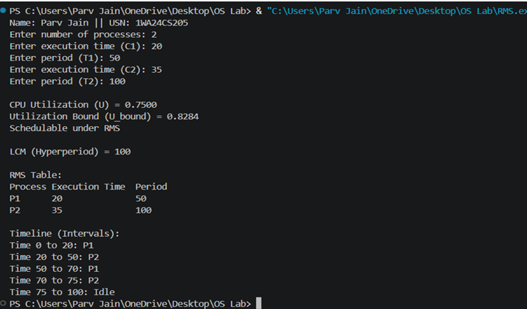
2. EDF
#include <stdio.h>
#define MAX 10
int main() {
int n;
int burst[MAX], deadline[MAX], period[MAX];
int remaining[MAX];
int time = 0;
printf("Enter number of tasks: ");
scanf("%d", &n);
for (int i = 0; i < n; i++) {
printf("Task %d (burst deadline period): ", i + 1);
scanf("%d %d %d", &burst[i], &deadline[i], &period[i]);
remaining[i] = 0; // initially no job released
}
printf("\nPID\tBurst\tDeadline\tPeriod\n");
for (int i = 0; i < n; i++) {
printf("%d\t%d\t%d\t\t%d\n", i + 1, burst[i], deadline[i], period[i]);
}
int limit = 20;
printf("\nScheduling occurs for %d ms\n\n", limit);

while (time < limit) {
for (int i = 0; i < n; i++) {
if (time % period[i] == 0) {
remaining[i] = burst[i];
}
}
int min_deadline = 9999;
int selected = -1;
for (int i = 0; i < n; i++) {
if (remaining[i] > 0) {
if (deadline[i] < min_deadline) {
min_deadline = deadline[i];
selected = i;
}
}
}
if (selected == -1) {
printf("%dms : CPU is idle.\n", time);
} else {
printf("%dms : Task %d is running.\n", time, selected + 1);
remaining[selected]--;
}
time++;
}
return 0;
}
Output:
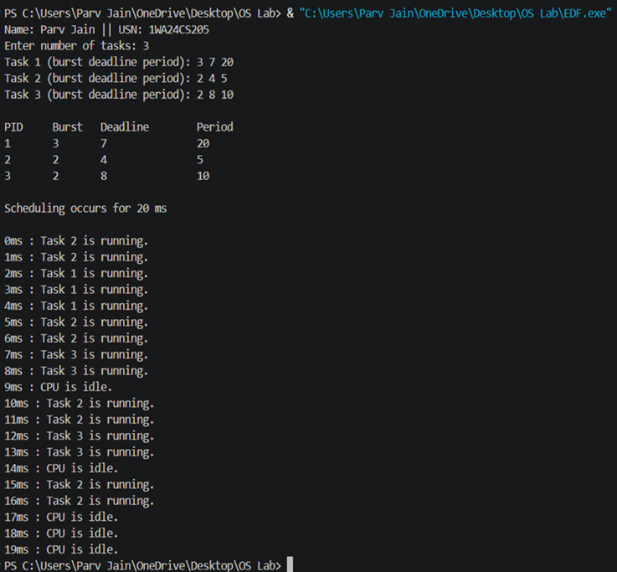
3. Propotional Share:
#include<stdio.h>
#include <stdlib.h>
#include <time.h>
typedef struct
{
char name[5]; int tickets;
}
Process;
int main() {
int n, total_tickets = 0; float total_T =0.0;
printf("Enter the number of Processes: ");
scanf("%d", &n);
Process p[n];
srand(time(NULL));
for (int i = 0; i < n; i++)
{
printf("\nProcess %d:\n", i + 1);
sprintf(p[i].name, "P%d", i + 1);
printf("Tickets: ");
scanf("%d", &p[i].tickets);
total_tickets += p[i].tickets;
total_T +=p[i].tickets;
}
printf("\n--- Proportional Share Scheduling ---\n");
printf("Enter the Time Period for scheduling: ");
int m;

scanf("%d",&m);
for (int i = 0; i < m; i++)
{
int winning_ticket = rand() % total_tickets + 1;
int accumulated_tickets = 0;
int winner_index;
for (int j = 0; j < n; j++)
{
accumulated_tickets += p[j].tickets;
if (winning_ticket <= accumulated_tickets)
{
winner_index = j; break;
}
}
printf("Tickets picked: %d, Winner: %s\n", winning_ticket,
p[winner_index].name);
}
for (int i = 0; i < n; i++)
{
printf("\nThe Process: %s gets %0.2f%% of Processor Time.\n", p[i].name,
((p[i].tickets / total_T) * 100));

}
return 0;
}
Output:
