OS LAB 6
- Producer-Consumer problem using semaphores.
- #include <stdio.h>
- #include <pthread.h>
- #include <unistd.h>
- #include <semaphore.h>

- #define BUFFER_SIZE 5

- int buffer[BUFFER_SIZE];
- int in = 0, out = 0;

- sem_t empty;
- sem_t full;
- pthread_mutex_t mutex;

- void* producer(void* arg) {
- int item, i = 0;
- while (1) {
- item = i++;

- sem_wait(&empty);
- pthread_mutex_lock(&mutex);

- buffer[in] = item;
- printf("Produced: %d at buffer[%d]\n", item, in);
- in = (in + 1) % BUFFER_SIZE;

- pthread_mutex_unlock(&mutex);
- sem_post(&full);

- sleep(1);
- }
- }

- void* consumer(void* arg) {
- int item;
- while (1) {
- sem_wait(&full);
- pthread_mutex_lock(&mutex);

- item = buffer[out];
- printf("Consumed: %d from buffer[%d]\n", item, out);
- out = (out + 1) % BUFFER_SIZE;

- pthread_mutex_unlock(&mutex);
- sem_post(&empty);

- sleep(2);
- }
- }

- int main() {
- pthread_t prod, cons;

- sem_init(&empty, 0, BUFFER_SIZE);
- sem_init(&full, 0, 0);
- pthread_mutex_init(&mutex, NULL);

- pthread_create(&prod, NULL, producer, NULL);
- pthread_create(&cons, NULL, consumer, NULL);

- pthread_join(prod, NULL);
- pthread_join(cons, NULL);

- sem_destroy(&empty);
- sem_destroy(&full);
- pthread_mutex_destroy(&mutex);

- return 0;
- }

Output:
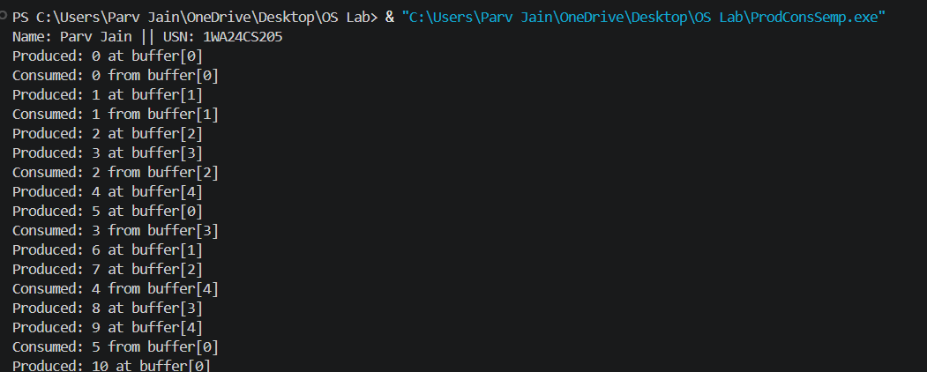

2. Dining-Philosopher’s problem
#include <stdio.h>
#include <pthread.h>
#include <unistd.h>

#define N 5

pthread_mutex_t forks[N];
pthread_t philosophers[N];

void* philosopher(void* num) {
int id = *(int*)num;
int left = id;
int right = (id + 1) % N;

while (1) {
printf("Philosopher %d is thinking.\n", id);
sleep(1);

if (id % 2 == 0) {

pthread_mutex_lock(&forks[left]);
printf("Philosopher %d picked up left fork %d.\n", id, left);

pthread_mutex_lock(&forks[right]);
printf("Philosopher %d picked up right fork %d.\n", id, right);
} else {
pthread_mutex_lock(&forks[right]);
printf("Philosopher %d picked up right fork %d.\n", id, right);

pthread_mutex_lock(&forks[left]);
printf("Philosopher %d picked up left fork %d.\n", id, left);
}

printf("Philosopher %d is eating.\n", id);
sleep(2);

pthread_mutex_unlock(&forks[left]);
pthread_mutex_unlock(&forks[right]);
printf("Philosopher %d put down forks %d and %d.\n", id, left, right);
}
return NULL;
}

int main() {
int i;
int ids[N];

for (i = 0; i < N; i++) {
pthread_mutex_init(&forks[i], NULL);
ids[i] = i;
}

for (i = 0; i < N; i++) {
pthread_create(&philosophers[i], NULL, philosopher, &ids[i]);
}

for (i = 0; i < N; i++) {
pthread_join(philosophers[i], NULL);
}

for (i = 0; i < N; i++) {
pthread_mutex_destroy(&forks[i]);
}

return 0;
}
Output:
