OS LAB 7
- Bankers’ algorithm for the purpose of deadlock avoidance.
- #include <stdio.h>

- int main() {
- int n, r;

- printf("Enter number of processes: ");
- scanf("%d", &n);
- printf("Enter number of resources: ");
- scanf("%d", &r);

- int alloc[n][r], max[n][r], avail[r], need[n][r], safeSeq[n];
- int finish[n];

- printf("Enter Allocation Matrix:\n");
- for (int i = 0; i < n; i++) {
- for (int j = 0; j < r; j++) {
- scanf("%d", &alloc[i][j]);
- }
- }

- printf("Enter Maximum Demand Matrix:\n");
- for (int i = 0; i < n; i++) {
- for (int j = 0; j < r; j++) {
- scanf("%d", &max[i][j]);
- need[i][j] = max[i][j] - alloc[i][j];
- }
- }

- printf("Enter Available Resources:\n");
- for (int i = 0; i < r; i++) {
- scanf("%d", &avail[i]);
- }

- for (int i = 0; i < n; i++) {
- finish[i] = 0;
- }

- int count = 0;
- while (count < n) {
- int found = 0;
- for (int p = 0; p < n; p++) {
- if (finish[p] == 0) {
- int j;
- for (j = 0; j < r; j++) {
- if (need[p][j] > avail[j])
- break;
- }

- if (j == r) {
- for (int k = 0; k < r; k++) {
- avail[k] += alloc[p][k];
- }
- safeSeq[count++] = p;
- finish[p] = 1;
- found = 1;
- }
- }
- }

- if (found == 0) {
- printf("\nSystem is not in a safe state.");
- return 0;
- }
- }

- printf("\nSystem is in a safe state.\n");
- printf("Safe sequence is: ");
- for (int i = 0; i < n; i++) {
- printf("P%d", safeSeq[i]);
- if (i != n - 1) printf(" -> ");
- }
- printf("\n");

- return 0;
- }
Output:
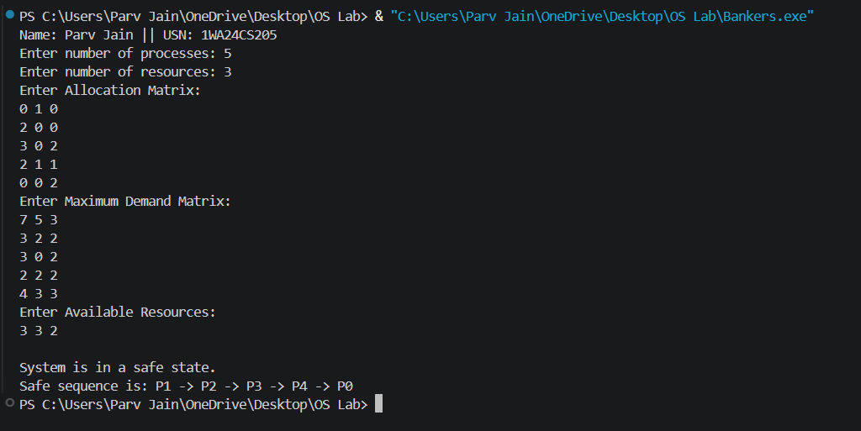

2. Deadlock Detection
#include <stdio.h>

int main() {
int n, r;

printf("Enter the number of processes: ");
scanf("%d", &n);
printf("Enter the number of resources: ");
scanf("%d", &r);

int alloc[n][r], request[n][r], avail[r], safeSeq[n];
int finish[n];

printf("Enter the allocation matrix:\n");
for (int i = 0; i < n; i++) {
printf("Process %d: ", i);
for (int j = 0; j < r; j++) {
scanf("%d", &alloc[i][j]);
}
}

printf("Enter the request matrix:\n");
for (int i = 0; i < n; i++) {
printf("Process %d: ", i);
for (int j = 0; j < r; j++) {
scanf("%d", &request[i][j]);
}
}

printf("Enter the available resources: ");
for (int i = 0; i < r; i++) {
scanf("%d", &avail[i]);
}

for (int i = 0; i < n; i++) {
finish[i] = 0;
}

int count = 0;
while (count < n) {
int found = 0;
for (int p = 0; p < n; p++) {
if (finish[p] == 0) {
int j;
for (j = 0; j < r; j++) {
if (request[p][j] > avail[j])
break;
}

if (j == r) {
for (int k = 0; k < r; k++) {
avail[k] += alloc[p][k];
}
safeSeq[count++] = p;
finish[p] = 1;
found = 1;
}
}
}

if (found == 0) {
printf("\nSystem is not in a safe state.\n");
return 0;
}
}

printf("System is in safe state.\n");
printf("Safe Sequence is: ");
for (int i = 0; i < n; i++) {
printf("P%d", safeSeq[i]);
if (i != n - 1) printf(" ");
}
printf("\n");

return 0;
}

Output:
