//Create a flume agent that streams data from Twitter and stores it in the HDFS cluster.

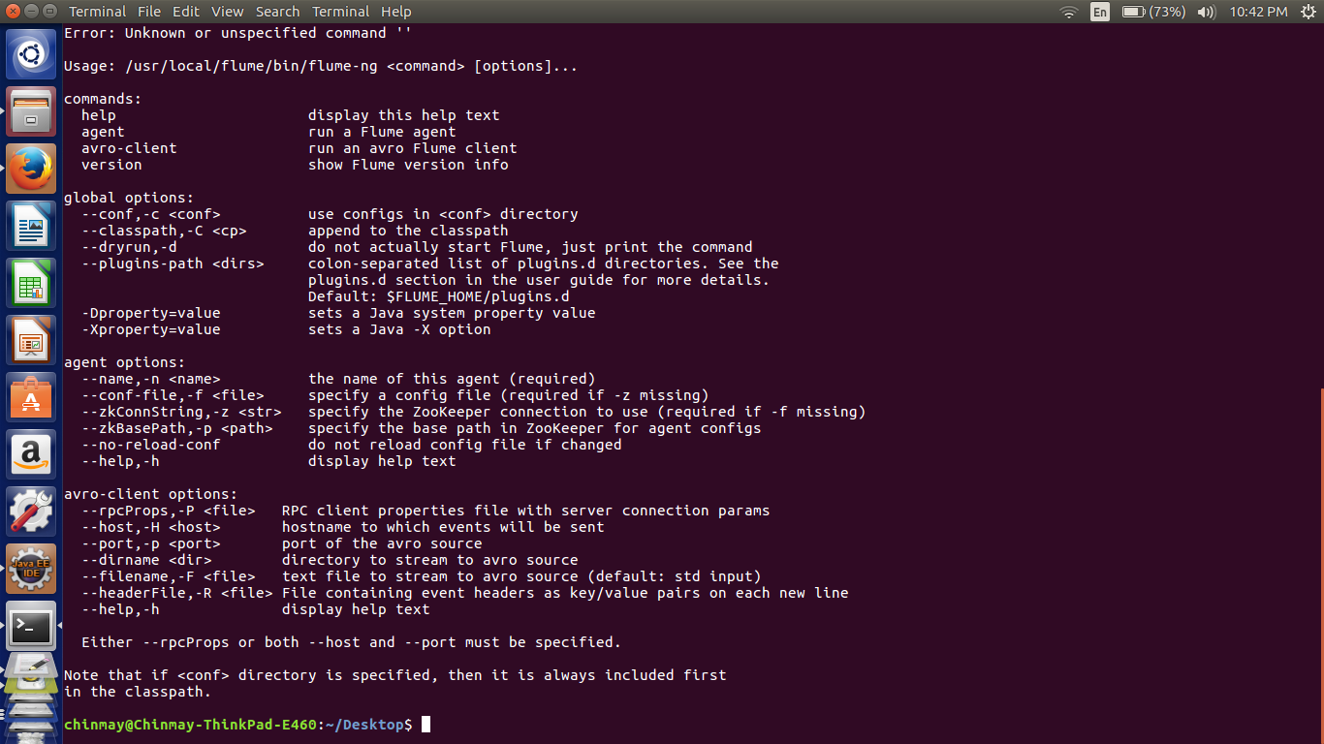

//creation of keys

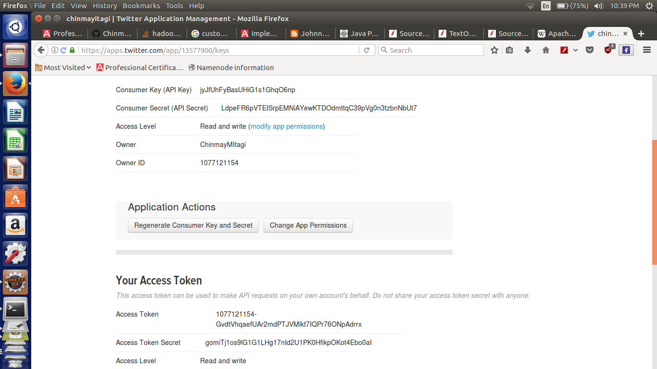

//Command used to execute the agent.

flume-ng agent -n TwitterAgent -f /usr/local/flume/conf/twitteragent.conf

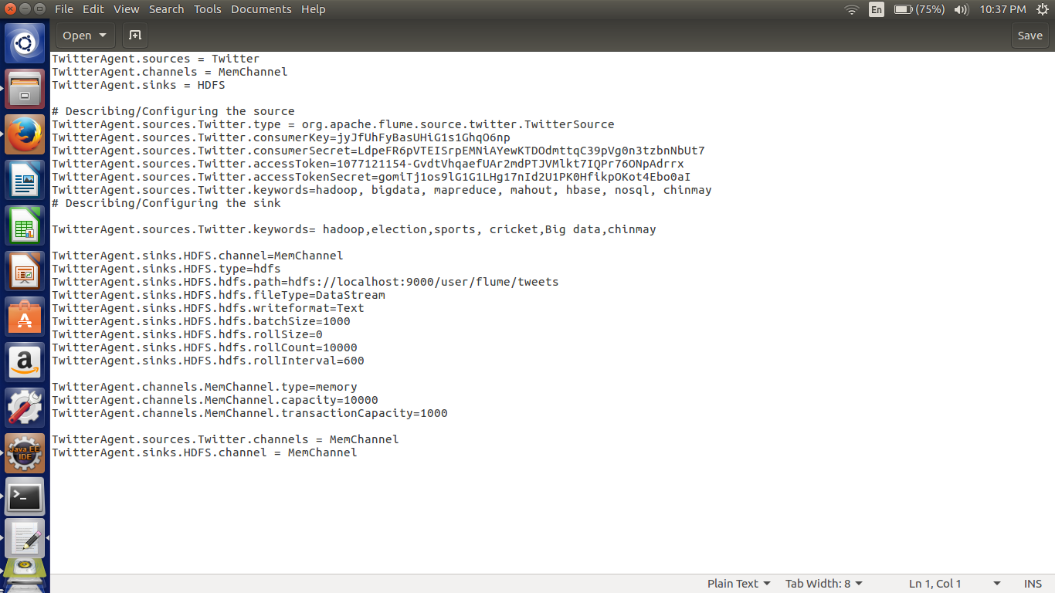

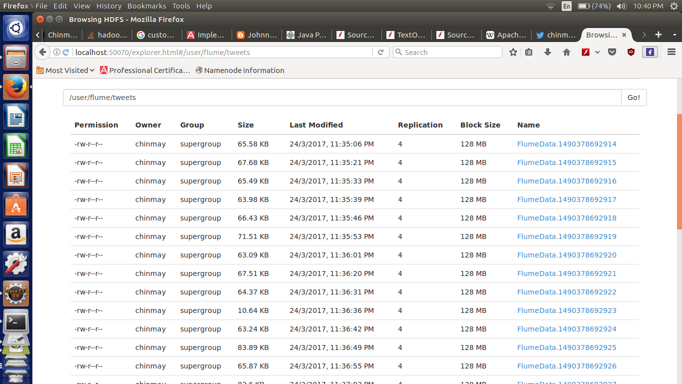

//output

