**Write a secondary sort program to generate the top 2 maximum temperatures corresponding to every year from the temperature dataset.**

**Driver**

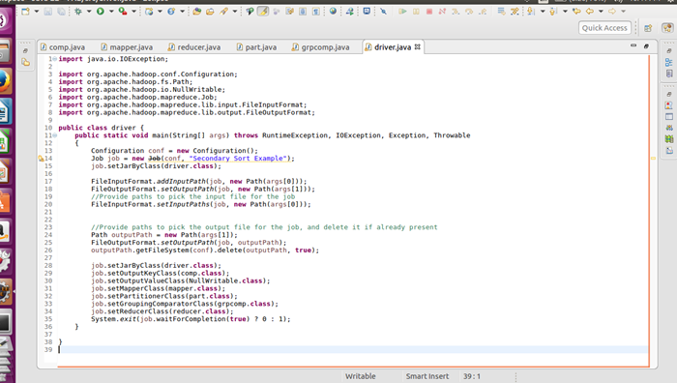

**Mapper**

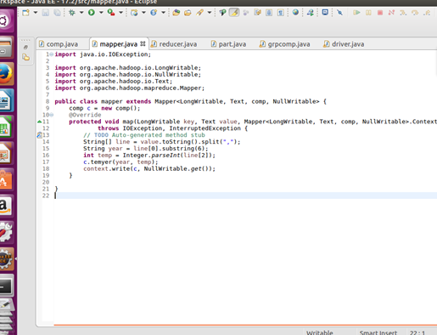

**Comparable writable**

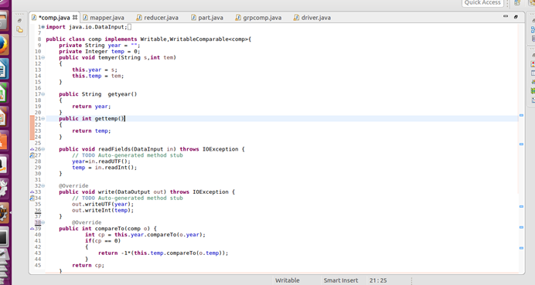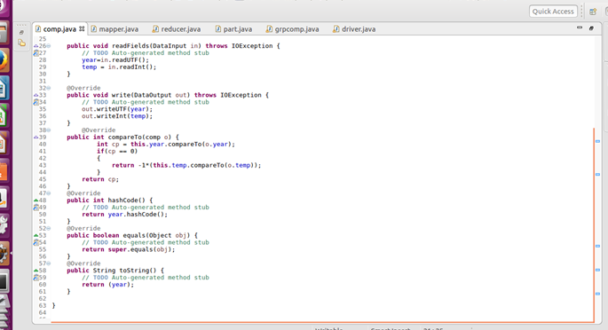

**partitioner**

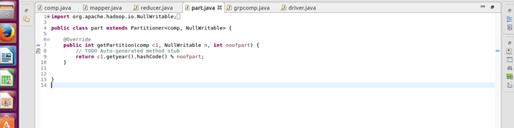

**Group comparator**

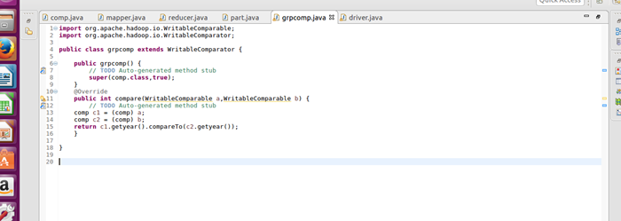

**Reducer**

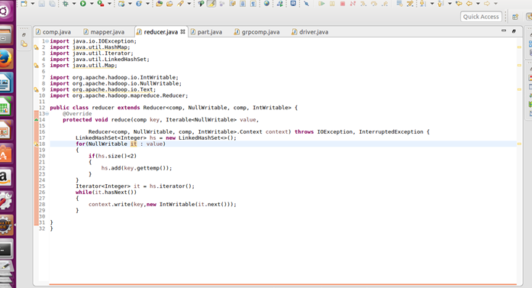

**Output**

