Find out what are the top 5 categories with maximum number of videos uploaded.

Driver

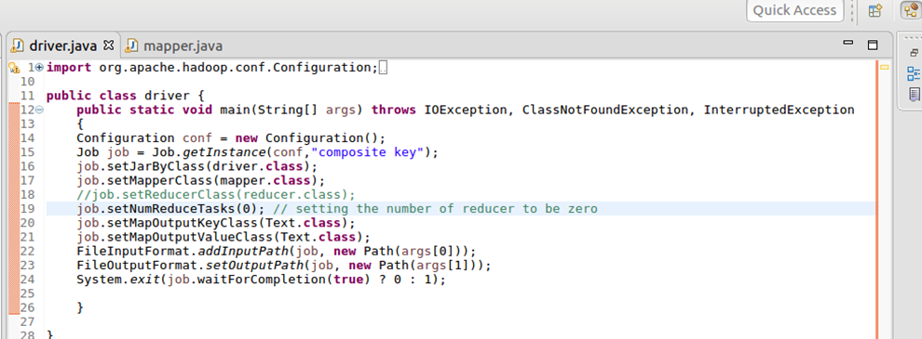

Mapper

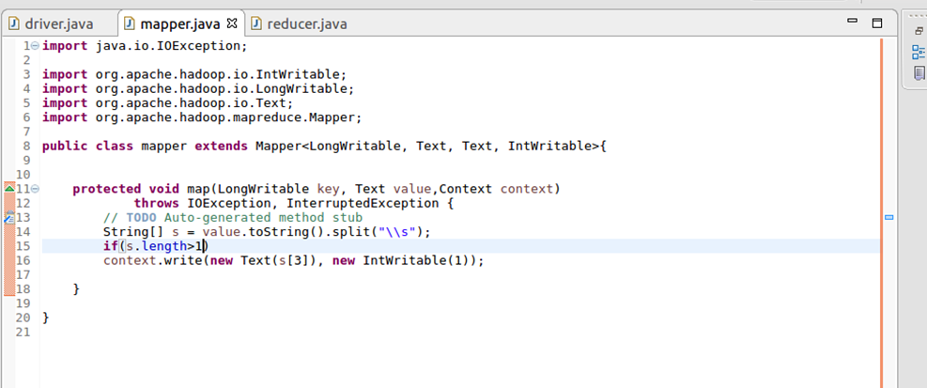

Reducer

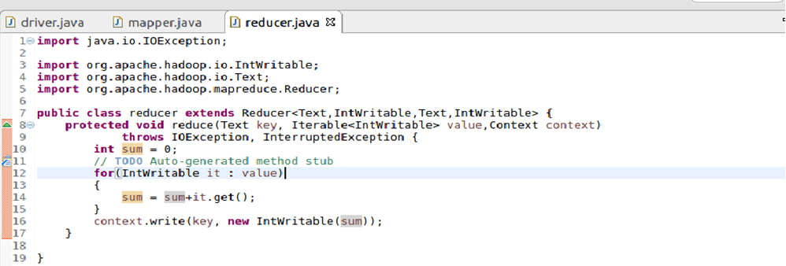

Output

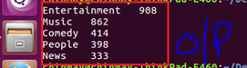

Find the top 10 rated videos in youtube.

Driver

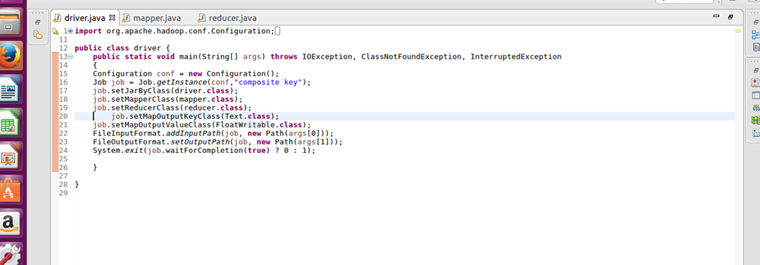

Mapper

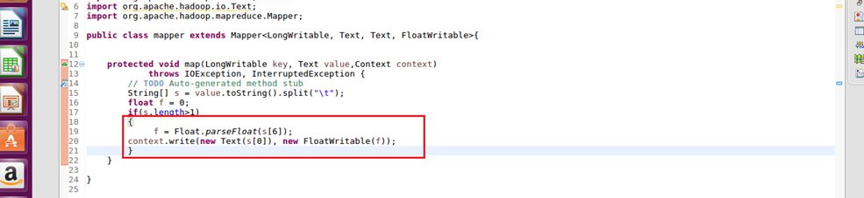

Reducer

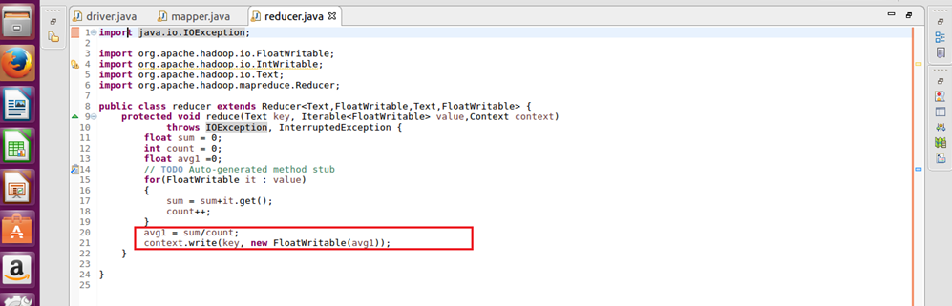

Output

