**Assignment 25.1**

1. **Write a Hive program to find the number of medals won by each country in swimming.**

**Commands:**

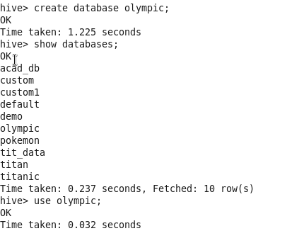

**Create table:**

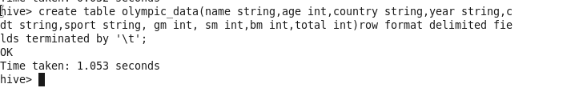

**Load dataset:**

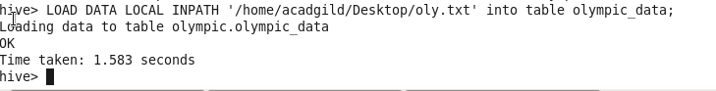

**Select country,count(total) from Olympic_data where sport=”Swimming” group by country;**

**Output:**

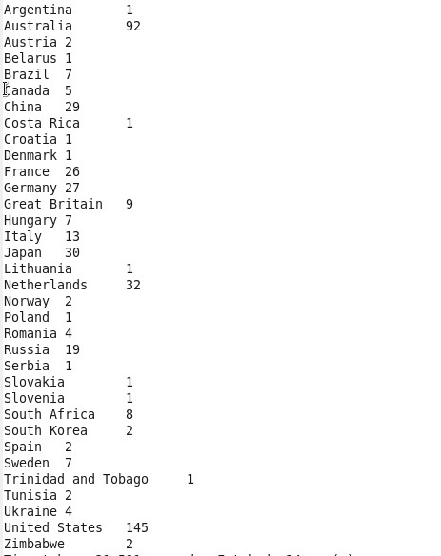

1. **Write a Hive program to find the number of medals that India won year wise.**

