**Assignment 25.2**

1. **Write a Hive Program to find the total number of medals each country won.**

**Commands:**

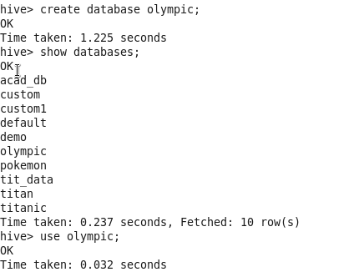

**Create table:**

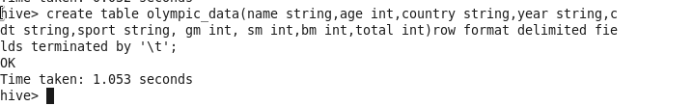

**Load Dataset:**

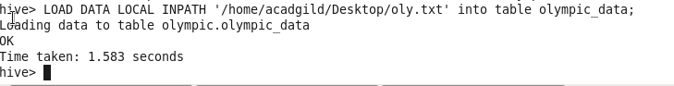

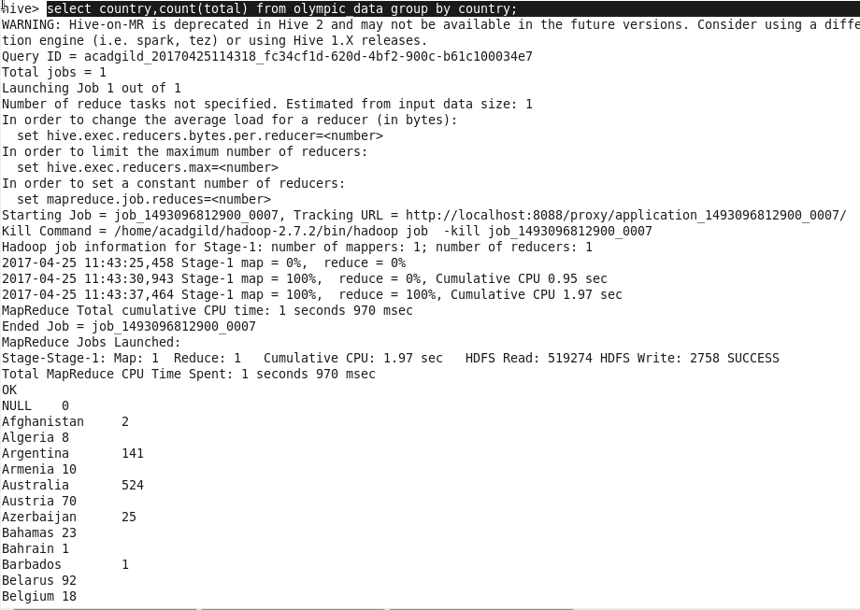

1. **Write a Hive program to find the number of gold medals each country won**

