1.Write a hive query to find the top 20 destination people travel the most

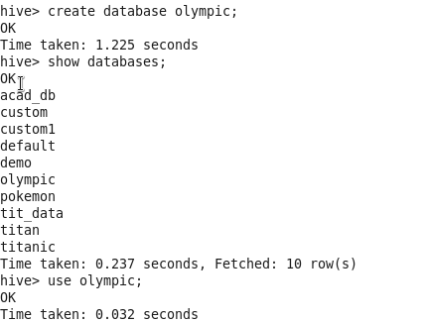

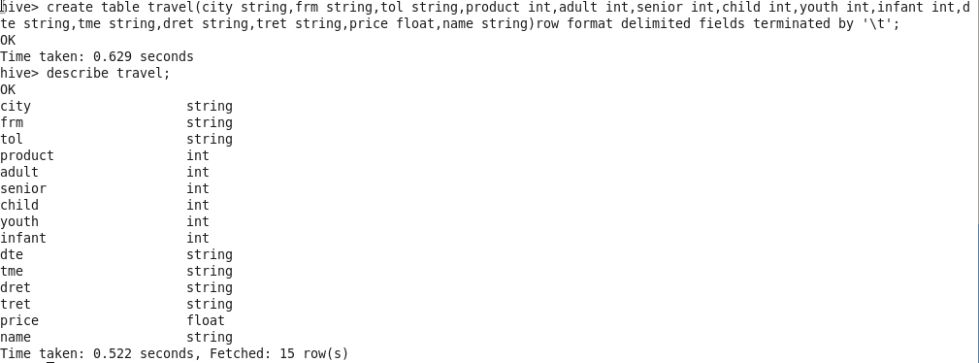

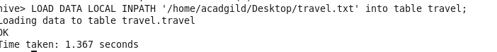

C:\Users\612834\Pictures\25.4query.PNG

Output

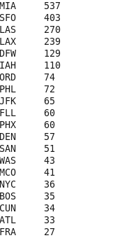

2. Write a hive query to find the top 20 locations from where people travel the mostC:\Users\612834\Pictures\25.4bquery.PNG

OUTPUT

