**Assignment 25.5**

1. **Write a hive query to list top 5 residency details which lie in the budget of 60000-120000, an area more than 1450, sold after 17th may, min bedroom 3 and, min bathroom 2.**

**Commands:**

**Create:**

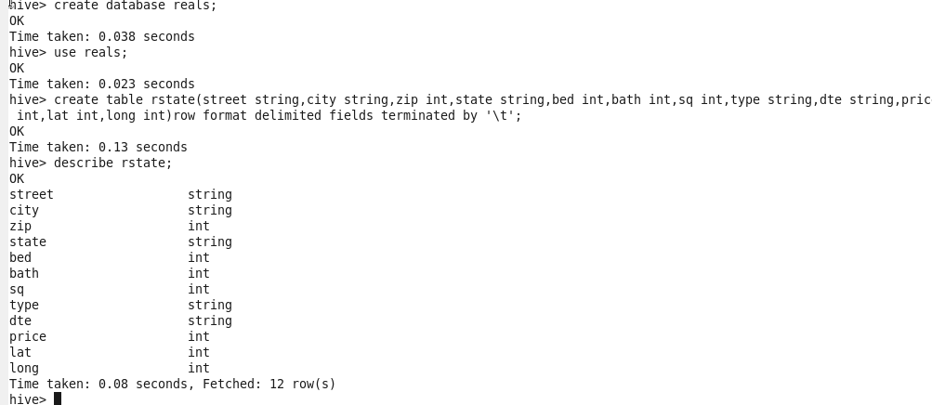

**Load:**

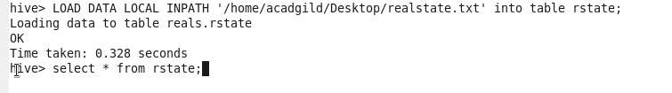

**Query:**



**Output:**

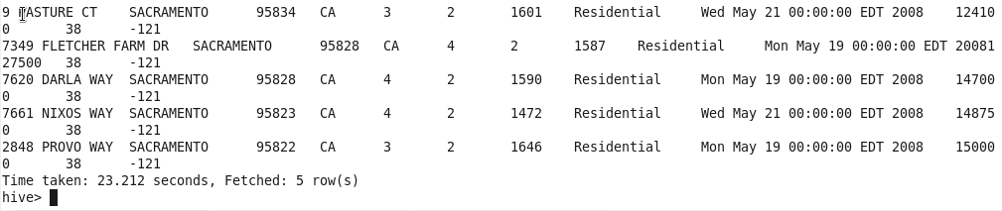

**B) Write a hive query to separate list of residential apartments with more than 2 beds. Also include columns in following order City,Baths,Sq_feet,Price,flat_type,Beds respectively.**

**Commands:**

**Create:**



**Insert**:



**Select:**



**Output:**

