**Input File-**

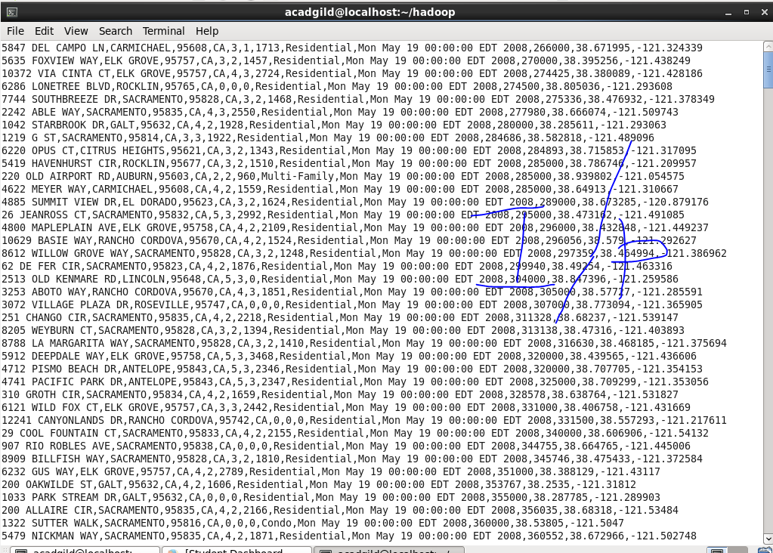

1. **Write a hive query to find the city wise list all the Condos which is not less than ten thousand.**

* **Display all the details using SELECT *.**
* **Condition to check for flat type.**
* **Condition to check for price >10000.**

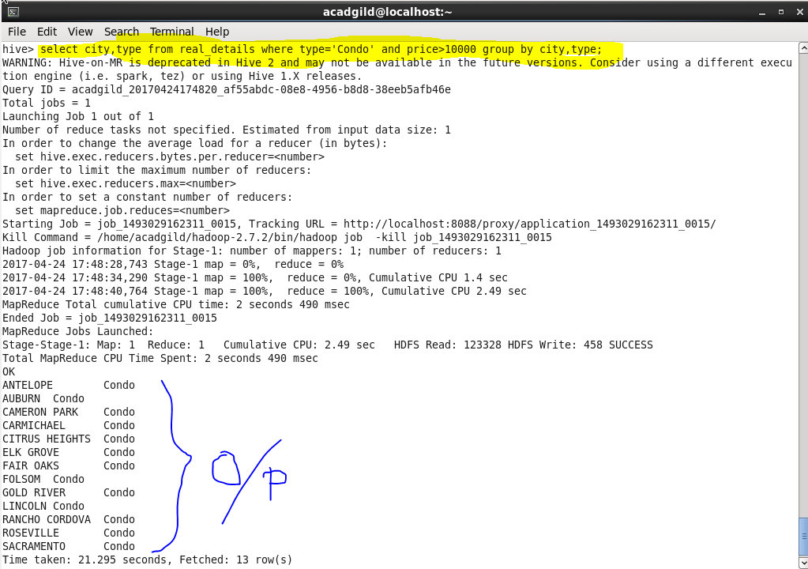

1. **Write a hive query to find which is the cheapest Condo in CA. name the city,street and price for the Condo.**

* **Display all the details using SELECT *.**
* **Condition to check for flat type.**
* **Condition to check for state.**
* **Condition to find top entry form the list.**

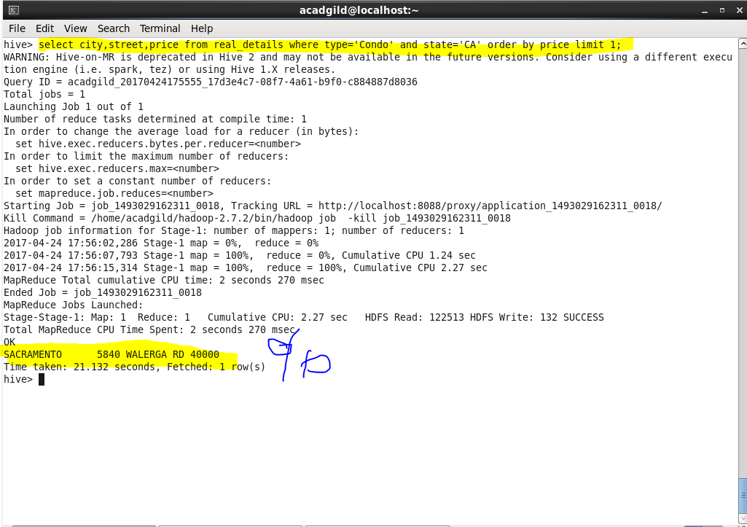

1. **Write a hive query to list top 5 residency details which lie in the budget of 60000-120000, an area more than 1450, sold after 17th may, min bedroom 3 and, min bathroom 2.**

* **Display all the details using SELECT *.**
* **Condition to check for price between range 60000-120000.**
* **Condition to check for area more than 1450 sq_ft.**
* **Condition to check for minimum bedroom and minimum bathroom.**
* **Condition to check for the date after 17 May.**

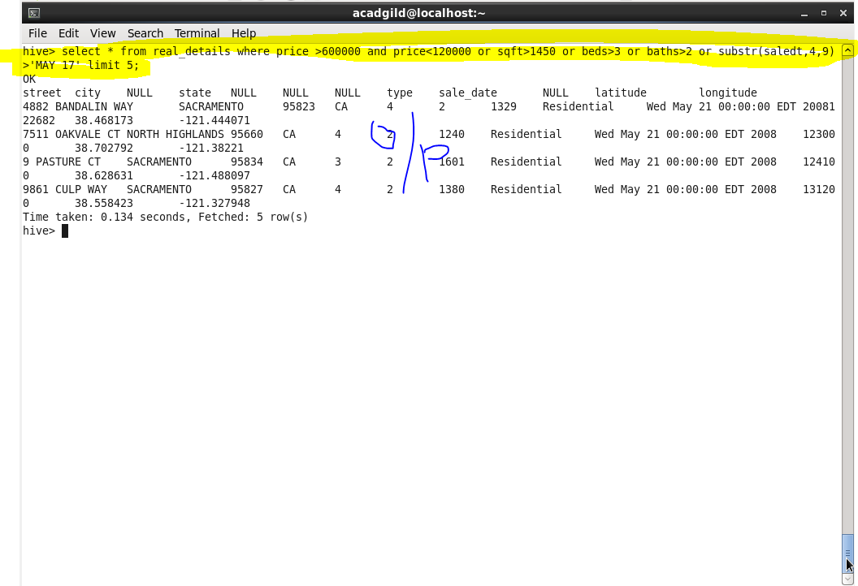

1. **Write a hive query to separate list of residential apartments with more than 2 beds. Also include columns in following order City,Baths,Sq_feet,Price,flat_type,Beds respectively.**

* **Display all the details using SELECT *.**
* **Condition to check for flat type.**
* **Condition to check for beds.**

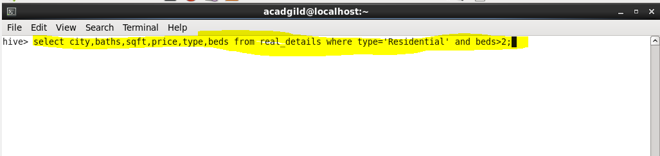

**Output- There are lot many details, just included some.**

