**Assignment 35.1**

**Ques: Create a employee table in Mysql and columns as Emp_id, Emp_name, Dept_name(Hadoop Developer), Emp_sal.**

Ans)

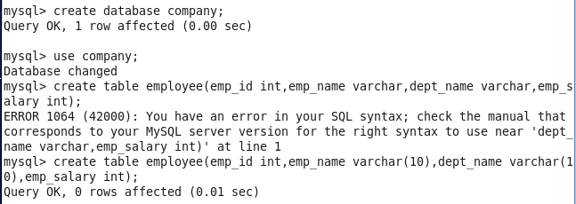

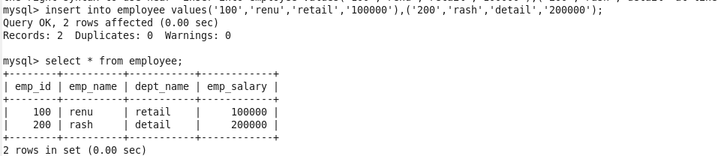

**● Import the employee table contents into the HDFS directory using Sqoop.**

**C:\Users\613000\Desktop\3.1.importcmd.PNG**



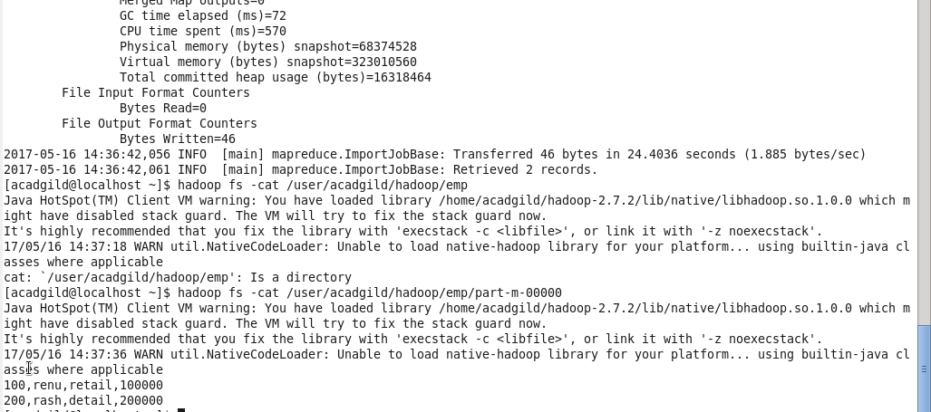

**Create a employee2 table in Mysql and Export employee details file from HDFS directory to Mysql table employee2 using Sqoop.**

**C:\Users\613000\Desktop\35.1.exportcmd.PNG**

