**Assignment 35.2**

**Ques: Explain and perform Sqoop Incremental Import operation to load data from Mysql To HDFS using Sqoop**

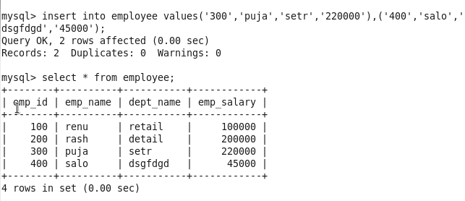

**OUTPUT:**

