**Write a map reduce program to use Sequence file as input and save the output in key value output format.**

**Driver**

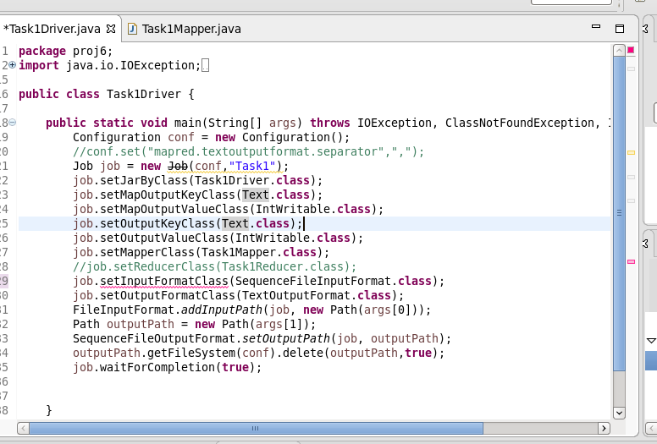

**Mapper**

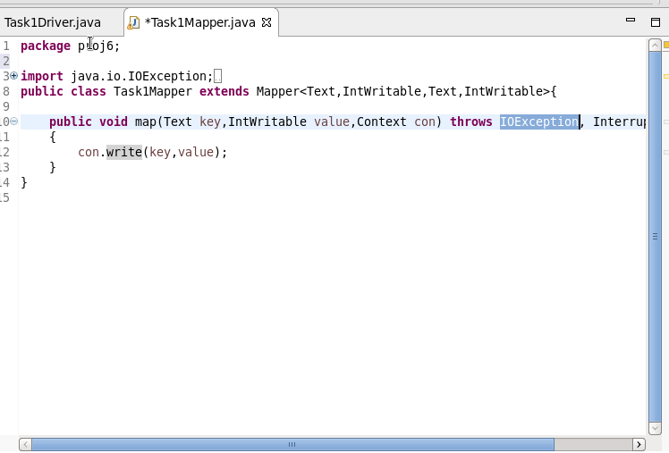

**Output**

