Write a word count program using partitioner and implement the following logic in the partitioner words with length 5 should go into reducer 1 and words with length 6 should go into reduer 2 and the rest of the words should go into reducer 3.

Sample Input:

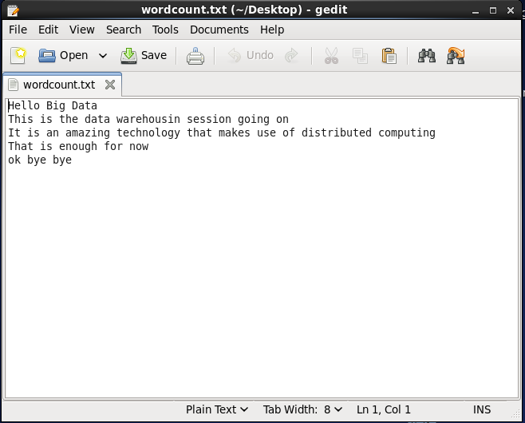

Driver class:

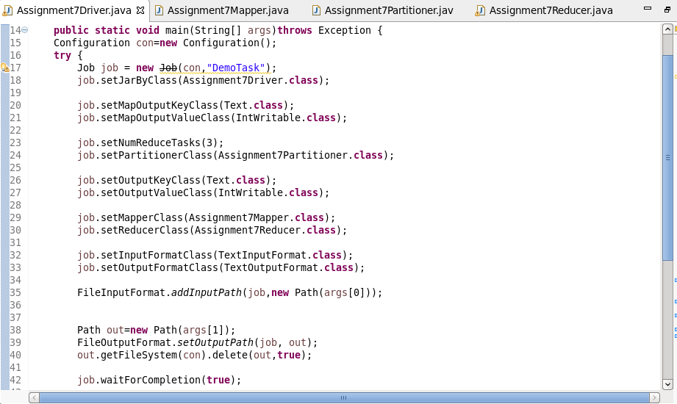

Mapper class:

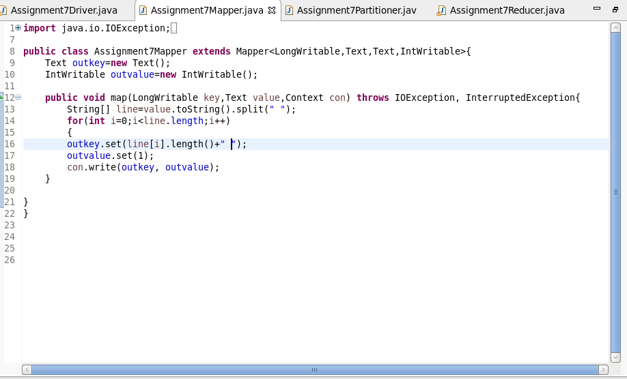

Partitioner class:

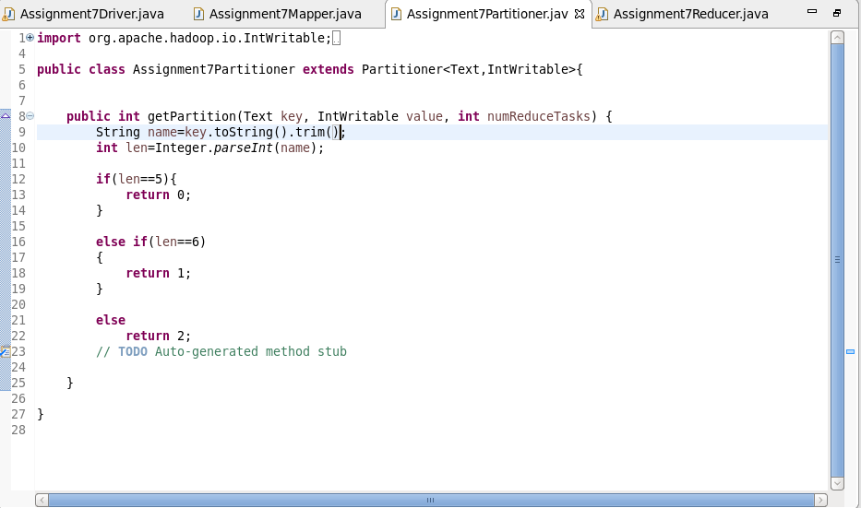

Reducer class:

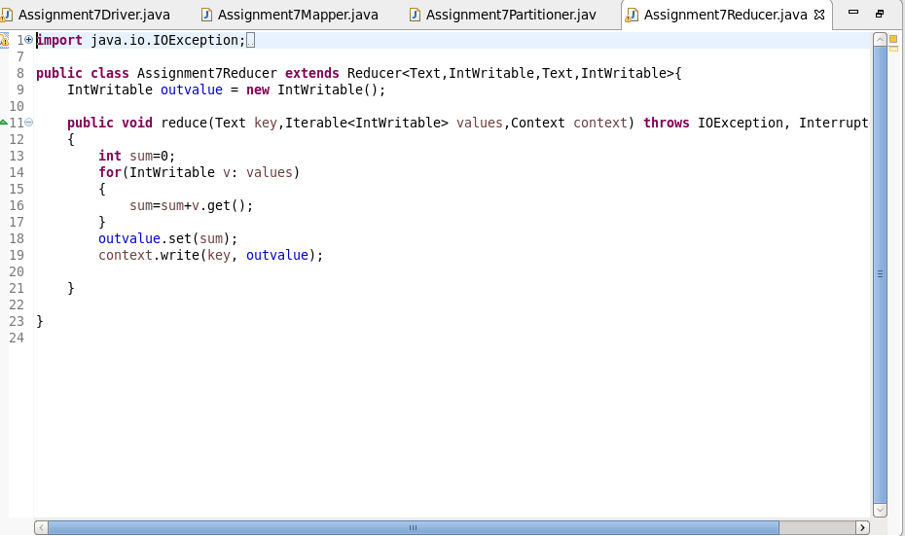

Output:

