Project

# Login Page

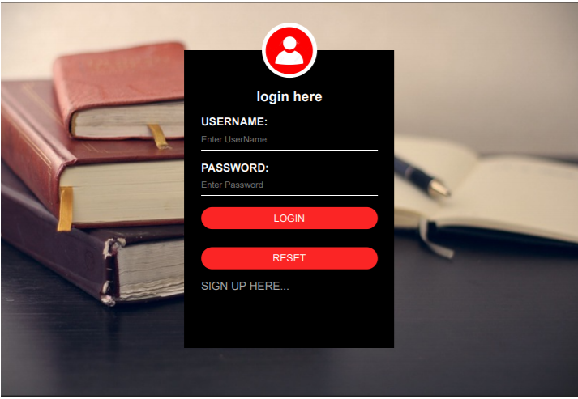

# Signup Page

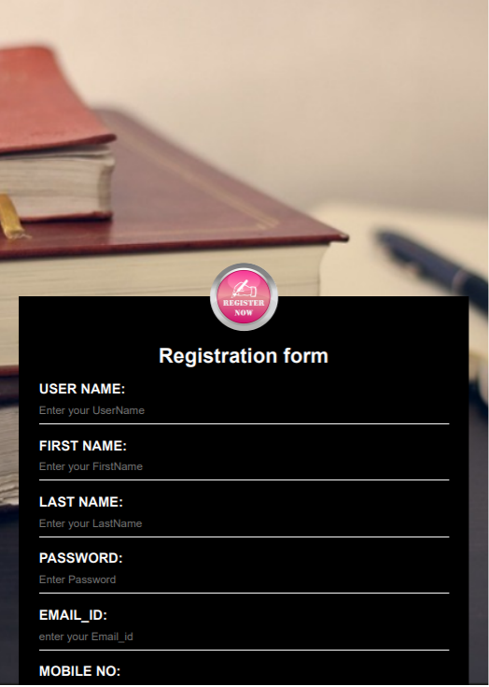

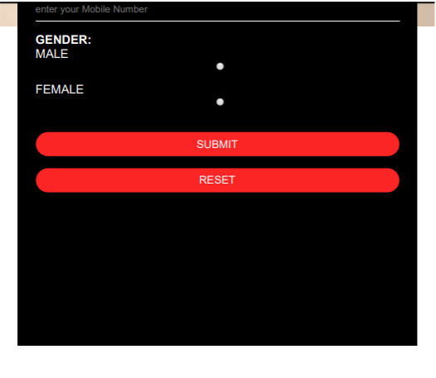

# Main Page

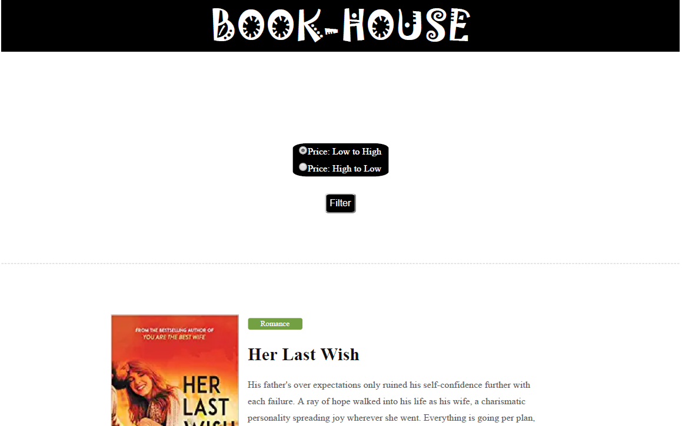

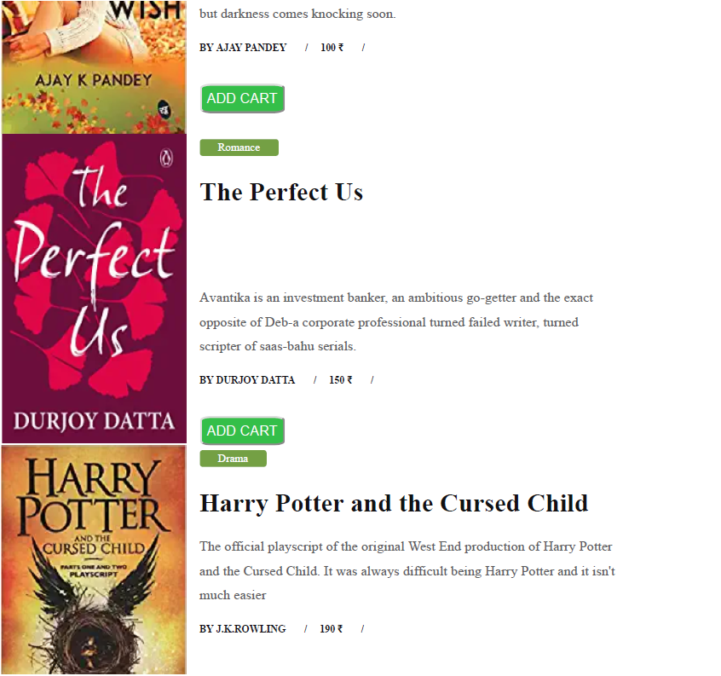

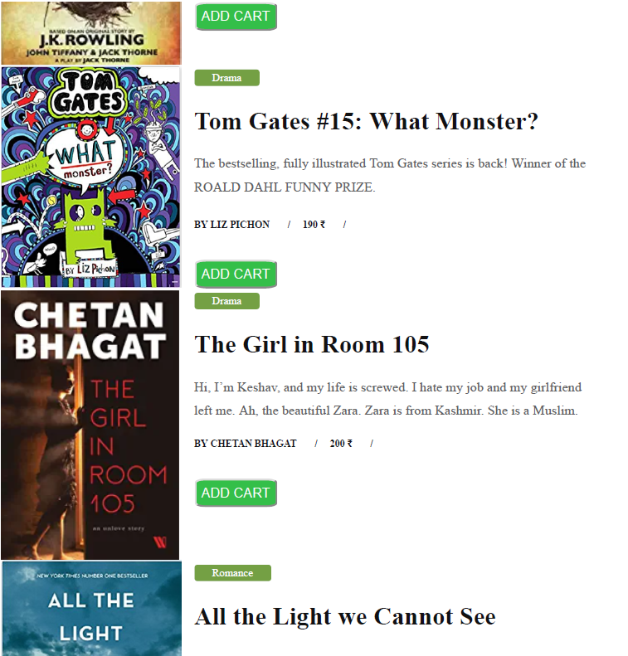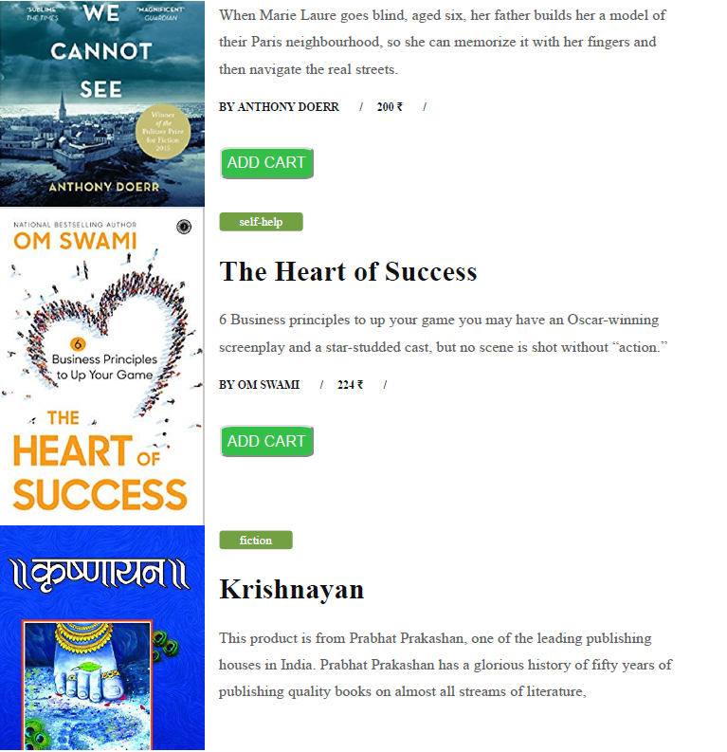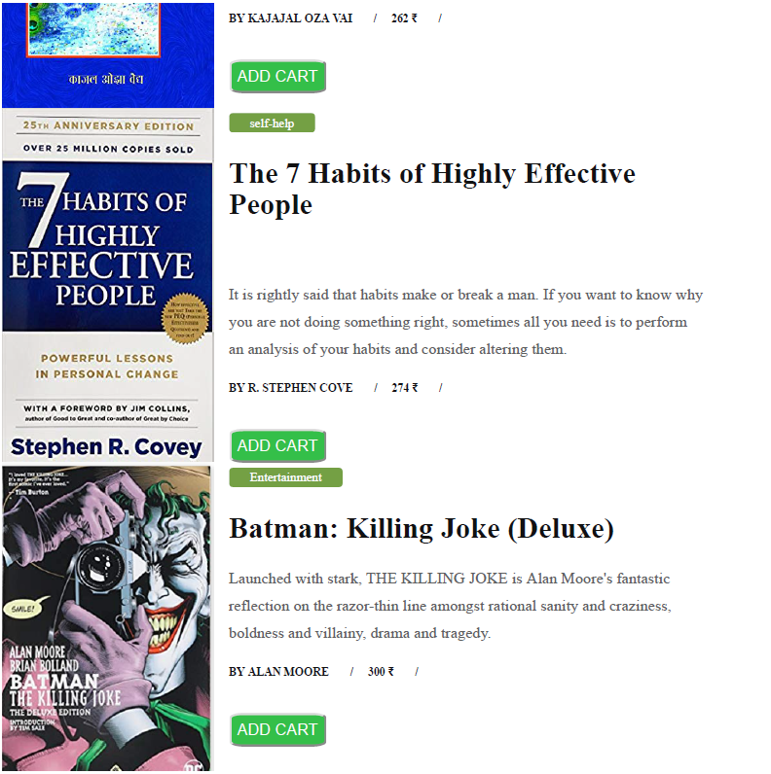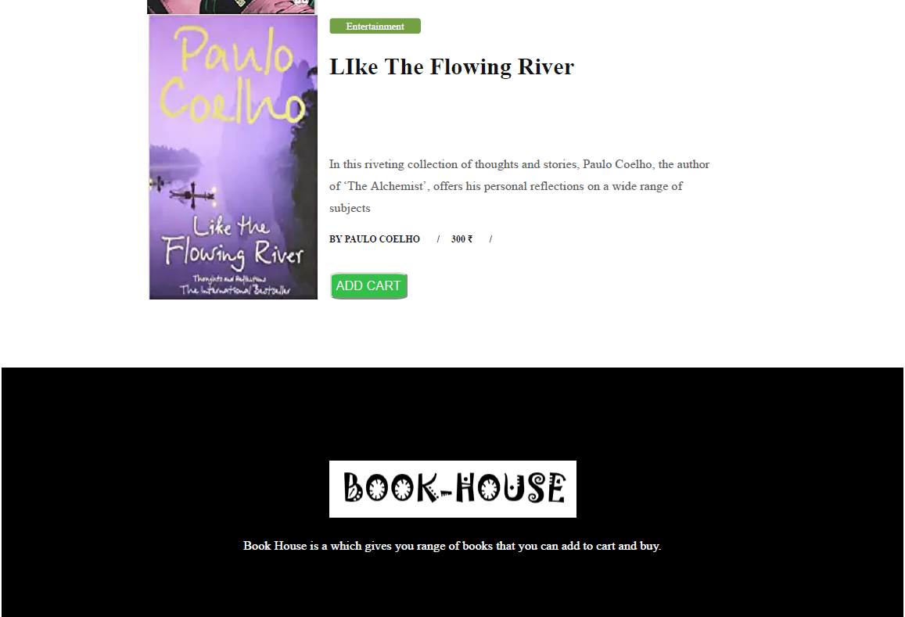

# Cart Page

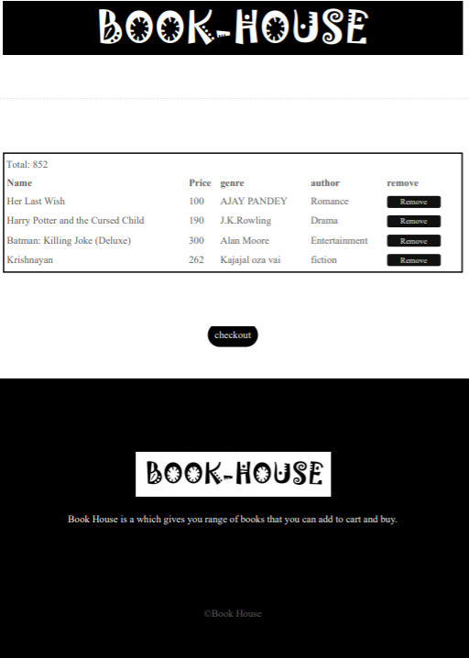

# Check Out Page

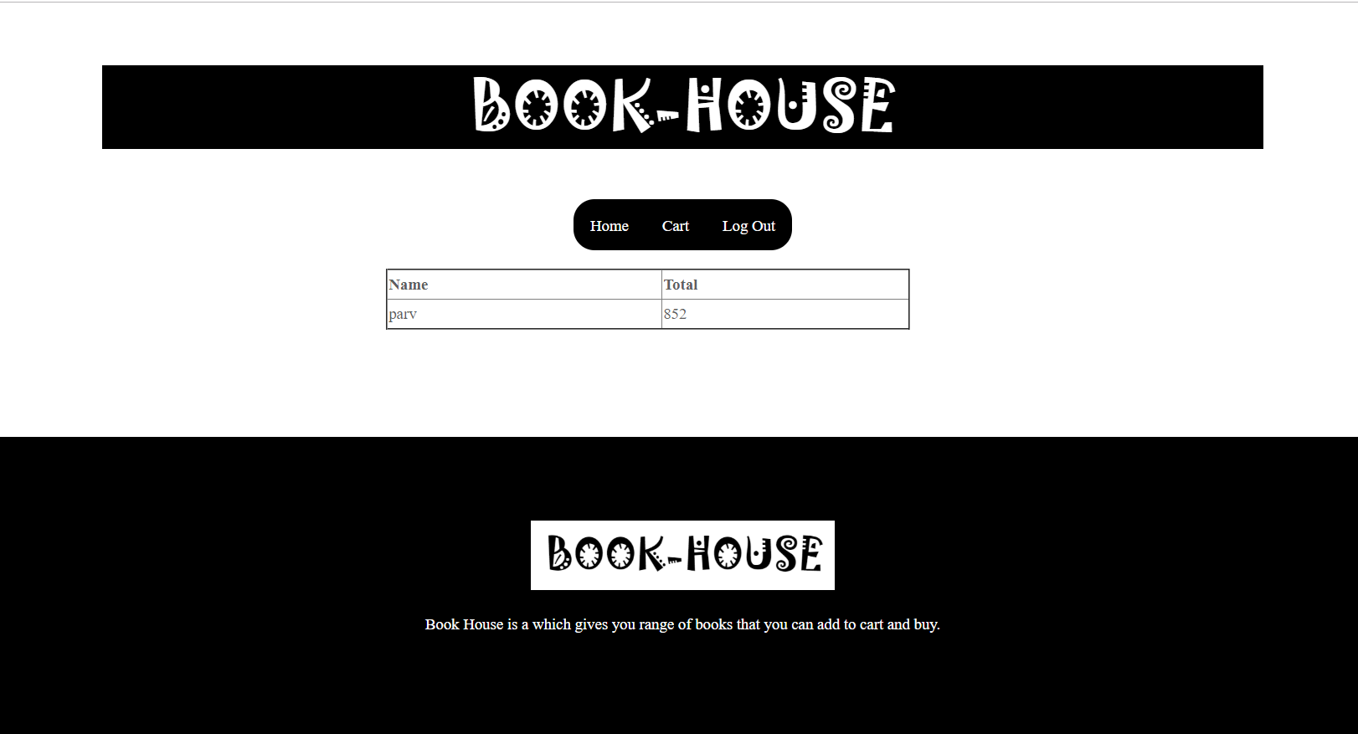

# Connection.php

<?php

$servername = "localhost";

$username = "root";

$password = "";

$db = "dp";

// Create connection

$conn = mysqli_connect($servername, $username, $password,$db);

// Check connection

if (!$conn) {

die("Connection failed: " . mysqli_connect_error());

}

?>

# Index.php(login page)

<?php

session_start();

include "connection.php";

?>

<html>

<head>

<title> login page </title>

<link rel="stylesheet" type="text/css" href="style1.css">

</head>

<body>

<div class="loginbox">

<img src="img/login.png" class="logo">

<h1> login here </h1>

<form name="login" method="post" action="login_verify.php" onSubmit="return validate(this)">

<?php if(isset($_GET['msg'])) echo $_GET['msg']; ?>

<p> USERNAME: </p>

<input type="text" name="u_nm" placeholder="Enter UserName">

<p> PASSWORD: </p>

<input type="password" name="u_pass" placeholder="Enter Password">

<input type="submit" value="LOGIN" name="login_submit">

<input type="reset" value="RESET" name="login_reset">

<a href="registrationform.php">SIGN UP HERE...</a>

</form>

</div>

</body>

<!--script to validate the login form on submit -->

<script type="text/javascript">

function validate(login)

{

if(login.u_nm.value == "")

{

alert("User Name Can Not Be Blank");

login.u_nm.focus();

return false;

}

if(login.u_pass.value == "")

{

alert("Password Can Not Be Blank");

login.u_pass.focus();

return false;

}

}

function onlyChar(e)

{

var charCode=e.which || e.keyCode;

if((charCode >= 65 && charCode <=90)|| (charCode >= 97 && charCode <=122) || charCode==9 || charCode==46 || charCode==8)

return true;

return false;

}

</script>

</html>

# Login_Verify.php

<html >

<head>

<meta http-equiv="Content-Type" content="text/html; charset=iso-8859-1" />

<title>Untitled Document</title>

</head>

<body>

<?php

session_start();

include "connection.php";

if($_SESSION['u_nm']=='')

{

header("Location:index.php");

}

?>

<?php if(isset($_GET['msg'])) echo $_GET['msg']; ?>

<?php

if(isset($_POST['u_nm']))

{

$u_nm = $_POST['u_nm'];

$u_pass = $_POST['u_pass'];

$rs ="select * from registration where u_nm='".$u_nm."' and u_pass='".$u_pass."'";

$res=mysqli_query($conn,$rs);

$cnt=mysqli_num_rows($res);

if($cnt > 0)

{

$_SESSION['u_nm'] = $u_nm;

header('Location:garden-index.php?sort="asc"');

}

else

{

$msg = "<center><h1> Username or Password are not correct, try again.</center></h1>";

header("Location:index.php?msg=$msg");

}

}

?>

</body>

</html>

# Registration.php

<?php session_start(); ?>

<html>

<head>

<title> login page </title>

<link rel="stylesheet" type="text/css" href="registration.css">

</head>

<body>

<p>&nbsp;&nbsp;</p>

<div class="loginbox">

<img src="img/reg.png"class="logo">

<?php if(isset($_GET['msg'])) echo $_GET['msg']; ?>

<h1> Registration form </h1>

<form name="crt_user" method="post" onSubmit="return validate(this)">

<p> USER NAME: </p>

<input type="text" name="u_nm" placeholder="Enter your UserName" onKeyDown="return onlyChar(event);"><br>

<p> FIRST NAME: </p>

<input type="text" name="f_nm" placeholder="Enter your FirstName" onKeyDown="return onlyChar(event);" ><br>

<p> LAST NAME: </p>

<input type="text" name="l_nm" placeholder="Enter your LastName" onKeyDown="return onlyChar(event);"><br>

<p> PASSWORD: </p>

<input type="password" name="u_pass" placeholder="Enter Password"><br>

<p> CONFORM PASSWORD: </p>

<input type="password" name="con_pass" placeholder="Enter Your conform Password"><br>

<p>EMAIL_ID:</p>

<input type="text" name="e_mail" placeholder="enter your Email_id " onBlur="return email1();">

<P>MOBILE NO:<p>

<input type="text" name="u_mob_no" placeholder="enter your Mobile Number " onKeyDown="return onlyNumbers(event);" maxlength="10"/><br>

<p> GENDER: </p>

MALE<input type="radio" name="gender" <?php if (isset($gender) && $gender=="M") echo "checked";?> value="M"> FEMALE <input type="radio" name="gender" <?php if (isset($gender) && $gender=="F") echo "checked";?> value="F">

<br><br>

<p>Select Secrete Question</p>

<select name="sec_question">

<option>What is Your Pet Name?</option>

<option>Which is Your Birth Place?</option>

<option>What is the Name of Your School?</option>

<option>What is Your Grand Mother Name?</option>

<option>Who is Your Favourite Hero?</option>

</select>

<br><br>

<p> Enter Your Answer</p>

<input type="text" name="sec_ans" placeholder="enter your answer" onKeyDown="return onlyChar(event);" />

<input type="text" name="captcha" onKeyDown="return onlyChar(event);">

<input type="submit" value="SUBMIT" name="create_login">

<input type="reset" value="RESET" name="reset_login">

</form>

</div>

</body>

<script type="text/javascript">

function validate(crt_user)

{

if(crt_user.u_nm.value == "")

{

alert("Enter User name");

crt_user.u_nm.focus();

return false;

}

else if(crt_user.f_nm.value == "")

{

alert("Enter User First Name");

crt_user.f_nm.focus();

return false;

}

else if(crt_user.l_nm.value == "")

{

alert("Enter User Last Name");

crt_user.l_nm.focus();

return false;

}

else if(crt_user.u_pass.value == "")

{

alert("Enter User Password");

crt_user.u_pass.focus();

return false;

}

else if(crt_user.con_pass.value == "")

{

alert("Enter User Confirm Password");

crt_user.con_pass.focus();

return false;

}

else if(crt_user.e_mail.value == "")

{

alert("Enter User Email Id");

crt_user.e_mail.focus();

return false;

}

else if(crt_user.u_mob_no.value == "")

{

alert("Enter User Mobile No");

crt_user.u_mob_no.focus();

return false;

}

else if(crt_user.sec_ans.value == "")

{

alert("Enter Your Secrete Answer");

crt_user.sec_ans.focus();

return false;

}

else if(crt_user.u_pass.value!=crt_user.con_pass.value)

{

alert("Reenter Your Correct Password");

crt_user.u_pass.focus();

return false;

}

return true;

}

function onlyChar(e)

{

var charCode=e.which || e.keyCode;

if((charCode >= 65 && charCode <=90)|| (charCode >= 97 && charCode <=122) || charCode==9 || charCode==46 || charCode==8)

return true;

return false;

}

function email1()

{

var reg=/^([A-Za-z0-9_\-\.])+\@([A-Za-z0-9_\-\.])+\.([A-Za-z]{2,4})$/;

if(reg.test(crt_user.e_mail.value) == false)

{

alert ('Invalid Email Address');

crt_user.e_mail.focus();

return false;

}

}

function onlyNumbers(e)

{

var charCode=e.which || e.keyCode;

//8-back space 9-tab key 48-57 0 to 9

if((charCode >= 48 && charCode <=57) || charCode==9 || charCode==8)

return true;

return false;

}

</script>

</html>

# Reg.php(for signup)

<?php

session_start();

include "connection.php";

if($_SESSION['u_nm']=='')

{

header("Location:index.php");

}

$u_nm=$_POST['u_nm'];

$f_nm=$_POST['f_nm'];

$l_nm=$_POST['l_nm'];

$u_pass=$_POST['u_pass'];

$e_mail=$_POST['e_mail'];

$u_mob_no=$_POST['u_mob_no'];

$gender=$_POST['gender'];

$select="select e_mail from registration where e_mail = ? Limit 1";

$ins="INSERT Into registration(u_nm,f_nm,l_nm,u_pass,e_mail,u_mob_no,gender) values (?,?,?,?,?,?,?)";

$stmt= $conn->prepare($select);

$stmt->bind_param("s",$e_mail);

$stmt->execute();

$stmt->bind_result($e_mail);

$stmt->store_result();

$rnum=$stmt->num_rows;

if($rnum==0)

{

$stmt->close();

$stmt= $conn->prepare($ins);

$stmt->bind_param("sssssis",$u_nm,$f_nm,$l_nm,$u_pass,$e_mail,$u_mob_no,$gender);

$stmt->execute();

header("Location:index.php");

}else

{

$msg="already register";

header("Location:index.php?msg=$msg");

}

$stmt->close();

?>

# Main Page

<?php

session_start();

include "connection.php";

if($_SESSION['u_nm']=='')

{

header("Location:index.php");

}

?>

<!DOCTYPE html>

<html lang="en">

<meta name="viewport" content="width=device-width, initial-scale=1, shrink-to-fit=no">

<title>BookStore</title>

<link href="css/bootstrap.css" rel="stylesheet">

<!-- FontAwesome Icons core CSS

<link href="css/font-awesome.min.css" rel="stylesheet">-->

<!-- Custom styles for this template -->

<link href="style.css" rel="stylesheet">

<!-- Responsive styles for this template -->

<link href="css/responsive.css" rel="stylesheet">

<!-- Colors for this template -->

<link href="css/colors.css" rel="stylesheet">

<!-- Version Garden CSS for this template -->

<link href="css/version/garden.css" rel="stylesheet">

</head>

<body>

<div class="header-section">

<div class="">

<div class="row">

<div class="col-md-12">

<div class="logo" style="background-color:black;height: 80px"><br>

<a href="C:\xampp\htdocs\dp\garden-index.php"><center><font size="100%" face="jokerman" color="white">BOOK-HOUSE</font></center></a>

</div><!-- end logo -->

</div>

</div><!-- end row -->

</div><!-- end header-logo -->

</div><!-- end header -->

<header class="header">

<div class="container">

<nav class="navbar navbar-inverse navbar-toggleable-md">

<div class="collapse navbar-collapse justify-content-md-center" id="Forest Timemenu">

<ul class="navbar-nav" style="background-color: black;border-radius: 20px;">

<li class="nav-item">

<a style="color:white;" class="nav-link color-green-hover" href='garden-index.php?sort="asc"'>Home</a>

</li>

<li class="nav-item">

<a style="color:white;" class="nav-link color-green-hover" href="cart.php">Cart</a>

</li>

<li class="nav-item">

<a style="color:white;" class="nav-link color-green-hover" href="logout.php">Log Out</a>

</li>

</ul>

</div>

</nav>

</div><!-- end container -->

</header><!-- end header -->

<br><br><br>

<center> <form action="garden-index.php" method="GET">

<div style="background-color:black;color:white;border-radius:15%;width: 150px"><input type="radio" name="sort" value="asc" checked>Price: Low to High<br><input type="radio" name="sort" value="dec">Price: High to Low</div>

<br>

<input type="submit" value="Filter" style="background-color:black;color:white;border-radius:15%;">

</form><br><br><br></center>

<section class="section wb">

<div class="container">

<div class="row">

<div class="col-lg-9 col-md-12 col-sm-12 col-xs-12">

<div class="page-wrapper">

<div class="blog-list clearfix">

<div class="blog-box row">

<?php

$u1="UPDATE `temp` SET `flag`=0 WHERE 1";

$ur1=mysqli_query($conn,$u1);

$q="select * from book";

$res=mysqli_query($conn,$q);

if($_GET["sort"] == "asc")

{

$q="select * from book ORDER BY b_price ASC";

$res=mysqli_query($conn,$q);

}else{

$q="select * from book ORDER BY b_price DESC";

$res=mysqli_query($conn,$q);

}

while($row=mysqli_fetch_array($res))

{

?>

<img width="200" height="400" src="<?php echo $row["b_img"]?>" alt="" class="img-fluid">

<div class="blog-meta big-meta col-md-8">

<span class="bg-aqua"><a href="#" title=""><?php echo $row["b_genre"]?></a></span>

<h4><a href="#" title=""><?php echo $row["b_name"]?></a></h4>

<p><?php echo $row["b_desc"]?></p>

<small><a href="#" title="">by <?php echo $row["b_author"]?></a></small>

<small><a href="#"><?php echo $row["b_price"]?> ₹</a></small><br><br>

<form method="get" action="Cart.php">

<input type="hidden" name="action" value="add">

<input type="hidden" name="b_id" value="<?php echo $row["b_id"]?>">

<input type="submit" name="add_cart" value="ADD CART"style="background-color:#34bf49;color:white;border-radius:15%;"></form>

</div>

<?php }?>

</div>

</div>

</div>

</div>

</div>

</div>

</section>

<footer class="footer">

<div class="container">

<div class="row">

<div class="col-lg-8 offset-lg-2">

<div class="widget">

<div class="footer-text text-center">

<a href="index.html"><img src="img/logo.png" alt="" class="img-fluid"></a>

<p>Book House is a which gives you range of books that you can add to cart and buy.</p>

<hr class="invis">

</div><!-- end footer-text -->

</div><!-- end widget -->

</div><!-- end col -->

</div>

<div class="row">

<div class="col-md-12 text-center">

<br> <br>

<div class="copyright">&copy;Book House</div>

</div>

</div>

</div><!-- end container -->

</footer></body></html>

# Cart.php

<?php

session_start();

include "connection.php";

if($_SESSION['u_nm']=='')

{

header("Location:index.php");

}

?>

<!DOCTYPE html>

<html lang="en">

<head>

<style>

tr:hover .addcart {background-color:gray;}

table

{

width:100%;

}

</style>

<meta name="viewport" content="width=device-width, initial-scale=1, shrink-to-fit=no">

<title>BookStore</title>

<link href="css/bootstrap.css" rel="stylesheet">

<link href="style.css" rel="stylesheet">

<link href="css/responsive.css" rel="stylesheet">

<link href="css/colors.css" rel="stylesheet">

<link href="css/version/garden.css" rel="stylesheet">

</head>

<body>

<div class="header-section">

<div class="container">

<div class="row">

<div class="col-md-12">

<div class="logo" style="background-color: black;height: 80px"><br>

<a href="C:\xampp\htdocs\dp\garden-index.php"><center><font size="100%" face="jokerman" color="white">BOOK-HOUSE</font></center></a>

</div><!-- end logo -->

</div>

</div><!-- end row -->

</div><!-- end header-logo -->

</div><!-- end header -->

<header class="header">

<div class="container">

<nav class="navbar navbar-inverse navbar-toggleable-md">

<div class="collapse navbar-collapse justify-content-md-center" id="Forest Timemenu">

<ul class="navbar-nav" style="background-color: black;border-radius: 20px;">

<li class="nav-item" >

<a class="nav-link color-green-hover" style="color:white;" href='garden-index.php?sort="asc"'>Home</a>

</li>

<li class="nav-item">

<a style="color:white;" class="nav-link color-green-hover" href="cart.php">Cart</a>

</li>

<li class="nav-item">

<a style="color:white;" class="nav-link color-green-hover" href="logout.php">Log Out</a>

</li>

</ul>

</div>

</nav>

</div><!-- end container -->

</header><!-- end header -->

<?php

$u1="UPDATE `temp` SET `flag`=0 WHERE 1";

$ur1=mysqli_query($conn,$u1);

if(isset($_GET["action"]))

{

if($_GET["action"] == "add")

{

$q="select * from book where b_id=".$_GET['b_id']."";

$res=mysqli_query($conn,$q);

$r="INSERT INTO temp (t_id,flag) VALUES ('".$_GET['b_id']."',0)";

$w=mysqli_query($conn,$r);

while($row=mysqli_fetch_array($res))

{

if(isset($_GET["add_cart"]))

{

if(isset($_SESSION["shopping_cart"]))

{

$b_id = array_column($_SESSION["shopping_cart"], "item_id");

if(!in_array($_GET["b_id"], $b_id))

{

$count = count($_SESSION["shopping_cart"]);

$item_array = array(

'item_id' => $_GET["b_id"],

'item_name' => $row["b_name"],

'item_price' => $row["b_price"],

'item_genre' => $row["b_genre"],

'item_author' => $row["b_author"]

);

$_SESSION["shopping_cart"][$count] = $item_array;

}

else

{

echo '<script>alert("Item Already Added")</script>';

}

}

else

{

$item_array = array(

'item_id' => $_GET["b_id"],

'item_name' => $row["b_name"],

'item_price' => $row["b_price"],

'item_genre' => $row["b_genre"],

'item_author' => $row["b_author"]

);

$_SESSION["shopping_cart"][0] = $item_array;

}

}

}

}

if($_GET["action"] == "delete")

{

foreach($_SESSION["shopping_cart"] as $keys => $values)

{

$r="DELETE FROM `temp` WHERE t_id = ('".$_GET['b_id']."')";

$w=mysqli_query($conn,$r);

if($values["item_id"] == $_GET["b_id"])

{

unset($_SESSION["shopping_cart"][$keys]);

echo '<script>window.location="Cart.php"</script>';

}

}

}

}

?>

<section class="section wb">

<div class="container">

<div class="row">

<div class="col-lg-9 col-md-12 col-sm-12 col-xs-12">

<div class="page-wrapper">

<div class="blog-list clearfix">

<div class="blog-box row">

<div class="blog-meta big-meta col-md-12">

<div style="border:2px solid black;padding:3px;">

Total:

<table>

<tr id="ac" onmouseout="change1()" onmouseover="change2()">

<th>Name</th>

<th>Price</th>

<th>genre</th>

<th>author</th>

<th>remove</th>

</tr>

<?php

$total=0;

if(!empty($_SESSION["shopping_cart"]))

{

$total = 0;

foreach($_SESSION["shopping_cart"] as $keys => $values)

{

$t1="select * from temp where flag=0";

$tr1=mysqli_query($conn,$t1);

while($row=mysqli_fetch_array($tr1))

{

$u1="UPDATE `temp` SET `flag`=1 WHERE `t_id`=".$row['t_id']."";

$ur1=mysqli_query($conn,$u1);

$o1="select * from book where b_id=".$row['t_id']."";

$or1=mysqli_query($conn,$o1);

$rw=mysqli_fetch_array($or1);

?>

<tr onmouseout="change1()" onmouseover="change2()">

<td><?php echo $rw["b_name"]; ?></td>

<td><?php echo $rw["b_price"]; ?></td>

<td><?php echo $rw["b_author"]; ?></td>

<td><?php echo $rw["b_genre"]; ?></td>

<td><a href="Cart.php?action=delete&b_id=<?php echo $rw["b_id"]; ?>"><span class="text-danger">Remove</span></a></td>

</tr>

<?php

$total = ($total + $rw["b_price"]);

}

?>

<?php

}

}

echo $total;

?>

<script type="text/javascript">

function change1()

{

document.getElementById("ac").style.color = "black";

document.getElementById("ac").style.backgroundColor ="white";

}

function change2()

{

document.getElementById("ac").style.color ="white";

document.getElementById("ac").style.backgroundColor ="black";

}

</script>

</table>

</div>

</div>

</div>

</div>

</div>

</div>

</div>

</div>

</section>

<center><?php echo "<a href='bill.php?rn=$total' style='background-color:black;color:white;margin:5px;padding:10px;border-radius:25px;'

>checkout</a>"; ?></center>

<br><br>

<footer class="footer">

<div class="container">

<div class="row">

<div class="col-lg-8 offset-lg-2">

<div class="widget">

<div class="footer-text text-center">

<a href="index.html"><img src="img/logo.png" alt="" class="img-fluid"></a>

<p>Book House is a which gives you range of books that you can add to cart and buy.</p>

<hr class="invis">

</div><!-- end footer-text -->

</div><!-- end widget -->

</div><!-- end col -->

</div>

<div class="row">

<div class="col-md-12 text-center">

<br>

<br>

<div class="copyright">&copy;Book House</div>

</div>

</div>

</div><!-- end container -->

</footer><!-- end footer -->

</body>

</html>

# Bill.php

<?php

session_start();

include "connection.php";

if($_SESSION['u_nm']=='')

{

header("Location:index.php");

}

?>

<!DOCTYPE html>

<html lang="en">

<!-- Mobile Metas -->

<meta name="viewport" content="width=device-width, initial-scale=1, shrink-to-fit=no">

<!-- Site Metas -->

<title>BookStore</title>

<link href="css/bootstrap.css" rel="stylesheet">

<link href="style.css" rel="stylesheet">

<!-- Responsive styles for this template -->

<link href="css/responsive.css" rel="stylesheet">

<!-- Colors for this template -->

<link href="css/colors.css" rel="stylesheet">

<!-- Version Garden CSS for this template -->

<link href="css/version/garden.css" rel="stylesheet">

</head>

<body>

<div class="header-section">

<div class="container">

<div class="row">

<div class="col-md-12">

<div class="logo" style="background-color: black;height: 80px"><br>

<a href="C:\xampp\htdocs\dp\garden-index.php"><center><font size="100%" face="jokerman" color="white">BOOK-HOUSE</font></center></a>

</div><!-- end logo -->

</div>

</div><!-- end row -->

</div><!-- end header-logo -->

</div><!-- end header -->

<header class="header">

<div class="container">

<nav class="navbar navbar-inverse navbar-toggleable-md">

<div class="collapse navbar-collapse justify-content-md-center" id="Forest Timemenu">

<ul class="navbar-nav" style="background-color: black;border-radius: 20px;">

<li class="nav-item">

<a style="color:white;" class="nav-link color-green-hover" href='garden-index.php?sort="asc"'>Home</a>

</li>

<li class="nav-item">

<a style="color:white;" class="nav-link color-green-hover" href="cart.php">Cart</a>

</li>

<li class="nav-item">

<a style="color:white;" class="nav-link color-green-hover" href="logout.php">Log Out</a>

</li>

</ul>

</div>

</nav>

</div><!-- end container -->

</header><!-- end header --><?php

$username=$_SESSION['u_nm'];

$t=$_GET['rn'];

?>

<div class="blog-box row">

<div class="blog-meta big-meta col-md-8">

<center>

<table border="2" width="50%" style="margin-left:450px;" >

<tr>

<th>Name</th>

<th>Total</th>

</tr>

<tr>

<td><?php echo $username?></td>

<td><?php echo $t?></td>

</tr>

</table>

</center>

</div>

</div>

<br><br><br><br>

<footer class="footer">

<div class="container">

<div class="row">

<div class="col-lg-8 offset-lg-2">

<div class="widget">

<div class="footer-text text-center">

<a href="index.html"><img src="img/logo.png" alt="" class="img-fluid"></a>

<p>Book House is a which gives you range of books that you can add to cart and buy.</p>

<hr class="invis">

</div><!-- end footer-text -->

</div><!-- end widget -->

</div><!-- end col -->

</div>

<div class="row">

<div class="col-md-12 text-center">

<br>

<br>

<div class="copyright">&copy;Book House</div>

</div>

</div>

</div><!-- end container -->

</footer><!-- end footer -->

<div class="dmtop">Scroll to Top</div>

</div><!-- end wrapper -->

</body>

</html>

# Logout.php

<?php

session_start();

$r="DELETE FROM `temp` WHERE 1";

$w=mysqli_query($conn,$r);

session_destroy();

header("Location:index.php");

?>

# Style1.css

body{

margin:0;

padding:0;

background-image:url(img/bookdp.png);

background-size:cover;

background-position:center;

font-family:Arial, Helvetica, sans-serif;

}

.loginbox

{

width:320px;

height:400px;

background:#000;

color:#fff;

top:50%;

left:50%;

position:absolute;

transform:translate(-50%,-50%);

box-sizing:boder-box;

padding:70px 30px;

}

.logo

{

width:100px;

height:100px;

border-radius:50%;

position:absolute;

top:-50px;

left:calc(50% - 50px);

}

h1

{

margin:0;

padding:0 0 20px;

text-align:center;

font-size:25px;

}

.loginbox p{

margin:0;

padding:0;

font-weight:bold;

}

.loginbox input

{

width:100%;

margin-bottom:20px;

}

.loginbox input[type="text"],input[type="password"]

{

border:none;

border-bottom:1px solid #fff;

background:transparent;

outline:none;

height:40px;

color:#fff;

font-size:16px;

}

.loginbox input[type="submit"]

{

border:none;

outline:none;

height:40px;

background:#fb2525;

color:#fff;

font-size:18px;

border-radius:20px;

}

.loginbox input[type="submit"]:hover

{

cursor:pointer;

background:#ffc107;

color:#000;

}

.loginbox input[type="reset"]

{

border:none;

outline:none;

height:40px;

background:#fb2525;

color:#fff;

font-size:18px;

border-radius:20px;

}

.loginbox input[type="reset"]:hover

{

cursor:pointer;

background:#ffc107;

color:#000;

}

.loginbox a

{

text-decoration:none;

font-size:20px;

line-height:20px;

color:darkgrey;

}

.loginbox a:hover

{

color:#ffc107;

}

# Registration.css

body{

margin:20;

padding:0;

background-image:url(img/bookdp.png);

background-size:cover;

background-position:center;

font-family:Arial, Helvetica, sans-serif;

}

.loginbox

{

width:600px;

height:1000px;

background:#000;

color:#fff;

top:100%;

left:50%;

position:absolute;

transform:translate(-50%,-50%);

box-sizing:boder-box;

padding:70px 30px;

}

.logo

{

width:100px;

height:100px;

border-radius:50%;

position:absolute;

top:-50px;

left:calc(50% - 50px);

}

h1

{

margin:0;

padding:0 0 20px;

text-align:center;

font-size:30px;

}

.loginbox p{

margin:0;

padding:0;

font-weight:bold;

}

.loginbox input

{

width:100%;

margin-bottom:20px;

}

.loginbox input[type="text"],input[type="password"],input[type="textarea"],input[type="dropdown"]

{

border:none;

border-bottom:1px solid #fff;

background:transparent;

outline:none;

height:40px;

color:#fff;

font-size:16px;

}

.loginbox input[type="submit"]

{

border:none;

outline:none;

height:40px;

background:#fb2525;

color:#fff;

font-size:18px;

border-radius:20px;

}

.loginbox input[type="submit"]:hover

{

cursor:pointer;

background:#ffc107;

color:#000;

}

.loginbox a

{

text-decoration:none;

font-size:12px;

line-height:20px;

color:darkgrey;

}

.loginbox a:hover

{

color:#ffc107;

}

.loginbox input[type="reset"]

{

border:none;

outline:none;

height:40px;

background:#fb2525;

color:#fff;

font-size:18px;

border-radius:20px;

}

.loginbox input[type="reset"]:hover

{

cursor:pointer;

background:#ffc107;

color:#000;

}

# Style.css

body {

font-size: 15px;

line-height: 26px;

background-color: #ffffff;

}

h1,

h2,

h3,

h4,

h5,

body,

p,

.topbar-section,

.navbar-inverse .navbar-nav .nav-link,

.header .dropdown-menu,

.navbar-nav .nav-link {

font-family: 'Roboto', serif;

}

h1,

h2,

h3,

h4,

h5,

h6 {

font-weight: 700;

line-height: 1.4;

color: #111111;

}

h1:hover a,

h2:hover a,

h3:hover a,

h4:hover a,

h5:hover a,

h6:hover a {

text-decoration: underline !important;

color: #111111 !important;

}

h1 {

font-size: 32px;

line-height: 40px;

margin-bottom: 23px

}

h2 {

font-size: 27px;

line-height: 38px;

margin-bottom: 20px

}

h3 {

font-size: 22px;

line-height: 30px;

margin-bottom: 17px

}

h4 {

font-size: 19px;

line-height: 29px;

margin-bottom: 14px

}

h5 {

font-size: 17px;

line-height: 25px;

margin-bottom: 11px

}

h6 {

font-size: 16px;

line-height: 24px;

margin-bottom: 11px

}

a {

color: #111111;

}

body,

p {

color: #5e5e5e;

}

p {

margin-bottom: 26px;

font-size: 15px;

line-height: 26px;

}

a {

text-decoration: none !important;

}

.blockquote {

border: 1px solid #edeff2;

background: #fff none repeat scroll 0 0;

border-left: 4px solid #eceeef;

font-size: 1.1rem;

font-style: italic;

margin-bottom: 1.5rem;

border-radius: 0 !important;

padding: 2rem;

}

/* HEADER

**************************************/

.header {

padding: 0.4rem 0;

position: relative;

background-color: #ffffff;

}

.navbar-inverse .navbar-nav .nav-link,

.navbar-nav .nav-link {

font-size: 15px;

font-weight: 500;

line-height: 1;

padding: 0.9rem 0 0.8rem;

text-transform: capitalize;

color: #121212;

}

.dropdown-toggle::after {

display: inline-block;

width: auto;

height: auto;

margin-left: 0.5em;

margin-top: 0rem;

vertical-align: middle;

content: "\f107";

border: 0;

font-family: 'FontAwesome';

}

.navbar-toggleable-md .navbar-nav .nav-link {

padding-left: 0.8rem;

padding-right: 0.8rem;

}

.header-section {

padding: 3rem 0 1.5rem;

background-color: #ffffff;

}

.logo img {

max-width: 324px;

max-width: 100%;

margin: auto;

text-align: center;

display: block;

}

.navbar-nav {

margin: 0;

}

.header .dropdown-menu {

padding: 0;

box-shadow: none;

border-radius: 0;

min-width: 240px;

margin-top: 15px !important;

border-color: #edeff2;

}

.header .dropdown ul li {

border-bottom: 1px solid #f5f5f5;

}

.header .dropdown-item {

font-weight: 400;

text-transform: capitalize;

font-size: 14px;

padding: 4px 1.8rem;

}

.header .dropdown-item:hover,

.header .dropdown-item:focus {

color: #121212 !important;

background-color: #edeff2;

}

.header .dropdown ul li:last-child {

border-bottom: 0;

}

.header .dropdown-item span {

position: absolute;

right: 20px;

top: 2px;

}

.header-section {

margin-bottom: 0;

}

.topsocial .fa {

margin-right: 0.5rem;

font-size: 15px;

}

.topbar-section {

display: block;

position: relative;

background-color: #ffffff;

padding: 1rem 2rem;

font-size: 14px;

border-bottom: 1px dashed #e2e2e2;

}

.topbar-section a {

color: rgba(0, 0, 0, 0.8) !important;

}

.topbar-section a:focus,

.topbar-section a:hover {

color: rgba(0, 0, 0, 1) !important;

}

.topbar-section .list-inline {

margin: 0;

padding: 0;

}

.topbar-section .tooltip-inner {

margin-top: 10px !important;

}

.topbar-section .list-inline-item {

padding: 0 0.4rem !important;

}

.topmenu i {

padding-right: 0.3rem;

}

.menu-large {

overflow: hidden;

position: static !important;

}

.dropdown-menu.megamenu {

margin-top: 7px !important;

left: 0;

right: 0;

width: 100%;

}

.dropdown-menu .dropdown-menu {

margin-top: -1px !important

}

.mega-menu-content {

position: relative;

padding: 0;

background-color: #ffffff;

}

.tab-details {

padding: 2rem 0;

}

.tab-details .blog-meta h4 {

font-size: 14px;

margin: 0;

padding: 0.5rem 0 0;

line-height: 1.4;

}

.menucat {

position: absolute;

bottom: 0;

left: 0;

background-color: #111111;

font-size: 11px;

padding: 0.3rem 0.6rem;

line-height: 1;

color: #ffffff;

}

.post-media:hover .menucat {

display: none;

}

.post-media img {

width: 100%;

}

/* Style the tab */

div.tab {

float: left;

padding: 2rem 0;

border-right: 1px solid #e1e3e6;

width: 20%;

background-color: #edeff2;

}

/* Style the buttons inside the tab */

div.tab button {

display: block;

background-color: inherit;

color: black;

padding: 0.5rem 1rem;

width: 100%;

border: 0;

outline: none;

text-align: right;

cursor: pointer;

-webkit-transition: all .3s ease-in-out;

-moz-transition: all .3s ease-in-out;

-ms-transition: all .3s ease-in-out;

-o-transition: all .3s ease-in-out;

transition: all .3s ease-in-out;

color: #121212;

font-size: 15px;

font-weight: 500;

border-bottom: 1px solid transparent;

line-height: 1;

text-transform: capitalize;

}

/* Change background color of buttons on hover */

div.tab button:hover,

div.tab button.active {

background-color: #ffffff;

border-right: 0 solid #e1e3e6;

border-bottom: 1px solid #e1e3e6;

border-left: 0 solid #e1e3e6;

}

div.tab button:hover {

border-top: 0;

}

/* Style the tab content */

.tabcontent {

float: left;

padding: 0 1rem;

display: none;

width: 80%;

border-left: none;

}

.tabcontent.active {

display: block;

}

.header .navbar-nav .has-submenu.menu-large ul li {

background: url(images/menubg.jpg) repeat-y center center #ffffff !important;

}

.tab-details {

padding: 0;

}

.tabcontent {

border-left: medium none;

display: none;

float: left;

padding: 2rem 1.5rem 0;

width: 80%;

}

/* SECTIONS

**************************************/

.section {

padding: 4rem 0;

display: block;

position: relative;

background-color: #ffffff;

}

.section.lb {

background-color: #edeff2;

}

.section.lb .single-post-media {

margin-bottom: 0;

}

.embed-responsive-item {

padding: 0.4rem !important;

display: block;

background-color: #fff;

}

.first-section {

padding: 0;

border-bottom: 0;

}

.first-section .container-fluid {

padding: 0 3px;

}

.section-title h3 {

display: block;

margin: 0 0 1.5rem;

padding: 0;

line-height: 1;

}

.section-title h3 a {

border-radius: 3px;

color: #fff !important;

font-size: 16px;

line-height: 1;

padding: 0.1rem 1.3rem;

}

.lightbg {

background-color: #f8e1f8;

}

.nopad {

padding: 0 !important;

margin: 0 !important;

}

.nopad img {

width: 100%;

}

.item-h2,

.item-h1 {

height: 100% !important;

height: auto !important;

}

.pitem {

padding: 1rem !important;

}

.pitem img {

width: 100%;

}

.isotope-item {

z-index: 2;

padding: 0;

}

.isotope-hidden.isotope-item {

pointer-events: none;

z-index: 1;

}

.isotope,

.isotope .isotope-item {

/* change duration value to whatever you like */

-webkit-transition-duration: 0.8s;

-moz-transition-duration: 0.8s;

transition-duration: 0.8s;

}

.isotope {

-webkit-transition-property: height, width;

-moz-transition-property: height, width;

transition-property: height, width;

}

.isotope .isotope-item {

-webkit-transition-property: -webkit-transform, opacity;

-moz-transition-property: -moz-transform, opacity;

transition-property: transform, opacity;

}

.portfolio .blog-meta span {

border-radius: 3px;

}

.portfolio .blog-meta small::after,

.portfolio .blog-meta small a {

color: #a3a5a8 !important;

letter-spacing: 0.1rem;

}

.portfolio .blog-meta span a {

color: #fff !important;

line-height: 1;

padding: 0.2rem 1rem;

font-size: 12px;

margin: 1rem 0 0;

display: inline-block;

}

.portfolio .blog-meta h4 {

margin: 0;

font-size: 20px;

padding: 0.4rem 0 0.2rem;

}

.center-side,

.left-side,

.right-side {

float: left;

width: 33.33333%;

}

.post-media img,

.masonry-box img {

-webkit-transition: all .3s ease-in-out;

-moz-transition: all .3s ease-in-out;

-ms-transition: all .3s ease-in-out;

-o-transition: all .3s ease-in-out;

transition: all .3s ease-in-out;

-webkit-transform: scale(1);

-moz-transform: scale(1);

-ms-transform: scale(1);

-o-transform: scale(1);

transform: scale(1);

}

.post-media:hover img,

.masonry-box:hover img {

-webkit-transform: scale(1.1);

-moz-transform: scale(1.1);

-ms-transform: scale(1.1);

-o-transform: scale(1.1);

transform: scale(1.1);

}

.masonry-box img,

.masonry-box {

width: 100%;

}

.masonry-box {

border: 0.34rem solid #fff;

}

.small-box {

width: 50%;

float: left;

}

.masonry-box .blog-meta h4 {

padding: 0.2rem 0;

}

.masonry-box .blog-meta span {

background-color: #111111;

border-radius: 3px;

font-size: 12px;

padding: 0.1rem 1rem;

}

/* FOOTER

**************************************/

.footer .widget-title {

display: table;

font-size: 18px;

line-height: 1;

margin: 0 0 2rem;

padding: 0 0 0.5rem;

}

.footer {

padding: 4rem 0 4rem;

background: url(images/footer.png) repeat-x center bottom #edeff2;

}

.footer.wb {

background-color: #ffffff;

}

.footer.wb .hovereffect {

opacity: 0.1;

background-color: rgba(0, 0, 0, 0.0.1);

}

.demos h4 a {

color: #000000 !important;

font-size: 21px;

}

.demos .btn {

padding: 0.6rem 1.5rem;

}

.demos p {

padding: 0 0 1.5rem;

margin: 0;

}

.section.demos {

background-color: #ffffff;

}

.demos .col-lg-10 .row {

padding: 2.5rem 1.5rem !important;

background-color: #ffffff;

border: 1px dashed #e2e2e2;

}

.demos .invis1 {

margin: 2rem 0;

}

.footer ul {

padding: 0;

margin: 0;

list-style: none;

}

.footer ul li {

margin-bottom: 0.3rem;

}

.footer ul li:last-child {

margin-bottom: 0;

}

.footer .fa-star {

font-size: 12px;

}

.footer h5,

.footer ul li a {

color: #111111;

}

.demos .blog-meta h4 {

font-size: 28px;

padding: 0 0 1rem;

}

.footer a,

.footer p,

.blog-list-widget small {

color: rgba(0, 0, 0, 0.6) !important;

}

.footer-text .fa {

font-size: 21px;

margin: 0 0.3rem;

}

.dmtop {

background-color: #111111;

background-image: url(images/arrow.png);

background-position: 50% 50%;

background-repeat: no-repeat;

z-index: 9999;

width: 40px;

height: 40px;

text-indent: -99999px;

position: fixed;

bottom: -100px;

right: 25px;

cursor: pointer;

-webkit-transition: all .7s ease-in-out;

-moz-transition: all .7s ease-in-out;

-o-transition: all .7s ease-in-out;

-ms-transition: all .7s ease-in-out;

transition: all .7s ease-in-out;

overflow: auto;

}