

MINOR-2 PROJECT

SYNOPSIS REPORT

Real-Time Product Availability Notification System

Submitted By

|  |  |  |
| --- | --- | --- |
| **Specialization** | **SAP ID** | **Name** |
| B.Tech-CSE Spl. CYBER SECURITY AND FORENSICS | 500085061 | Raghav Tiwari |
| B.Tech-hons. CSE Spl. CYBER SECURITY AND FORENSICS | 500086935 | Parv Kumar Singhal |

Department of Systemics School Of Computer Science

UNIVERSITY OF PETROLEUM & ENERGY STUDIES,

DEHRADUN- 248007. Uttarakhand

**Ms. Shahina Anwarul Dr. Neelu Jyoti Ahuja**

# Project Guide Cluster Head



**School of Computer Science**

University of Petroleum & Energy Studies, Dehradun

# Project Title :

# Real-Time Product Availability Notification System

# Abstract

# Introduction

# Problem Statement

# Project Objectives

# Methodology

1. **PERT Chart**



1. **Flowchart:**

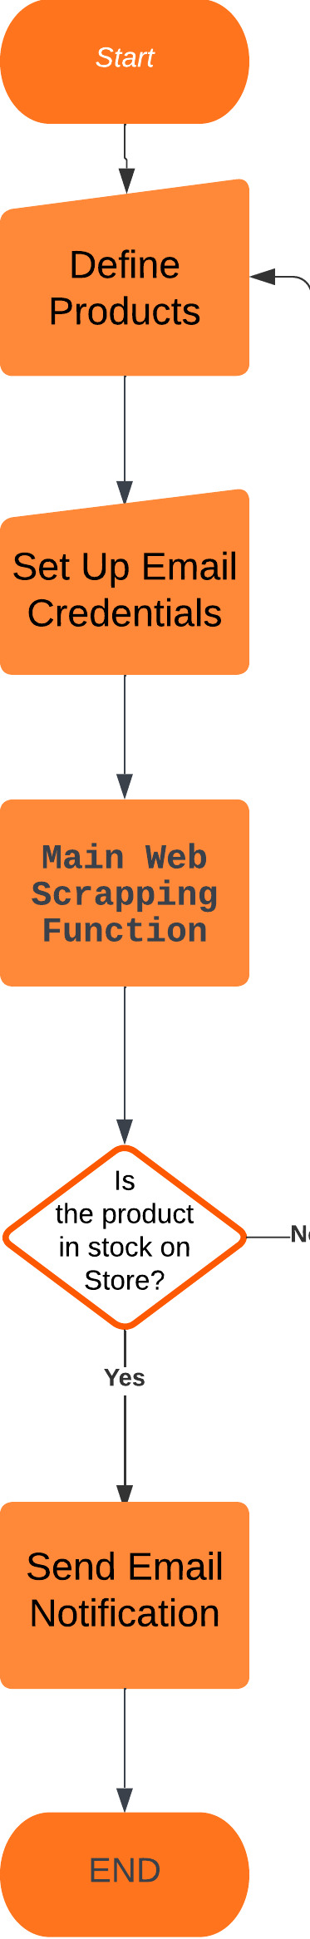

1. **Literature Review**

# References/Bibliography