**Taaza Khabar**

**MCA Semester I MCA-16: Mini Project - I**

SUBMITTED IN PARTIAL FULFILMENT OF THE REQUIRETIALMENTS FOR THE AWARD OF THE DEGREE OF

**MASTER OF COMPUTER APPLICATIONS**

**SUBMITTED TO**

**

**KADI SARVA VISHWAVIDYALAYA**

**SUBMITTED BY**

|  |  |
| --- | --- |
| Name of Student(s) | University Exam No(s) |
| Patel Himanshu K.  Ranavaya Harshal D.  **SUPERVISED BY**  Dr. Monika Patel  S K Patel Institute of Management and Computer Studies | 0  0 |
|  |  |

### ACKNOWLEDGEMENT

We would like to express my sincere gratitude to all the individuals who have contributed to the successful completion of this project. We would like to thank our supervisor for their guidance and support throughout the project. We also grateful to all the faculty members who have provided valuable insights and feedback.

We would like to acknowledge the support and encouragement of our family and friends, who have been a constant source of motivation for me. We also thankful to all the participants who took part in the study and provided valuable data for analysis.

We would also like to express my appreciation to the staff and resources at the university, without whom this project would not have been possible.

Lastly, we would like to thank everyone who has been a part of this project in any capacity, no matter how big or small. Your contributions have been invaluable, and We are truly grateful for your support

**Signature(s) of Students**

Patel Himanshu K.

Ranavaya Harshal D.



CERTIFICATE FROM DIRECTOR

*This is to certify that the projectdocumentation entitled “Taaza Khabar” is bonafide project work done by Mr. Patel Himanshu , Ranavaya Harshal in partial fulfilllment of the requiremnet for the award of degree of Master of Computer Application at*

*S. K. Patel Institute of Management and Computer Studies(MCA) – a constituent college of KADI SARVA VISHWAVIDYALAYA.*

*We further certify that the project work done by them is original work carried out under the supervision and guidence.*

*Date:* ***__________*** *Director*



# 

CERTIFICATE FROM INTERNAL SUPERVISOR

*This is to certify that the project report compiled by Mr. Patel Himanshu, Ranvaya Harshal, student of semester- 1 from MCA department, S. K. Patel Institute of Management & Computer Studies, a constituent college of Kadi Sarva Vishwavidyalaya, Gandhinagar, is done under my guidence.To the best of my knowledge, this work is satisfactorily completed. During the tenure, he/she was found to be very hard working and sincere. He/She completed all the tasks assigned and suggested to him/her.*

***Comments:***

1

2

3

Date: ___________ **Name & sign of Internal**

**Supervisor**



DECLARATION

*We hereby declare that the project entitled “Taaza Khabar” submitted for the M.C.A Degree is my original work and the project has not formed the basis for the award of any degree or any other similar titles in any other University.*

*Signature of the Student:*

*1*

*2*

*Place: Gandhinagar*

*Date:*

|  |  |  |  |  |
| --- | --- | --- | --- | --- |
| **NO** | **TITLE** | | | **PAGE NO** |
| 1 | Introduction of Project | | | 1 |
| 2 | Current/Existing System | | | 1 |
|  | 2.1 | Flowchart and Diagram | | 3 |
|  | 2.2 | Drawbacks | | 4 |
| 3 | Proposed System | | | 5 |
|  | 3.1 | Module | | 6 |
|  | 3.2 | Features | | 9 |
|  | 3.3 | Scope | | 11 |
| 4 | Hardware and Software Specification | | | 12 |
| 5 | Analysis | | | 13 |
|  | 5.1 | Fact Finding Method | | 13 |
|  | 5.2 | Feasibility Study | | 14 |
|  | 5.3 | Process Model | | 16 |
|  | 5.4 | Diagram | | 17 |
|  |  | 5.4.1 | Estimated Grant Chart/Time Line Chart | 17 |
|  |  | 5.4.2 | UML Diagrams (Use Case, Activity and Class) | 18 |
| 6 | Design | | | 23 |
|  | 6.1 | Data Dictionary | | 23 |
|  | 6.2 | Screens/Forms | | 27 |
| 7 | Future Enhancement | | | 30 |
| 8 | Reference/Bibliography | | | 31 |

**Index**

1. **Introduction of Project:**

The **TAAZA KHABER News System** is a cutting-edge digital platform designed to transform how news is delivered and consumed. By utilizing modern technologies such as APIs and the internet, this system provides real-time access to news across diverse categories like politics, sports, entertainment, technology, and business. With its focus on interactivity, personalization, and timely updates, it offers a superior alternative to traditional media, ensuring users are always informed and connected to the latest developments.

**Key Features of TAAZA KHABER News System:**

* **Real-Time News Updates**: Delivers the latest news instantly, ensuring users are always aware of current events.
* **Diverse Categories**: Covers a wide range of topics, including politics, sports, entertainment, technology, and more.
* **Personalized Content**: Uses intelligent algorithms to tailor news recommendations based on user preferences.
* **User-Friendly Interface**: Features an intuitive design with easy navigation and advanced search options.
* **Interactive Features**: Includes comment sections, polls, and social sharing tools for greater engagement.
* **API Integration**: Seamlessly connects to external systems for reliable and up-to-date content delivery.
* **Notifications and Alerts**: Provides instant updates on breaking news and important events.
* **Global Accessibility**: Ensures users can access news anytime, anywhere, through various devices.

1. **Current / Existing System:**
2. **Landing on the Website/App**:  
   When users visit the website or open the app, they are greeted with a homepage displaying trending and breaking news headlines prominently.
3. **News Categorization**:  
   Users can navigate through various sections like politics, sports, business, entertainment, and technology via the main menu or category tabs.
4. **Search Functionality**:  
   If users want specific information, they can use the search bar to find articles, topics, or keywords across the platform.
5. **Personalized Recommendations**:  
   Based on browsing history or user preferences, the system suggests articles or videos relevant to their interests on the homepage or a dedicated "For You" section.
6. **Interactive Features**:  
   Users can comment on articles, participate in polls, and share content on social media platforms directly from the website or app.
7. **Notifications and Alerts**:  
   Mobile apps or email subscriptions send breaking news alerts or daily summaries, keeping users informed even when they are not actively browsing the site.
8. **Subscription or Advertisement**:  
   Users may encounter advertisements as part of the free service or opt for a subscription plan to access premium, ad-free content and exclusive articles.
   1. **Flowchart and Diagram:**

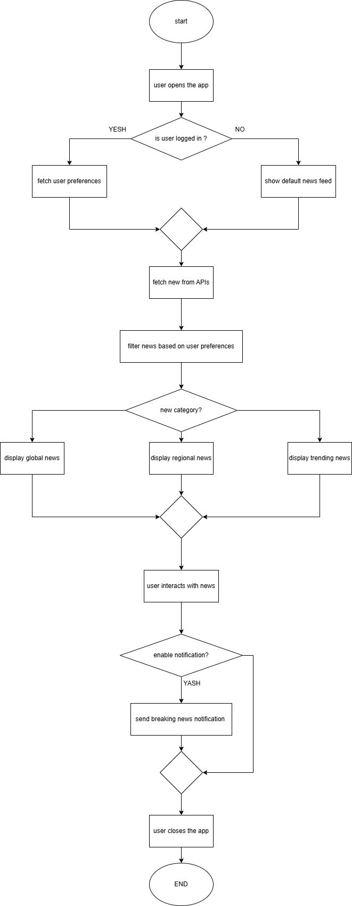

**Figure 1: Flowchart**

|  |  |  |
| --- | --- | --- |
| **aspect** | **Aaj tak** | **India today** |
| Regional focus | ❌ Overlay focused on India news | ❌Primarily Indian centric |
| Global coverage | ❌Minimal global news coverage | ❌Limited global focus |
| Multi-language support | ❌Limited to Indian language only | ❌Only support English and hindi |
| Ui/Ux | ❌Feels cluttered and ad-heavy | ❌Slightly ad-heavy, can feel over whelming |
| Offline support | ❌Doesn’t support offline read | ❌Limited to premium app features |

* 1. **Drawbacks**

.

1. **Proposed System:**

The proposed news website aims to redefine how users access and consume information by offering a sleek, user-friendly interface designed to cater to modern browsing habits. Upon visiting the platform, users will encounter a well-organized homepage featuring trending headlines, breaking news, and categorized sections for topics like Politics, Technology, Sports, and Entertainment. Personalization will play a significant role, as the system leverages intelligent algorithms to analyse user preferences and provide tailored news recommendations, ensuring a highly engaging experience.With features like online payments, automated notifications, digital attendance, and inventory tracking, the system ensures efficient and transparent management. Accessible anytime via a mobile-friendly website, it saves time, reduces errors, and enhances convenience for both residents and staff.

The platform will support multi-media content, including articles, videos, podcasts, and photo galleries, making it versatile and appealing to a wide audience. Advanced search functionality with filters for date, category, or region will empower users to find specific information effortlessly. Additionally, real-time updates will ensure that users are always informed about the latest events as they happen. Interactive features like comments, polls, and social sharing options will foster a sense of community, while subscription-based notifications and alerts will keep users connected to their topics of interest.

* 1. **Module**
* **Admin Module**

1. **Dashboard Overview:**

* A centralized dashboard displaying key metrics such as the number of published articles, active users, traffic analytics, and recent activities for quick insights.

1. **Content Management:**

* Create, edit, and delete news articles, multimedia content (images, videos, podcasts), and categories.
* Schedule articles for future publication or set them as drafts.
* Tag articles with keywords for better categorization and search optimization.

1. **User Management:**

* Manage user accounts, including roles (e.g., admin, editor, subscriber).
* Monitor user activity and handle issues such as reported content or account suspension.
* Send notifications or announcements to all users.

1. **Category and Tag Management:**

* Add, update, or remove categories and tags to ensure content is organized effectively.
* Monitor trending topics and adjust categories accordingly.

1. **Advertisement Management:**

* Upload and manage advertisements displayed on the website.
* Track ad performance through click-through rates (CTR) and impressions.

1. **Analytics and Reporting:**

* Access detailed reports on user engagement, article performance, and site traffic.
* Identify trends and popular content through visual graphs and statistics.

1. **Real-Time Notifications:**

* Push breaking news alerts or important updates to users through email or app notifications.
* Monitor and approve notifications created by editors or contributors.

1. **Settings and Configurations:**

* Manage website settings, including themes, layouts, and regional preferences.
* Integrate APIs for content feeds or third-party tools.
* Ensure compliance with privacy policies and data security regulations.
* **User Module**

1. **User Registration and Login:**

* Users can sign up with an email, mobile number, or third-party accounts (Google, Facebook).
* Secure login options with two-factor authentication (optional).
* Guest users can browse limited content without registration.

1. **Personalized Dashboard:**

* Registered users get a personalized homepage displaying tailored news recommendations based on their interests.
* Access to saved articles, reading history, and preferred topics.

1. **Content Browsing and Search:**

* Explore news articles across categories like Politics, Sports, Technology, Entertainment, and more.
* Use advanced search filters (e.g., date, category, region) to find specific content.

1. **Interactive Features:**

* Comment on articles and participate in discussions.
* Like, bookmark, or share articles across social media platforms.
* Take part in polls, quizzes, or live chats integrated into the platform.

1. **Notifications and Alerts:**

* Receive real-time alerts for breaking news or updates in their chosen categories.
* Customize notification settings to control the frequency and type of alerts.

1. **Subscription Options:**

* Access premium features, such as ad-free browsing and exclusive articles, through subscription plans.
* View payment history and manage subscription settings from their profile.

1. **Multimedia Accessibility:**

* Watch embedded videos, listen to podcasts, or view photo galleries directly on the platform.
* Adjust playback settings or download content where allowed.

1. **Multi-Device Compatibility:**

* Seamless access to content across devices, including desktops, tablets, and smartphones.
* Progress sync for reading articles or watching videos on multiple devices.

1. **Feedback and Support:**

* Submit feedback, report issues, or request support via a dedicated Help section.
* Access FAQs for common queries and solutions.
  1. **Admin Features:**

1. **Dashboard:**

* A centralized hub to monitor site performance, user statistics, published articles, and overall traffic.

1. **Content Management:**

* Admins can create, edit, schedule, and delete news articles, manage multimedia content, and organize them into categories.

1. **User and Role Management:**

* Manage user accounts, assign roles (Admin, Editor, Subscriber), and track user activity or handle flagged content.

1. **Category and Tag Management:**

* Organize news into categories, manage tags, and update them to reflect the latest trends and topics.

1. **Advertisement Management:**

* Upload and manage ads displayed on the website, track performance metrics like impressions and click-through rates.

1. **Real-Time Notifications:**

* Send push notifications for breaking news, updates, or other important alerts to users.

1. **Analytics and Reporting:**

* Generate detailed reports on site traffic, article performance, and user engagement, providing insights for content strategy.
  1. **User Features:**

1. **User Registration and Login:**

* Users can sign up via email or social media accounts (Google, Facebook), and log in securely to access personalized content and features.

1. **Personalized News Feed:**

* Based on user interests and browsing behavior, the system will suggest relevant articles, ensuring a personalized and engaging experience.

1. **Content Browsing and Search:**

* Users can browse news by categories such as Politics, Sports, Entertainment, and more.
* Advanced search functionality allows users to filter articles by date, category, region, or keywords.

1. **Interactive Features:**

* Users can comment on articles, share them on social media, and participate in polls or quizzes to engage with the content.

1. **Notifications and Alerts:**

* Users can receive real-time notifications for breaking news or updates on specific topics they follow, customized based on their preferences.

1. **Save and Bookmark Articles:**

* Users can bookmark articles for later reading, save them in their profile, and easily access them at any time.

1. **Subscription Options:**

* Users can subscribe to premium features, gaining access to exclusive content, ad-free browsing, and advanced functionalities.
  1. **Scope:**

The **TAAZA KHABER** News System aims to revolutionize the way users consume news by offering real-time updates, personalized content, and access to diverse topics.   
It bridges the gap between traditional media and digital platforms, leveraging API and internet technologies to deliver interactive and timely news experiences.

1. **Hardware and Software Specification:**
   * **Hardware Requirement:**

* **Student Side:**
* **Device:** Any device with internet access
* **Processor:** Dual-core (1.8 GHz or better)
* **RAM:** 2 GB (Minimum), 4 GB (Recommended)
* **Storage:** 20 GB HDD/SSD
* **Admin Side:**
* **Processor:** Dual-core (2.0 GHz) or Quad-core (Recommended)
* **RAM:** 4 GB (Minimum), 8 GB (Recommended)
* **Storage:** 50 GB HDD (Minimum), 128 GB SSD (Recommended)
* **Network:** 5 Mbps Internet speed (Minimum), 10 Mbps (Recommended)
  + **Software Requirement:**
* **Student Side:**
* **Browser:** Latest versions of Chrome, Firefox, or Edge
* **Internet Connection:** Stable connection for website access and transactions
* **Admin Side:**
* **Backend:** Node.js, Express.js
* **Database:** MongoDB
* **Admin Panel:** React.js (or similar)
* **OS:** Ubuntu Server 22.04 LTS or Windows Server 2016+

1. **Analysis:**
   * **Fact Finding Method:**

|  |  |  |
| --- | --- | --- |
| **FEATURE** | **AAJ TAK** | **INDIA TODAY** |
| Regional lang support | ✅ | ✅ |
| Live tv/ streaming | ✅ | ✅ |
| Multi language content | ✅ | ✅ |
| Breaking news alerts | ✅ | ✅ |
| Video news coverage | ✅ | ✅ |

* + **Feasibility Study:**

**1. Technical Feasibility**

* News Api for global news custom Apis/rss for Indian news
* React, node, express, MySQL
* Use googles translate Api pre translated feeds regional support
* YouTube Api for videos, and push notifications

**2. Operational Feasibility**

* Developers, designers, and testers for app creation.
* Content curators and moderators for news verification.
* Marketing team for user acquisition.

**3. Economic Feasibility**

* App design and development.
* Server and database setup.
* Licensing for APIs or third-party tools.

**4. Schedule Feasibility**

* Prototype: 2-3 months.
* Full-scale development: 6-8 months.
* Testing and launch: 2 months.
  + **Process Model:**
* **Agile Model**

The **Agile Model** for the TAAZA Khabar News Website is an iterative and flexible approach to developing the platform. It focuses on delivering incremental updates and features in short development cycles, known as sprints. Each sprint aims to enhance a specific functionality of the website, such as user interface improvements, content management tools, or real-time notifications.

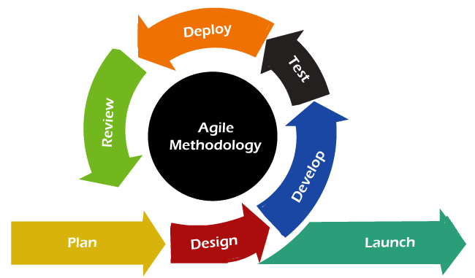

**Figure 2: Agile Model Design**

1. **Iterative and Incremental Development**
   * Releases small, functional updates regularly.
2. **Flexibility and Adaptability**
   * Adjusts to changing user feedback and market trends.
3. **Active Collaboration**
   * Fosters teamwork among developers, stakeholders, and users.
4. **Continuous Testing and Improvement**
   * Ensures quality through ongoing testing in every sprint.
   * **Diagram:**
     1. **Estimate Gantt Chart**

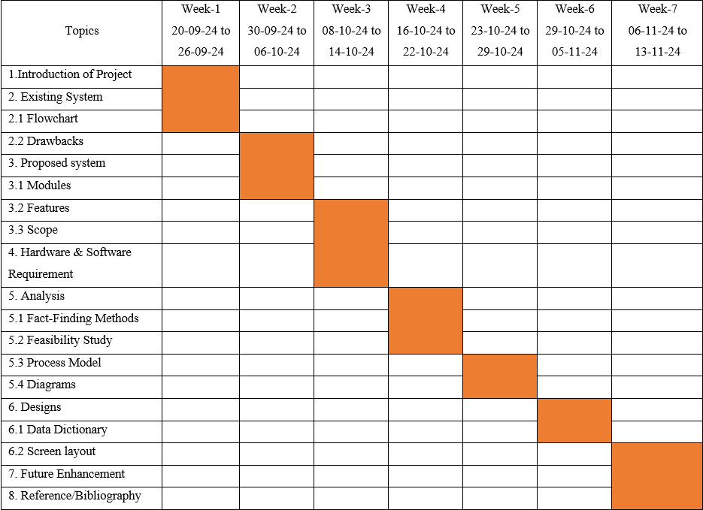

**Figure 3 Gantt Chart**

* + 1. **UML Diagram (Use Case, Activity, Class):**
* **Use Case:**
* **Admin:**

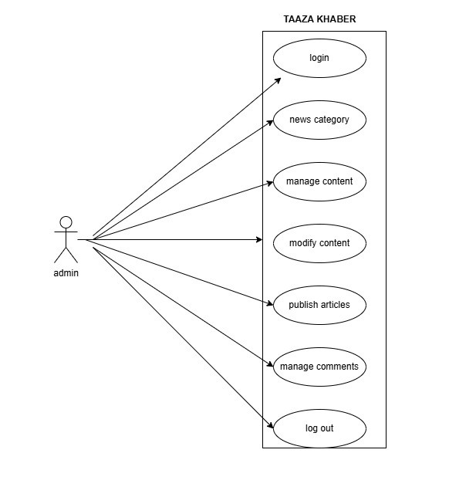

**Figure 4 (a) Admin Use Case Diagram**

* **User:**

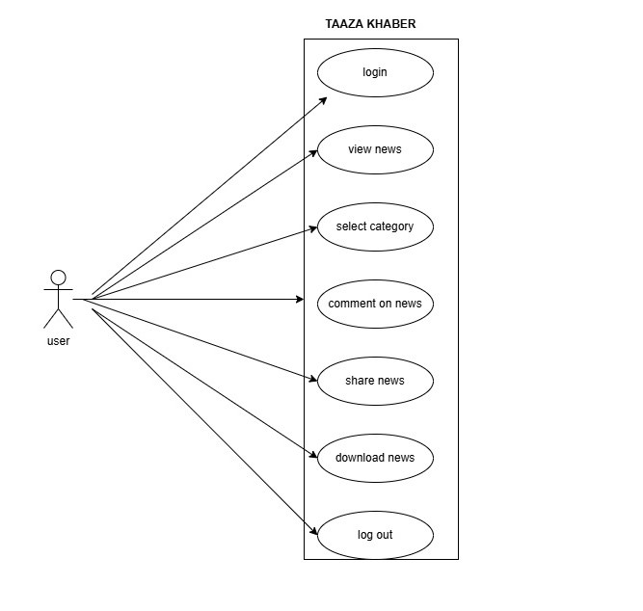

**Figure 4 (b) user Use Case Diagram**

* **Activity Diagram:**
* **Admin**

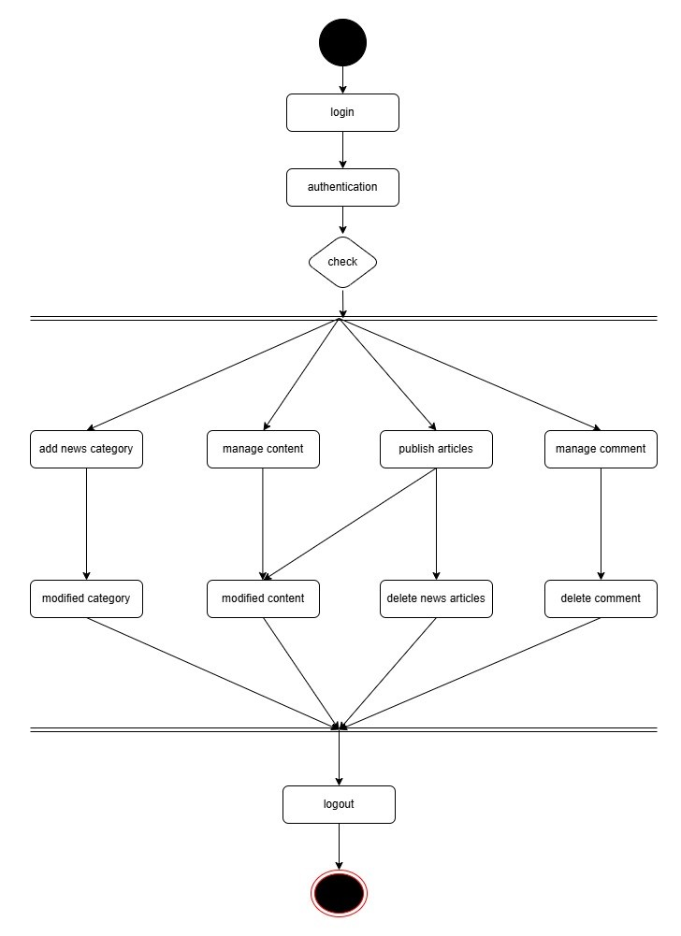

**Figure 5 (a) Admin Activity Diagram**

* **User:**

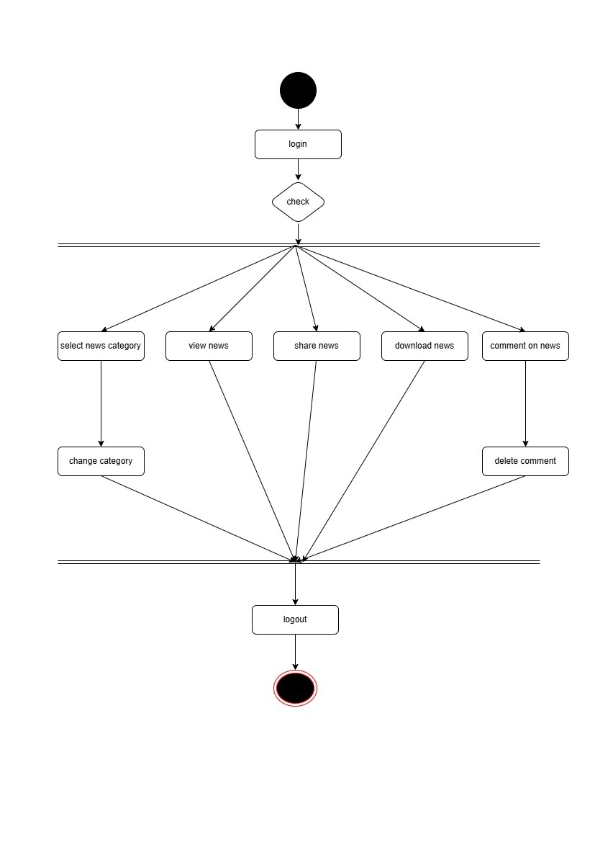

**Figure 5 (b) user Activity Diagram**

* **Class Diagram:**

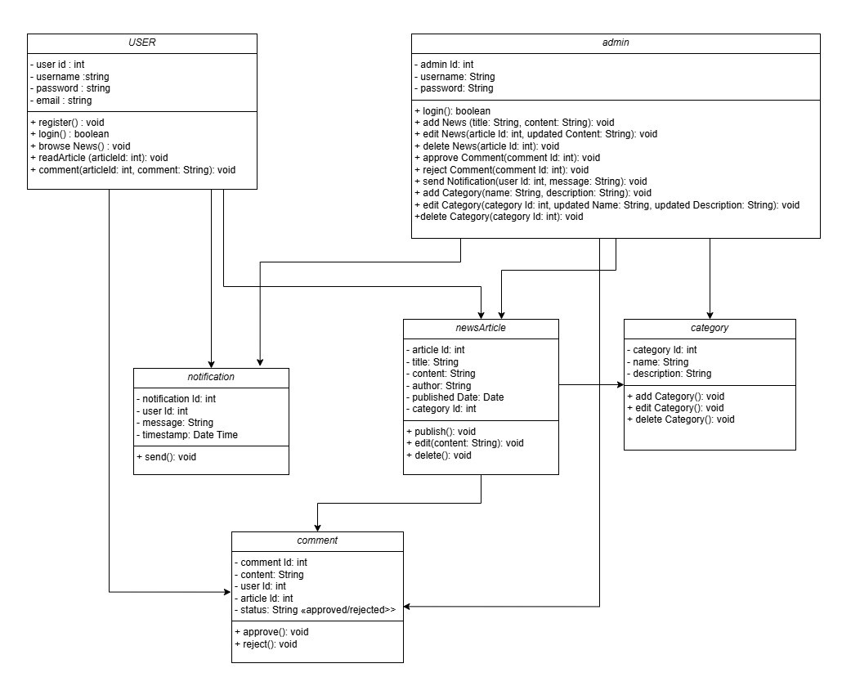

**Figure 6 Class diagram**

`

1. **Design**
   * **Data Dictionary** 
     1. **User Table**

* **Table 1:** user
* **Primary Key: userId**
* **Table Designing**

|  |  |  |  |  |
| --- | --- | --- | --- | --- |
| **Field Name** | **Datatype** | **Field Size** | **Constraints** | **Description** |
| **userId** | **INT** | **11** | **PRIMARY KEY** | **Unique identifier each user** |
| **username** | **VARCHAR** | **255** | **NOT NULL, UNIQUE** | **User's login name** |
| **password** | **VARCHAR** | **255** | **NOT NULL** | **User's password** |
| **email** | **VARCHAR** | **255** | **NOT NULL, UNIQUE** | **User's email address** |

* **Table 2:** Admin
* **Primary Key:** adminId
* **Table Designing**

|  |  |  |  |  |
| --- | --- | --- | --- | --- |
| **Field Name** | **Datatype** | **Field Size** | **Constraints** | **Description** |
| **adminId** | **INT** | **11** | **PRIMARY KEY** | **Unique identifier for each admin** |
| **username** | **VARCHAR** | **255** | **NOT NULL, UNIQUE** | **Admin's login name** |
| **password** | **VARCHAR** | **255** | **NOT NULL** | **Admin's password** |

* **Table 3:** Article table
* **Primary Key:** Doc_Id
* **Table Designing**

|  |  |  |  |  |
| --- | --- | --- | --- | --- |
| **Field Name** | **Datatype** | **Field Size** | **Constraints** | **Description** |
| **articleId** | INT | 11 | PRIMARY KEY | Unique identifier for each article |
| **title** | VARCHAR | 255 | NOT NULL | Title of the article |
| **content** | TEXT | - | NOT NULL | Main content of the article |
| **author** | VARCHAR | 255 | NOT NULL | Author of the article |
| **publishedDate** | DATE | - | NOT NULL | Date of article publication |
| **categoryId** | INT | 11 | FOREIGN KEY | Foreign key to the Category table |

* **Table 4:** comment Table
* **Primary Key:** commentId
* **Table Designing**

|  |  |  |  |  |
| --- | --- | --- | --- | --- |
| **Field Name** | **Datatype** | **Field Size** | **Constraints** | **Description** |
| **commentId** | INT | 11 | PRIMARY KEY | Unique identifier for each comment |
| **content** | TEXT | 11 | NOT NULL | Content of the comment |
| **userId** | INT | 11 | FOREIGN KEY | Foreign key to the User table |
| **articleId** | INT | 11 | FOREIGN KEY | Foreign key to the NewsArticle table |
| **status** | ENUM | ('approved', 'rejected') | NOT NULL | Approval status of the comment |

* **Table 5:** notification Table
* **Primary Key:** notificationId
* **Table Designing**

|  |  |  |  |  |
| --- | --- | --- | --- | --- |
| **Field Name** | **Datatype** | **Field Size** | **Constraints** | **Description** |
| **notificationId** | INT | 11 | PRIMARY KEY | Unique identifier for each notification |
| **userId** | INT | 11 | FOREIGN KEY | Foreign key to the User table |
| **message** | TEXT | 255 | NOT NULL | Content of the notification |
| **timestamp** | DATETIME | - | NOT NULL | Time when the notification was sent |

* **Table 6:** category Table
* **Primary Key:** categoryId
* **Table Designing**

|  |  |  |  |  |
| --- | --- | --- | --- | --- |
| **Field Name** | **Datatype** | **Field Size** | **Constraints** | **Description** |
| **categoryId** | INT | 11 | PRIMARY KEY | Unique identifier for each category |
| **name** | VARCHAR | 255 | NOT NULL | Name of the category |
| **description** | TEXT | 255 | NULLABLE | Description of the category |

* + **Screens / Forms:**
* **User Screens:**
* **User Register:**

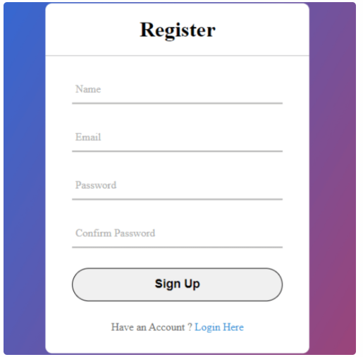

* **user Login:**

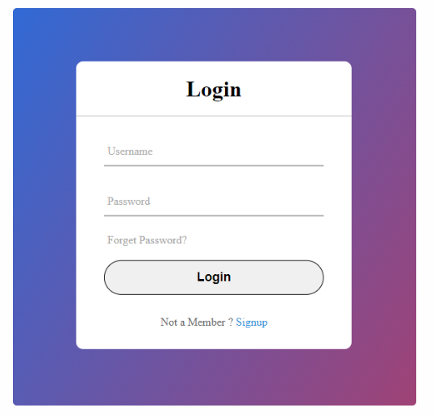

* **User Home page:**

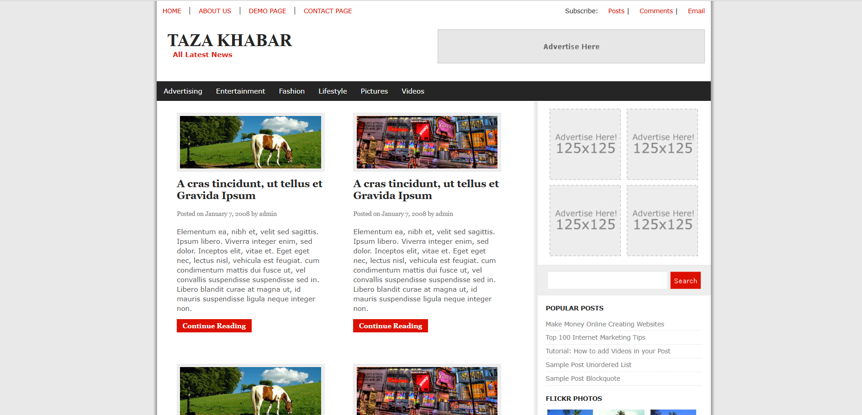

* **Features:**

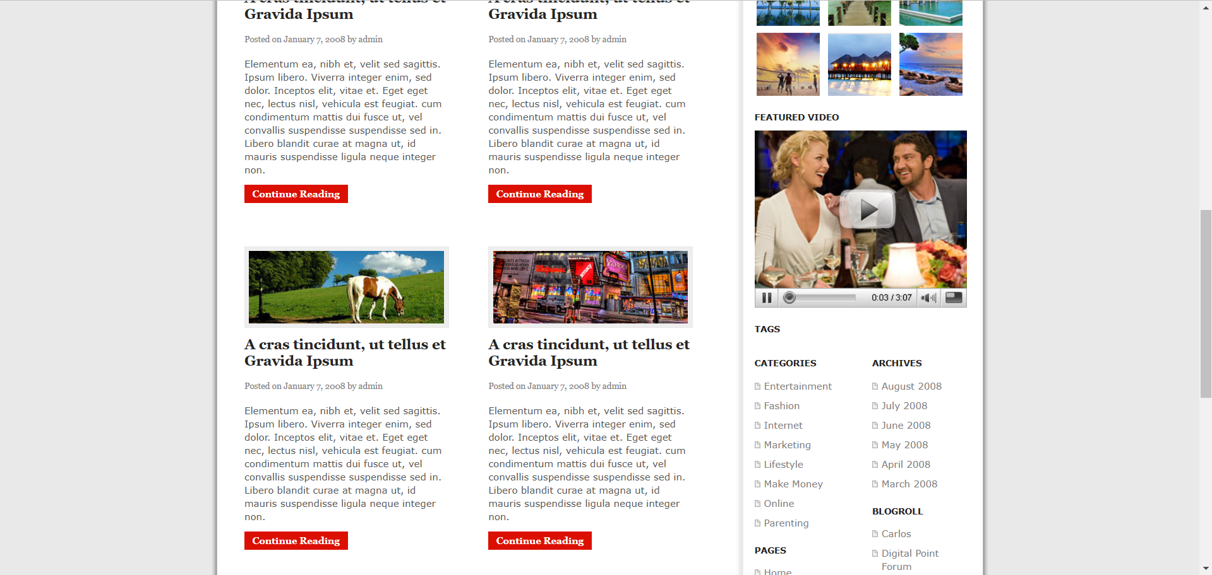

* **About us**

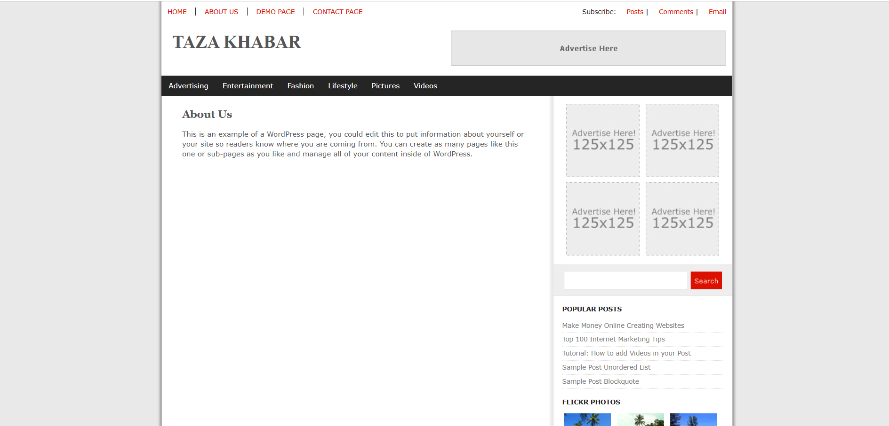

* **Admin Screens / Forms:**
* **Admin Sign in:**



* **Admin Panel:**

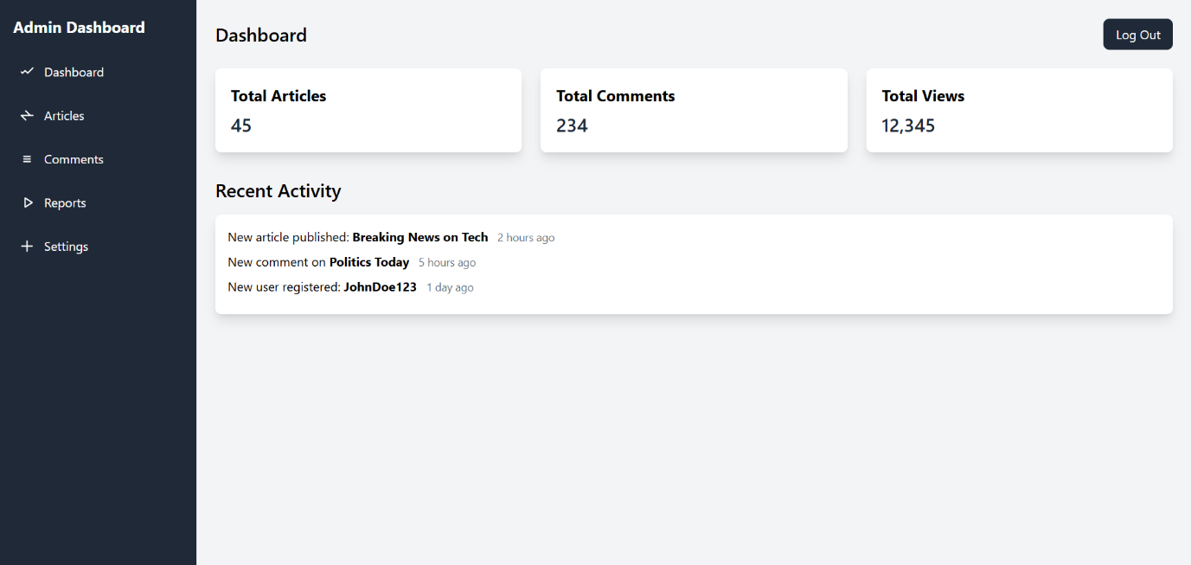

1. **Future Enhancement:**

• **Integration with Biometric Systems**  
Add a biometric authentication system for secure room access and attendance tracking to enhance security and reduce manual errors.

• **Mobile Application Support**  
Develop a mobile app version of the system to enable students and administrators to access functionalities on-the-go, such as submitting leave requests, making payments, or receiving notifications.

• **AI-Powered Complaint Resolution**  
Implement AI-based systems to categorize and prioritize complaints, suggesting resolutions and automating minor fixes for faster problem-solving.

• **Advanced Analytics and Insights**  
Incorporate data visualization tools to generate detailed insights and trends for room usage, fee payment delays, and complaint types for better decision-making.

• **Multi-Language Support**  
Introduce multi-language options to cater to a diverse student and administrative user base, making the platform more user-friendly for non-native English speakers.

1. **Reference / Bibliography:**

Existing System

* Aajtak - https://www.aajtak.in/
* Times of INDIA - http://timesofindia.indiatimes.com/