Flask and MongoDB Atlas
Project Explanation
A visual guide to the implemented form, API, and database workflow
Framework | Flask (Python)
Database | MongoDB Atlas
Application URL | http://127.0.0.1:5000

1. Project Overview
This project is a Flask web application that demonstrates two connected features. First, it exposes a JSON API at /api, reading its response from data.json. Second, it provides a browser form that validates user input and saves each submission to the MongoDB Atlas database.
The complete request flow is:
- The user opens the form at http://127.0.0.1:5000/.
- The user enters a name, email address, and message.
- Flask receives the POST request at /submit.
- The app checks the fields, connects to MongoDB Atlas, and inserts a document.
- After a successful insert, the browser redirects to /success.
- The saved document can be viewed in MongoDB for VS Code or MongoDB Atlas.

2. Project Files
File | Purpose
app.py | Defines the Flask app, API route, form route, MongoDB connection, and success route.
data.json | Backend JSON file read by GET /api.
templates/index.html | Frontend form for name, email, and message.
templates/success.html | Page shown after a successful MongoDB insert.
atlas-credentials.env | Local Atlas connection settings; protected from Git by .gitignore.
requirements.txt | Python dependencies: Flask, PyMongo, and python-dotenv.

3. Screenshot 1: Frontend Submission Form
The first screenshot shows the running Flask frontend at the root URL. The form contains three required fields: Name, Email, and Message. The Submit data button sends the form to the /submit route using an HTTP POST request. The View JSON API link opens the /api route.
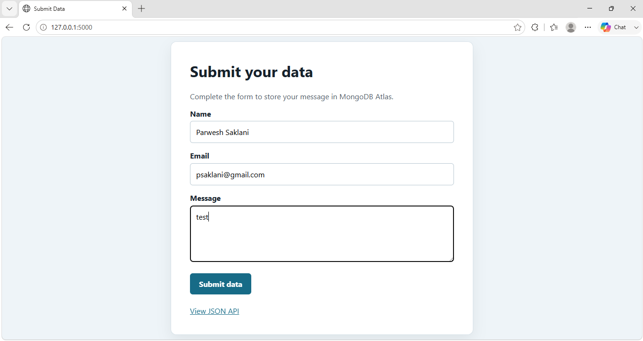
Figure 1. Flask frontend form with sample input.

4. Screenshot 2: Successful Submission
After validation succeeds and MongoDB Atlas accepts the insert, Flask redirects the browser to /success. The page confirms that the data was submitted successfully and provides a link to submit another response.
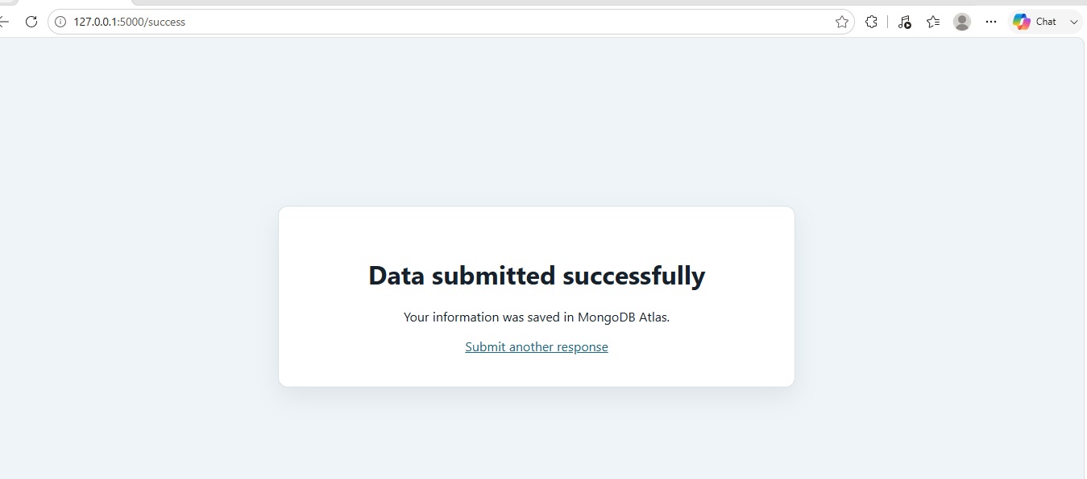
Figure 2. Success page displayed after the database insert.

5. Screenshot 3: MongoDB Atlas Data in VS Code
The third screenshot shows the MongoDB for VS Code extension connected to the Atlas cluster. The database flask_app is expanded, followed by the submissions collection. Two documents are visible, proving that form submissions reached MongoDB Atlas. Each document contains the fields name, email, message, and the automatically generated _id.
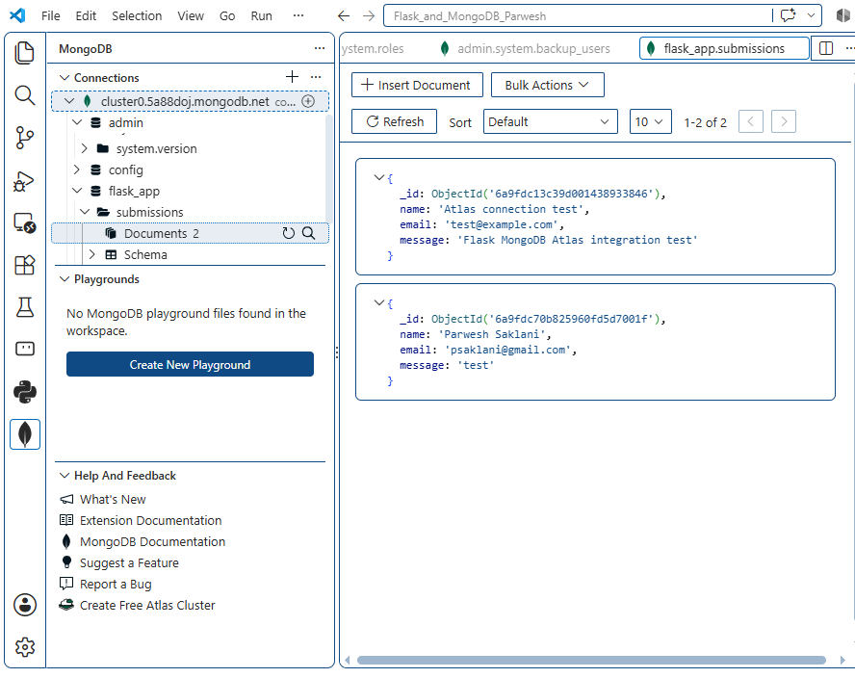
Figure 3. Submitted documents visible in flask_app.submissions.

6. Important Routes
Method | Route | Behavior
GET | / | Renders the frontend submission form.
GET | /api | Reads data.json and returns its contents as a JSON list.
POST | /submit | Validates fields, inserts a document into MongoDB Atlas, and redirects on success.
GET | /success | Displays the message Data submitted successfully.

7. MongoDB Document Structure
A successful form submission is stored in the submissions collection in this shape:
{
"name": "Parwesh Saklani",
"email": "psaklani@gmail.com",
"message": "test"
}
MongoDB automatically adds an _id value to uniquely identify the document. The database name defaults to flask_app and the collection name defaults to submissions.

8. Configuration and Running the App
The app loads the Atlas connection from atlas-credentials.env. Keep this file private and never commit it to a public repository.
MONGODB_URI=mongodb+srv://<username>:<password>@<cluster>.mongodb.net
MONGO_DB_NAME=flask_app
MONGO_COLLECTION_NAME=submissions
Start the application from the project folder:
.\.venv\Scripts\Activate.ps1
python app.py
Then open http://127.0.0.1:5000/ in a browser. To inspect records in VS Code, open the MongoDB extension and expand cluster0 > flask_app > submissions.

9. Error Handling
If a required field is empty, the form stays on the same page and displays a validation error. If MongoDB is not configured or the connection fails, the form also stays on the same page and displays an error instead of redirecting. Only a successful database insert redirects to /success.
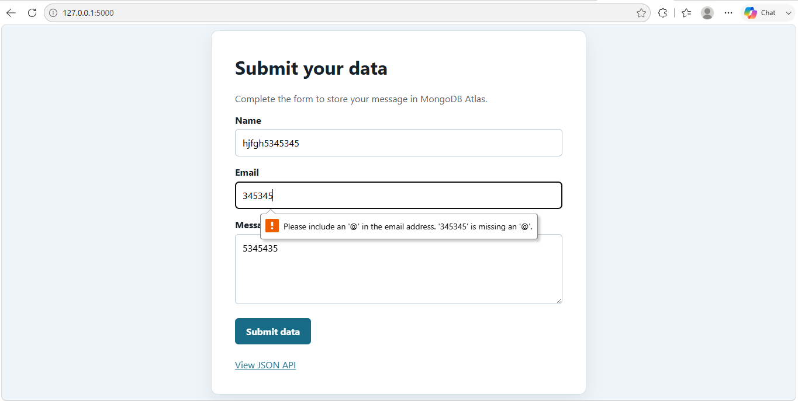

10. Conclusion
The screenshots demonstrate the entire working application: data is entered through the Flask form, the user receives a success confirmation, and the resulting records are visible in MongoDB Atlas through VS Code.

