EXPRESS + FLASK
DOCKER ASSIGNMENT
Frontend, Backend and Docker

Document Item | Value
Project name | Express and Flask Docker Assignment
Document version | 1.0
Document date | 17 September 2026
Repository | Node.js-with-Express
Runtime deployment | Docker Compose with two services
Project GitHub link | https://github.com/parweshsaklani1984-netizen/Node.js-with-Express

1. Project Overview
This project is a small full-stack form-processing application. A user opens a browser page served by an Express frontend, enters a name, email address, and response, and submits the form. Express receives the browser request and forwards the JSON payload to a Flask backend. Flask validates the data and returns a JSON result. The result is returned through Express and displayed in the browser.
The repository contains no database, persistence layer, authentication system, external API integration, or ORM. Submission data is processed in memory and returned in the response; it is not stored.
Concern | Implementation in this repository
Frontend technology | Node.js 20 Alpine container running Express 4.21.2 and static HTML/CSS/JavaScript.
Backend technology | Python 3.12 slim container running Flask 3.1.0 through Gunicorn 23.0.0.
Database technology | Not applicable. No database service or persistence code is present.
API communication | JSON over HTTP. Browser -> Express POST /submit -> Flask POST /process.
Containerization | One Docker image for the frontend and one for the backend, orchestrated by Docker Compose.
External ports | Host port 3000 is published for the frontend. Backend port 5000 is internal to the Compose network.

2. System Architecture
The deployed architecture is a two-container request path. The database stage shown in some standard full-stack diagrams is not present in this project.
User / Browser
|
v
Frontend container: Express :3000
| HTTP/JSON over Docker Compose network
v
Backend container: Flask + Gunicorn :5000
|
+--> In-memory validation and response
Database: Not applicable
Figure 1. Runtime architecture of the repository implementation.
- The browser loads public/index.html from Express at http://localhost:3000.
- The page JavaScript sends a JSON POST request to the Express /submit route.
- Express calls the backend using the BACKEND_URL environment variable. In Compose, the value is http://backend:5000/process, where backend is the service name.
- Flask validates the name, email, and message, then returns JSON with either a success message or an error.
- Docker Compose provides the default private network and uses the backend health check before starting the frontend dependency path.

3. Project Folder Structure
Node.js-with-Express/
|-- .gitignore
|-- README.md
|-- docker-compose.yml
|-- frontend/
| |-- .dockerignore
| |-- Dockerfile
| |-- package.json
| |-- server.js
| `-- public/
| `-- index.html
`-- backend/
|-- .dockerignore
|-- Dockerfile
|-- app.py
`-- requirements.txt
The actual repository is intentionally smaller than a layered enterprise template. Folders such as Controllers, Services, Repositories, Models, DTOs, Data, migrations, and frontend src/components are not present and are therefore not applicable.

4. Frontend Application
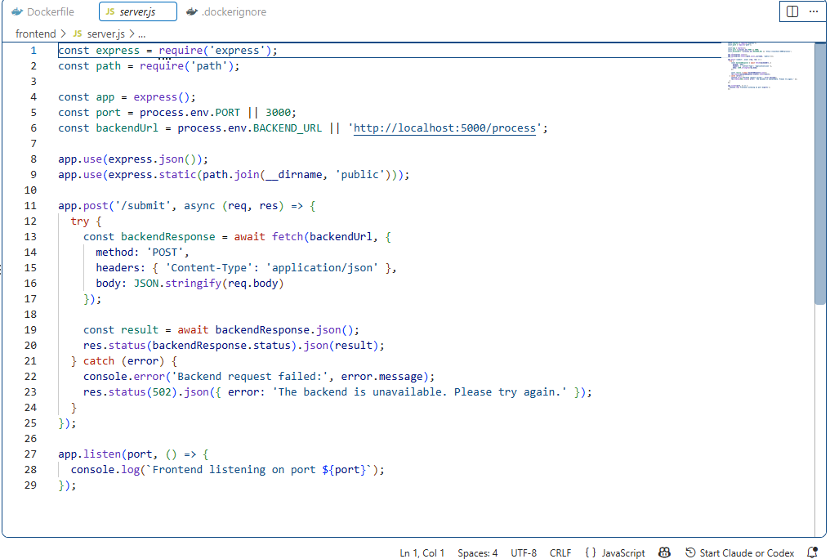

Technology and Responsibilities
The frontend is a Node.js application using Express 4.21.2. Express serves static files from frontend/public and exposes a server-side POST /submit route. The user interface itself is a single HTML page with embedded CSS and browser JavaScript; there is no React, Angular, Vue, or other frontend framework.
File/Folder | Purpose | Responsibility
frontend/package.json | Node package manifest | Defines the application name, start command, and Express dependency.
frontend/server.js | Express entry point | Creates the server, serves static content, parses JSON, forwards submissions, and handles backend failures.
frontend/public/index.html | Browser user interface | Renders the form and implements browser-side submission, status, success, and error handling.
frontend/Dockerfile | Frontend image definition | Installs production Node dependencies and starts Express on port 3000.
frontend/.dockerignore | Build context filter | Excludes node_modules, npm logs, and .env files from the image build context.

Pages, Routing, and API Integration
There is one page: public/index.html. Express has no application router module. Static file routing is handled by express.static. The only custom application route is POST /submit. The browser calls /submit on the same origin, and server.js calls the Flask backend using fetch. This server-side forwarding avoids exposing the internal Docker service name to the browser.

Validation and Error Handling
- Browser validation: name, email, and response are required; name is limited to 100 characters, email to 254 characters, and response to 2,000 characters. The email input also uses the browser email type.
- Backend validation: Flask trims all values, rejects missing values with HTTP 400, and checks email format with EMAIL_PATTERN.
- Express forwards the backend status and JSON body. A network or backend failure returns HTTP 502 with a user-facing error message.
- The browser displays Sending..., a success message, or an error message and resets the form after success.

Models, Authentication, and State
No TypeScript models, interfaces, frontend state-management library, authentication, authorization, session handling, or token handling are present. Form state is held by native HTML controls and a small browser script. These areas are not applicable to the current implementation.

Important Frontend Source
// frontend/server.js (request forwarding)
app.post('/submit', async (req, res) => {
const backendResponse = await fetch(backendUrl, {
method: 'POST',
headers: { 'Content-Type': 'application/json' },
body: JSON.stringify(req.body)
});
const result = await backendResponse.json();
res.status(backendResponse.status).json(result);
});

5. Backend Application
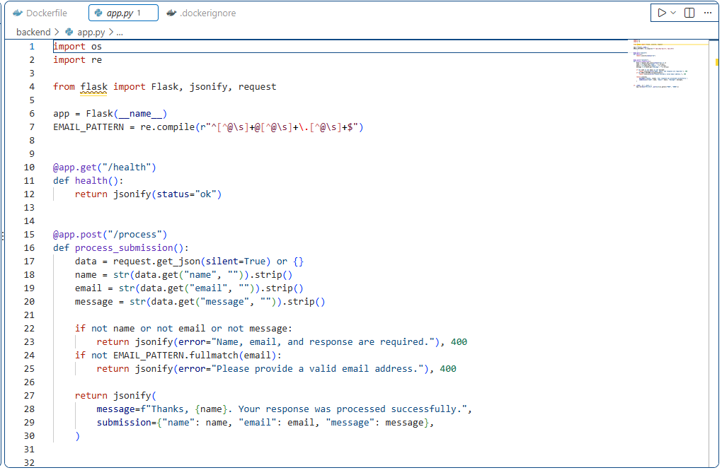

Technology and Structure
The backend is a Flask 3.1.0 application in backend/app.py. Gunicorn runs the Flask application in the container. The implementation uses direct route functions rather than separate controller, service, repository, model, DTO, or database-context modules.
Layer | Responsibility | Example in this project
Application entry point | Creates the Flask app and configures routes. | app = Flask(__name__) in backend/app.py.
Controller/route | Accepts HTTP requests and returns JSON responses. | @app.post('/process') function process_submission().
Validation | Normalizes and checks incoming values. | Required-field checks and EMAIL_PATTERN.fullmatch(email).
Service layer | Not applicable as a separate layer. | Processing is implemented directly in process_submission().
Repository/data access | Not applicable. | No database or repository code exists.
Models/entities/DTOs | Not applicable as separate types. | The request is read from a JSON dictionary and the response is built inline.
Middleware | Flask built-in request handling and JSON response handling. | request.get_json and jsonify.
Logging | Gunicorn/container stdout and an Express console error for forwarding failures. | console.error in server.js; no Python logging configuration is present.

API Endpoints
HTTP Method | Endpoint | Purpose | Request | Response
GET | /health | Container health check. | None | 200 JSON: {"status": "ok"}
POST | /process | Validate and process a form submission. | JSON with name, email, message | 200 success JSON or 400 validation JSON
POST | /submit | Express proxy route used by the browser. | Same JSON payload as /process | Backend response forwarded; 502 if backend unavailable

Sample REST Request and Responses
POST /process
Content-Type: application/json
{
"name": "Ada",
"email": "ada@example.com",
"message": "Hello"
}
200 OK
{
"message": "Thanks, Ada. Your response was processed successfully.",
"submission": {
"name": "Ada",
"email": "ada@example.com",
"message": "Hello"
}
}
400 Bad Request
{
"error": "Name, email, and response are required."
}

7. Docker Overview
Docker packages an application and its runtime dependencies into an image. A container is a running instance of an image. The image is the reusable, immutable-ish package definition; the container is the process created from that package with runtime configuration, networking, and a lifecycle.
Concept | Application use
Image | Built from each service Dockerfile: assignment-frontend or assignment-backend.
Container | A running frontend or backend process created from its image.
Compose | Defines both services, their build contexts, environment variables, port publication, health check, and dependency.
Network | Compose creates a private default network where the service name backend resolves to the Flask container.
Benefit | The same declared runtime can be built and run consistently on a developer machine or deployment host.

8. Frontend Dockerfile
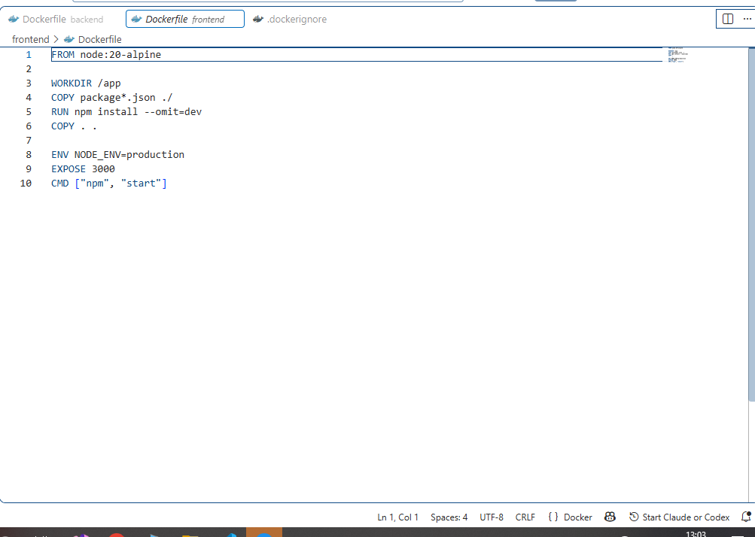
FROM node:20-alpine
WORKDIR /app
COPY package*.json ./
RUN npm install --omit=dev
COPY . .
ENV NODE_ENV=production
EXPOSE 3000
CMD ["npm", "start"]
Instruction | Line-by-line explanation
FROM node:20-alpine | Uses the Node.js 20 Alpine Linux base image. Alpine keeps the runtime image relatively small.
WORKDIR /app | Sets /app as the working directory for subsequent instructions and the running process.
COPY package*.json ./ | Copies package.json and any package-lock.json into the image before application source.
RUN npm install --omit=dev | Installs production dependencies, excluding development dependencies. There is no package-lock.json currently present, so npm resolves from package.json.
COPY . . | Copies the remaining frontend source, including server.js and public/index.html, into /app.
ENV NODE_ENV=production | Sets the runtime environment variable to production.
EXPOSE 3000 | Documents the port on which Express listens. Compose publishes it to host port 3000.
CMD ["npm", "start"] | Starts the package.json start script, which runs node server.js. There is no ENTRYPOINT and no multi-stage build.

The Dockerfile has no separate compile/build stage because the frontend is server-rendered static content plus Node.js code and does not require a framework build step. Production dependency installation is the production build step for this implementation.

9. Backend Dockerfile
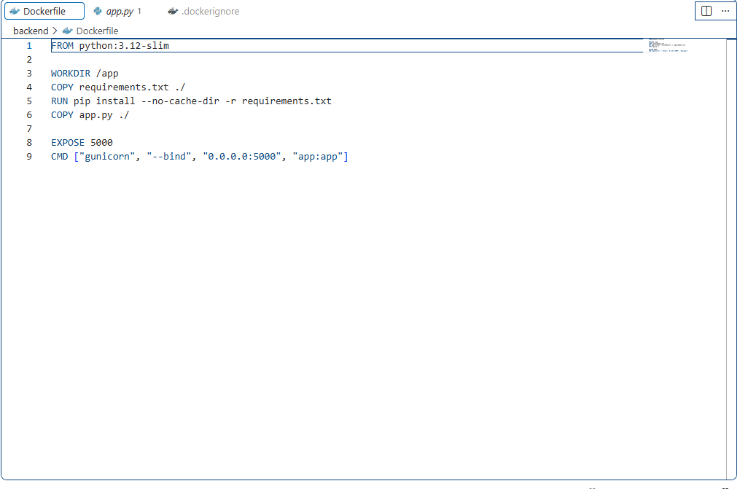
FROM python:3.12-slim
WORKDIR /app
COPY requirements.txt ./
RUN pip install --no-cache-dir -r requirements.txt
COPY app.py ./
EXPOSE 5000
CMD ["gunicorn", "--bind", "0.0.0.0:5000", "app:app"]
Instruction | Line-by-line explanation
FROM python:3.12-slim | Uses a smaller Debian-based Python 3.12 runtime image.
WORKDIR /app | Sets /app as the working directory.
COPY requirements.txt ./ | Copies the pinned Flask and Gunicorn dependency list first to improve Docker layer caching.
RUN pip install --no-cache-dir -r requirements.txt | Installs Flask 3.1.0 and Gunicorn 23.0.0 without retaining pip's download cache.
COPY app.py ./ | Copies the Flask application source into the image.
EXPOSE 5000 | Documents the internal port used by Gunicorn and Flask.
CMD ["gunicorn", ...] | Starts Gunicorn bound to all container interfaces at port 5000 and loads the Flask app object from app.py.

There is no RESTORE, BUILD, PUBLISH, ENTRYPOINT, .NET SDK image, ASP.NET runtime image, or multi-stage build because this is a Python Flask service. A multi-stage build is therefore not applicable to the current backend Dockerfile. The separation between dependency copy and source copy still improves rebuild caching.

10. Docker Compose Configuration
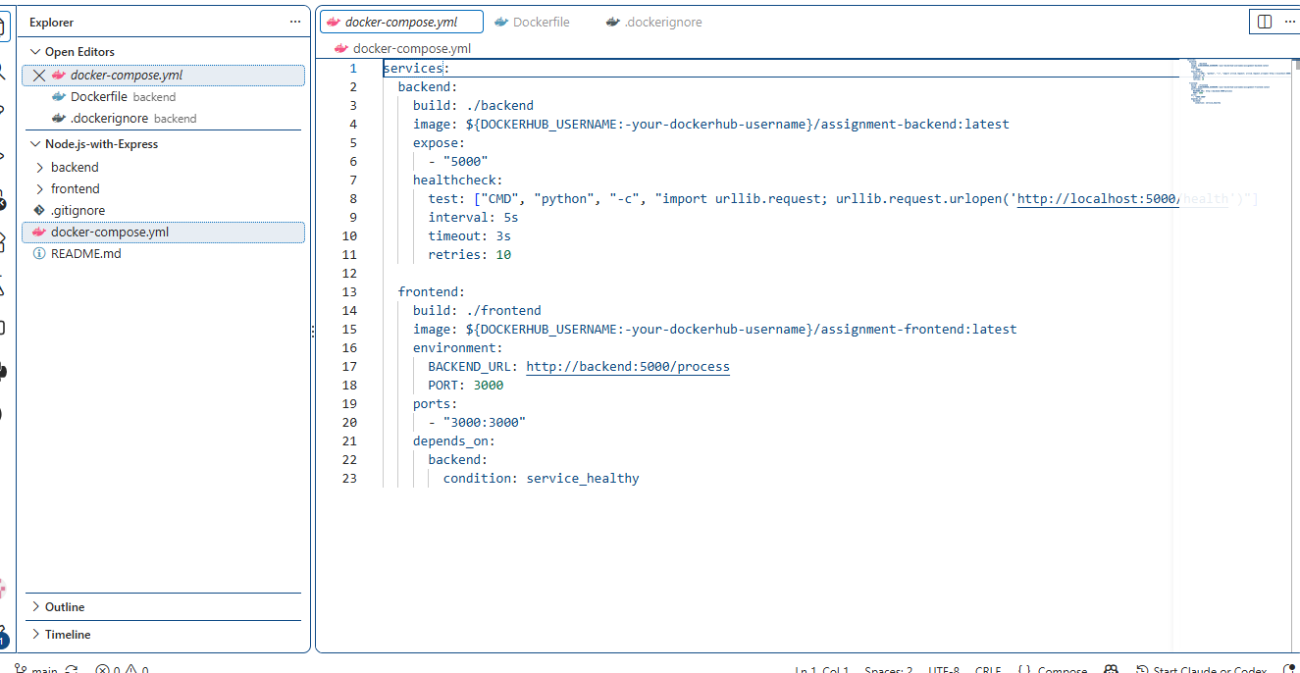
services:
backend:
build: ./backend
image: ${DOCKERHUB_USERNAME:-your-dockerhub-username}/assignment-backend:latest
expose:
- "5000"
healthcheck:
test: ["CMD", "python", "-c", "import urllib.request; urllib.request.urlopen('http://localhost:5000/health')"]
interval: 5s
timeout: 3s
retries: 10
frontend:
build: ./frontend
image: ${DOCKERHUB_USERNAME:-your-dockerhub-username}/assignment-frontend:latest
environment:
BACKEND_URL: http://backend:5000/process
PORT: 3000
ports:
- "3000:3000"
depends_on:
backend:
condition: service_healthy
Compose element | Explanation
services | Declares the backend and frontend containers. The Compose file does not declare a database service.
build | Uses ./backend or ./frontend as the build context; each context contains its own Dockerfile.
image | Names the built image using DOCKERHUB_USERNAME, defaulting to a placeholder username.
backend.expose | Makes port 5000 available to other services on the Compose network without publishing it to the host.
backend.healthcheck | Calls /health inside the backend container every five seconds, with a three-second timeout and ten retries.
frontend.environment | Sets BACKEND_URL to the backend service address and PORT to 3000.
frontend.ports | Maps host port 3000 to container port 3000 so a browser can access Express.
depends_on | Starts the frontend dependency after backend reports healthy. It does not replace application-level retry logic.
networks | Not written explicitly; Compose creates a default private network for both services.
volumes | Not applicable; no volumes are declared because the application has no persistent files or database.
restart | Not configured. A deployment environment may add a restart policy based on operational requirements.
version | No version field is present; current Compose specification syntax is used.

Docker Compose allows both images to be built and both containers to be run as one application. The image names also support Docker Hub publishing after DOCKERHUB_USERNAME is set and docker login succeeds.

11. Docker Network Communication
Frontend container (Express :3000)
|
| http://backend:5000/process
v
Backend container (Flask/Gunicorn :5000)
|
+--> No database container in this project
Figure 2. Container-to-container communication.
- Inside the Compose network, backend is a DNS service name. The frontend must use http://backend:5000/process, not localhost, to reach Flask.
- localhost inside a container means that same container. It does not mean the host machine or another service container.
- Port 5000 is internal because Compose uses expose. It is not directly published to the host by this file.
- Port 3000 is published as 3000:3000, allowing the browser on the host to reach Express at http://localhost:3000.

13. Application Startup Flow
docker compose up --build
|
v
Compose builds frontend and backend images
|
v
Backend container starts Gunicorn on port 5000
|
v
Backend health check calls GET /health
| healthy
v
Frontend container starts Express on port 3000
|
v
Browser loads http://localhost:3000
|
v
Browser -> Express /submit -> backend /process
|
v
Flask validates and returns JSON; no database write occurs

14. Configuration and Environment Variables
Variable/file | Current behavior
BACKEND_URL | Compose sets http://backend:5000/process for Express. server.js defaults to http://localhost:5000/process outside Compose.
PORT | Compose sets frontend PORT=3000. Flask's direct-run fallback reads PORT with a default of 5000; Gunicorn is explicitly bound to 5000 in the image.
DOCKERHUB_USERNAME | Used by Compose image names. If unset, the placeholder your-dockerhub-username is used.
.env | Ignored by Git and Docker build contexts. No .env file is supplied by the repository.
appsettings.json | Not applicable; this is not an ASP.NET Core project.
appsettings.Development.json | Not applicable.
Database connection string | Not applicable because there is no database.
Frontend framework environment file | Not applicable; the plain HTML frontend uses the Express proxy and runtime environment on the server.

Secrets and passwords should never be hard-coded into Dockerfiles or source code. Supply credentials through a secret manager, deployment environment, or protected CI/CD variables. The current repository has no secrets or credentials because it has no authenticated service or database.
- Apply least privilege if the deployment platform supports a non-root runtime user; the current Dockerfiles do not define a custom user.

Docker Execution – Terminal Evidence

1. Project Directory
The Docker commands were executed from the project root directory:
PowerShell
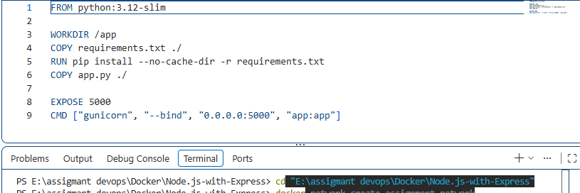

2. Docker Network Creation
A dedicated Docker network was created so the frontend and backend containers can communicate using Docker container/service names.
Command and Result
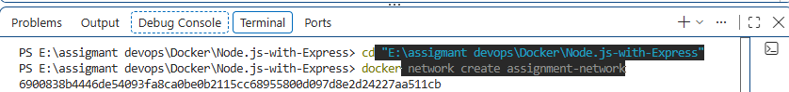
Figure 1. Docker network creation completed successfully.

3. Backend Image Build
The backend image was built from the ./backend directory and tagged as assignment-backend.
Command
PS E:\assigmant devops\Docker\Node.js-with-Express> docker build -t assignment-backend ./backend

Build Evidence
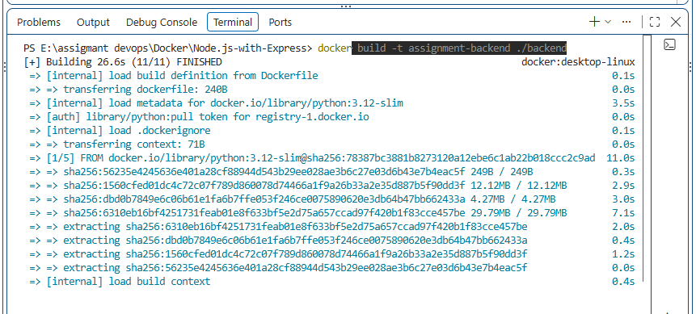
Figure 2. Backend Docker image built successfully.

4. Frontend Image Build
The frontend image was built from the ./frontend directory and tagged as assignment-frontend.
Command
PS E:\assigmant devops\Docker\Node.js-with-Express> docker build -t assignment-frontend ./frontend

Build Evidence
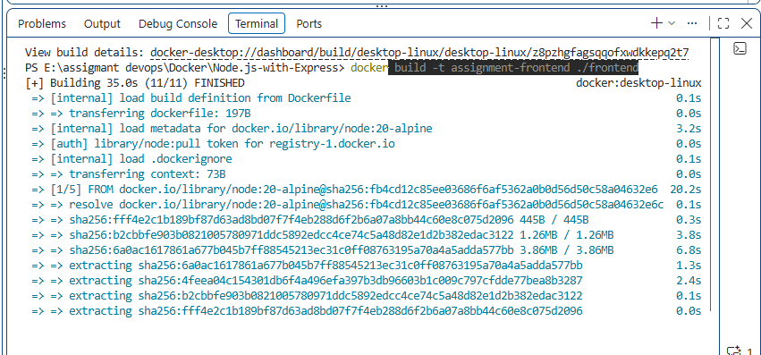
Figure 3. Frontend Docker image built successfully.

5. Backend Container Execution
The backend container was started in detached mode and attached to assignment-network.
Command and Result
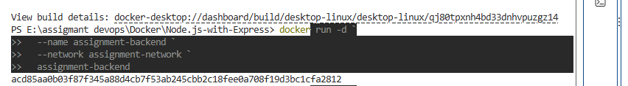
Figure 4. Backend container started successfully.

6. Frontend Container Execution
The frontend container was started with the backend URL, application port, Docker network, and host-to-container port mapping.
Command and Result
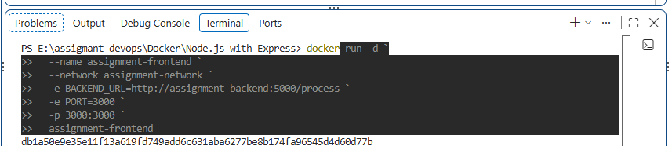
Figure 5. Frontend container started successfully.

7. Verify Running Containers
The docker ps command was used to confirm that both application containers were running.
Command and Output
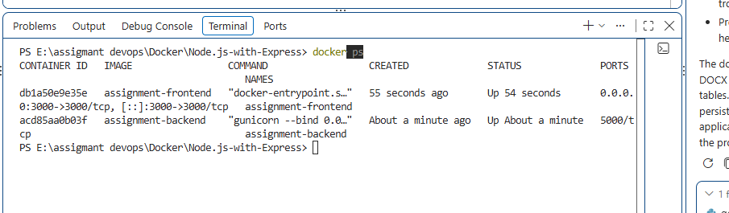
Figure 6. Both frontend and backend containers are shown as running.

Browser output
