**PracticalNo.12**

### **Program 1:**Counting Uppercase and Lowercase Letters

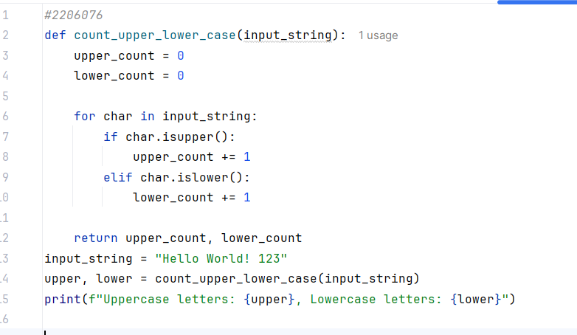

**Output:**

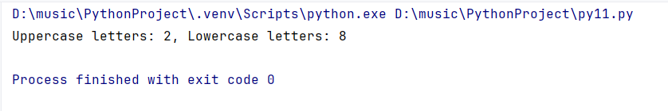

### **Program 2:**Prime Number Check

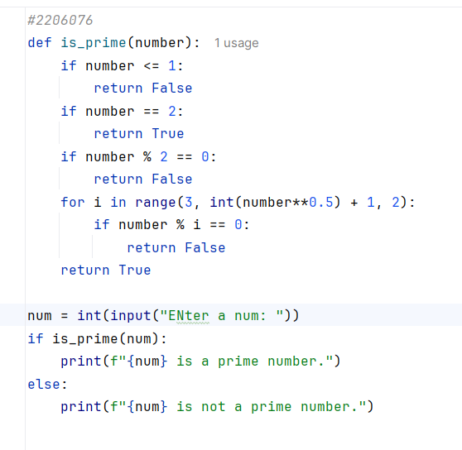

**Output:**

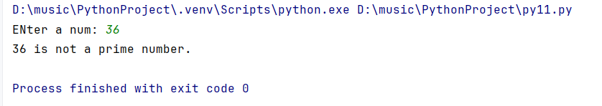

### Program 3:Factorial Calculation

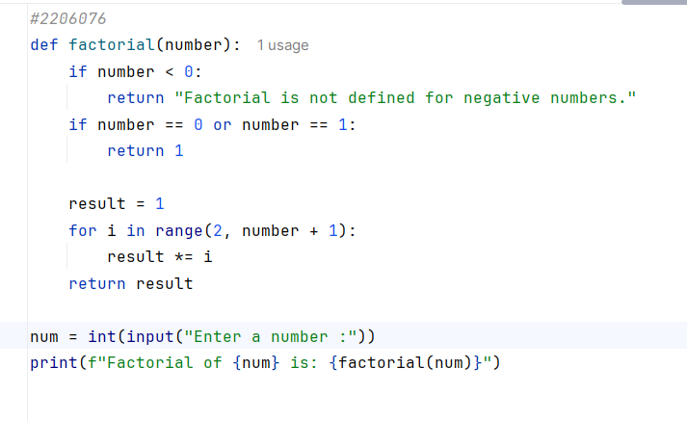

**Output:**

