**The National Health Insurance Claim**

**SQL Report :-**

The purpose of this report is to present the analysis and management of data using Structured Query Language (SQL). SQL is an essential tool for database interaction, widely used in industries for data storage and retrieval. In this project, various SQL operations such as table creation, data insertion, filtering, grouping, and joining have been performed. Through this work, an understanding of database concepts like normalization, primary keys, and relationships between tables has been developed.

**Dataset** :- [National Health Insurance dataset](https://drive.google.com/drive/folders/17XJ86cTPusRRx0W_CrVH0na9CpQM9Jm9?usp=drive_link)

The Above Dataset contains three table.

1. Insurance claims
2. Patient details
3. Region

Step 1 :- Creating the tables for each file

1. Created insurance_claims table and imported the Insurance_claims data into it

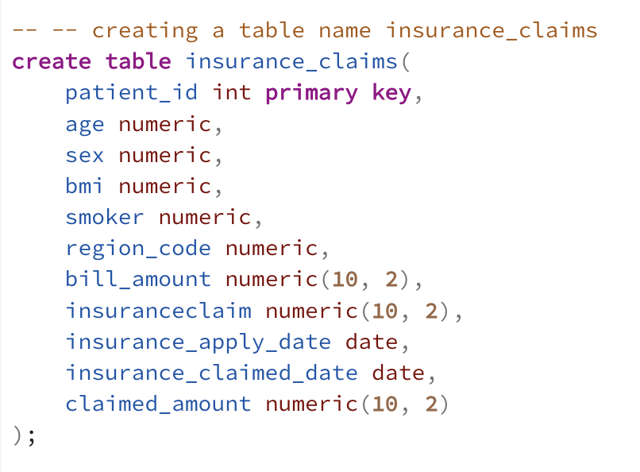

1. Created patients_details table and imported the patient details data into it

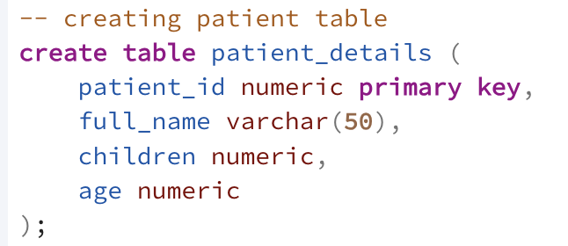

1. Created Regions table and imported the regions data into it

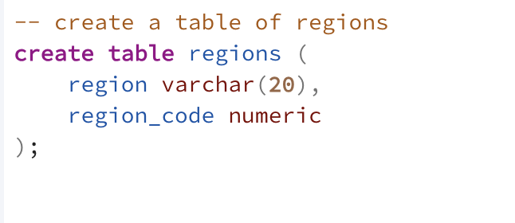

**Step 2** :- Displaying the structure of the table

For Describe :-

Insurance_claim table :-

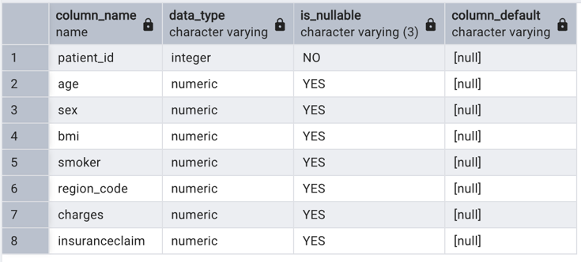

Patient_details table :-

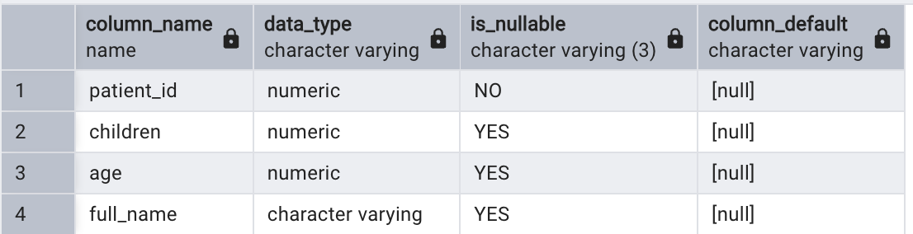

Region table :-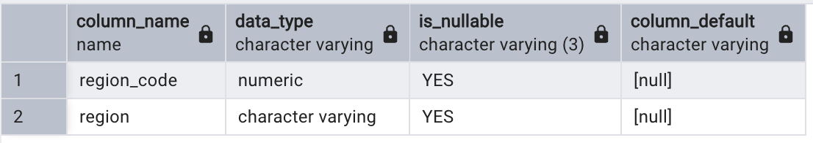

For Counting of rows and columns :-

SQL statement :- -- SELECT COUNT(*) AS total_rows

FROM insurance_claims;

SELECT COUNT(*) AS total_columns;

FROM information_schema.columns

WHERE table_name = ‘insurance_claims’;

**Step 4** :- Combining all the tables into one table as nhic (National Health Insurance Claims).

SQL statement :-

create table nhic as (

select p.patient_id, p.full_name, p.age, p.children, i.sex, r.region_code, r.region, i.bmi, i.smoker, i.bill_amount, i.insuranceclaim,i.insurance_apply_date, i.insurance_claimed_date, i.claimed_amount

from insurance_claims i

join patient_details p

on i.patient_id = p.patient_id

left join regions r

on r.region_code = i.region_code

);

**Step 5** :- Cleaning of nhic table

Counting of Null values of nhic tables

Select

count(*) filter(where patient_id is null) as patient_id,

count(*) filter(where full_name is null) as full_name,

count(*) filter(where age is null) as age,

count(*) filter(where children is null) as children,

count(*) filter(where sex is null) as sex,

count(*) filter(where region_code is null) as region_code,

count(*) filter(where region is null) as region,

count(*) filter(where bmi is null) as bmi,

count(*) filter(where smoker is null) as smoker,

count(*) filter(where charges is null) as charges,

count(*) filter(where insuranceclaim is null) as insuranceclaim

from nhic;

After apply those statements we find there are no null values



Check for duplicate values

with dup as (select *,row_number() over(partition by patient_id, full_name, age, children, sex, region_code, region, bmi, smoker, charges, insuranceclaim order by patient_id) as rn

from nhic)

select * from dup

where rn > 1;

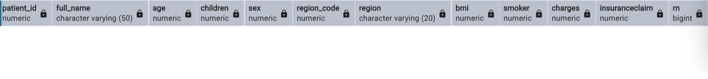

Removing Extra Spaces

There are two columns contain text values

We can perform removing the extra spaces

SQL statement :- UPDATE nhic

SET full_name = TRIM(full_name),

region = TRIM(region);

Removing the special characters :-

UPDATE nhic

SET full_name = REGEXP_REPLACE(full_name, '[^a-zA-Z0-9\s]', '', 'g'),

region = REGEXP_REPLACE(region, '[^a-zA-Z0-9\s]', '', 'g');

**step 6** :-

**Add a column amount paid**

alter table nhic

add column amount_paid numeric(10, 2);

**storing values in that column**

update nhic

set amount_paid = bill_amount - claimed_amount;

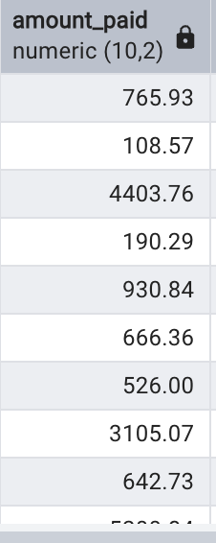

**Add a column Duration :**

alter table nhic

add column duration numeric;

**storing values in that column :**

update nhic

set duration = insurance_claimed_date - insurance_apply_date;

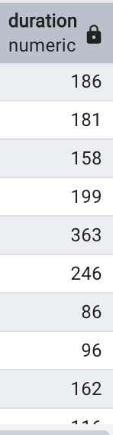

**start and end date of insurance claims**

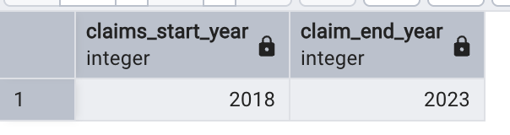

**wise claimed percentage**

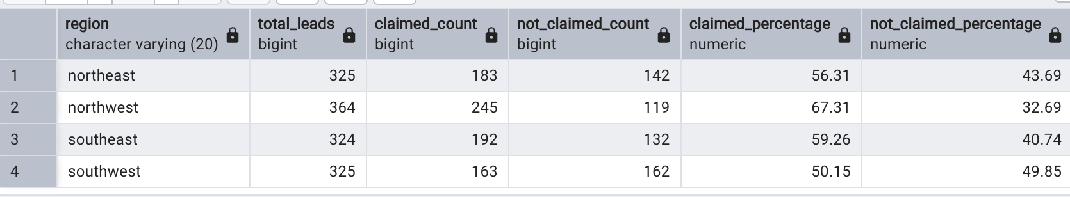

**smoker and bmi based on Insurance claims :**

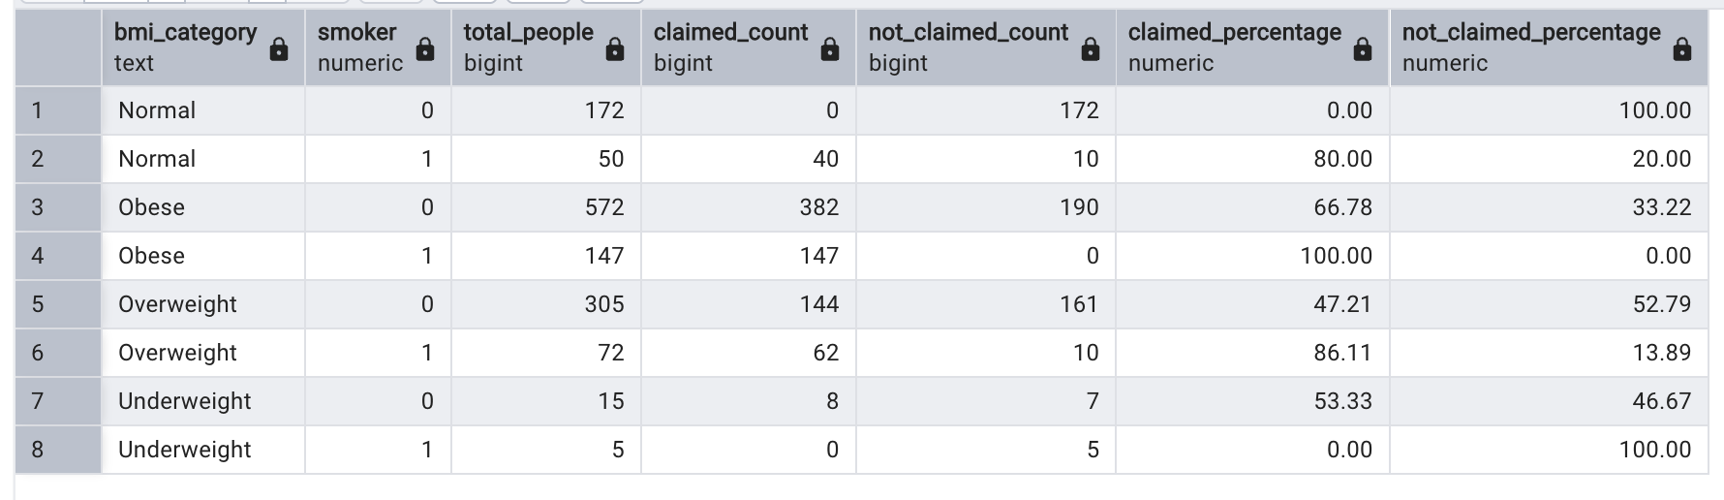

**step 7** :-

conversion of the sql into csv file :-

SQL statement ;- copy nhic TO '/Users/yourname/Downloads/nhic_cleaned.csv' DELIMITER ',' CSV HEADER;