

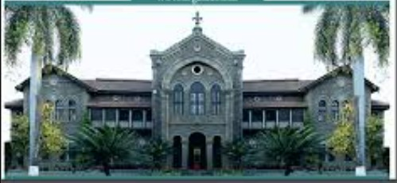

Deccan Education Society's

**FERGUSSON COLLEGE**

**(AUTONOMOUS)**

**PUNE - 411 004, MAHARASHTRA, INDIA.**

**Empowered Autonomous College (Under Savitribai Phule Pune University)  
(ID No. PU/PN/AS/002/1885) Reaccredited with "A+" Grade by NAAC (4th Cycle) | AISHE Code: C-41431**

**UGC Special Heritage Status | UGC - College of Excellence (CE) | DBT - STAR Status**