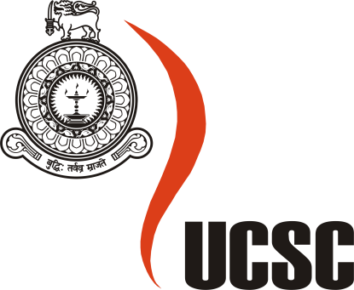

**Masters Project Final Report**

**December 2014**

|  |  |  |  |  |
| --- | --- | --- | --- | --- |
| **Project Title** | Enhance UCSC Virtual Campus by Developing New Modules | | | |
| **Student Name** | W.A.Pasan Buddhika | | | |
| **Registration No.**  **& Index No.** | 2012/MCS/012  12440124 | | | |
| **Supervisor’s Name** | Prof. K. P. Hewagamage | | | |
| **Please Circle the appropriate** | **Master’s Program** | | **Type** | |
| **MIT** | **MCS** | **Research** | **Implementation** |

|  |
| --- |
| **For Office Use ONLY** |
|  |
|  |