# **Liferay Form QA Testing Interview**

**Bug Repor**

*Changelog*

|  |  |  |  |
| --- | --- | --- | --- |
| **Version** | **Change Date** | **Prepared by** | **Changes description** |
| V01 | 15/11/2021 | Pablo Mantas | Form Release 01 |
|  |  |  |  |
|  |  |  |  |
|  |  |  |  |

**Table of content**

**LFR-FORM-BUG-0001** 3

**LFR-FORM-BUG-0002** 4

**LFR-FORM-BUG-0003** 5

**LFR-FORM-BUG-0004** 6

**LFR-FORM-BUG-0005** 7

**LFR-FORM-BUG-0006** 8

**LFR-FORM-BUG-0007** 9

**LFR-FORM-BUG-0008** 10

**LFR-FORM-BUG-0009** 11

**LFR-FORM-BUG-0010** 12

## **LFR-FORM-BUG-0001**

|  |  |
| --- | --- |
| Bug Id | # LFR-FORM-BUG-0001 |
| Name | Wrong language in some Portuguese texts |
| Reporter | Pablo Mantas |
| Submit Date | 15/11/2021 |
| Summary | Some texts remain in English when switching to the PT region |
| URL | https://forms.liferay.com/web/forms/shared/-/form/122548 |
| Screenshot | EVIDENCE-BUG-0001 |
| Operating System | Windows 10 |
| Browser | Chrome 95.0.46 |
| Severity | Major |
| Assigned to | Pending |
| Priority | High |

**Steps to reproduce**

1. As a standard User
2. Open Chrome browser
3. Go to form URL
4. Click on region Action button
5. Select Brasil region
6. Observe results

**Expected result**

All the text that instructs the user should be in Portuguese

**Actual result**

Some texts appear in a language other than that of the region.

**Evidence**:

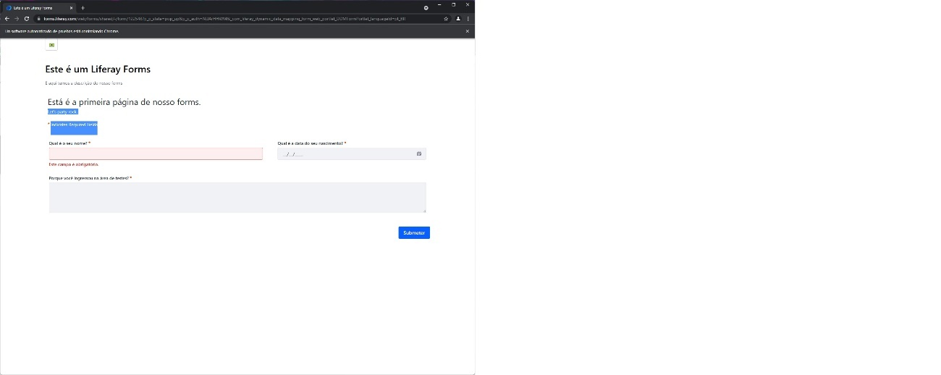

**Notes**

## **LFR-FORM-BUG-0002**

|  |  |
| --- | --- |
| Bug Id | # LFR-FORM-BUG-0002 |
| Name | Wrong data in warning message for US form |
| Reporter | Pablo Mantas |
| Submit Date | 15/11/2021 |
| Summary | An unknown numbering appears after the error message and is not related to the message to the user. |
| URL | https://forms.liferay.com/web/forms/shared/-/form/122548 |
| Screenshot | EVIDENCE-BUG-0002 |
| Operating System | Windows 10 |
| Browser | Chrome 95.0.46 |
| Severity | Major |
| Assigned to | Pending |
| Priority | High |

**Steps to reproduce**

1. As a standard User
2. Open Chrome browser
3. Go to form URL
4. Submit the form with required fields empty
5. Observe results

**Expected result**

Show the error message in the form submission followed by the first field that has been left empty "This form is invalid. Check field ___"

All required fields must be marked in red

Display the warning text "This field is required." just below each mandatory one.

**Actual result**

Some texts appear in a language other than that of the region. Observe the screenshot

**Evidence**:

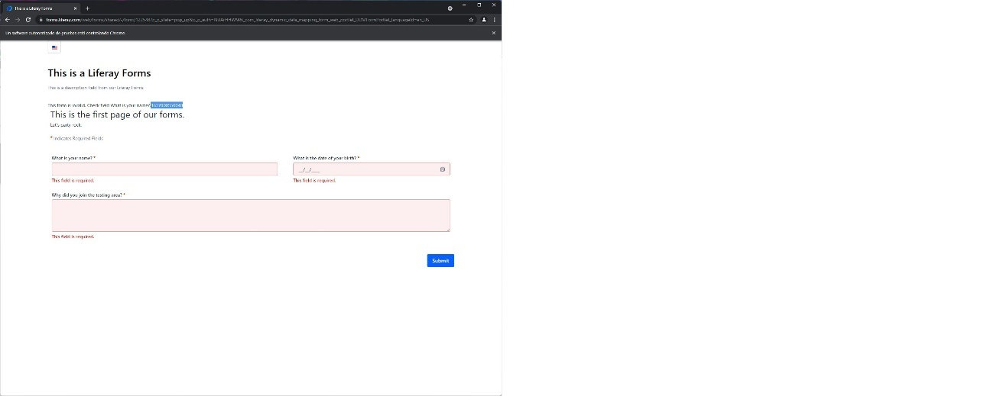

**Notes**

## **LFR-FORM-BUG-0003**

|  |  |
| --- | --- |
| Bug Id | # LFR-FORM-BUG-0003 |
| Name | Missed warning red color for Birth Date field for US form |
| Reporter | Pablo Mantas |
| Submit Date | 15/11/2021 |
| Summary | When the date of birth field is left unfilled, it does not warn the user until the submit button has been pressed. Look at the screenshot |
| URL | https://forms.liferay.com/web/forms/shared/-/form/122548 |
| Screenshot | EVIDENCE-BUG-0003 |
| Operating System | Windows 10 |
| Browser | Chrome 95.0.46 |
| Severity | Low |
| Assigned to | Pending |
| Priority | Low |

**Steps to reproduce**

1. As a standard User
2. Open Chrome browser
3. Go to form URL
4. Select Birth date and leave it empty
5. Select other input field
6. Observe results

**Expected result**

If we leave Birth Date field and select another field, the Birth Date field is marked in red and the warning text "This field is required." also appears in red below

**Actual result**

When the date of birth field is left unfilled, it does not warn the user until the submit button has been pressed. Look at the screenshot

**Evidence**:

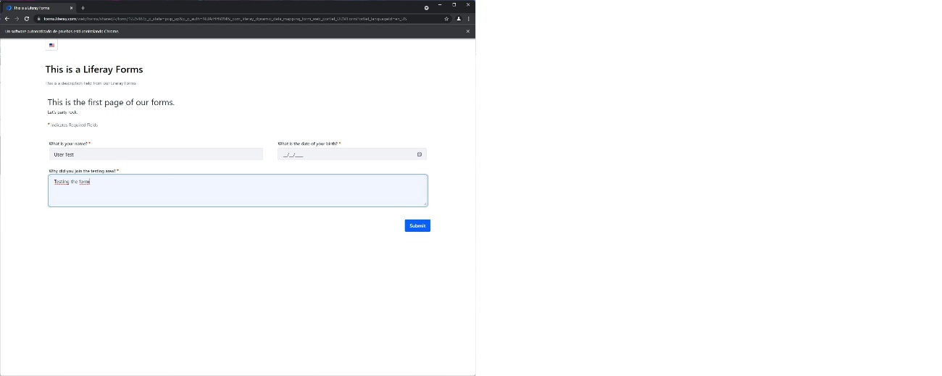

**Notes**

## **LFR-FORM-BUG-0004**

|  |  |
| --- | --- |
| Bug Id | # LFR-FORM-BUG-0004 |
| Name | Special chars in input field could be unsafe for US form |
| Reporter | Pablo Mantas |
| Submit Date | 15/11/2021 |
| Summary | Special characters should not be allowed on forms, in the absence of security tests, unless strictly necessary. |
| URL | https://forms.liferay.com/web/forms/shared/-/form/122548 |
| Screenshot | EVIDENCE-BUG-0004 |
| Operating System | Windows 10 |
| Browser | Chrome 95.0.46 |
| Severity | Minor |
| Assigned to | Pending |
| Priority | Normal |

**Steps to reproduce**

1. As a standard User
2. Open Chrome browser
3. Go to form URL
4. Fill the name field with special chars

like !=”@

1. Fill all the requested fields
2. Submit the form
3. Observe results

**Expected result**

Inform the user that there are characters not allowed in the Name field

**Actual result**

Special characters should not be allowed on forms, in the absence of security tests, unless strictly necessary.

**Evidence**:

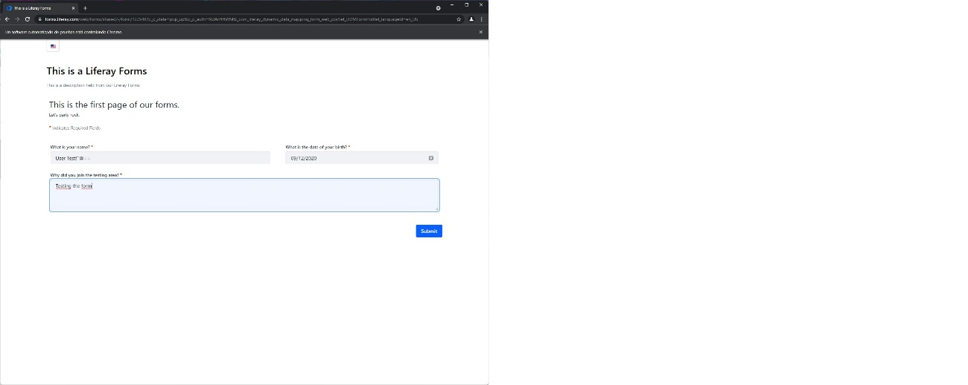

**Notes**

## **LFR-FORM-BUG-0005**

|  |  |
| --- | --- |
| Bug Id | # LFR-FORM-BUG-0005 |
| Name | Wrong validation of birth date field for US form |
| Reporter | Pablo Mantas |
| Submit Date | 15/11/2021 |
| Summary | Being a date of birth, the form should validate that at least it is not a date in the future. |
| URL | https://forms.liferay.com/web/forms/shared/-/form/122548 |
| Screenshot | EVIDENCE-BUG-0005 |
| Operating System | Windows 10 |
| Browser | Chrome 95.0.46 |
| Severity | Major |
| Assigned to | Pending |
| Priority | High |

**Steps to reproduce**

1. As a standard User
2. Open Chrome browser
3. Go to form URL
4. Select Birth date field and set a future date
5. Fill all requested fields
6. Submit the form
7. Observe results

**Expected result**

Inform the user that the birth date cannot be in the future

**Actual result**

Being a date of birth, the form should validate that at least it is not a date in the future.

**Evidence**:

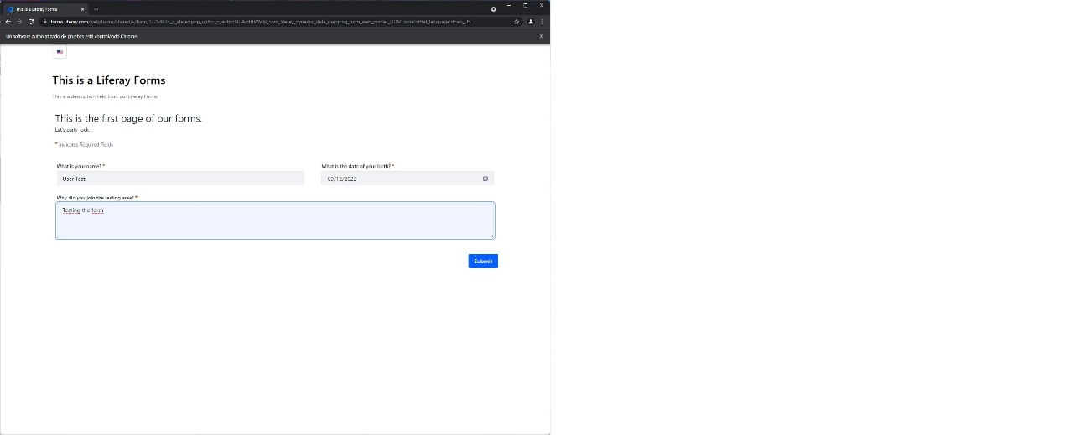

**Notes**

## **LFR-FORM-BUG-0006**

|  |  |
| --- | --- |
| Bug Id | # LFR-FORM-BUG-0006 |
| Name | Wrong data validation in PT form |
| Reporter | Pablo Mantas |
| Submit Date | 15/11/2021 |
| Summary | The form for the Portuguese region does not allow the sending of the data unless in any case since an error is detected in the field of the date of birth. |
| URL | https://forms.liferay.com/web/forms/shared/-/form/122548 |
| Screenshot | EVIDENCE-BUG-0006 |
| Operating System | Windows 10 |
| Browser | Chrome 95.0.46 |
| Severity | Critical |
| Assigned to | Pending |
| Priority | Very High |

**Steps to reproduce**

1. As a standard User
2. Open Chrome browser
3. Go to form URL
4. Click on region Action button
5. Select Brasil region
6. Fill all requested fields with valid data
7. Submit the form
8. Observe results

**Expected result**

The successfully submitted form screen is displayed

**Actual result**

The form for the Portuguese region does not allow the sending of the data unless in any case since an error is detected in the field of the date of birth.

**Evidence**:

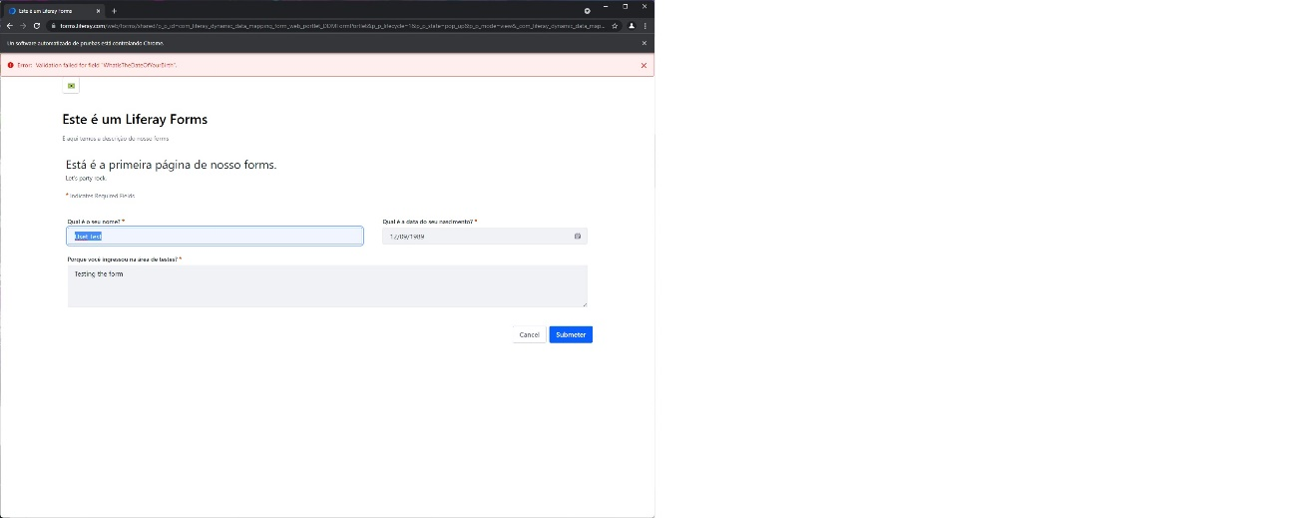

**Notes**

## **LFR-FORM-BUG-0007**

|  |  |
| --- | --- |
| Bug Id | # LFR-FORM-BUG-0007 |
| Name | Wrong data in warning message for PT form |
| Reporter | Pablo Mantas |
| Submit Date | 15/11/2021 |
| Summary | Following the warning text is a numeric identifier that it should not. It could confuse the user. Observe the screenshot |
| URL | https://forms.liferay.com/web/forms/shared/-/form/122548 |
| Screenshot | EVIDENCE-BUG-0007 |
| Operating System | Windows 10 |
| Browser | Chrome 95.0.46 |
| Severity | Major |
| Assigned to | Pending |
| Priority | High |

**Steps to reproduce**

1. As a standard User
2. Open Chrome browser
3. Go to form URL
4. Click on region Action button
5. Select Brasil region
6. Submit the form with required fields empty
7. Observe results

**Expected result**

Show the error message in the form submission followed by the first field that has been left empty "This form is invalid. Check field ___"

All required fields must be marked in red

Display the warning text "This field is required." just below each mandatory one.

**Actual result**

Following the warning text is a numeric identifier that it should not. It could confuse the user. Observe the screenshot

**Evidence**:

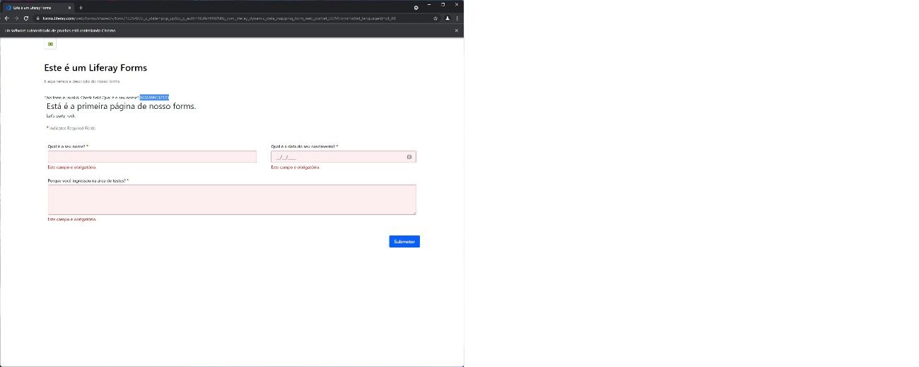

**Notes**

## **LFR-FORM-BUG-0008**

|  |  |
| --- | --- |
| Bug Id | # LFR-FORM-BUG-0008 |
| Name | Missed warning red color for Birth Date field for PT form |
| Reporter | Pablo Mantas |
| Submit Date | 15/11/2021 |
| Summary | When the date of birth field is left unfilled, it does not warn the user until the submit button has been pressed. Look at the screenshot |
| URL | https://forms.liferay.com/web/forms/shared/-/form/122548 |
| Screenshot | EVIDENCE-BUG-0008 |
| Operating System | Windows 10 |
| Browser | Chrome 95.0.46 |
| Severity | Low |
| Assigned to | Pending |
| Priority | Low |

**Steps to reproduce**

1. As a standard User
2. Open Chrome browser
3. Go to form URL
4. Click on region Action button
5. Select Brasil region
6. Select Birth date and leave it empty
7. Select other input field
8. Observe results

**Expected result**

If we leave Birth Date field and select another field, the Birth Date field is marked in red and the warning text "This field is required." also appears in red below

**Actual result**

When the date of birth field is left unfilled, it does not warn the user until the submit button has been pressed. Look at the screenshot

**Evidence**:

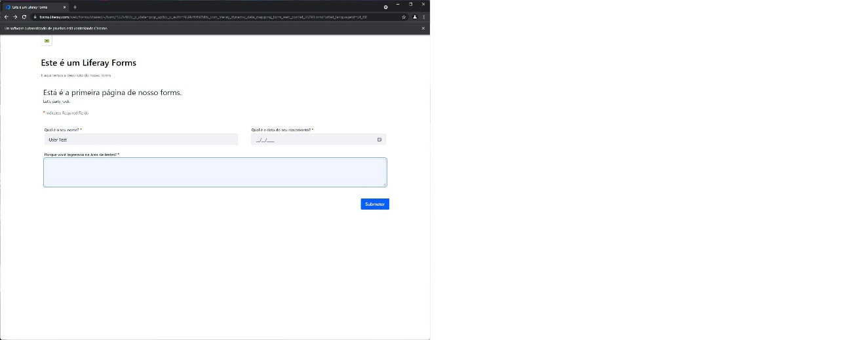

**Notes**

## **LFR-FORM-BUG-0009**

|  |  |
| --- | --- |
| Bug Id | # LFR-FORM-BUG-0009 |
| Name | Special chars in input field could be unsafe for PT form |
| Reporter | Pablo Mantas |
| Submit Date | 15/11/2021 |
| Summary | Special characters should not be allowed on forms, in the absence of security tests, unless strictly necessary. |
| URL | https://forms.liferay.com/web/forms/shared/-/form/122548 |
| Screenshot | EVIDENCE-BUG-0009 |
| Operating System | Windows 10 |
| Browser | Chrome 95.0.46 |
| Severity | Minor |
| Assigned to | Pending |
| Priority | Normal |

**Steps to reproduce**

1. As a standard User
2. Open Chrome browser
3. Go to form URL
4. Click on region Action button
5. Select Brasil region
6. Fill the name field with special chars

!=”@

1. Fill all the requested fields
2. Submit the form
3. Observe results

**Expected result**

Inform the user that there are characters not allowed in the Name field

**Actual result**

Special characters should not be allowed on forms, in the absence of security tests, unless strictly necessary.

**Evidence**:

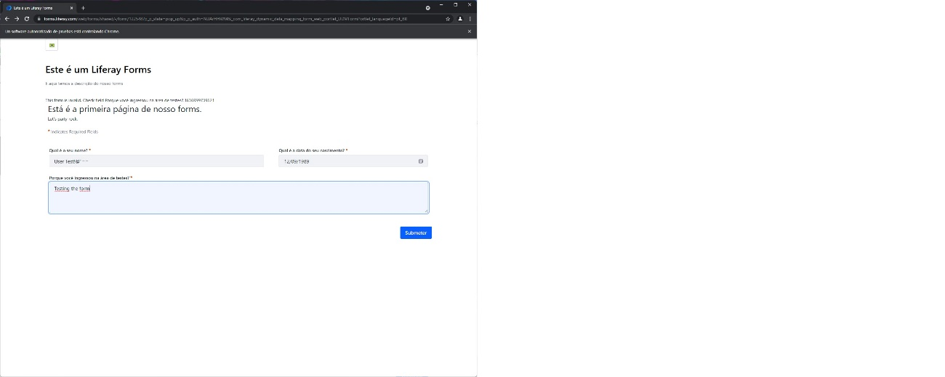

**Notes**

## **LFR-FORM-BUG-0010**

|  |  |
| --- | --- |
| Bug Id | # LFR-FORM-BUG-0010 |
| Name | Wrong validation of birth date field for US form |
| Reporter | Pablo Mantas |
| Submit Date | 15/11/2021 |
| Summary | Being a date of birth, the form should validate that at least it is not a date in the future. |
| URL | https://forms.liferay.com/web/forms/shared/-/form/122548 |
| Screenshot | EVIDENCE-BUG-0010 |
| Operating System | Windows 10 |
| Browser | Chrome 95.0.46 |
| Severity | Major |
| Assigned to | Pending |
| Priority | High |

**Steps to reproduce**

1. As a standard User
2. Open Chrome browser
3. Go to form URL
4. Click on region Action button
5. Select Brasil region
6. Select Birth date field and set a future date
7. Fill all requested fields
8. Submit the form
9. Observe results

**Expected result**

Inform the user that the birth date cannot be in the future

**Actual result**

Being a date of birth, the form should validate that at least it is not a date in the future.

**Evidence**:

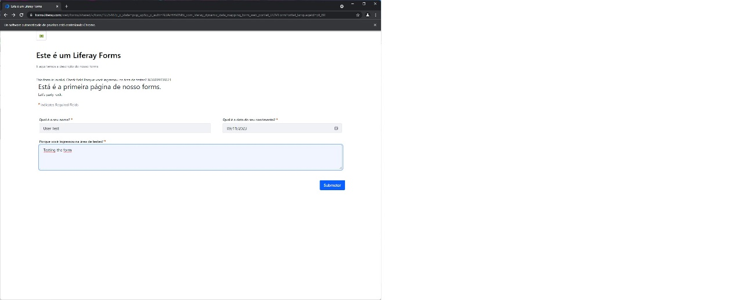

**Notes**

END OF THE DOCUMENT