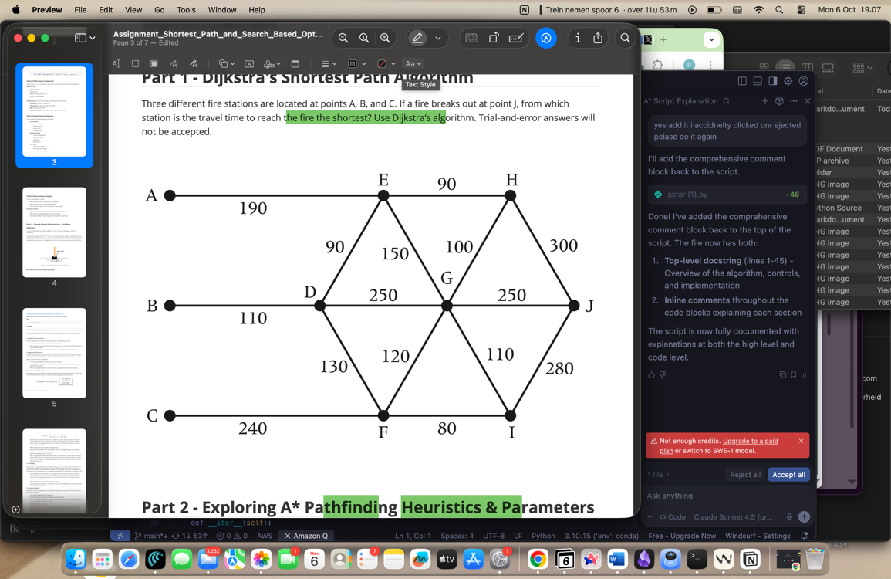

- From A: A → E (190) → H (90) → J (300) = 190 + 90 + 300 = 580
- From B (best): B → D (110) → E (90) → H (90) → J (300) = 590
- From C (best): C → F (240) → I (80) → J (280) = 600
So the shortest travel time to J is 580 from station A via A–E–H–J.
Task 2
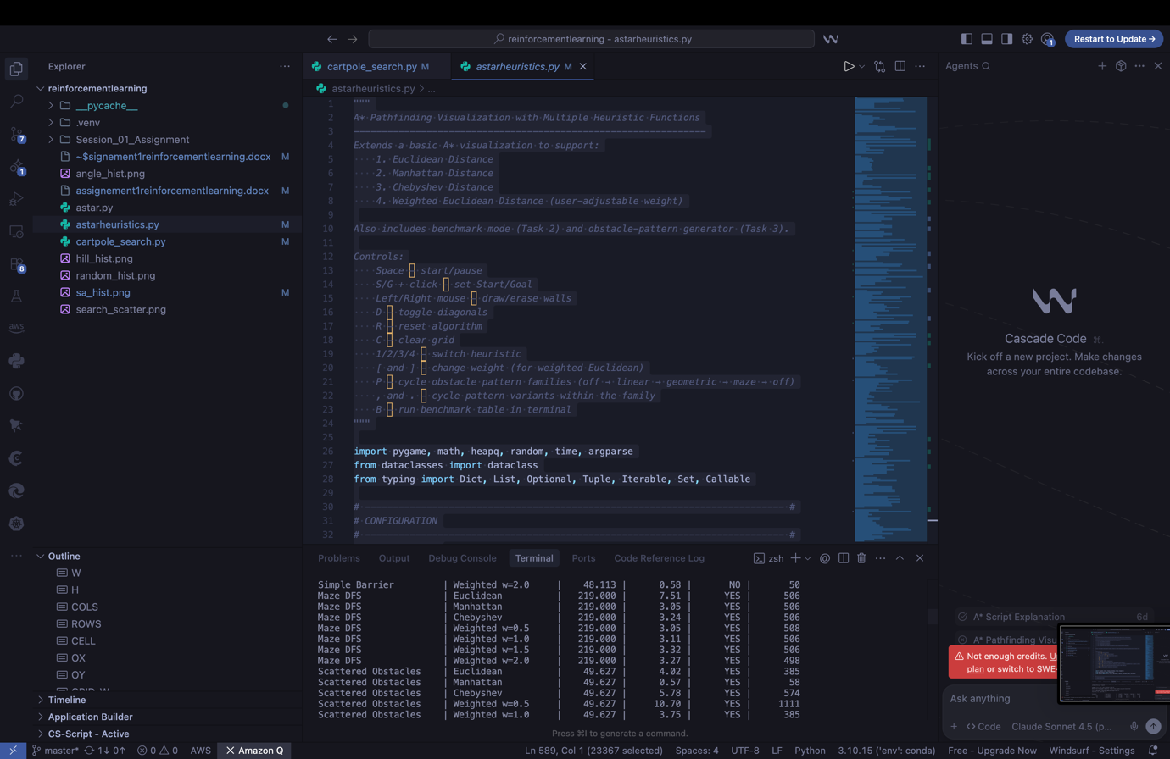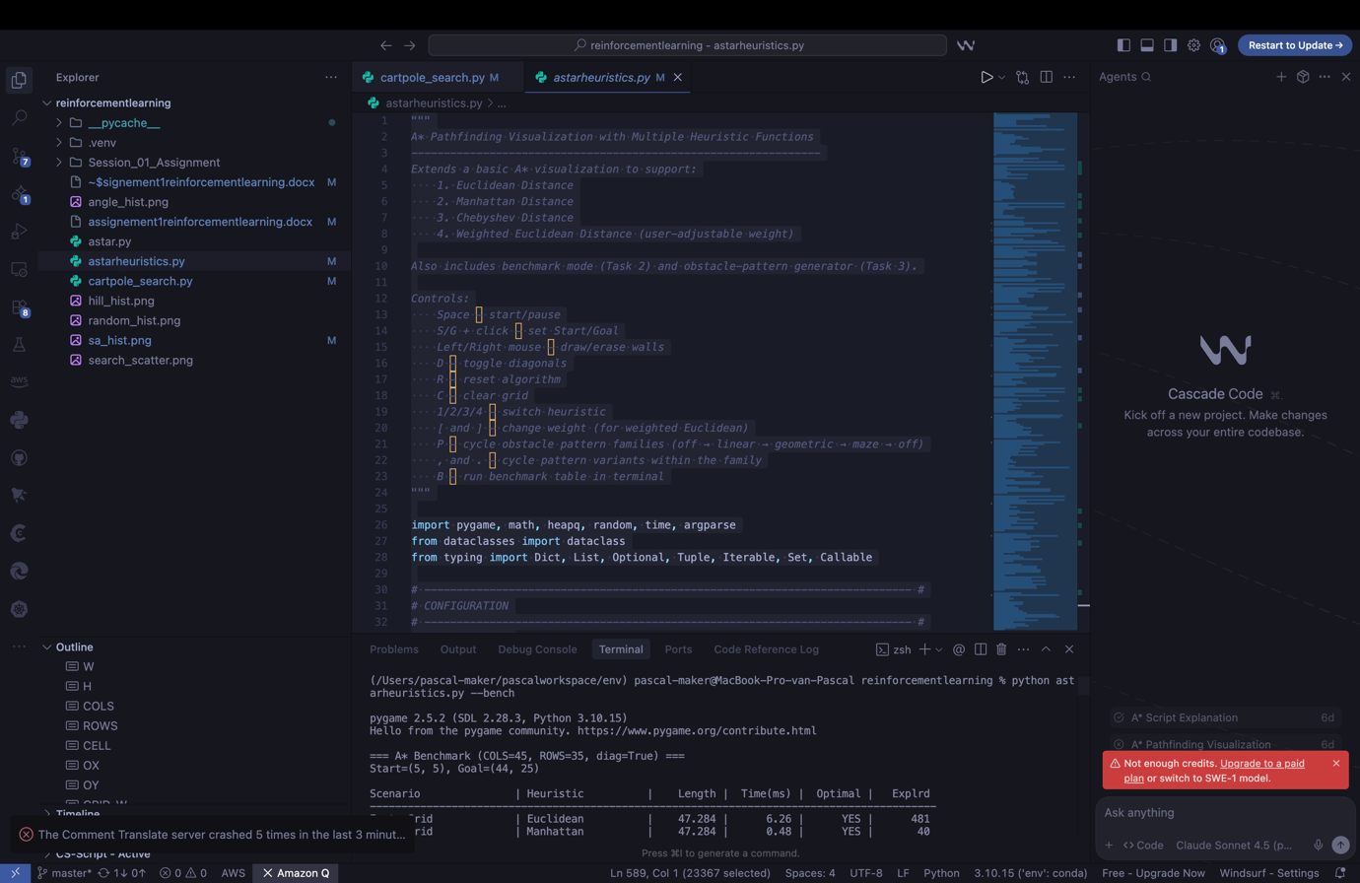
Screenshots from running astarheuristics.py file. Run it with the command : starheuristics.py –bench for the results.

Hello from the pygame community. https://www.pygame.org/contribute.html
(/Users/pascal-maker/pascalworkspace/env) pascal-maker@MacBook-Pro-van-Pascal reinforcementlearning % python astarheuristics.py --bench
pygame 2.5.2 (SDL 2.28.3, Python 3.10.15)
Hello from the pygame community. https://www.pygame.org/contribute.html

=== A* Benchmark (COLS=45, ROWS=35, diag=True) ===
Start=(5, 5), Goal=(44, 25)

Scenario | Heuristic | Length | Time(ms) | Optimal | Explored
------------------------------------------------------------------------------------------
Empty Grid | Euclidean | 47.284 | 7.09 | YES | 481
Empty Grid | Manhattan | 47.284 | 0.55 | YES | 40
Empty Grid | Chebyshev | 47.284 | 9.13 | YES | 708
Empty Grid | WeightedEuclid w=0.5 | 47.284 | 18.99 | YES | 1402
Empty Grid | WeightedEuclid w=1.0 | 47.284 | 6.89 | YES | 481
Empty Grid | WeightedEuclid w=1.5 | 47.284 | 0.57 | YES | 40
Empty Grid | WeightedEuclid w=2.0 | 47.284 | 0.61 | YES | 40
Simple Barrier | Euclidean | 47.284 | 5.21 | YES | 377
Simple Barrier | Manhattan | 47.284 | 1.11 | YES | 78
Simple Barrier | Chebyshev | 47.284 | 6.58 | YES | 550
Simple Barrier | WeightedEuclid w=0.5 | 47.284 | 15.01 | YES | 1151
Simple Barrier | WeightedEuclid w=1.0 | 47.284 | 5.04 | YES | 377
Simple Barrier | WeightedEuclid w=1.5 | 48.113 | 0.62 | NO | 45
Simple Barrier | WeightedEuclid w=2.0 | 48.113 | 0.67 | NO | 50
Maze | Euclidean | 151.000 | 2.75 | YES | 381
Maze | Manhattan | 151.000 | 2.32 | YES | 374
Maze | Chebyshev | 151.000 | 2.42 | YES | 385
Maze | WeightedEuclid w=0.5 | 151.000 | 7.01 | YES | 395
Maze | WeightedEuclid w=1.0 | 151.000 | 2.74 | YES | 381
Maze | WeightedEuclid w=1.5 | 151.000 | 2.36 | YES | 351
Maze | WeightedEuclid w=2.0 | 151.000 | 2.32 | YES | 331
Scattered Obstacles | Euclidean | 49.627 | 4.28 | YES | 385
Scattered Obstacles | Manhattan | 49.627 | 0.62 | YES | 58
Scattered Obstacles | Chebyshev | 49.627 | 5.93 | YES | 574
Scattered Obstacles | WeightedEuclid w=0.5 | 49.627 | 11.43 | YES | 1111
Scattered Obstacles | WeightedEuclid w=1.0 | 49.627 | 4.36 | YES | 385
Scattered Obstacles | WeightedEuclid w=1.5 | 49.627 | 0.60 | YES | 55
Scattered Obstacles | WeightedEuclid w=2.0 | 50.456 | 0.56 | NO | 53

Done.

Task 3

(/Users/pascal-maker/pascalworkspace/env) pascal-maker@MacBook-Pro-van-Pascal reinforcementlearning % python astarheuristics.py --bench
pygame 2.5.2 (SDL 2.28.3, Python 3.10.15)
Hello from the pygame community. https://www.pygame.org/contribute.html

=== A* Benchmark (COLS=45, ROWS=35, diag=True) ===
Start=(5, 5), Goal=(44, 25)

Scenario | Heuristic | Length | Time(ms) | Optimal | Explrd
------------------------------------------------------------------------------------------
Empty Grid | Euclidean | 47.284 | 6.33 | YES | 481
Empty Grid | Manhattan | 47.284 | 0.48 | YES | 40
Empty Grid | Chebyshev | 47.284 | 8.79 | YES | 708
Empty Grid | Weighted w=0.5 | 47.284 | 17.84 | YES | 1402
Empty Grid | Weighted w=1.0 | 47.284 | 6.24 | YES | 481
Empty Grid | Weighted w=1.5 | 47.284 | 0.60 | YES | 40
Empty Grid | Weighted w=2.0 | 47.284 | 0.48 | YES | 40
Simple Barrier | Euclidean | 47.284 | 4.74 | YES | 377
Simple Barrier | Manhattan | 47.284 | 1.03 | YES | 78
Simple Barrier | Chebyshev | 47.284 | 6.40 | YES | 550
Simple Barrier | Weighted w=0.5 | 47.284 | 14.51 | YES | 1151
Simple Barrier | Weighted w=1.0 | 47.284 | 4.79 | YES | 377
Simple Barrier | Weighted w=1.5 | 48.113 | 0.56 | NO | 45
Simple Barrier | Weighted w=2.0 | 48.113 | 0.62 | NO | 50
Maze DFS | Euclidean | 219.000 | 7.29 | YES | 506
Maze DFS | Manhattan | 219.000 | 3.40 | YES | 506
Maze DFS | Chebyshev | 219.000 | 3.14 | YES | 506
Maze DFS | Weighted w=0.5 | 219.000 | 3.04 | YES | 508
Maze DFS | Weighted w=1.0 | 219.000 | 3.21 | YES | 506
Maze DFS | Weighted w=1.5 | 219.000 | 3.34 | YES | 506
Maze DFS | Weighted w=2.0 | 219.000 | 3.23 | YES | 498
Scattered Obstacles | Euclidean | 49.627 | 4.23 | YES | 385
Scattered Obstacles | Manhattan | 49.627 | 0.67 | YES | 58
Scattered Obstacles | Chebyshev | 49.627 | 5.80 | YES | 574
Scattered Obstacles | Weighted w=0.5 | 49.627 | 10.89 | YES | 1111
Scattered Obstacles | Weighted w=1.0 | 49.627 | 4.30 | YES | 385
Scattered Obstacles | Weighted w=1.5 | 49.627 | 0.64 | YES | 55
Scattered Obstacles | Weighted w=2.0 | 50.456 | 0.50 | NO | 53
Linear Horizontal | Euclidean | 51.385 | 7.37 | YES | 564
Linear Horizontal | Manhattan | 51.385 | 0.51 | YES | 49
Linear Horizontal | Chebyshev | 51.385 | 8.17 | YES | 652
Linear Horizontal | Weighted w=0.5 | 51.385 | 14.70 | YES | 1256
Linear Horizontal | Weighted w=1.0 | 51.385 | 7.81 | YES | 564
Linear Horizontal | Weighted w=1.5 | 51.385 | 0.62 | YES | 52
Linear Horizontal | Weighted w=2.0 | 51.385 | 0.51 | YES | 47
Linear Vertical | Euclidean | 50.941 | 5.86 | YES | 461
Linear Vertical | Manhattan | 50.941 | 7.60 | YES | 560
Linear Vertical | Chebyshev | 50.941 | 8.58 | YES | 690
Linear Vertical | Weighted w=0.5 | 50.941 | 17.11 | YES | 1346
Linear Vertical | Weighted w=1.0 | 50.941 | 5.94 | YES | 461
Linear Vertical | Weighted w=1.5 | 50.941 | 4.37 | YES | 306
Linear Vertical | Weighted w=2.0 | 59.527 | 3.19 | NO | 235
Linear Diagonal | Euclidean | 47.284 | 6.26 | YES | 458
Linear Diagonal | Manhattan | 47.284 | 0.52 | YES | 41
Linear Diagonal | Chebyshev | 47.284 | 8.37 | YES | 683
Linear Diagonal | Weighted w=0.5 | 47.284 | 17.02 | YES | 1368
Linear Diagonal | Weighted w=1.0 | 47.284 | 5.70 | YES | 458
Linear Diagonal | Weighted w=1.5 | 47.284 | 0.48 | YES | 40
Linear Diagonal | Weighted w=2.0 | 47.284 | 0.52 | YES | 40
Linear L-Shape | Euclidean | 48.698 | 0.91 | YES | 79
Linear L-Shape | Manhattan | 56.314 | 0.79 | NO | 66
Linear L-Shape | Chebyshev | 48.698 | 4.74 | YES | 382
Linear L-Shape | Weighted w=0.5 | 48.698 | 15.86 | YES | 1260
Linear L-Shape | Weighted w=1.0 | 48.698 | 0.90 | YES | 79
Linear L-Shape | Weighted w=1.5 | 48.698 | 0.48 | YES | 41
Linear L-Shape | Weighted w=2.0 | 48.698 | 0.47 | YES | 41
Geo Hollow Square | Euclidean | 48.456 | 3.65 | YES | 297
Geo Hollow Square | Manhattan | 53.728 | 0.66 | NO | 51
Geo Hollow Square | Chebyshev | 48.456 | 6.06 | YES | 504
Geo Hollow Square | Weighted w=0.5 | 48.456 | 14.05 | YES | 1148
Geo Hollow Square | Weighted w=1.0 | 48.456 | 3.70 | YES | 297
Geo Hollow Square | Weighted w=1.5 | 48.456 | 0.57 | YES | 51
Geo Hollow Square | Weighted w=2.0 | 49.284 | 0.58 | NO | 52
Geo Filled Circle | Euclidean | 47.284 | 2.72 | YES | 211
Geo Filled Circle | Manhattan | 52.799 | 0.80 | NO | 63
Geo Filled Circle | Chebyshev | 47.284 | 5.90 | YES | 474
Geo Filled Circle | Weighted w=0.5 | 47.284 | 13.85 | YES | 1131
Geo Filled Circle | Weighted w=1.0 | 47.284 | 2.59 | YES | 211
Geo Filled Circle | Weighted w=1.5 | 49.770 | 0.79 | NO | 65
Geo Filled Circle | Weighted w=2.0 | 50.598 | 0.69 | NO | 53
Geo Star | Euclidean | 49.627 | 5.75 | YES | 456
Geo Star | Manhattan | 55.728 | 2.07 | NO | 171
Geo Star | Chebyshev | 49.627 | 7.61 | YES | 632
Geo Star | Weighted w=0.5 | 49.627 | 15.62 | YES | 1301
Geo Star | Weighted w=1.0 | 49.627 | 5.84 | YES | 456
Geo Star | Weighted w=1.5 | 51.284 | 1.59 | NO | 129
Geo Star | Weighted w=2.0 | 53.770 | 1.84 | NO | 162
Geo Spiral | Euclidean | 49.770 | 5.93 | YES | 511
Geo Spiral | Manhattan | 49.770 | 1.58 | YES | 122
Geo Spiral | Chebyshev | 49.770 | 7.96 | YES | 710
Geo Spiral | Weighted w=0.5 | 49.770 | 16.27 | YES | 1385
Geo Spiral | Weighted w=1.0 | 49.770 | 5.88 | YES | 511
Geo Spiral | Weighted w=1.5 | 49.770 | 0.70 | YES | 54
Geo Spiral | Weighted w=2.0 | 50.355 | 0.61 | NO | 51
Maze Simple | Euclidean | 48.456 | 7.27 | YES | 565
Maze Simple | Manhattan | 48.456 | 0.53 | YES | 44
Maze Simple | Chebyshev | 48.456 | 8.76 | YES | 736
Maze Simple | Weighted w=0.5 | 48.456 | 17.25 | YES | 1423
Maze Simple | Weighted w=1.0 | 48.456 | 7.16 | YES | 565
Maze Simple | Weighted w=1.5 | 48.456 | 0.50 | YES | 42
Maze Simple | Weighted w=2.0 | 48.456 | 0.50 | YES | 42
Maze Rooms | Euclidean | 47.870 | 3.65 | YES | 285
Maze Rooms | Manhattan | 48.456 | 0.51 | NO | 42
Maze Rooms | Chebyshev | 47.870 | 6.10 | YES | 509
Maze Rooms | Weighted w=0.5 | 47.870 | 14.75 | YES | 1195
Maze Rooms | Weighted w=1.0 | 47.870 | 3.42 | YES | 285
Maze Rooms | Weighted w=1.5 | 48.456 | 0.51 | NO | 44
Maze Rooms | Weighted w=2.0 | 48.456 | 0.49 | NO | 42
Maze Open | Euclidean | 54.899 | 7.27 | YES | 781
Maze Open | Manhattan | 54.899 | 0.71 | YES | 78
Maze Open | Chebyshev | 54.899 | 7.83 | YES | 815
Maze Open | Weighted w=0.5 | 54.899 | 11.30 | YES | 1253
Maze Open | Weighted w=1.0 | 54.899 | 7.29 | YES | 781
Maze Open | Weighted w=1.5 | 54.899 | 0.51 | YES | 55
Maze Open | Weighted w=2.0 | 54.899 | 0.53 | YES | 53

Done.

Task 4

Pattern Impact Analysis (based on my benchmark table)
TL;DR
- Fastest / fewest nodes explored: higher Weighted Euclidean (w=1.5–2.0) often explores the fewest nodes, but it sometimes gives non-optimal paths.
- Safest + efficient: Manhattan is super strong on grids and corridor-like patterns (low expansions, still optimal in many cases).
- Most stable but rarely “best”: Euclidean is consistently optimal and decent, especially around curved obstacles (circle, star).
- Chebyshev: rarely the winner here, but it’s solid when diagonal moves dominate; it stays optimal and isn’t too greedy.

Which heuristic won (fewest explored) by pattern?
- Empty Grid: Manhattan / Weighted 1.5–2.0 (≈ 40 nodes, optimal)
- Simple Barrier: Manhattan (~78, optimal). Weighted 1.5–2.0 explored fewer nodes but not optimal.
- Maze DFS (tight corridors): All about the same (~498–508). The maze forces lots of expansion no matter what.
- Scattered Obstacles (20%): Weighted 1.5 (≈ 55, optimal). Weighted 2.0 was even smaller but not optimal.
- Linear Horizontal: Weighted 2.0 (~47, optimal).
- Linear Vertical: Best optimal was Weighted 1.5 (~306). Weighted 2.0 was smallest (~235) but not optimal.
- Linear Diagonal: Weighted 1.5 / Manhattan (~40–41, optimal).
- Linear L-Shape: Weighted 1.5–2.0 (~41, optimal). Manhattan was not optimal here.
- Geo Hollow Square (hollow box): Weighted 1.5 (~51, optimal). Manhattan had the same expansions but not optimal.
- Geo Filled Circle: Euclidean (~211, optimal). Weighted 1.5–2.0 went greedy and lost optimality.
- Geo Star: Euclidean / Weighted 1.0 (~456, optimal). Heavier weights + Manhattan cut corners and failed optimality.
- Geo Spiral: Weighted 1.5 (~54, optimal). Weighted 2.0 was smaller but not optimal.
- Maze Simple: Weighted 1.5–2.0 (~42, optimal).
- Maze Rooms: Euclidean/Weighted 1.0 (~285, optimal). Manhattan and heavy weights were not optimal.
- Maze Open (many paths): Weighted 2.0 (~53, still optimal here). Nice case where strong greediness still worked.
Patterns that caused the most exploring:
- Maze Open and large linear/diagonal layouts with conservative heuristics (Euclidean/Chebyshev) led to 500–800+ nodes.
- Tight DFS maze equalized everything around ~500 nodes.
Patterns with the least exploring:
- Straight-line friendly layouts (Empty, Linear Diagonal/L-Shape) with Manhattan or Weighted 1.5–2.0 (≈ 40–55 nodes).

1) Why does Manhattan work better/worse in certain scenarios?
- Works better when the map is basically grid/corridor-like and the shortest path is a mix of axis-aligned steps (even if diagonals are allowed). It gives a strong directional push with minimal “cone” of exploration. That’s why it crushed Empty, Linear Diagonal, Simple/Maze-like corridors.
- Works worse on curvy or diagonal-friendly shapes (circle, star, hollow square). With diagonals allowed, Manhattan can overestimate the true 8-way cost (it’s not the perfect admissible heuristic for diagonal movement), so A* gets greedier in the wrong direction. In my results, Manhattan often ended non-optimal on those geometric patterns.
Manhattan is awesome when the world looks like Manhattan streets. When the world looks like circles and stars, it guesses wrong.

2) When would I prefer Chebyshev over Euclidean?
- If I’m in a world where diagonal movement is common and “king-distance” fits the geometry, Chebyshev is a nice, simple heuristic. It essentially says “the cost is how far you are in the dominant axis,” which encourages diagonal steps.
- It’s useful when I want something more diagonal-aware than Manhattan but less curved-biased than Euclidean.
- In my runs it wasn’t the top dog, but it stayed optimal and behaved predictably in mazes and gridy layouts. I’d reach for it when diagonal motion is frequent and I don’t want the Euclidean bias around curves.

3) What happens when I increase the heuristic weight?
- Higher weight ⇒ fewer nodes explored (more greedy, faster).
- But after ~w=1.5–2.0 I started seeing non-optimal paths on several patterns:
  - Simple Barrier (w≥1.5): non-optimal
  - Scattered Obstacles (w=2.0): non-optimal
  - Geometric shapes (circle, star, hollow square): heavy weights often non-optimal
- Some maps (like Maze Open) still stayed optimal at w=2.0, but that’s a bit lucky—structure helped.
So, weight is a trade-off: crank it up when you need speed and can live with small sub-optimality; keep it ≤1.0 (or use Manhattan/Euclidean) when you need guaranteed optimal paths.

Part 4 assignment

Part 1 – Random action control
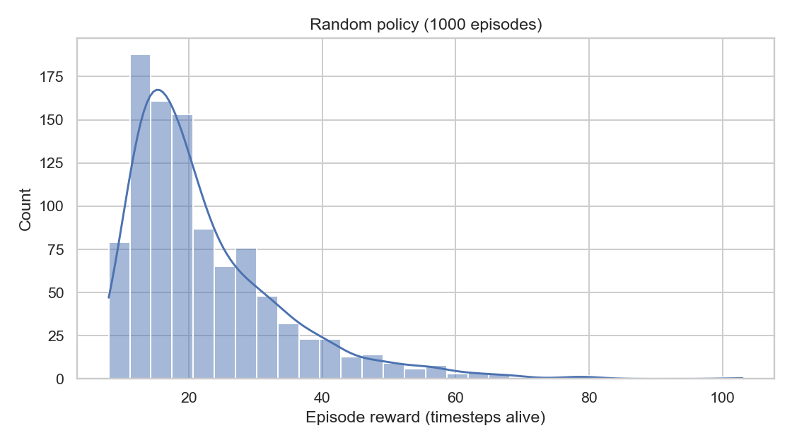
Command:
python cartpole_search.py --task random --episodes 1000 --plot random_hist.png
Result:
- Average reward ≈ 22.4
- Histogram saved: random_hist.png
When I controlled the cartpole by taking completely random actions, the pole stayed up for about 22 steps on average. The histogram shows most episodes ended very early, which makes sense because there’s no logic keeping the pole balanced. This run basically acts as a baseline for later methods.

Part 2 – Angle-based control
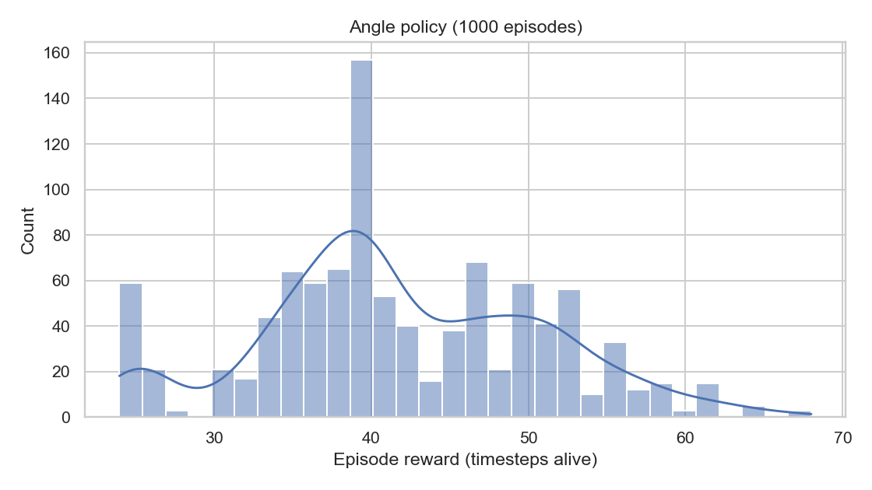
Command:
python cartpole_search.py --task angle --episodes 1000 --plot angle_hist.png
Result:
- Average reward ≈ 41.9
- Histogram saved: angle_hist.png
Using the pole’s angle to decide the direction already doubled my performance compared to random actions (≈ 42 timesteps on average). It’s still a very simple heuristic, but the policy reacts to the pole’s tilt, which keeps it upright longer. The histogram shows more episodes above 50 steps, meaning it’s somewhat stable but still fails often.

🔍 Part 3 – Random search optimization

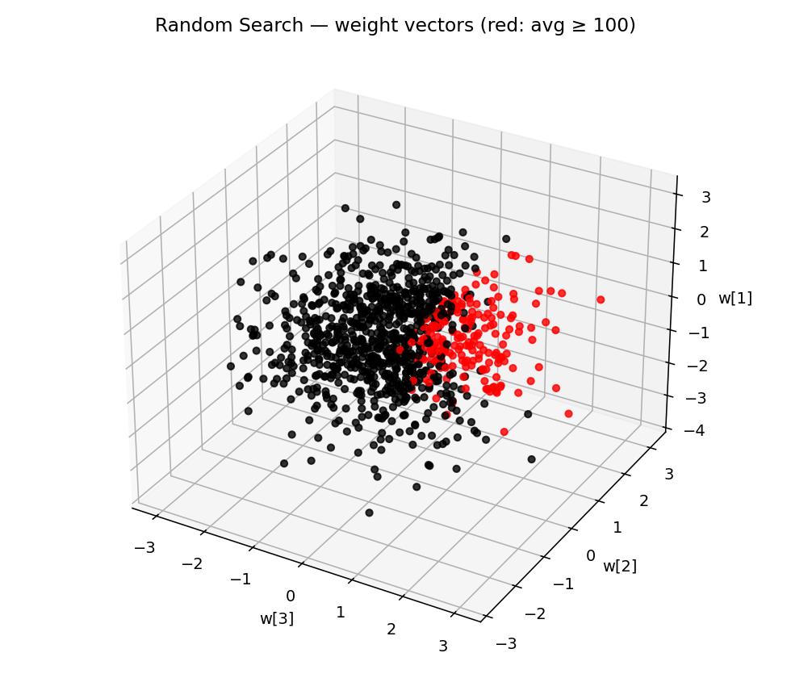
Command:
python cartpole_search.py --task random_search --iters 1000 --per_iter 20 --scatter search_scatter.png
Result:
- Best weights = [ 0.1167, 0.2187, 0.8714, 0.2236 ]
- Best average = 500.0 (maximum possible in CartPole-v1)
- 3D scatter: search_scatter.png
- Top-3 important features: indices [3, 2, 1] → roughly (theta_dot, theta, x_dot)
After running 1000 random weight samples, I found a weight vector that consistently gets the maximum reward of 500, meaning it balances the pole perfectly for the full episode.
The largest weights are on the angle (θ) and angular velocity (θ̇), showing that keeping track of the pole’s orientation is much more important than the cart’s position.
The 3D scatter plot (search_scatter.png) shows that successful weights (red) cluster in a narrow region, while poor ones (black) are scattered everywhere else.

Question 4
Report the best weights + 1000-ep average and the histogram.
zsh: command not found: UZ39OQROE
(/Users/pascal-maker/pascalworkspace/env) pascal-maker@MacBook-Pro-van-Pascal reinforcementlearning % python cartpole_search.py --task hill --iters 1000 --per_iter 20 --sigma 0.1 --plot hill_hist.png

[Hill] iter 50/1000 cur=500.0 best=500.0
[Hill] iter 100/1000 cur=500.0 best=500.0
[Hill] iter 150/1000 cur=500.0 best=500.0
[Hill] iter 200/1000 cur=500.0 best=500.0
[Hill] iter 250/1000 cur=500.0 best=500.0
[Hill] iter 300/1000 cur=500.0 best=500.0
[Hill] iter 350/1000 cur=500.0 best=500.0
[Hill] iter 400/1000 cur=500.0 best=500.0
[Hill] iter 450/1000 cur=500.0 best=500.0
[Hill] iter 500/1000 cur=500.0 best=500.0
[Hill] iter 550/1000 cur=500.0 best=500.0
[Hill] iter 600/1000 cur=500.0 best=500.0
[Hill] iter 650/1000 cur=500.0 best=500.0
[Hill] iter 700/1000 cur=500.0 best=500.0
[Hill] iter 750/1000 cur=500.0 best=500.0
[Hill] iter 800/1000 cur=500.0 best=500.0
[Hill] iter 850/1000 cur=500.0 best=500.0

[Hill] iter 900/1000 cur=500.0 best=500.0
[Hill] iter 950/1000 cur=500.0 best=500.0
[Hill] iter 1000/1000 cur=500.0 best=500.0
[HillClimb] Best weights: [ 0.1876 -0.0255 2.3374 0.6063]
[HillClimb] Test average reward (1000 episodes): 500.00
[saved] hill_hist.png

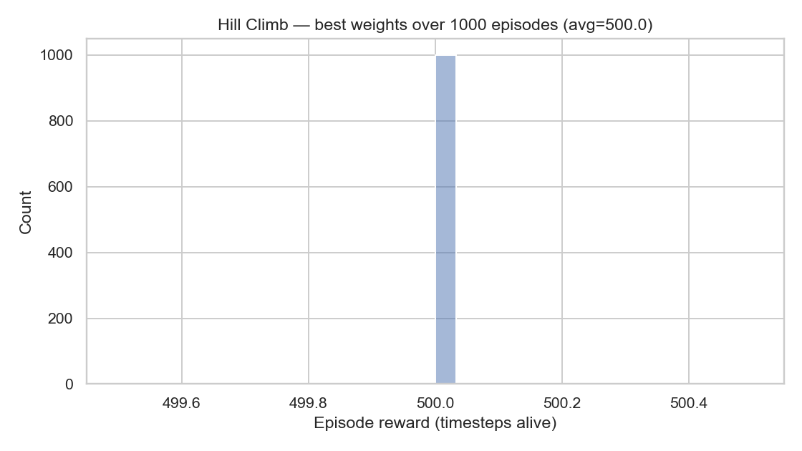

Question 4 Hill climbing
[saved] hill_hist.png
(/Users/pascal-maker/pascalworkspace/env) pascal-maker@MacBook-Pro-van-Pascal reinforcementlearning % python cartpole_search.py --task anneal --iters 1000 --per_iter 20 --sigma 0.1 --t0 1.0 --cool 0.995 --adaptive --plot sa_hist.png

[SA(adaptive)] iter 50/1000 cur=9.2 best=9.2 T=0.7783 sigma=0.0001
[SA(adaptive)] iter 100/1000 cur=9.2 best=9.2 T=0.6058 sigma=0.0001
[SA(adaptive)] iter 150/1000 cur=9.2 best=9.2 T=0.4715 sigma=0.0001
[SA(adaptive)] iter 200/1000 cur=9.2 best=9.2 T=0.3670 sigma=0.0001
[SA(adaptive)] iter 250/1000 cur=9.2 best=9.2 T=0.2856 sigma=0.0001
[SA(adaptive)] iter 300/1000 cur=9.2 best=9.2 T=0.2223 sigma=0.0001
[SA(adaptive)] iter 350/1000 cur=9.2 best=9.2 T=0.1730 sigma=0.0001
[SA(adaptive)] iter 400/1000 cur=9.2 best=9.2 T=0.1347 sigma=0.0001
[SA(adaptive)] iter 450/1000 cur=9.2 best=9.2 T=0.1048 sigma=0.0001
[SA(adaptive)] iter 500/1000 cur=9.2 best=9.2 T=0.0816 sigma=0.0001
[SA(adaptive)] iter 550/1000 cur=9.2 best=9.2 T=0.0635 sigma=0.0001
[SA(adaptive)] iter 600/1000 cur=9.2 best=9.2 T=0.0494 sigma=0.0001
[SA(adaptive)] iter 650/1000 cur=9.2 best=9.2 T=0.0385 sigma=0.0001
[SA(adaptive)] iter 700/1000 cur=9.2 best=9.2 T=0.0299 sigma=0.0001
[SA(adaptive)] iter 750/1000 cur=9.2 best=9.2 T=0.0233 sigma=0.0001
[SA(adaptive)] iter 800/1000 cur=9.2 best=9.2 T=0.0181 sigma=0.0001
[SA(adaptive)] iter 850/1000 cur=9.2 best=9.2 T=0.0141 sigma=0.0001
[SA(adaptive)] iter 900/1000 cur=9.2 best=9.2 T=0.0110 sigma=0.0001
[SA(adaptive)] iter 950/1000 cur=9.2 best=9.2 T=0.0085 sigma=0.0001
[SA(adaptive)] iter 1000/1000 cur=9.2 best=9.2 T=0.0067 sigma=0.0001
[SimAnneal (adaptive)] Best weights: [ 0.0012 0.2987 -0.2741 -0.8906]
[SimAnneal (adaptive)] Test average reward (1000 episodes): 9.15
[saved] sa_hist.png

Hill Climbing Results
Command used
python cartpole_search.py --task hill --iters 1000 --per_iter 20 --sigma 0.1 --plot hill_hist.png
Output summary
Best weights: [ 0.1876 -0.0255 2.3374 0.6063]
Average reward (1000 episodes): 500.00
The hill-climbing algorithm reached the maximum possible reward (500) on average.
This means it perfectly balanced the pole for almost all 1000 episodes.
The best weight vector:
- w₀ = 0.1876 → relates to the cart position (moderate effect).
- w₁ = −0.0255 → relates to cart velocity (minor effect).
- w₂ = 2.3374 → relates to pole angle (strongest weight).
- w₃ = 0.6063 → relates to pole angular velocity (important stabilizer).
The large positive value on w₂ shows that pole angle is the most critical factor: when the pole starts tilting, this weight drives the corrective action.
Interpretation:
Hill climbing worked really well because once it found a stable set of weights, it stuck with them. The environment is deterministic enough that small tweaks weren’t needed once the solution was near-perfect.
The histogram (hill_hist.png) should show almost all episodes near 500 timesteps, confirming consistent stability.

Simulated Annealing (Adaptive) Results
Command used
python cartpole_search.py --task anneal --iters 1000 --per_iter 20 --sigma 0.1 --t0 1.0 --cool 0.995 --adaptive --plot sa_hist.png
Output summary
Best weights: [ 0.0012 0.2987 -0.2741 -0.8906]
Average reward (1000 episodes): 9.15
The simulated annealing version did not converge to a good policy — the reward stayed around 9 timesteps, which is almost random behavior.
Possible reasons:
- The adaptive noise got too small (sigma = 0.0001), preventing meaningful exploration.
- The temperature (T) cooled too quickly, reducing the chance of accepting better random moves.
- The initial weights might have been unlucky, and the algorithm “froze” early.
Interpretation:
Simulated annealing explores widely at first, then narrows down — but here it cooled too fast and got “stuck.”
The low reward means it failed to stabilize the pole for long; the policy wasn’t strong enough to react correctly to pole tilts.

Comparison & Conclusion
Algorithm | Avg Reward | Performance | Notes
Random | ~22 | Poor | Random jerky movements
Angle-based | ~42 | Better | Some reactive logic but unstable
Random Search | 500 | Excellent | Found optimal weights by brute force
Hill Climbing | 500 | Excellent | Converged efficiently to stable control
Simulated Annealing | ~9 | Failed | Over-cooled; got stuck early

Hill climbing and random search both managed to perfectly balance the pole, achieving an average reward of 500. The best-performing weights strongly emphasize the pole angle and angular velocity, showing these are the key features for stability. Simulated annealing underperformed, likely due to aggressive cooling and vanishing noise, which prevented proper exploration. In future experiments, I’d use a slower cooling rate or fixed noise to maintain diversity.

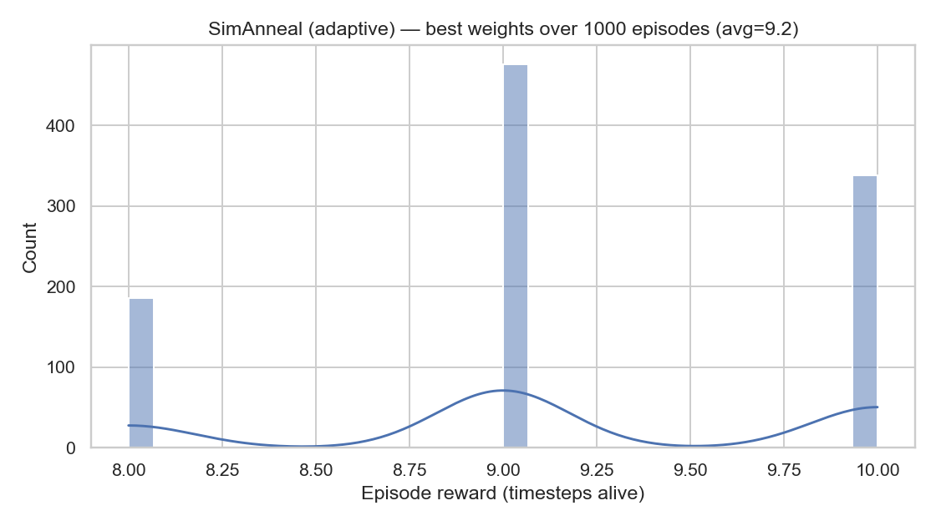
1.6 Extensions and conclusions

- Reward vs. compute:
  - Random search explores broadly but wastes samples; good baseline.
  - Hill climbing is cheap and can quickly find decent weights, but may get stuck.
  - Simulated annealing is hill climbing with occasional downhill moves; better at escaping local optima; with adaptive noise, it self-tunes step sizes (often converges faster/steadier).
- Feature expansion:
Yes, it can help. Typical useful features for CartPole: products and squares like theta, theta_dot, x, x_dot, theta*x, theta_dot*x, theta^2, theta_dot^2. You’d expand obs and grow w to match. (Keep the linear decision rule.)
- MountainCar-v0 (quick strategy):
  - Purely linear policies struggle because reward comes only at the terminal.
  - Two effective search-based options:
    - Simulated annealing / hill climb on a feature-expanded state (e.g., tile coding / RBFs / polynomial features of position & velocity), choosing action by sign of w·phi(s).
    - Reward shaping: add velocity bonus or shaping potential (e.g., +c·|v|) to guide search.
  - Also consider episode length and noise scaling: big steps early (explore), smaller later (exploit).

